when you want to return single value as o/p then use functions

calculate net for one employee

DA-10% sal

HRA ----15% sal

pf ---- 8% sal

Net sal=psal+da+hra-pf

create function netsal(psal decimal(9,2),pda int,phra int,ppf int) returns decimal

begin

declare vnetsal decimal(9,2);

set vnetsal=psal*(pda/100)-psal*(ppf/100)+psal*(phra/100)+psal;

return vnetsal;

end//

--------call the function

select empno,ename,sal,netsal(sal)

from emp;

----------based on comm we need to display performance of use

comm null or 0 then “need improvement”

comm<300 then ok

com < 500 then good

else excellent

create function getprformance(pcomm decimal(9,2)) returns varchar(20)

begin

declare vperform varchar(20) default ‘’;

if pcomm is null or pcomm=0 then

set vperform=’need improvement’;

elseif pcomm < 300 then

set vperform=’ok’;

elseif pcomm < 500 then

set vperform=’good’

else

set vperform=’Excellent’

end if;

return vperform;

end//

--------write a procedure to display empno,ename,sal,comm,performance of all employees of a particular department

create procedure display_empdetails(in pdeptno int)

begin

select empno,ename,sal,comm, getprformance(comm)

from emp

where deptno=pdeptno;

end//

------triggers --- automatically called

2 types of trigger

1. statement level -------- this deoenot supported by mysql
2. row level

timing

1. before
2. after
3. instead of -------- views --doesnot work in mysql

DML

insert

delete

update

audit, secure,

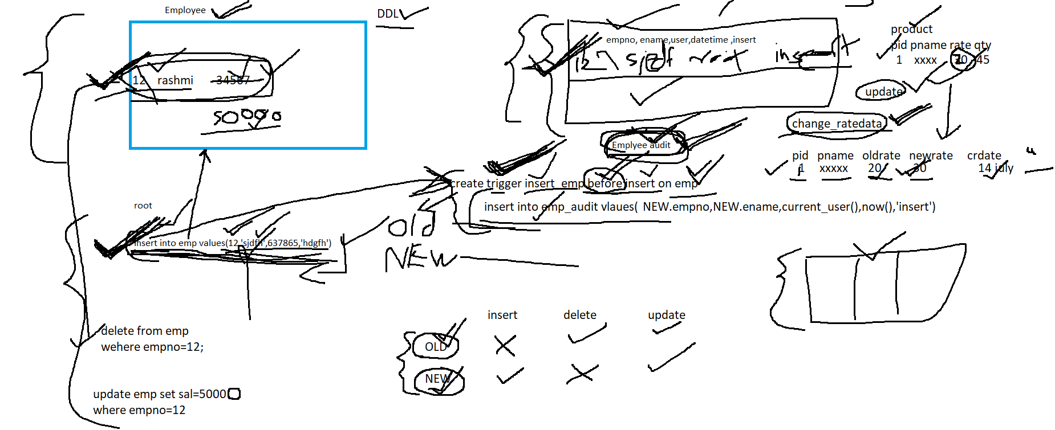

step 1:

create necessary audit table

step2:

create trigger

in audit table if you want to store

deptno,dname,username,date,action

create table dept_audit(

deptno int,

olddname varchar(20),

newname varchare(20),

username varchar(20),

dt_action datetime,

action varchar(20))

-------- write a trigger to audit, insert, delete, update information on dept

create trigger insert_dept before insert on dept

for each row

insert into dept_audit(deptno,newname,username,dt_action,action) values(NEW.deptno,New.dname,current_user(),now(),’insert’)

create trigger delete_dept before delete on dept

for each row

insert into dept_audit values(OLD.deptno,OLD.dname,current_user(),now(),’delete’)

|  |  |  |
| --- | --- | --- |
| Deptno | Dname | location |
| 10 | HR | Mumbai |
| 20 | Accounts | Chennai |
| 30 | Purchase | Pune |
| 40 | Sales | Pune |

update dept

set dloc=’chennai’

where deptno=40

OLD

|  |  |  |
| --- | --- | --- |
| 40 | Sales | Pune |

NEW

|  |  |  |
| --- | --- | --- |
| 40 | sales | chennai |

insert into dept values(50,’xxx’,’pune’)

NEW

|  |  |  |
| --- | --- | --- |
| 50 | xxx | Pune |

OLD

|  |  |  |
| --- | --- | --- |
|  |  |  |

delete from dept

where deptno>20

OLD

|  |  |  |
| --- | --- | --- |
| 30 | Purchase | Pune |

NEW

|  |  |  |
| --- | --- | --- |
|  |  |  |

OLD

|  |  |  |
| --- | --- | --- |
| 40 | Sales | Pune |

NEW

|  |  |  |
| --- | --- | --- |
|  |  |  |

create trigger update_dept before update on dept

for each row

insert into dept_audit values(OLD.deptno,OLD.dname,current_user(),now(),’update’)

-----to write triggers on product table

create table product_analysis

(pid int,

pname varchar(20),

oldrate decimal(9,2),

newrate decimal(9,2),

uname varchar(20),

dt_time datetime,

action varchar(20));

create trigger update_pr after update on product

for each row

insert into product_analysis values(OLD.pid,OLD.pname,OLD.price,,NEW.price,current_user(),now(),’update’)

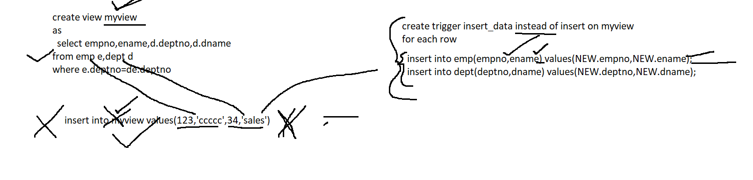

--------to delete the trigger

drop tigger <trigger-name>

-----to display all triggers

show trigger

Exception handling

hanlder

1. exit
2. continue

condition

mysql_error_code

SQLEXCEPTION

NOT FOUND

declare continue handler for SQLEXCEPTION select ‘Error Occured’

declare exit handler for SQLEXCEPTION set cset=1

create procedure insertproduct(ppid int,ppname varchar(20),pqty int,pprice decimal(9,2),pcid int)

begin

declare exit handler for SQLEXCEPTION select ‘error occur’;

insert into product values(ppid,ppname,pqty,pprice,pcid);

select ‘done’;

end//

create procedure insert_userentity111(puid int,puname varchar(20),paddrid int)

-> begin

-> declare exit handler for SQLEXCEPTION select 'error occured';

-> insert into userentity values(puid,puname,paddrid);

-> select 'done';

-> end//

create procedure insert_userentity111(puid int,puname varchar(20),paddrid int)

-> begin

-> declare exit handler for 1062 select ‘duplicate user id';

declare exit handler for 1366 select ‘data type mismatch;

-> declare exit handler for SQLEXCEPTION select 'error occured';

-> insert into userentity values(puid,puname,paddrid);

-> select 'done';

-> end//

NOSQL ------ MONGODB

------CRUD ----- create,read,update,delete

use installation step by step to install mongodb

set up the path to

C:\Program Files\MongoDB\Server\4.2\bin

step 1. start the server

open cmd

c:system32>mongod –dbpath c:\data\db

27017

step 2: start client

open cmd

c:\system32> mongo

>show dbs -------- to list all databases

>use test ----------------- create and switch to the database

>show collections --------- to list all collections

step 3: import data

c:\mydata ----- store json files

restaurant.json

movie.json

open new cmd

c:\system32>mongoimport –db test –collection movie --file c:\mydata\movie.json

c:\system32>mongoimport –db test –collection restaurent --file c:\mydata\restaurent.json

---------in mongo client window

> db.movie.find().pretty()

>db.restaurent.find().pretty()

JSON---- Javascript object notation

RDBMS VS MongoDB(NoSQL)

|  |  |
| --- | --- |
| RDBMS | NOSQL |
| Structured | Unstructured |
| Vertical scaling | Horizontal scaling |
| Less available compared to NOSQL | Highly available----replica is avaialable |
| Compare to NOSQL this is slower | Faster----sharding |
| Transaction control(ACID) | No transaction(CAP) |

employee(emp int,ename varchar(20))

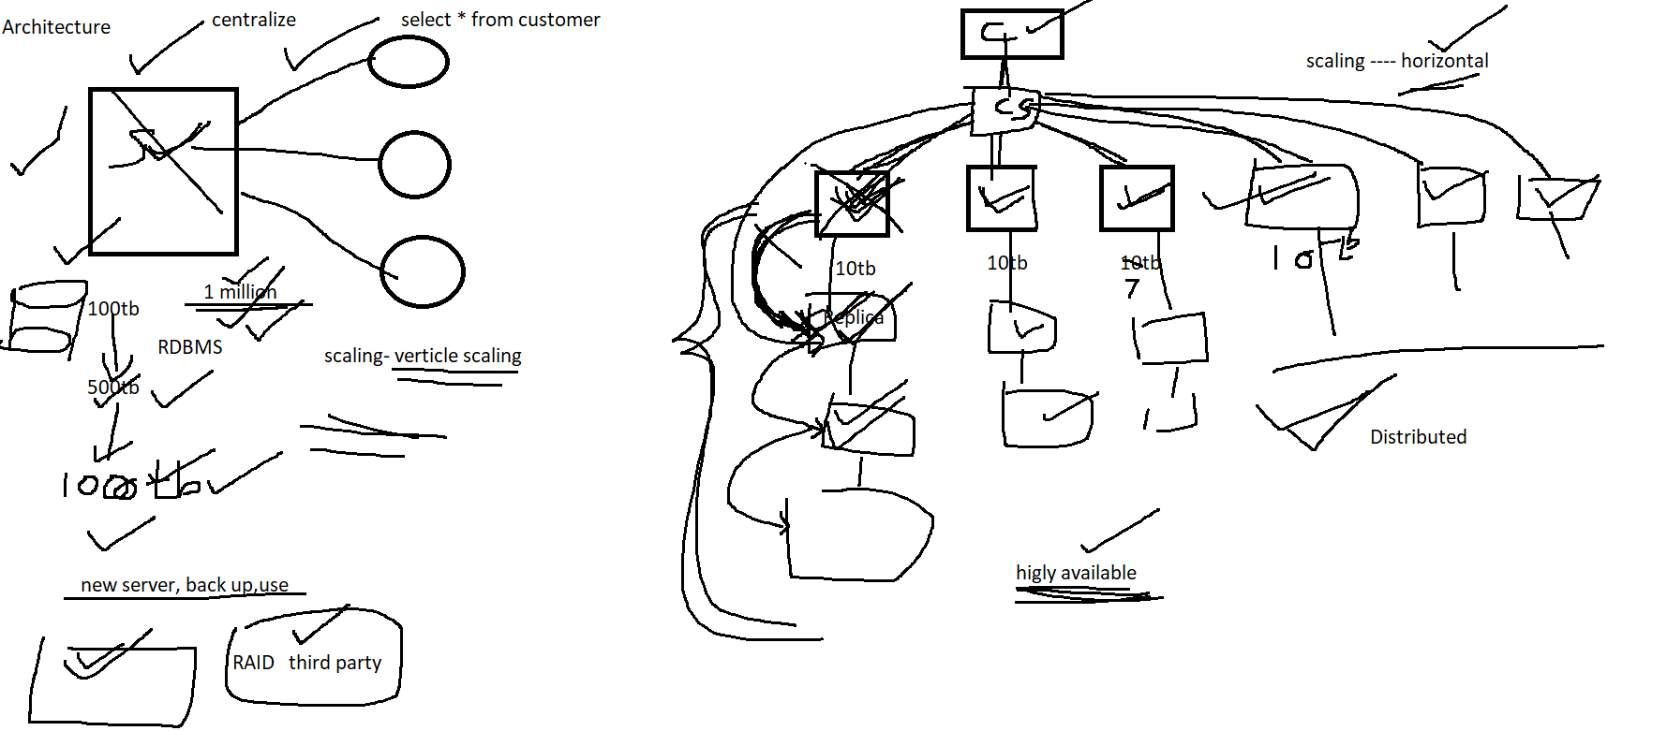

Media image,text,video

comment -----emoji,,image,text,video

Terminologies

|  |  |
| --- | --- |
| RDBMS | NOSQL |
| Database | Database |
| Table | Collection |
| Record | Document |
| Index | Index |
|  |  |

Mongodb ----- stores data internally in Binary-JSON (BSON)

create a database iacsdedac

add 5 documents in emp collection

{

empid:123,

ename:'kishori',

skills:['java','python','mongodb','spring boot','hibernate'],

joining_dt: ISODate('2000-04-27'),

dept:{deptno:11,dname:'hr',dloc:'pune'},

experience:[{name:'hsbc',years:3},{name:'igate',years:4},{name:'Capgemini',years:5}],

maritalStatus:null

}

{

empid:123,

ename:’Rajan’,

skills:’jzxcjkh’,

salary:3456

joining_dt: ISODate(’2000-04-27’),

experience:[{name:‘hsbc’,years:3},{name:’igate’,years:4},{name:Capgemini,years:5}],

maritalStatus:null

}

{

pid:123,

pname:’kjdhshdg’

}

-------create a friend collection

add 5 documents

name,bdate,hobbies,address,mobileno