  - AKHIL KUMAR 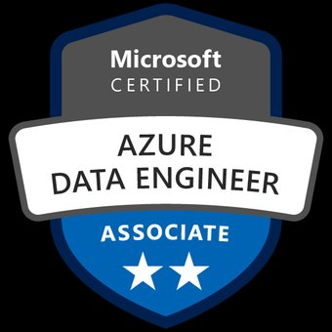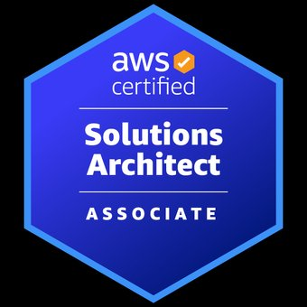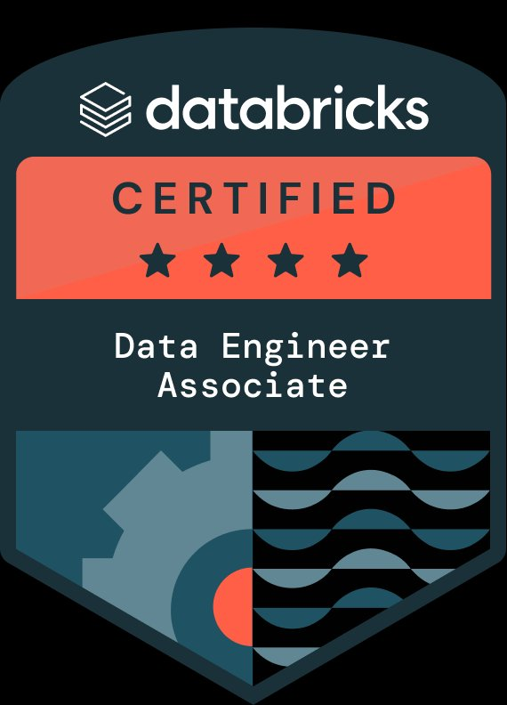
• (972) 584-7024 • akhilkumar.datacloud@gmail.com

Senior Data Engineer

I am a Data Engineer with 9+ years of experience building scalable data platforms across retail, banking, public sector, and enterprise warehousing domains. I work with Python, PySpark, Databricks, Snowflake, Kafka, Airflow, AWS, Azure, Informatica, Oracle, SQL Server, Teradata, Talend, Hadoop, Hive, Power BI, Tableau, dbt, Terraform, Jenkins, and data governance practices to deliver secure pipelines, curated analytics, reconciliations, and production-ready reporting solutions reliably across enterprise-wide batch and streaming ecosystems.
- Building scalable batch and streaming data pipelines using Python, PySpark, Databricks, Kafka, Airflow, Snowflake, AWS, and Azure for enterprise analytics.
- Designing curated data lake and warehouse layers across Delta Lake, S3, Azure Data Lake, Synapse, Redshift, Teradata, and SQL Server.
- Developing ETL and ELT workflows with Informatica IICS, PowerCenter, Talend, dbt, SSIS, AWS Glue, and Azure Data Factory for enterprise pipelines.
- Creating data models, fact tables, dimensions, marts, and certified datasets for retail, finance, public sector, and operational reporting domains consistently.
- Conducting data quality validations using Great Expectations, reconciliation queries, control totals, null checks, duplicate checks, and schema drift monitoring before publishing.
- Implementing secure data access through IAM, KMS, Key Vault, Purview, Lake Formation, encryption, masking, secrets management, and governance controls enterprise-wide.
- Optimizing Spark jobs, Snowflake warehouses, SQL queries, indexes, partitions, clustering, and execution plans to improve large-scale processing performance consistently daily.
- Integrating real-time events through Kafka, IBM MQ, NiFi, CDC patterns, AWS DMS, and message-driven pipelines for operational intelligence use-cases consistently.
- Orchestrating production schedules through Airflow, Control-M, Oozie, Jenkins, GitHub Actions, and Azure DevOps pipelines for reliable delivery cycles nightly operations.
- Building dashboards and reporting datasets using Power BI, Tableau, SSRS, SSAS, Cognos, and Redshift Spectrum for business insights regularly across departments.
- Managing relational and NoSQL platforms including Oracle, SQL Server, PostgreSQL, MongoDB, DynamoDB, Teradata, and Snowflake across diverse workloads securely daily.
- Automating file validation, archive movement, log capture, deployment checks, and failure notifications using UNIX Shell, PowerShell, and CI/CD scripts daily.
- Supporting regulatory, compliance, and audit reporting needs across PII, PCI, GLBA, public records, financial reconciliation, and operational governance scenarios effectively.
- Collaborating with architects, analysts, product owners, data stewards, cybersecurity teams, and operations teams to define requirements and delivery standards clearly.
- Documenting source-to-target mappings, lineage diagrams, runbooks, data dictionaries, recovery steps, and support procedures for maintainable data operations practices consistently accurately.
- Resolving production incidents through root cause analysis, log reviews, pipeline reruns, defect tracking, and coordinated release support activities across environments.
- Using Jira, ServiceNow, Confluence, SharePoint, Bitbucket, Git, SVN, HP ALM, and Agile ceremonies to manage delivery transparency across teams consistently.

Skills
Programming & Scripting: Python, Scala, Spark SQL, SQL, PL/SQL, T-SQL, UNIX Shell, PowerShell, Excel VBA.
Big Data & Processing: PySpark, Apache Spark, Databricks, Hadoop HDFS, Hive, Sqoop, Oozie, Delta Lake.
Cloud Platforms: AWS, Azure, AWS S3, AWS Glue, AWS Redshift, AWS DMS, Azure Synapse, Azure Data Lake Gen2.
Data Warehousing: Snowflake, Oracle, SQL Server, Teradata, PostgreSQL, Redshift Spectrum, Synapse SQL pools, dimensional modeling.
ETL & Data Integration: Informatica IICS, Informatica PowerCenter, Talend, SSIS, Azure Data Factory, Fivetran, dbt, Control-M.
Streaming & Messaging: Apache Kafka, IBM MQ, Apache NiFi, CDC pipelines, event-driven ingestion, message validation, queue processing.
Reporting & BI: Power BI, Tableau, SSRS, SSAS, IBM Cognos, operational dashboards, executive reporting, certified datasets.
Data Governance & Quality: Microsoft Purview, Great Expectations, Lake Formation, data lineage, reconciliation, audit controls, masking, encryption.
DevOps & Automation: Jenkins, GitHub Actions, Azure DevOps, Terraform, ARM Templates, Docker, Kubernetes, Bitbucket, Git, SVN.
Tools & Platforms: ServiceNow, Jira, Confluence, SharePoint, HP ALM, Toad, SQL Developer, PuTTY, WinSCP, Visual Studio Code.

CERTIFICATIONS:
- AWS Certified Solutions Architect Associate
- Azure Certified Data Engineer Associate
- Databricks Certified Data Engineer Associate

Experience

MAR 2024 – Present

Senior Data Engineer | Nike | Portland,OR (Remote)
Athlete Data Hub: Built an enterprise retail data engineering platform for athlete engagement, digital commerce, product demand sensing, store replenishment, campaign attribution, membership analytics, inventory visibility, and fulfillment intelligence. Engineered pipelines across Databricks, PySpark, Delta Lake, Snowflake, Kafka, Airflow, AWS Glue, S3, Redshift, dbt, Fivetran, DynamoDB, Tableau, Power BI, GitHub Actions, and Terraform, enabling curated data products, governed metrics, reliable batch processing, and near real-time operational insights for merchandising, loyalty, finance, and logistics teams.
- Designed ingestion pipelines from POS, eCommerce, mobile, and loyalty feeds to centralize retail events, improving trusted availability for analytics teams.
- Built PySpark transformations in Databricks to cleanse product, order, shipment, and return datasets, producing reusable Delta Lake tables for downstream reporting.
- Modeled Snowflake marts for membership, merchandising, allocation, and demand planning so analysts received consistent dimensions, governed facts, and simplified query paths.
- Developed Kafka streaming jobs for clickstream, cart, inventory, and fulfillment signals, supporting faster operational monitoring across digital commerce channels teams.
- Orchestrated Airflow DAGs for incremental loads, dependency checks, retries, and SLA alerts, reducing pipeline interruptions across daily curated data products.
- Created dbt models, tests, snapshots, and documentation to standardize transformations, strengthening lineage, auditability, and metric definitions across critical retail business domains.
- Optimized Delta Lake partitions, Z-ordering, compaction, and vacuum jobs to improve scan efficiency for large-scale product analytics queries workloads daily.
- Implemented data quality rules with Great Expectations to validate nulls, duplicates, schema drift, and referential integrity before publishing enterprise datasets.
- Built secure AWS S3 zones for raw, refined, and consumption layers, enabling structured storage across marketing, supply chain, and finance data.
- Configured IAM policies, KMS encryption, Secrets Manager, and Lake Formation controls to protect sensitive customer, payment, and membership attributes securely.
- Migrated legacy SQL workloads into Spark and Snowflake patterns, improving maintainability for replenishment, margin, pricing, and seasonal planning datasets pipelines.
- Tuned Snowflake warehouses, clustering keys, materialized views, and query profiles to stabilize dashboard performance during executive reporting cycles monthly reviews.
- Automated CI/CD workflows with GitHub Actions and Terraform to promote data assets consistently across development, staging, and production environments securely.
- Developed APIs and Athena-accessible datasets for personalization teams, enabling feature consumption across recommendation, segmentation, campaign, and experimentation workflows modeling use-cases.
- Created Redshift Spectrum external tables over parquet datasets to support finance reconciliation, margin analysis, vendor reporting, and promotional performance reviews.
- Implemented CDC patterns with AWS DMS to capture order, payment, and shipment changes, improving freshness for omnichannel fulfillment metrics daily.
- Built Tableau and Power BI certified datasets so business users accessed trusted KPIs for sell-through, returns, inventory turns, and allocation accuracy.
- Monitored pipelines through CloudWatch, Datadog, and Splunk alerts to detect latency, failed loads, schema issues, and abnormal processing volumes early.
Environments: Python 3.11, PySpark 3.5, Databricks Runtime 14.x, Delta Lake 3.x, Snowflake Enterprise, Apache Kafka 3.6, Apache Airflow 2.8, AWS Glue 4.0, AWS S3, AWS Redshift, AWS DMS, Amazon Athena, DynamoDB, dbt Core 1.7, Fivetran, Great Expectations 0.18, Terraform 1.6, GitHub Actions, Docker 24.x, Kubernetes 1.29, Tableau 2024.1, Power BI 2024, Datadog, Jira Cloud.

MAY 2022 – FEB 2024

Senior Data Engineer | Huntington National Bank | Columbus,OH
Banking DataGrid: Developed a banking data integration platform for deposit operations, loan servicing, ACH processing, fraud surveillance, customer risk scoring, regulatory reporting, branch analytics, and treasury reconciliation. Built governed pipelines using Informatica IICS, Oracle 19c, SQL Server 2019, Teradata, Control-M, IBM MQ, SAS, UNIX Shell, Bitbucket, Jenkins, Azure Data Factory, Azure Synapse, Purview, SSIS, SSRS, Power BI, and ServiceNow, enabling compliant data movement, audit traceability, exception monitoring, and executive reporting across financial operations.
- Analyzed banking source feeds from deposits, loans, ACH, and cards to design ingestion patterns, improving reliable availability for compliance reporting.
- Built Informatica IICS mappings for customer, account, transaction, and branch datasets to standardize transformation logic across regulated financial domains efficiently.
- Developed Oracle PL/SQL procedures, packages, indexes, and partitions to process high-volume payment records, reducing reconciliation delays during month-end cycles effectively.
- Created SQL Server staging tables, stored procedures, views, and error logs to support controlled ETL processing for banking operations teams.
- Configured Control-M schedules for nightly batches, dependency chains, restart steps, and alerts to maintain predictable execution across critical data workflows.
- Designed Teradata reporting tables for risk, treasury, branch performance, and customer profitability, enabling faster analytical access for business users securely.
- Built Azure Data Factory pipelines to move curated datasets into Synapse, supporting enterprise reporting without disrupting core banking databases regularly.
- Implemented data quality checks for balances, transaction codes, customer identifiers, and duplicate records to improve confidence in regulatory submissions cycles.
- Created SSIS packages for legacy file processing, encryption handling, FTP transfers, and audit logging to modernize older banking interfaces safely.
- Developed SSRS reports for operational exceptions, settlement summaries, GL reconciliation, and compliance extracts, giving teams controlled distribution formats monthly securely.
- Built Power BI dashboards for deposit trends, loan volumes, transaction exceptions, and branch KPIs to improve leadership visibility across operations.
- Supported fraud analytics datasets by preparing transaction velocity, account behavior, device signals, and suspicious activity indicators for investigation teams securely.
- Optimized SQL queries, execution plans, statistics, and indexes across Oracle, SQL Server, and Teradata to improve batch performance windows consistently.
- Automated UNIX Shell scripts for file validation, archive movement, control totals, and failure notifications, reducing manual operational checks daily nightly.
- Collaborated with cybersecurity teams to apply masking, encryption, access controls, and retention rules for PII, PCI, and GLBA data consistently.
- Validated data movement through reconciliation queries, source counts, target counts, hash totals, and exception reports before production releases safely consistently.
- Managed Jenkins and Bitbucket workflows for ETL code promotions, peer reviews, version control, and deployment traceability across environments securely consistently.
- Worked with business analysts, risk officers, and operations teams to refine data requirements, acceptance criteria, and defect resolution plans carefully.
Environments: Informatica IICS 2023, Oracle 19c, SQL Server 2019, Teradata 16.20, Control-M 9.0, IBM MQ 9.2, SAS 9.4, UNIX Shell, Bitbucket Server, Jenkins 2.x, Azure Data Factory, Azure Synapse Analytics, Microsoft Purview, SSIS 2019, SSRS 2019, Power BI 2023, ServiceNow, Jira, Confluence, WinSCP, PuTTY, Toad 14, SQL Developer 21, Git.

Aug 2019 – APR 2022

Data Engineer | State of Illinois (Department of Human Services) | Springfield, IL
Citizen DataLake: Built a public-sector data modernization solution for citizen services, unemployment claims, benefits eligibility, workforce programs, Medicaid referrals, case management, document intake, and legislative reporting. Developed pipelines using Azure SQL Database, Azure Data Lake Gen2, Synapse SQL pools, Databricks, Scala, Spark SQL, Talend, PostgreSQL, MongoDB, Kafka, NiFi, SSAS, Tableau, PowerShell, Azure DevOps, ARM templates, and Key Vault, enabling secure data consolidation, repeatable reporting, improved case visibility, and governed analytics for agency operations.
- Built Talend jobs to extract citizen, employer, provider, and case records from mixed sources, reducing manual collection across agency systems.
- Developed Spark SQL transformations in Databricks to cleanse benefits, claims, hearings, and workforce datasets for consistent analytical consumption and reporting.
- Created Azure Data Lake Gen2 zones for landing, standardized, curated, and archive layers, improving structured storage for public sector records.
- Modeled Synapse SQL pool tables for claims volume, case status, payment activity, and program participation, enabling faster executive reporting cycles.
- Configured Apache NiFi flows for secure file ingestion, schema routing, validation checks, and delivery tracking across partner data exchanges nightly.
- Integrated Kafka topics for case updates, document events, appointment changes, and payment notifications, improving near real-time operational awareness across departments.
- Built PostgreSQL reference tables for county codes, office locations, program rules, and service categories to support consistent transformations across datasets.
- Designed MongoDB collections for semi-structured intake forms, correspondence metadata, document tags, and workflow notes, improving flexible data capture patterns securely.
- Developed SSAS tabular models for program performance, workload aging, backlog analysis, and payment summaries to support governed self-service analytics reporting.
- Created Tableau dashboards for claims trends, processing queues, demographic insights, and service outcomes, improving visibility for agency leadership reviews monthly.
- Automated PowerShell scripts for file monitoring, encryption checks, archive movement, and log validation, reducing repetitive production support tasks daily operations.
- Implemented Azure Key Vault secrets, private endpoints, managed identities, and role assignments to strengthen security across data pipelines and services.
- Built data quality rules for invalid dates, missing identifiers, duplicate cases, and unmatched payments, improving reliability before dashboard publication cycles.
- Created reconciliation routines comparing source extracts, lake files, warehouse counts, and exception logs to validate regulated reporting outputs accurately nightly.
- Optimized Spark jobs with broadcast joins, caching, partition pruning, and adaptive execution, improving processing stability for large claims datasets consistently.
- Configured Azure DevOps boards, repositories, YAML pipelines, and release approvals to standardize delivery across development, test, and production environments consistently.
- Produced ARM templates for repeatable deployment of storage, compute, networking, and security resources, reducing configuration inconsistencies across environments reliably safely.
- Resolved production defects through root cause analysis, query inspection, pipeline reruns, and incident documentation, improving operational reliability across releases steadily.
Environments: Azure SQL Database, Azure Data Lake Gen2, Azure Synapse Analytics, Databricks Runtime 7.x, Apache Spark 3.0, Scala 2.12, Spark SQL, Talend Open Studio 7.3, PostgreSQL 12, MongoDB 4.4, Apache Kafka 2.6, Apache NiFi 1.12, SSAS 2019, Tableau 2021.2, PowerShell 7, Azure DevOps Server 2020, ARM Templates, Azure Key Vault, SharePoint 2019, Git, Visual Studio Code, ServiceNow Orlando, Windows Server 2019.

APR 2017 – MAY 2019

Data Engineer | Capgemini | HYD,INDIA
Warehouse Support: Supported an enterprise data warehouse build for retail sales, finance extracts, customer master, vendor feeds, inventory files, operational reporting, and reconciliation processing. Developed batch data flows using Informatica PowerCenter, Oracle 12c, SQL Server 2016, Hadoop HDFS, Hive, Sqoop, Oozie, Unix Shell, Control-M, Excel macros, SSRS, Cognos, SVN, Jenkins, Putty, WinSCP, and Toad, enabling structured staging, dimensional loading, scheduled reporting, defect tracking, and controlled production support for distributed client delivery teams.
- Developed Informatica PowerCenter sessions, workflows, lookups, expressions, and aggregators to load customer, product, vendor, and sales datasets into staging tables.
- Wrote Oracle SQL queries, joins, subqueries, and validation scripts to compare source counts, target counts, and rejected records accurately daily.
- Created SQL Server stored procedures and views for operational extracts, supporting finance reconciliation, inventory tracking, and daily reporting needs consistently.
- Prepared Unix Shell scripts for file presence checks, log capture, archive movement, and email notifications during nightly batch processing runs.
- Configured Control-M job entries, calendars, dependencies, and rerun steps to support predictable execution of recurring ETL workloads each week reliably.
- Loaded flat files into Hadoop HDFS using Sqoop and shell utilities, enabling scalable storage for historical sales and vendor data.
- Created Hive external tables, partitions, and simple transformations to support exploratory analysis across large archived transaction datasets for reporting teams.
- Maintained Oozie workflows for Hadoop jobs, dependency sequencing, parameter handling, and completion tracking across recurring data processing cycles successfully nightly.
- Built Excel macro templates for business users to review exception records, reconciliation summaries, and manually corrected reference data weekly accurately.
- Developed SSRS reports for sales trends, vendor aging, inventory variance, and finance extracts, helping stakeholders review operational performance monthly easily.
- Performed data cleansing for null values, invalid codes, duplicate customers, and mismatched product identifiers before warehouse loads were published successfully.
- Created dimensional tables for product, location, vendor, customer, and calendar structures, supporting simplified reporting across multiple subject areas consistently daily.
- Tested ETL workflows through unit cases, sample files, negative scenarios, and reconciliation checks before handing builds to QA teams safely.
- Resolved production issues by reviewing workflow logs, session errors, database locks, rejected rows, and failed job dependencies carefully during support.
- Used Toad and SQL Developer to debug packages, inspect indexes, validate constraints, and review execution behavior across Oracle schemas efficiently.
- Managed SVN commits, branch updates, code comparisons, and deployment folders to maintain version control discipline across project releases consistently safely.
- Prepared Jenkins build jobs for ETL package movement, environment variable checks, and deployment notifications across development and test servers regularly.
- Documented mapping specifications, job schedules, support notes, and reconciliation procedures, improving knowledge transfer for offshore and onsite teams consistently daily.
Environments: Informatica PowerCenter 10.2, Oracle 12c, SQL Server 2016, Hadoop HDFS 2.7, Hive 2.x, Sqoop 1.4, Oozie 4.x, Unix Shell, Control-M 8, SSRS 2016, IBM Cognos 11, Excel VBA, Toad 12, SQL Developer 17, Jenkins 2.x, SVN, HP ALM 12, PuTTY, WinSCP, Windows Server 2016, Red Hat Linux 7, Autosys 11, Notepad++, Oracle SQL Loader.
Education
MAY 2017
Bachelor of Technology in Mechanical Engineering | JNTUH | Hyderabad

