Task 7: Kubernetes Deployment (Real Production GKE/EKS Scenario)*
📖 Scenario Explanation
Imagine your company has developed a FoodExpress application.
The application consists of three components:
Users
│
▼
Frontend (Nginx)
│
▼
Backend API (Node.js)
│
▼
MySQL Database
Initially, the application was deployed using Docker on a single EC2 server.
EC2 Server
Docker
├── Frontend Container
├── Backend Container
└── MySQL Container
Everything works fine while there are only a few users.

The Problem
As the business grows, thousands of users start accessing the application.
Problems begin to appear:
- If the EC2 server crashes, the entire application goes down.
- If the backend container crashes, someone must restart it manually.
- During heavy traffic, the application becomes slow because only one backend container is handling all requests.
- Updating the application can cause downtime.
- Managing resources becomes difficult.
The company needs a better solution.

The Solution: Kubernetes
The company decides to migrate the application from Docker to Kubernetes.
Kubernetes provides:
- High Availability
- Auto Scaling
- Self-Healing
- Load Balancing
- Rolling Updates
- Better Resource Management

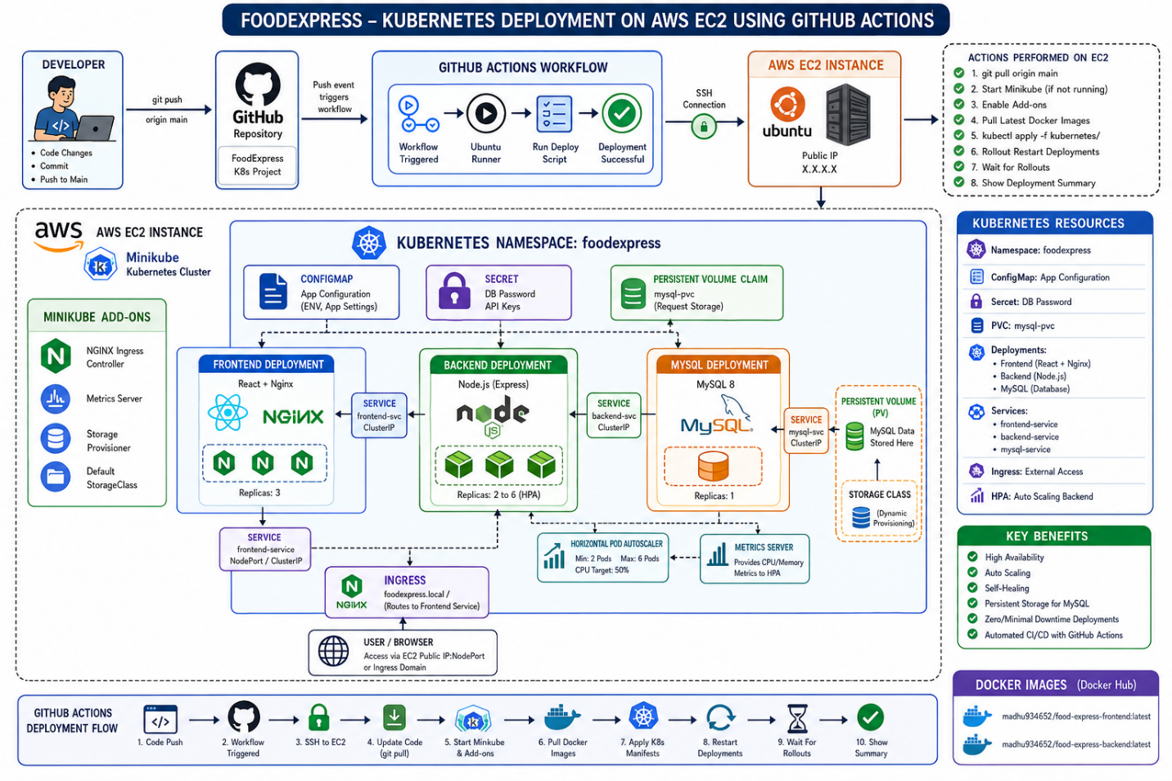

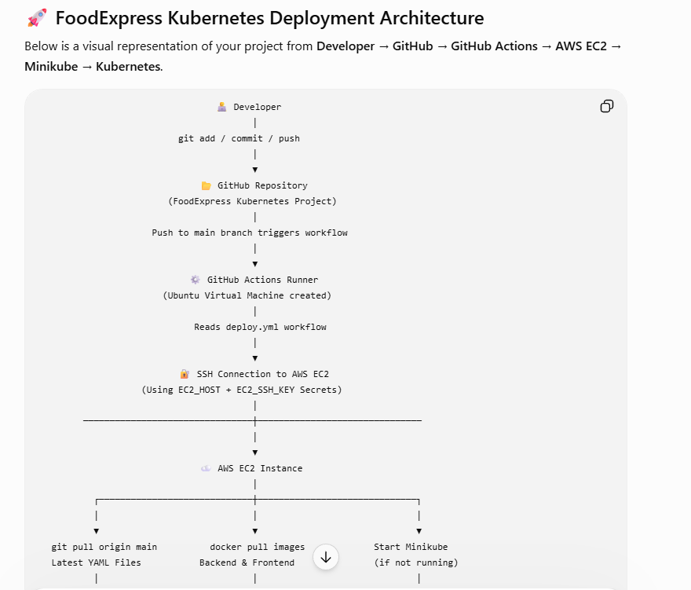
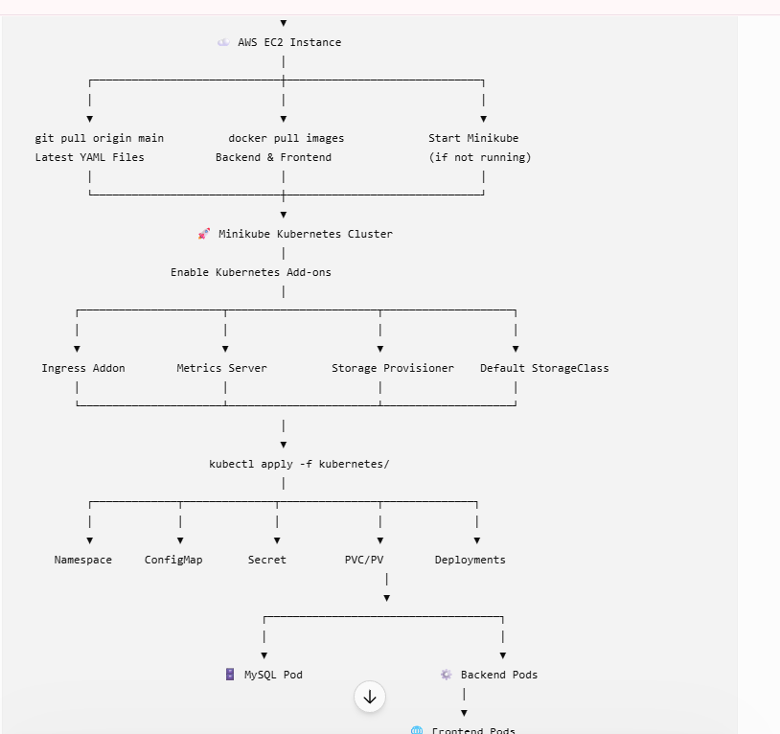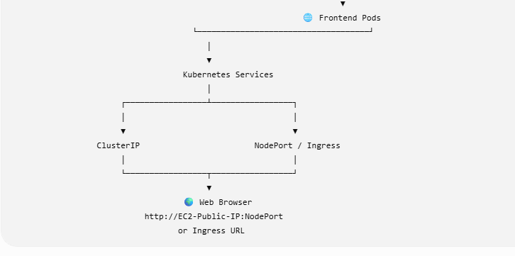

Minikube vs EKS
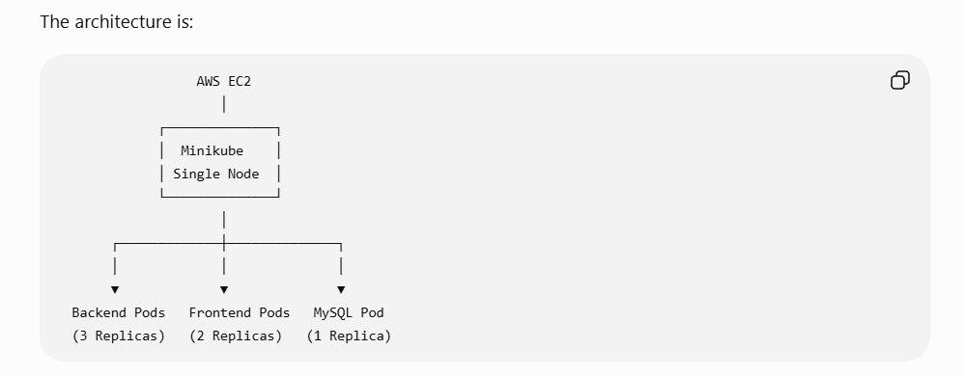
The scheduler places all of these pods on the same node because that's the only node available.
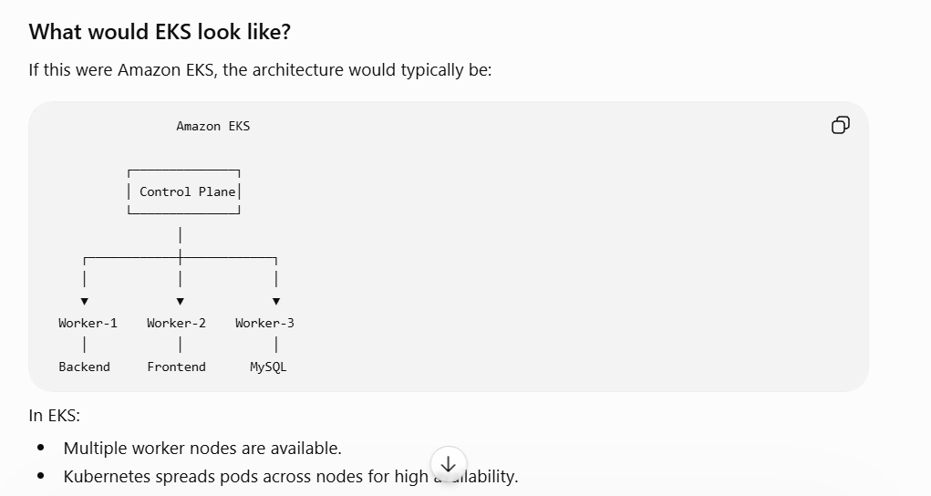

# Step 1 - Launch AWS EC2
Create an Ubuntu EC2 instance.
Recommended:
- Ubuntu 22.04
- t3.medium
- 30 GB Storage

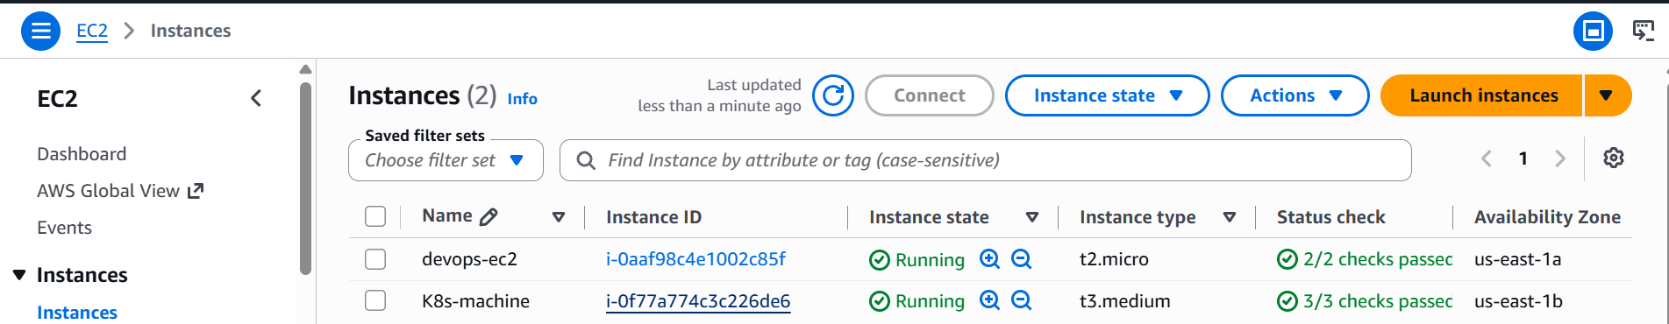

Open Security Group ports:
| Port | Purpose |
|-------|----------|
|22|SSH|
|80|HTTP|
|443|HTTPS|
|8083| CustomTcp|
|30323| CustomTcp |NodePort|

SSH into EC2 using putty or mobaxtream

# Step 2 - Install Docker
sudo apt update
sudo apt install docker.io -y
sudo systemctl enable docker
sudo systemctl start docker
sudo usermod -aG docker ubuntu
newgrp docker
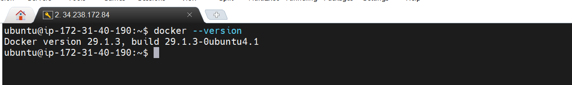

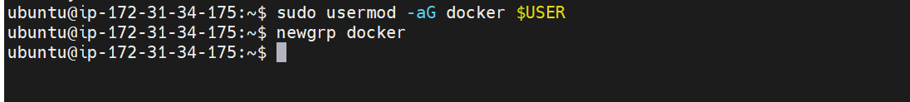

# Step 3 - Install kubectl
curl -LO "https://dl.k8s.io/release/$(curl -L -s https://dl.k8s.io/release/stable.txt)/bin/linux/amd64/kubectl"
chmod +x kubectl
sudo mv kubectl /usr/local/bin/

Verify
kubectl version --client

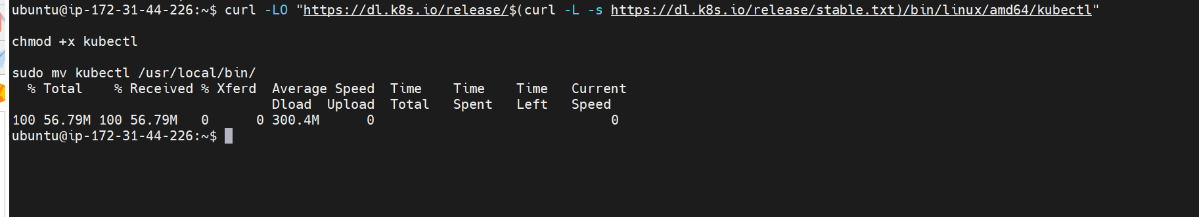

# 🚀 Step 4 - Install Minikube

curl -LO https://storage.googleapis.com/minikube/releases/latest/minikube-linux-amd64
sudo install minikube-linux-amd64 /usr/local/bin/minikube

Verify
minikube version
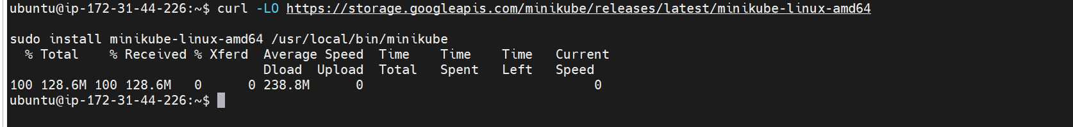

Start minikube
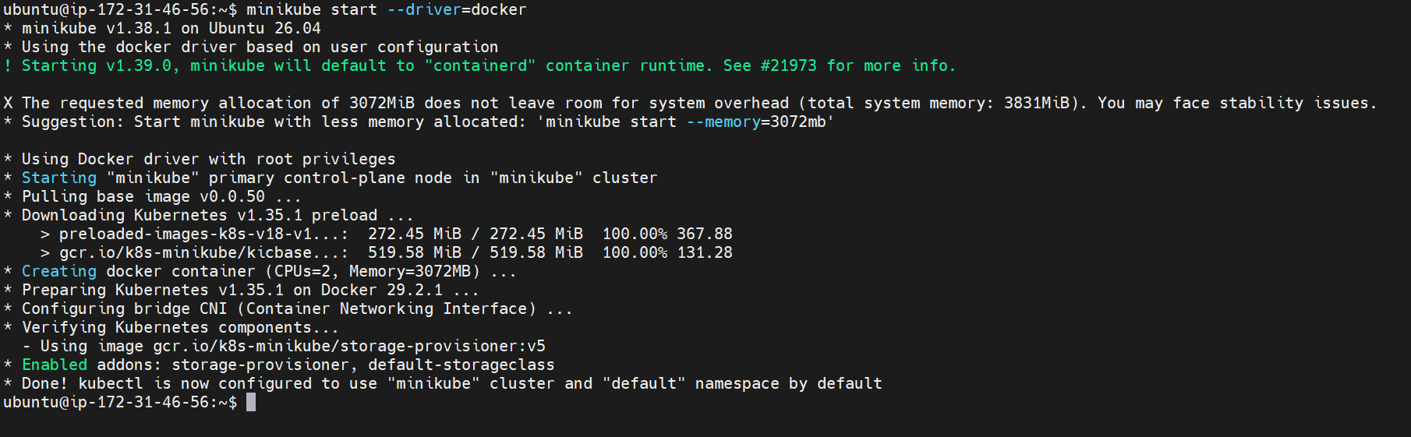
# 🚀 Step 5 - Start Minikube

minikube start --driver=docker
Verify
kubectl get nodes
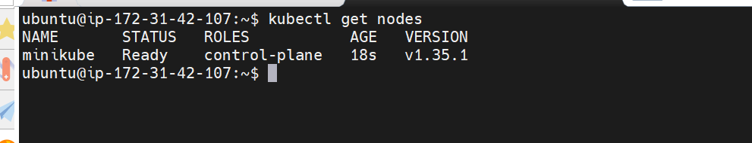
# 🚀 Step 6 - Clone Repository

git clone https://github.com/Madhurichennupati010/Task7-foodexpress-K8s.git

Github actions overall flow

Developer
│
▼
git push origin main
│
▼
GitHub Actions Triggered
│
▼
Create Ubuntu Runner
│
▼
SSH into AWS EC2
│
▼
git pull latest code
│
▼
Start Minikube (if needed)
│
▼
Enable Ingress, Metrics Server, Storage Provisioner
│
▼
Pull latest Docker images
│
▼
kubectl apply -f kubernetes/
│
▼
Restart backend and frontend deployments
│
▼
Wait for rollouts to complete
│
▼
Display Pods, Services, PVC, PV, HPA, and Ingress
│
▼
Deployment Complete

After successful workflow execution check the pods and services and deployments

cd Task7-foodexpress-K8s
cd kubernetes
# Create namespace using kubectl apply -f namespace.yaml
# Check all the resources running in namespace after running github actions pipeline
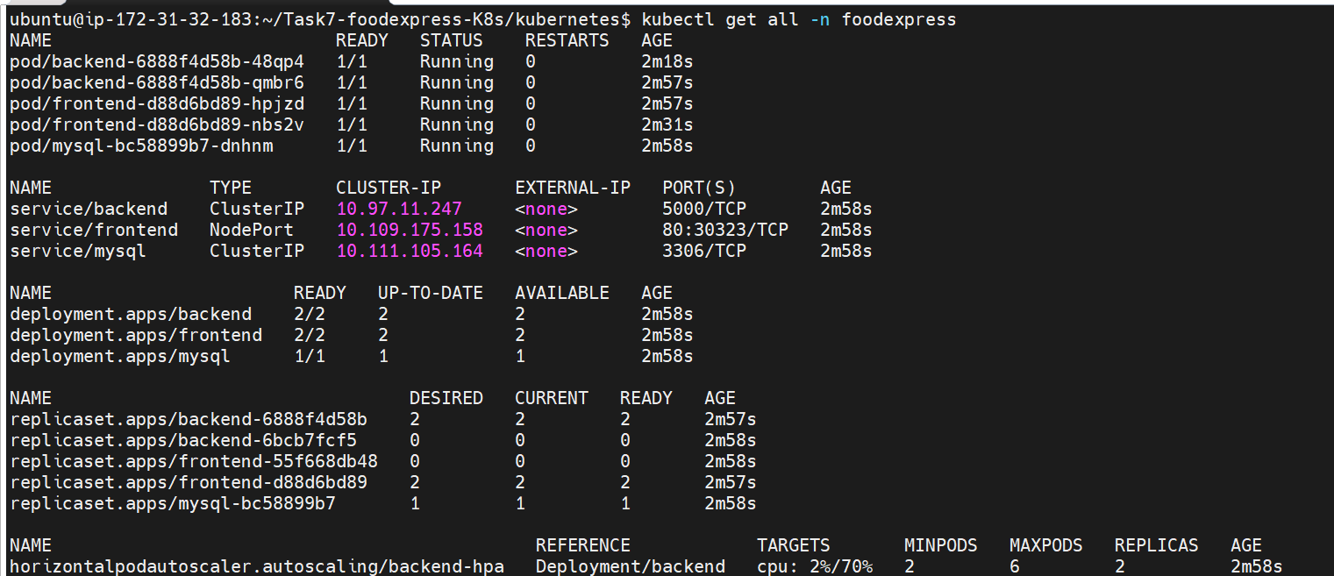
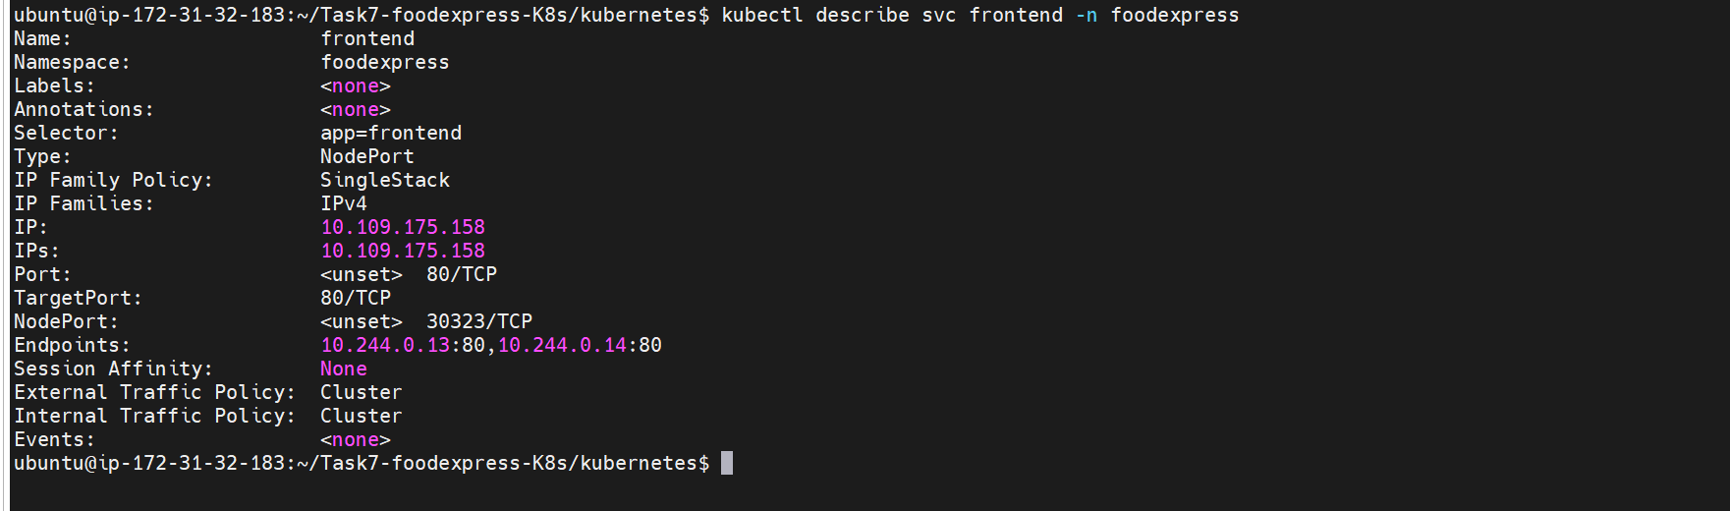
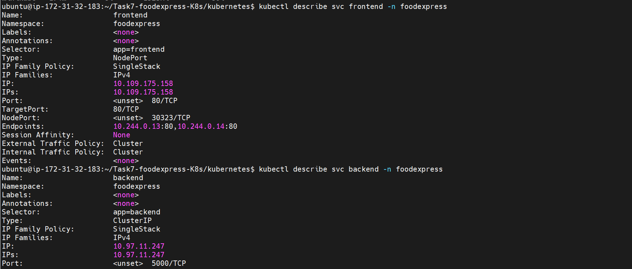
Verify Pods
kubectl get pods -n foodexpress

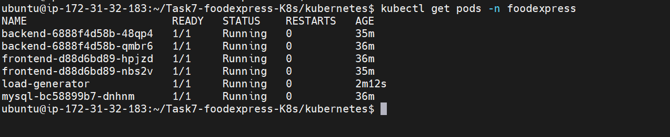
What is a Deployment in Kubernetes?
A Deployment is a Kubernetes resource that manages the lifecycle of your application pods.
It ensures that:
- The desired number of pod replicas are always running.
- Failed pods are automatically recreated (self-healing).
- Applications can be updated using rolling updates.
- Applications can be scaled up or down.
In simple terms:
A Deployment is a controller that creates and manages Pods through a ReplicaSet to keep your application in the desired state.

Verify Deployments
kubectl get deployments -n foodexpress

What is a Service in Kubernetes?
A Service is a Kubernetes object that provides a stable network endpoint to access one or more pods.
Pods are temporary:
- They can be created.
- They can be deleted.
- Their IP addresses change.
A Service solves this problem by giving pods a permanent IP address and DNS name, so other applications can communicate with them reliably.

Verify Services
kubectl get svc -n foodexpress
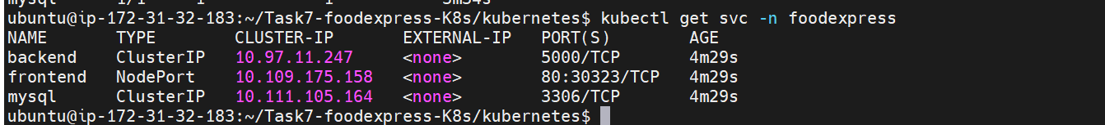
Verify Secrets
kubectl get secrets -n foodexpress
Verify ConfigMap
kubectl get configmap -n foodexpress
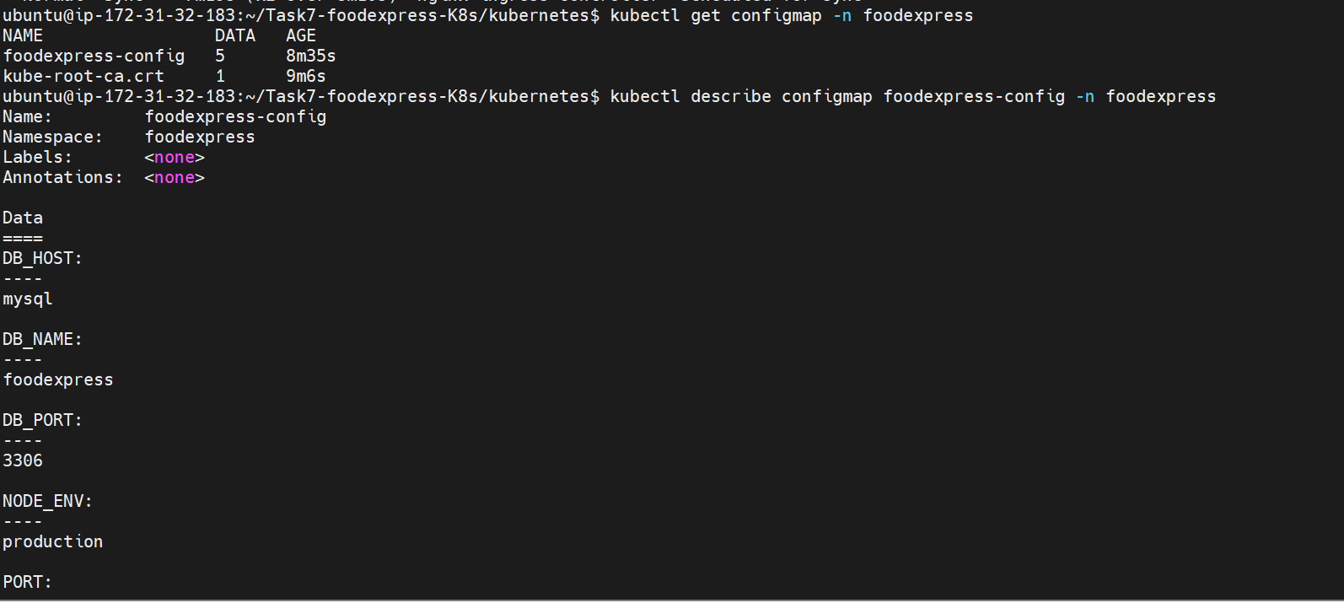
Verify Ingress
kubectl get ingress -n foodexpress
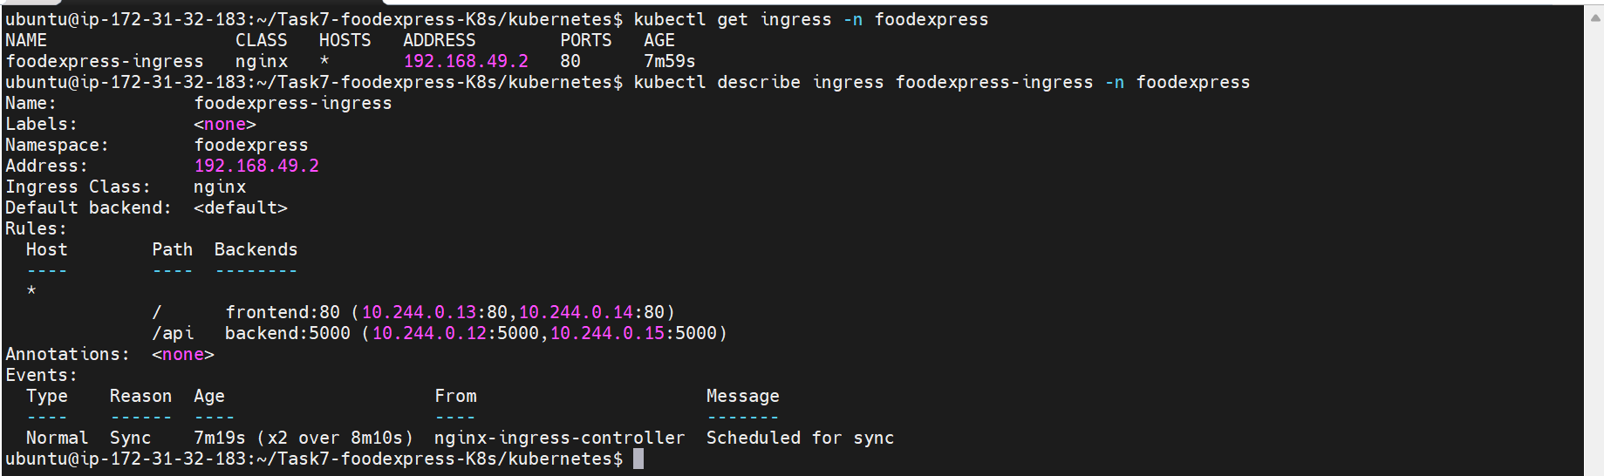
Verify HPA
kubectl get hpa -n foodexpress

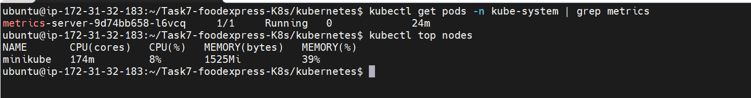
Persistent Volume :
You use Persistent Volume (PV) and Persistent Volume Claim (PVC) in Kubernetes to ensure that application data is not lost when a pod is restarted, recreated, or rescheduled.
For your FoodExpress project, MySQL stores data such as menu items and orders. Without persistent storage, that data would be lost whenever the MySQL pod is deleted or recreated.
Why do we need a Persistent Volume (PV)?
A Persistent Volume (PV) is a storage resource in the Kubernetes cluster that provides durable storage for applications.
Purpose: It provides permanent storage for MySQL data, independent of the pod lifecycle.
Example:

MySQL Pod
│
▼
Persistent Volume (PV)
│
▼
Data Stored Permanently
Why do we need a Persistent Volume Claim (PVC)?
A Persistent Volume Claim (PVC) is a request for storage made by a pod.
Instead of directly using a PV, the pod requests storage through a PVC. Kubernetes then binds the PVC to an available PV.
Purpose: It requests and attaches persistent storage to the MySQL pod.
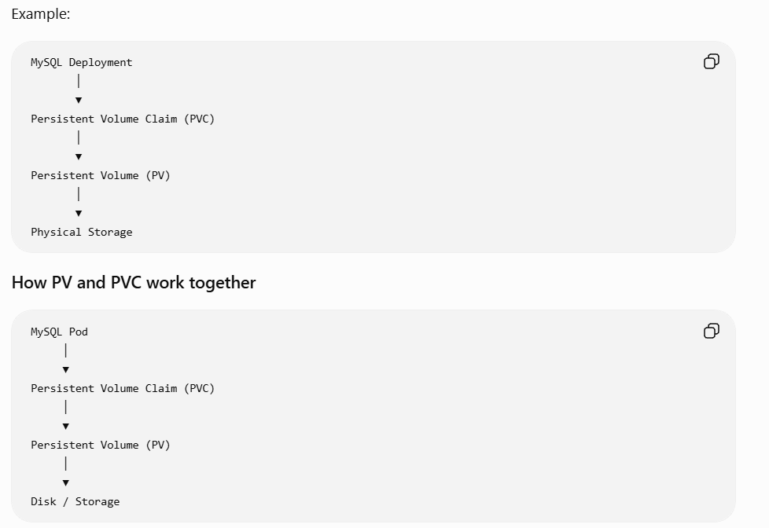

Verify persistent volume
Kubectl get pvc -n foodexpress

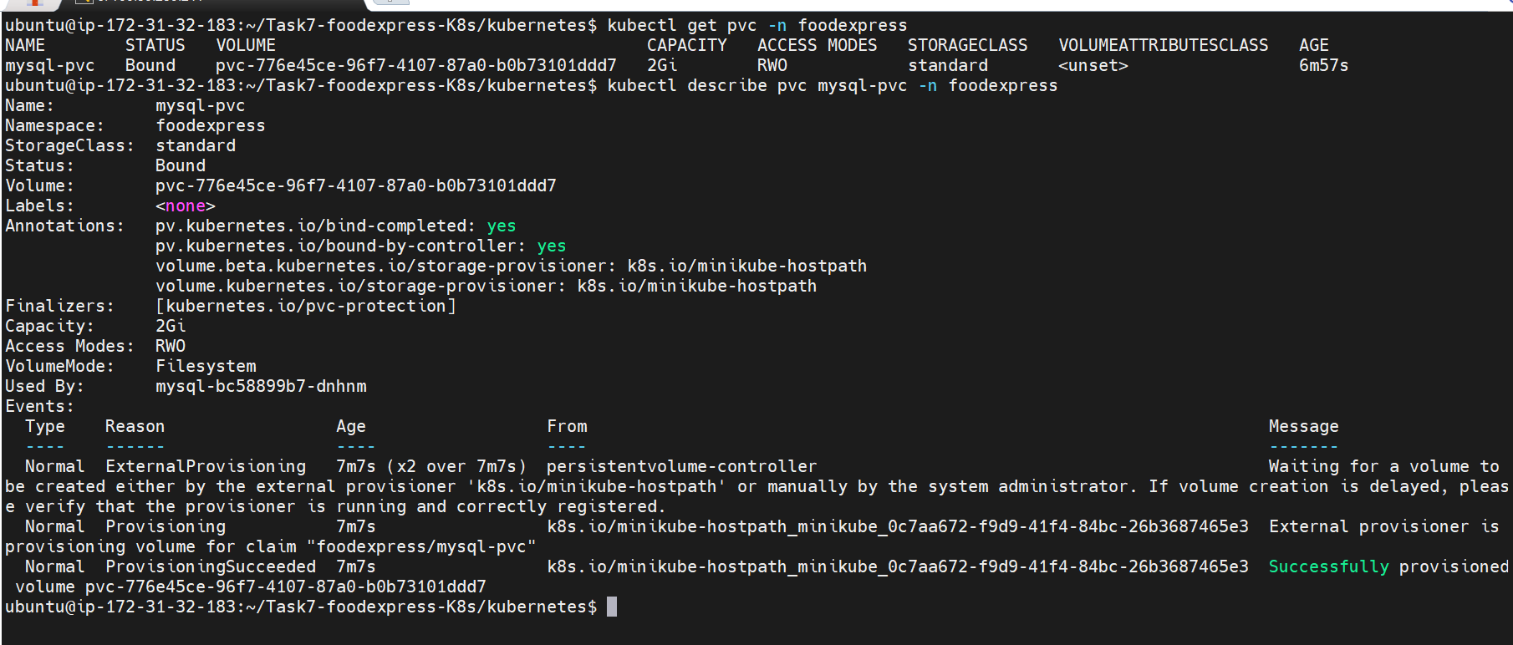

Verify kubectl get pv

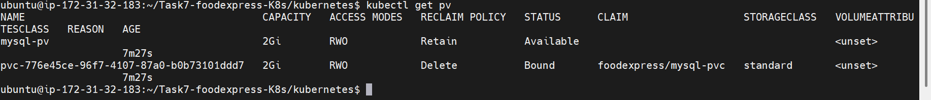

Verify application in the server
Get minikube ip using command – minikube ip
Curl <<minikube ip >>
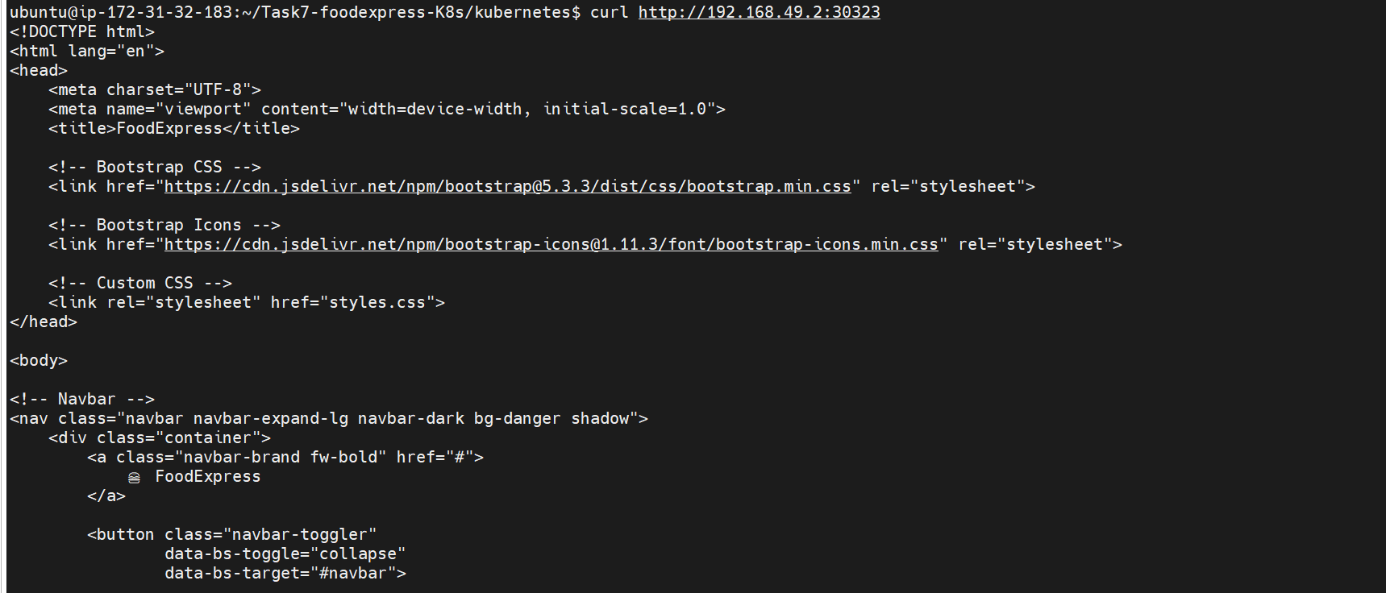

Check Front end running or not inside minikube using – curl http://<<minikubeip>>: Nodeport


frontend service is already NodePortYou can access it directly:
http://<EC2_PUBLIC_IP>:<NodePort>
For example:
http://<EC2_PUBLIC_IP>:30323

Sometimes NodePort isn't directly reachable from outside the EC2 instance. In that case, use port forwarding:
kubectl port-forward svc/frontend 8083:80 -n foodexpress --address 0.0.0.0
Then open:
http://<EC2_PUBLIC_IP>:8083

By using port forwarding
Suppose your frontend service is named frontend and exposes port 80.
Run:
kubectl port-forward service/frontend 8083:80 -n foodexpress --address 0.0.0.0

Verify application in the browser

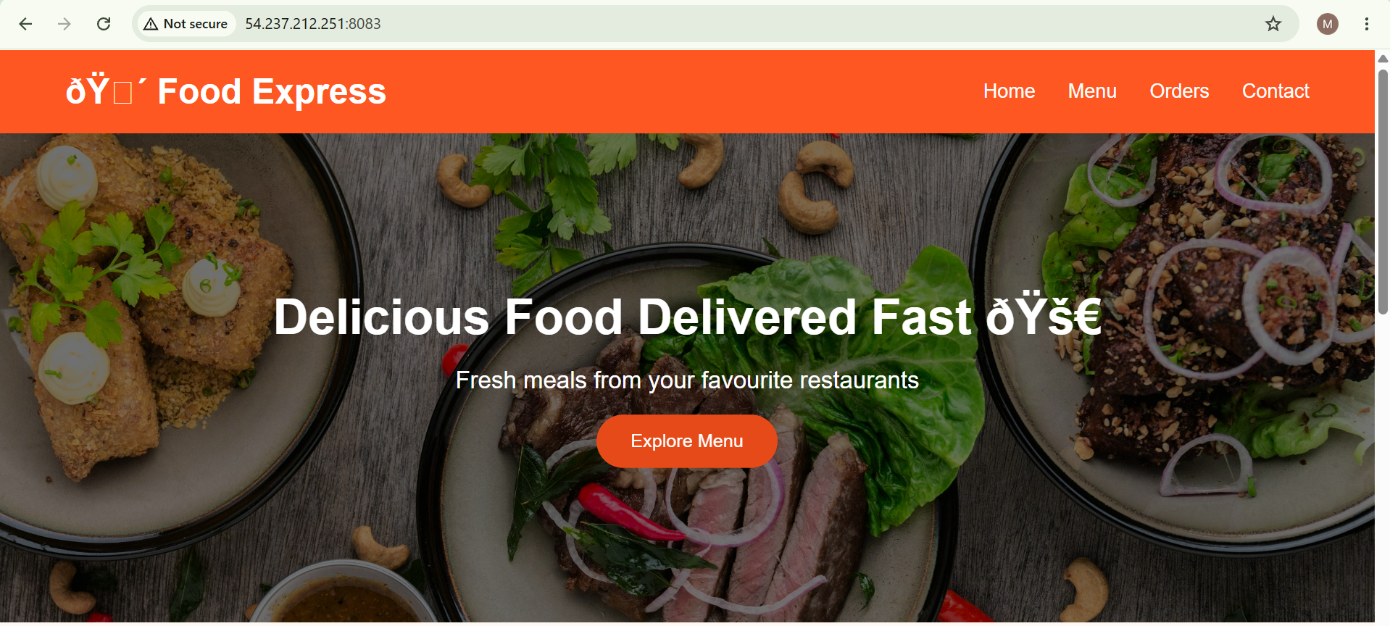
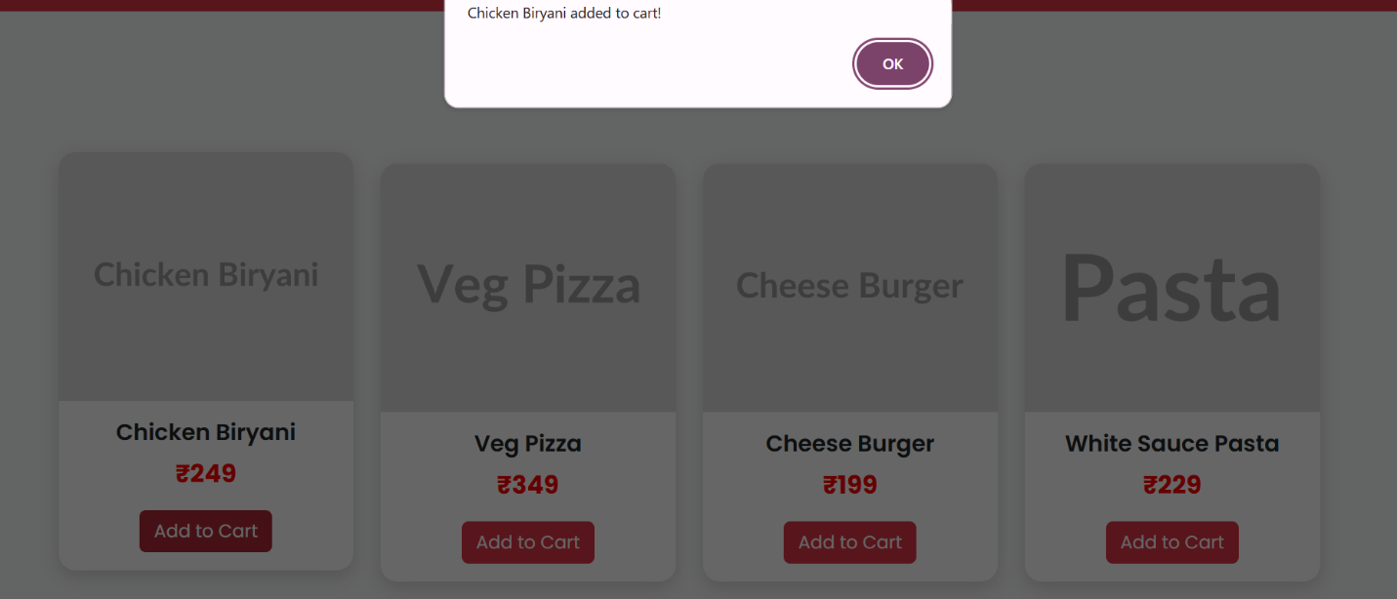

Verify Hpa
Horizontal Pod Autoscaler

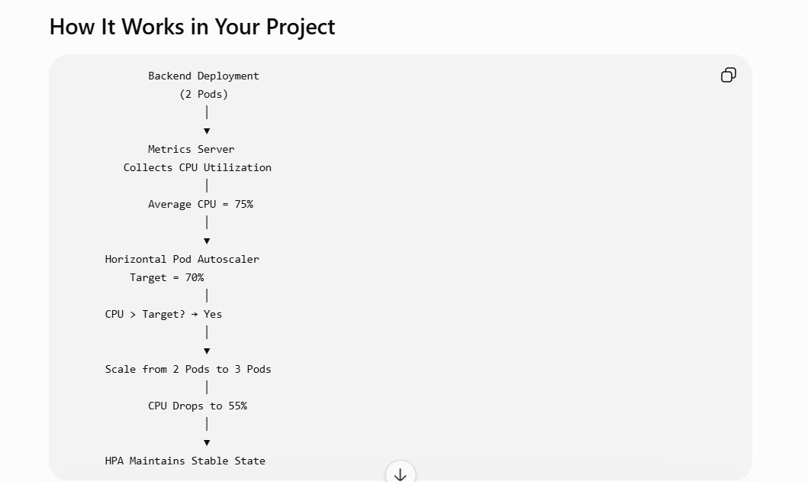
Generate load
kubectl run load-generator \
--rm -it \
--image=busybox \
--restart=Never \
-- /bin/sh

Type this Inside pod
```
while true;
do
wget -q -O- http://frontend-service;
done
```
Watch pods
kubectl get hpa -w -n foodexpress

