WiT HACKATHON -

Presented by Team POWERPUFF

**Commander –**

**Sowmya Sunny** (sowmya.sunny@optum.com)

**Team Members –**

**Sindhuja, Badimela** ([badimela-sindhuja@optum.com](mailto:badimela-sindhuja@optum.com))

**Madhuri D Darla** ([madhuri_d_darla@optum.com](mailto:madhuri_d_darla@optum.com))

**Darshan Lal Madanlal** ([darshanla.madanlal@optum.com](mailto:darshanla.madanlal@optum.com))

**Vijaya L Kasu** ([Vijaya.l.kasu@optum.com](mailto:Vijaya.l.kasu@optum.com))

Problem Statement 2

Idea – How Technology Can Help? 2

How do we connect people - 2

**Who do not have access to technology?** 2

**Who have access to technology/smart phones?** 2

Business Model 2

How to Sustain the New Normal – The Conclusion 3

# Problem Statement

During the Covid-19 pandemic situation the most vulnerable ones are those without the means to meet the basic necessities and are struggling every day of their lives. The daily wage workers, migrant workers without the means to work and senior citizens, single women with no help are majorly affected. By means of this platform, we envision to reach out to these populations to provide support and create a work environment in order to resume their normal lives.

# Idea – How Technology Can Help?

Our idea is to create a **KIOSK**, incorporated with an interactive app - **SAHAYAK** which can be operated by hand gesture/foot for navigations to avoid Corona impacts, installed at public places/essential shops to empower needy people (**Requestors**) by connecting them with **Donors** who are geographically closer.

For this idea we will be leveraging – **COMMUNITY COLLABORATION** starter kit of IBM.

# How do we connect people -

### **Who do not have access to technology?**

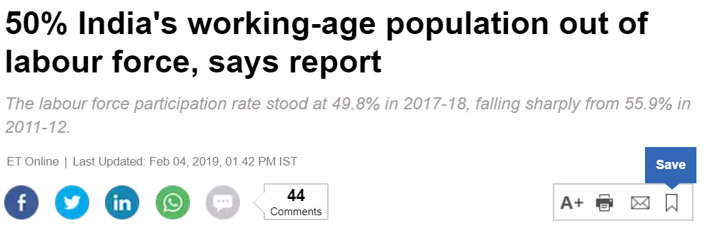This is a major challenge in the present times when there are many people who don’t have access to technology and whose voices are not heard. Our idea is to give them the right platform to reach **Donors** who can provide them solution.

**KIOSK** with app - SAHAYAK set up at public places/essential shops does not require Requestor to have knowledge of technology as the essential shop keeper or person dedicated to the KIOSK can assist them in entering their requirement.

### **Who have access to technology/smart phones?**

Although many have access to technology and are ready to help do not know of several needy who stay close to them. They can use install the **SAHAYAK** app on their smart phones to reach out to the Requestor.

The skilled labors that do not have work during the pandemic can use the **SAHAYAK** app installed in their smart phones to connect with Requestors who need help in the area of their skill. To have certainty about the professionals Requestors hire, our **SAHAYAK** team can hire a retired Police/volunteer to do the background check (using Adhaar card, address proof, etc.) which again helps in creation of job opportunity.

# Business Model

1. **KIOSK –** The migrant workers, the under privileged, other Requestors (who do not know about the app – **SAHAYAK**) can use the Kiosk to provide their details – name, picture, area of stay and the kind of help they require either with the help of person designated at the Kiosk / the shop keeper at essential shop / voice to text (**WATSON** assistant). The details collected will be stored in the cloud.
2. **APP SAHAYAK installed in smart phones –** Requestors, Donors (including skilled workers) provide the information which gets immediately stored in the cloud.

**What next?**

Per every request raised by Requestor:

* The **Here location service** identifies all the relevant Donors geographically close to that Requestor and sends an alert to them to help the Requestor.
* The service required for the requests can be either free of cost or paid service.
* Also, there will be an interface in **SAHAYAK** to conduct sessions online by Donors, such as, Music classes, Art and Craft classes, Instrument classes, Online tutors, etc. which can be paid service that in turn helps skilled people to earn some livelihood.

Here are two instances:

**Instance 1**: An under privileged man (Requestor) raises the request in **KIOSK** for food using **WATSON** assistant. **HERE** location service sends alert to all the geographically closest Donors registered in **SAHAYAK**. The interested Donor, say Donor1 - who is a woman staying alone with infants - can choose that request but is unable to travel to complete the request, can raise a request for Rider. **HERE** location service sends alert to all the geographically closest Riders registered in **SAHAYAK**. The interested Rider (Donor) can choose that request and complete the request and get paid by the Donor1.

**Instance 2**: A senior citizen (Requestor) raises a request in **SAHAYAK** for electronic appliance repair. **HERE** location service sends alert to all the geographically closest electricians registered in **SAHAYAK**. The interested electrician (Donor) can choose that request and complete the request and get paid by the Requestor.

# How to Sustain the New Normal – The Conclusion

Technology blended with the right idea, right people can do wonders and make the new normal a smooth ride for everyone living in the society. This idea of team **POWERPUFF** enables everyone in the society to sustain the new normal.