**9 a) Fetch data from a REST API.**

import 'package:flutter/material.dart';

import 'package:http/http.dart' as http;

import 'dart:convert';

void main() {

runApp(MyApp());

}

class MyApp extends StatelessWidget {

@override

Widget build(BuildContext context) {

return MaterialApp(

title: 'API Fetch Example',

theme: ThemeData(

primarySwatch: Colors.blue,

),

home: MyApiFetchWidget(),

);

}

}

class MyApiFetchWidget extends StatefulWidget {

@override

_MyApiFetchWidgetState createState() => _MyApiFetchWidgetState();

}

class _MyApiFetchWidgetState extends State<MyApiFetchWidget> {

late Future<List<Post>> _posts;

@override

void initState() {

super.initState();

_posts = fetchPosts();

}

Future<List<Post>> fetchPosts() async {

final response =

await http.get(Uri.parse('https://jsonplaceholder.typicode.com/posts'));

if (response.statusCode == 200) {

// If the server returns a 200 OK response,

// parse the JSON and return a list of posts.

List<dynamic> data = json.decode(response.body);

List<Post> posts = data.map((post) => Post.fromJson(post)).toList();

return posts;

} else {

// If the server did not return a 200 OK response,

// throw an exception.

throw Exception('Failed to load posts');

}

}

@override

Widget build(BuildContext context) {

return Scaffold(

appBar: AppBar(

title: Text('API Fetch Example'),

),

body: FutureBuilder<List<Post>>(

future: _posts,

builder: (context, snapshot) {

if (snapshot.connectionState == ConnectionState.waiting) {

return CircularProgressIndicator();

} else if (snapshot.hasError) {

return Text('Error: ${snapshot.error}');

} else {

return ListView.builder(

itemCount: snapshot.data!.length,

itemBuilder: (context, index) {

return ListTile(

title: Text(snapshot.data![index].title),

subtitle: Text(snapshot.data![index].body),

);

},

);

}

},

),

);

}

}

class Post {

final int userId;

final int id;

final String title;

final String body;

Post({

required this.userId,

required this.id,

required this.title,

required this.body,

});

factory Post.fromJson(Map<String, dynamic> json) {

return Post(

userId: json['userId'],

id: json['id'],

title: json['title'],

body: json['body'],

);

}

}

**Output:**

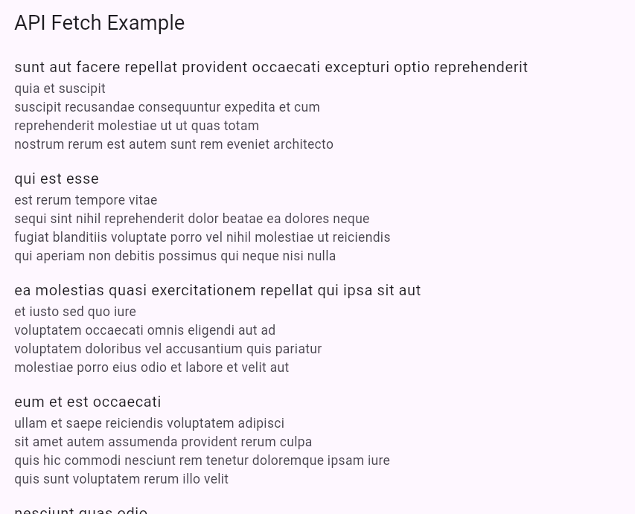

**9 b) Display the fetched data in a meaningful way in the UI.**

import 'package:flutter/material.dart';

import 'package:http/http.dart' as http;

import 'dart:convert';

void main() {

runApp(MyApp());

}

class MyApp extends StatelessWidget {

@override

Widget build(BuildContext context) {

return MaterialApp(

title: 'API Fetch Example',

theme: ThemeData(

primarySwatch: Colors.blue,

),

home: MyApiFetchWidget(),

);

}

}

class MyApiFetchWidget extends StatefulWidget {

@override

_MyApiFetchWidgetState createState() => _MyApiFetchWidgetState();

}

class _MyApiFetchWidgetState extends State<MyApiFetchWidget> {

late Future<List<Post>> _posts;

@override

void initState() {

super.initState();

_posts = fetchPosts();

}

Future<List<Post>> fetchPosts() async {

final response =

await http.get(Uri.parse('https://jsonplaceholder.typicode.com/posts'));

if (response.statusCode == 200) {

List<dynamic> data = json.decode(response.body);

List<Post> posts = data.map((post) => Post.fromJson(post)).toList();

return posts;

} else {

throw Exception('Failed to load posts');

}

}

@override

Widget build(BuildContext context) {

return Scaffold(

appBar: AppBar(

title: Text('API Fetch Example'),

),

body: FutureBuilder<List<Post>>(

future: _posts,

builder: (context, snapshot) {

if (snapshot.connectionState == ConnectionState.waiting) {

return Center(child: CircularProgressIndicator());

} else if (snapshot.hasError) {

return Center(child: Text('Error: ${snapshot.error}'));

} else {

return PostList(posts: snapshot.data!);

}

},

),

);

}

}

class PostList extends StatelessWidget {

final List<Post> posts;

PostList({required this.posts});

@override

Widget build(BuildContext context) {

return ListView.builder(

itemCount: posts.length,

itemBuilder: (context, index) {

return PostItem(post: posts[index]);

},

);

}

}

class PostItem extends StatelessWidget {

final Post post;

PostItem({required this.post});

@override

Widget build(BuildContext context) {

return Card(

margin: EdgeInsets.all(10),

elevation: 3,

child: Padding(

padding: EdgeInsets.all(15),

child: Column(

crossAxisAlignment: CrossAxisAlignment.start,

children: [

Text(

post.title,

style: TextStyle(

fontSize: 18,

fontWeight: FontWeight.bold,

),

),

SizedBox(height: 10),

Text(

post.body,

style: TextStyle(fontSize: 16),

),

],

),

),

);

}

}

class Post {

final int userId;

final int id;

final String title;

final String body;

Post({

required this.userId,

required this.id,

required this.title,

required this.body,

});

factory Post.fromJson(Map<String, dynamic> json) {

return Post(

userId: json['userId'],

id: json['id'],

title: json['title'],

body: json['body'],

);

}

}

**Output:**

