Challenging Task – 1
Register number : 21MIS1155
Name : Gangireddy Madhurima

Task – Connecting UltraSonic Sensor with RaspberryPI by displaying sensor values on dashboard and publishing messages using MQTT Protocol.

Procedure:
1. Connecting RaspberryPI with Ultrasonic Sensor.
2. Creating Nodes for RaspberryPI and MQTT.
3. Setting up the Configurations of Nodes.
4. Connecting SetUp with MQTT Server using MQTT Nodes.
5. Deploy the setup and Connect to MQTT Server.

Components:
1. RaspberryPI
2. Ultrasonic sensor
3. NodeRed

Code:
Function of Distance Calculation:
// Assume Trig is on GPIO 23 and Echo on GPIO 24\n
var trigPin = 23;
var echoPin = 24;

// Send trigger pulse to measure distance

var distance = 0;
// Add actual code to read data from ultrasonic sensor.
// Usually, you'll need to trigger the sensor and measure time until echo comes back

msg.payload = distance; // Return calculated distance

return msg;

JSON Code:
[
{
"id": "1ca8360b8d15cdb5",
"type": "tab",
"label": "Flow 1",
"disabled": false,
"info": "",
"env": []
},
{
"id": "8c5a520b42110efc",
"type": "inject",
"z": "1ca8360b8d15cdb5",
"name": "Trigger Ultrasonic",
"props": [],
"repeat": "5",
"crontab": "",
"once": true,
"onceDelay": 0.1,
"topic": "",
"x": 210,
"y": 160,
"wires": [
[
"40988a832e2f54af"
]
]
},
{
"id": "40988a832e2f54af",
"type": "rpi-gpio in",
"z": "1ca8360b8d15cdb5",
"name": "Read Ultrasonic",
"pin": "11",
"intype": "input",
"debounce": "25",
"read": "all",
"bcm": true,
"x": 460,
"y": 360,
"wires": [
[
"b2786f89662383bb"
]
]
},
{
"id": "b2786f89662383bb",
"type": "function",
"z": "1ca8360b8d15cdb5",
"name": "Distance Calculation",
"func": "// Assume Trig is on GPIO 23 and Echo on GPIO 24\\n\nvar trigPin = 23;\nvar echoPin = 24;\n\n// Send trigger pulse to measure distance\n\nvar distance = 0;\n// Add actual code to read data from ultrasonic sensor.\n// Usually, you'll need to trigger the sensor and measure time until echo comes back\n\nmsg.payload = distance; // Return calculated distance\n\nreturn msg;\n",
"outputs": 1,
"timeout": "",
"noerr": 0,
"initialize": "",
"finalize": "",
"libs": [],
"x": 720,
"y": 360,
"wires": [
[
"abc846693b36982a",
"d28ae952e65c8d7b",
"1cf1dc9f238e55a7"
]
]
},
{
"id": "abc846693b36982a",
"type": "debug",
"z": "1ca8360b8d15cdb5",
"name": "debug 8",
"active": true,
"tosidebar": true,
"console": false,
"tostatus": false,
"complete": "false",
"statusVal": "",
"statusType": "auto",
"x": 1080,
"y": 480,
"wires": []
},
{
"id": "d28ae952e65c8d7b",
"type": "mqtt out",
"z": "1ca8360b8d15cdb5",
"name": "",
"topic": "testtopic/1",
"qos": "",
"retain": "",
"respTopic": "",
"contentType": "",
"userProps": "",
"correl": "",
"expiry": "",
"broker": "8d5ffdf2.b881a8",
"x": 1070,
"y": 280,
"wires": []
},
{
"id": "1cf1dc9f238e55a7",
"type": "ui_text",
"z": "1ca8360b8d15cdb5",
"group": "f1db3f7b.a3122",
"order": 0,
"width": 6,
"height": 1,
"name": "Ultrasonic Distance",
"label": "Distance",
"format": "{{msg.payload}} cm",
"layout": "row-spread",
"x": 950,
"y": 600,
"wires": []
},
{
"id": "8d5ffdf2.b881a8",
"type": "mqtt-broker",
"name": "Local MQTT Broker",
"broker": "localhost",
"port": "1883",
"tls": "",
"clientid": "",
"autoConnect": true,
"usetls": false,
"protocolVersion": "4",
"keepalive": "60",
"cleansession": true,
"autoUnsubscribe": true,
"birthTopic": "",
"birthQos": "0",
"birthPayload": "",
"birthMsg": {},
"closeTopic": "",
"closePayload": "",
"closeMsg": {},
"willTopic": "",
"willQos": "0",
"willPayload": "",
"willMsg": {},
"userProps": "",
"sessionExpiry": ""
},
{
"id": "f1db3f7b.a3122",
"type": "ui_group",
"name": "Ultrasonic Dashboard",
"tab": "b2c1e865.e9bc98",
"order": 1,
"disp": true,
"width": "6",
"collapse": "false",
"className": ""
},
{
"id": "b2c1e865.e9bc98",
"type": "ui_tab",
"name": "Dashboard",
"icon": "dashboard",
"order": 1,
"disabled": false,
"hidden": false
}
]
Output:
Node Red Setup
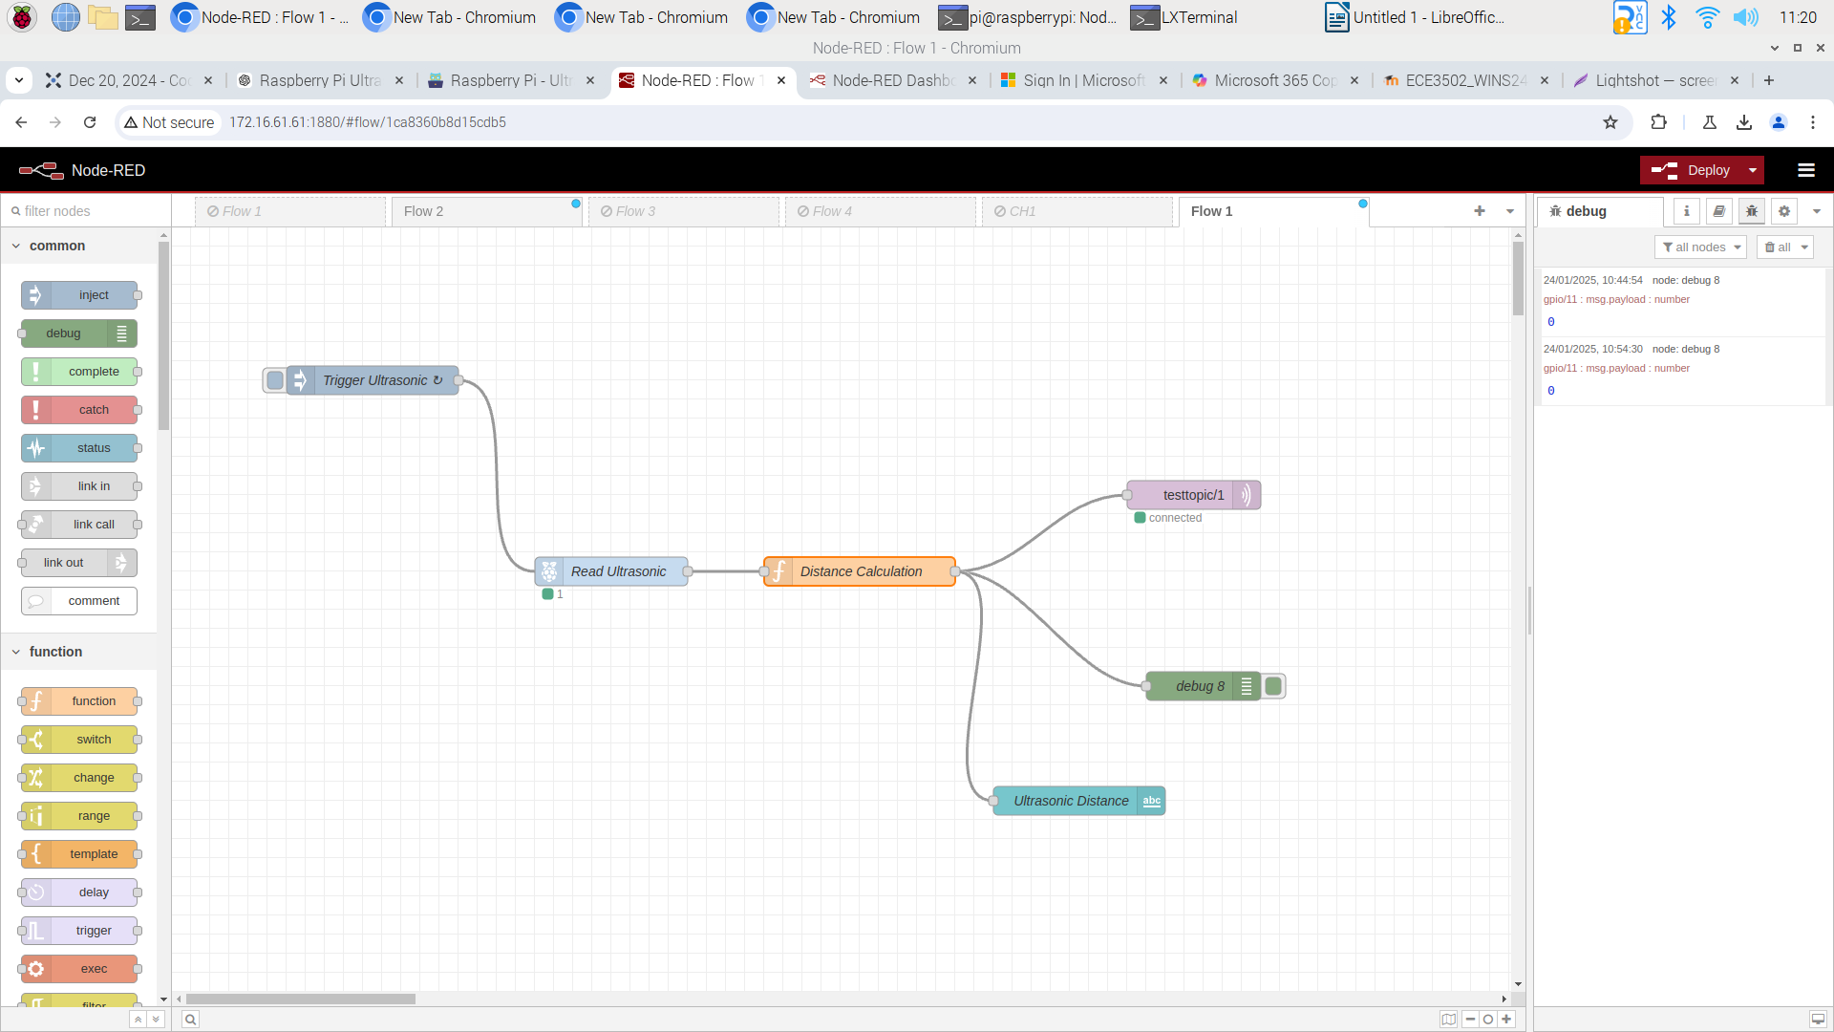

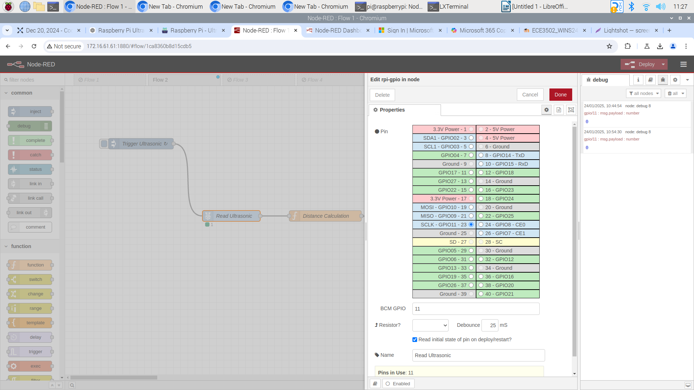
Dashboard
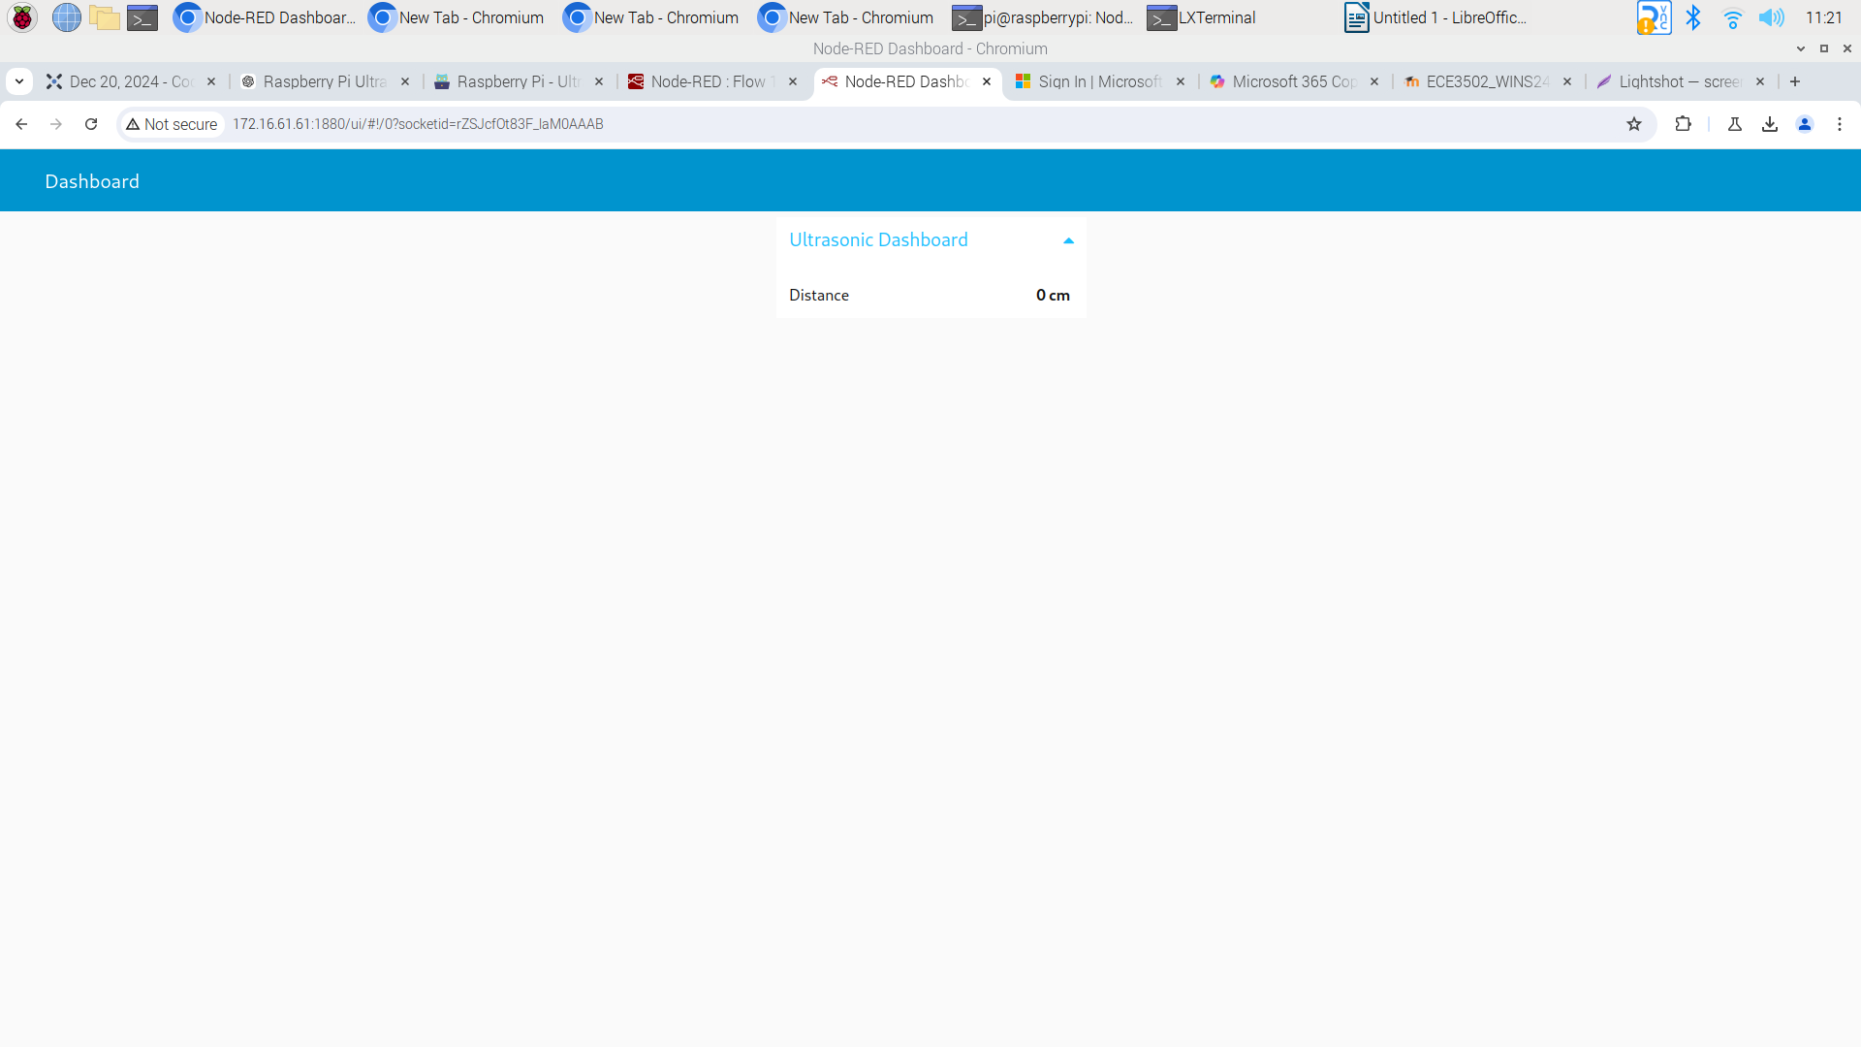
Debug Window
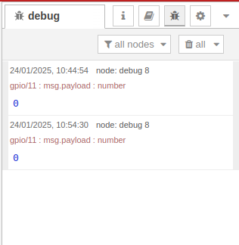

MQTT Server(Mosqitto is installed and used for this experiment, due to connection issues)

1. Starting MQTT Mosquitto Server
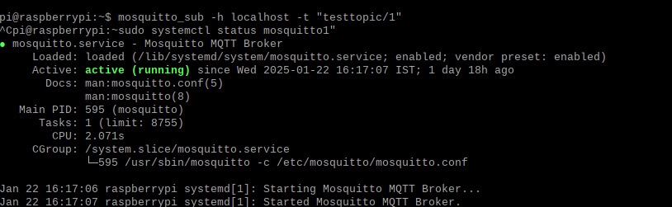
2. Publishing Messages
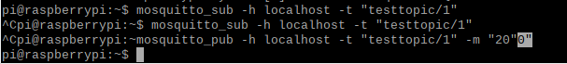
“0” – from Debug

