1. Write a program which will find all such numbers which are divisible by 7 but are not a multiple of 5, between 2000 and 3200 (both included). The numbers obtained should be printed in a comma-separated sequence on a single line.

num=3200

i=0

a=[]

for x in range(2000, num+1):

if((x%7==0) and (x%5!=0)):

a.append(x)

print(a)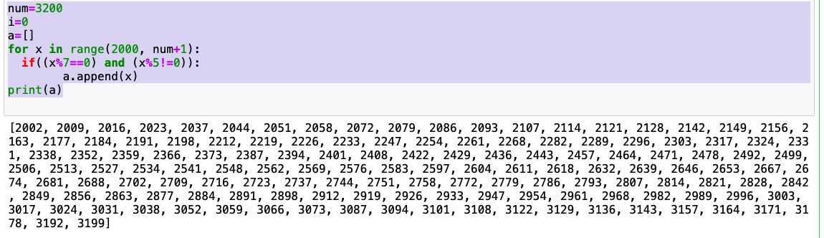

2. Write a Python program to accept the user's first and last name and then getting them printed in the the reverse order with a space between first name and last name.

firstName = input("Enter First Name :")

print(firstName)

lastName = input("Enter Last Name :")

print(lastName)

fullName = lastName + " " + firstName

print(fullName)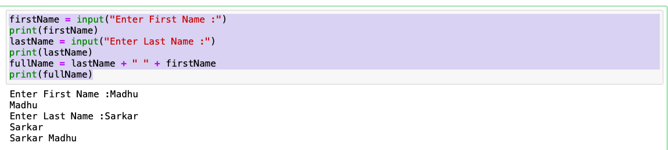

3. Write a Python program to find the volume of a sphere with diameter 12 cm.

d=12

r=d/2

pie=3.14

V=4/3\*pie\*(r\*r\*r)

print(V)

print("Volume of sphere : " + str(V))

