1. Create the below pattern using nested for loop in Python

*

* *

* * *

* * * *

* * * * *

* * * *

* * *

* *

*

def pyramidpattern(n):

for i in range(0, n):

for j in range(0, i+1):

print("* ",end="")

print("\r")

for i in range(n-1,0,-1 ):

for j in range(1,i+1):

print("* ",end="")

print("\r")

n = 5

pyramidpattern(n)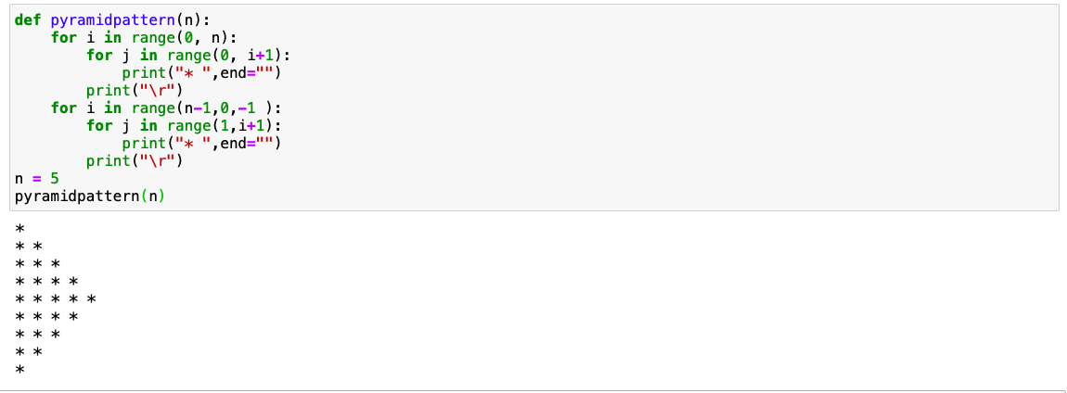

2.Write a Python program to reverse a word after accepting the input from the user

Approach 1:

def reverse_word(str):

rev_str=""

for i in str:

rev_str=i + rev_str

return rev_str

str = input("Enter a word :")

print(str)

print("Reversed input word :" + reverse_word(str))

Approach 2:

def reverse_word(str):

rev_str=""

rev_str=str[::-1]

return rev_str

str = input("Enter a word :")

print(str)

print("Reversed input word :" , reverse_word(str))