1. Write a Python Program to implement your own myreduce() function which works exactly like Python's built-in function reduce()

Approach 1: applying add function to the list

def myreduce(add,ls):

return a

def add(a,b):

ls=[1,2,3,4,5]

a=ls[0]

for i in range(1,len(ls)):

b=ls[i]

a=a+b

return a

print(myreduce(add,ls))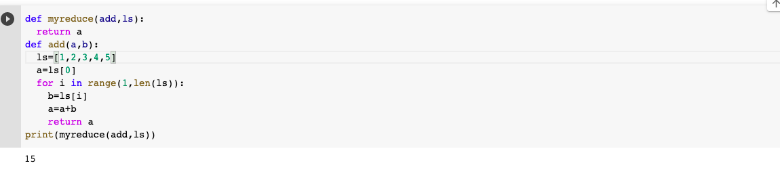

Approach 2: applying compare function to the list

def myreduce(compare,ls):

return a

def compare(a,b):

if(a>b):

return a

else:

return b

ls=[2,4,5,6,3,2]

a=ls[0]

for i in range(1,len(ls)):

b=ls[i]

a=compare(a,b)

print(myreduce(compare,ls))

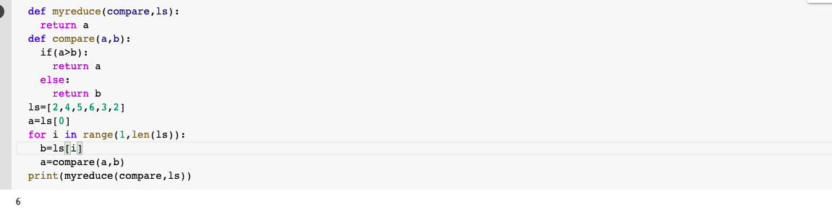

2. Write a Python program to implement your own myfilter() function which works exactly like Python's built-in function filter()

**Approach 1: applying check_even function to list**

def myfilter(check_even,ls):

return check_even(ls_2)

ls=[2,3,4,5,6]

ls_2=[]

def check_even(ls_2):

for i in ls:

if i%2==0:

ls_2.append(i)

print(ls_2)

myfilter(check_even,ls)

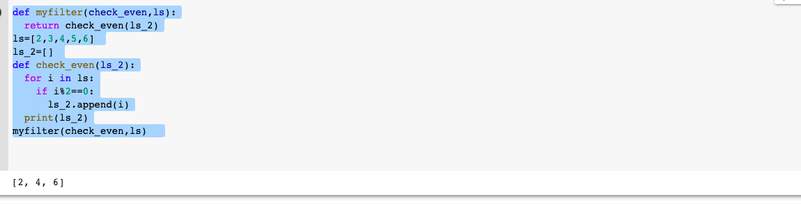

**Approach 2: applying check_vowel function to list of characters**

def myfilter(check_vowel,ls):

return check_vowel(ls_returned)

ls=['a','b','c','d','e']

ls_vowel=['a','e','i','o','u']

ls_returned=[]

def check_vowel(ls_returned):

for i in range(0,len(ls)):

if(ls[i] in ls_vowel):

ls_returned.append(ls[i])

print(ls_returned)

myfilter(check_vowel,ls)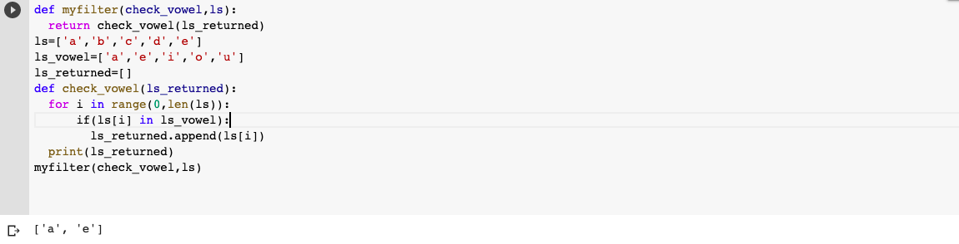

3. Implement List comprehensions to produce the following lists.

Write List comprehensions to produce the following Lists

List1: [‘x', 'xx', 'xxx', 'xxxx', 'y', 'yy', 'yyy', 'yyyy', 'z', 'zz', 'zzz', 'zzzz']

List2: [‘x', 'y', 'z', 'xx', 'yy', 'zz', 'xxx', 'yyy', 'zzz', 'xxxx', 'yyyy', ‘zzzz’]

letters=['x', 'y', 'z']

pattern=[]

[pattern.append(i*j) for i in letters for j in range(1,5)]

print(pattern)

pattern1=[]

[pattern1.append(i*j) for j in range(1,5) for i in letters]

print(pattern1)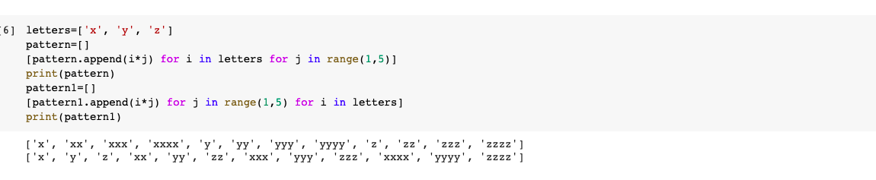

List3: [[2], [3], [4], [3], [4], [5], [4], [5], [6]]

list=[[x+y] for x in range(2,5) for y in range(0,3)]

print(list)

List4: [(1, 1), (2, 1), (3, 1), (1, 2), (2, 2), (3, 2), (1, 3), (2, 3), (3, 3)]

num=[1,2,3]

num1=[1,2,3]

num2=[(i,j) for j in num1 for i in num]

print(num2)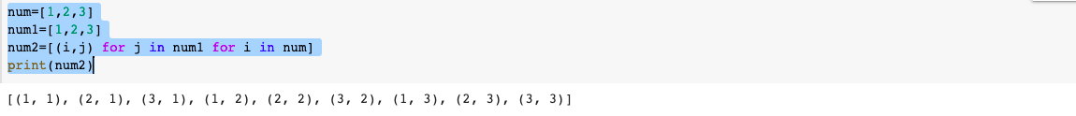

List5: [[2, 3, 4, 5], [3, 4, 5, 6],[4, 5, 6, 7], [5, 6, 7, 8]]

#lst1 = [x for x in range(2,10)]

idx = 1

#lst2 = [[x for x in range (lst1[idx+y] , lst1[idx+y+4])] for y in range (0,4)]

lst2 = [[x for x in range (idx+y , idx+y+4)] for y in range (1,5)]

print(lst2)