WORKSHEET 3 SQL

**Refer the following ERD and answer all the questions in this worksheet. You have to write the queries using mysql for the required Operation.**

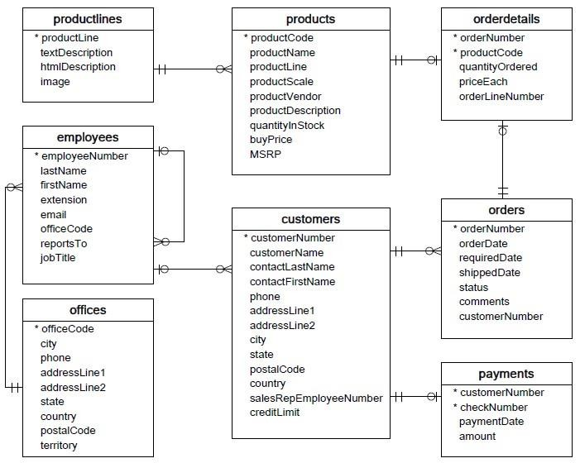

* **Customers**: stores customer’s data.
* **Products**: stores a list of scale model cars.
* **ProductLines**: stores a list of product line categories.
* **Orders**: stores sales orders placed by customers.
* **OrderDetails**: stores sales order line items for each sales order.
* **Payments**: stores payments made by customers based on their accounts.
* **Employees**: stores all employee information as well as the organization structure such as who reports to whom.
* **Offices**: stores sales office data.
  1. Write SQL query to create table **Customers.**

**Answer - CREATE TABLE Customers** ( customerNumber int NOT NULL, customerName char(50) NOT NULL, customerName char(50) NOT NULL, customer Name char(50) NOT NULL address char(50), city char(50), state char(25), postalcode char(10), PRIMARY KEY (customerNumber) );

* 1. Write SQL query to create table **Orders.**

**Answer- Answer - CREATE TABLE Orders** (Ordernumber int NOT NULL, orderdate int NOT NULL, shippeddate int NOT NULL, status char(20), comments char(50),PRIMARY KEY( CostumerNumber) );

* 1. Write SQL query to show all the columns data from the **Orders** Table.

Answer- SELECT * FROM orders;

* 1. Write SQL query to show all the comments from the **Orders** Table.

Answer- SELECT comments FROM orders;

* 1. Write a SQL query to show orderDate and Total number of orders placed on that date, from **Orders** table.

Answer- CREATE VIEW orderdate (orderdate, Ordernumber)

AS SELECT orderdate, COUNT (*)

FROM orders

GROUP BY orderdate;

* 1. Write a SQL query to show employeNumber, lastName, firstName of all the employees from **employees**

table.

Answer - SELECT employeNumber, lastName, firstName FROM **employees;**

* 1. Write a SQL query to show all orderNumber, customerName of the person who placed the respective order.

Answer- SELECT orderNumber

FROM orders

LEFT JOIN customers

ON customerNumber = customerNumber

WHERE customerName

* 1. Write a SQL query to show name of all the customers in one column and salerepemployee name inanother column.

Answer- SELECT salerepemployee,name

FROM salesman a

WHERE 1 <

(SELECT COUNT(*)

FROM customer

WHERE salesman_id=a.salesman_id);

* 1. Write a SQL query to show Date in one column and total payment amount of the payments made on that date from the **payments** table.
  2. Write a SQL query to show all the products productName, MSRP, productDescription from the **products**

table.

* 1. Write a SQL query to print the productName, productDescription of the most ordered product.
  2. Write a SQL query to print the city name where maximum number of orders were placed.
  3. Write a SQL query to get the name of the state having maximum number of customers.
  4. Write a SQL query to print the employee number in one column and Full name of the employee in the second column for all the employees.
  5. Write a SQL query to print the orderNumber, customer Name and total amount paid by the customer for that order (quantityOrdered × priceEach).

