WORKSHEET 4 SQL

**Refer the following ERD and answer all the questions in this worksheet. You have to write the queries using MySQL for the required Operation.**

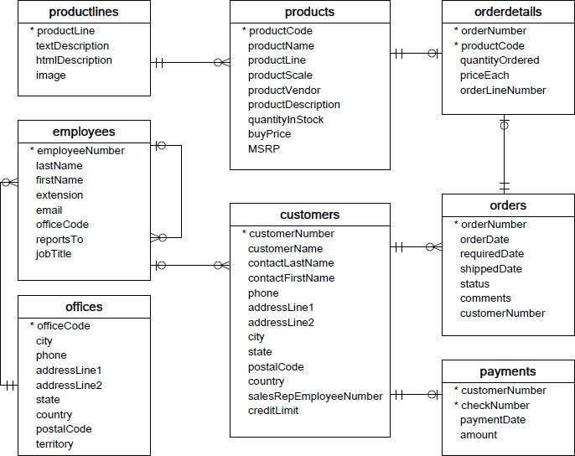

* **Customers**: stores customer’s data.
* **Products**: stores a list of scale model cars.
* **Product Lines**: stores a list of product line categories.
* **Orders**: stores sales orders placed by customers.
* **Order Details**: stores sales order line items for each sales order.
* **Payments**: stores payments made by customers based on their accounts.
* **Employees**: stores all employee information as well as the organization structure such as who reports towhom.
* **Offices**: stores sales office data.

**QUESTIONS:**

1. Write a SQL query to show average number of orders shipped in a day (use Orders table).

Answer- SELECT shippedorder , SUM(order_total)

FROM orders

GROUP BY order_placed_date;

1. Write a SQL query to show average number of orders placed in a day.

Answer-

1. Write a SQL query to show the product name with minimum MSRP (use Products table).

Answer- SELECT productname, productprice

FROM products

WHERE productprice =

(SELECT MIN(productprice) FROM products);

1. Write a SQL query to show the product name with maximum value of stockQuantity.

Answer- SELECT max( mark ) FROM `student`

1. Write a query to show the most ordered product Name (the product with maximum number of orders).
2. Write a SQL query to show the highest paying customer Name.
3. Write a SQL query to show cutomerNumber, customerName of all the customers who are from Melbourne city.
4. Write a SQL query to show name of all the customers whose name start with “N”.
5. Write a SQL query to show name of all the customers whose phone start with ‘7’ and are from city ‘LasVegas’.
6. Write a SQL query to show name of all the customers whose creditLimit < 1000 and city is either “Las Vegas” or ”Nantes” or “Stavern”.
7. Write a SQL query to show all the orderNumber in which quantity ordered <10.
8. Write a SQL query to show all the orderNumber whose customer Name start with letter ‘N’**.**

**Answer-** SELECT o.orderNumber

FROM orders o

LEFT JOIN customers c

ON c.customerNumber = o.customerNumber

WHERE c.customerName LIKE 'N%'

1. Write a SQL query to show all the customerName whose orders are “Disputed” in status.
2. Write a SQL query to show the customerName who made payment through cheque with checkNumber starting with H and made payment on “2004-10-19”.

Answer-

1. Write a SQL query to show all the checkNumber whose amount > 1000.

Answer- SELECT *

FROM orders a

WHERE productamount>

(SELECT AVG(productamount) FROM orders

WHERE b.customer_id = a.customer_id);