EXPERIMENT- 13

Implementation of HLDC using Packet Tracer

By

**Madhurya Mozumder (RA1911028010036)**

Under the guidance of

**Mrs. P. Visalakshi**

*In partial fulfilment for the course*

Of

**18CSC302J- COMPUTER NETWORKS**



**FACULTY OF ENGINEERING AND TECHNOLOGY**

**SRM ISNTITUTE OF SCEINCE AND TECHNOLOGY**

Kattankulathur, Chengalpattu District

November 2021

**ABSTRACT**: High-level Data Link Control (HDLC) is a group of communication protocols of the data link layer for transmitting data between network points or nodes. Since it is a data link protocol, data is organized into frames. A frame is transmitted via the network to the destination that verifies its successful arrival. It is a bit - oriented protocol that is applicable for both point - to - point and multipoint communications.

## Transfer Modes

HDLC supports two types of transfer modes, normal response mode and asynchronous balanced mode.

* **Normal Response Mode (NRM)** − Here, two types of stations are there, a primary station that send commands and secondary station that can respond to received commands. It is used for both point - to - point and multipoint communications.
* **Asynchronous Balanced Mode (ABM)** − Here, the configuration is balanced, i.e. each station can both send commands and respond to commands. It is used for only point - to - point communications.

**AIM:** To implement HLDC Configuration using Cisco Packet Tracer.

**Procedure:** Create the setup as shown in the following figure and configure everything according to it.

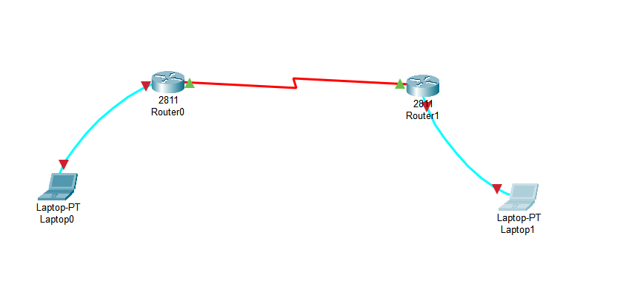

**1. Use the connected laptops to find the DCE and DTE routers**

**Router-A#show controllers serial 0/3/0**

**Interface Serial0/0/0**

**Hardware is PowerQUICC MPC860**

**DTE V.35 TX and RX clocks detected**

**Router-B#show controllers serial 0/3/0**

**Interface Serial0/3/0**

**Hardware is PowerQUICC MPC860**

**DCE V.35, clock rate 250000**

In this example, Router-A is the DTE side, and Router-B the DCE side

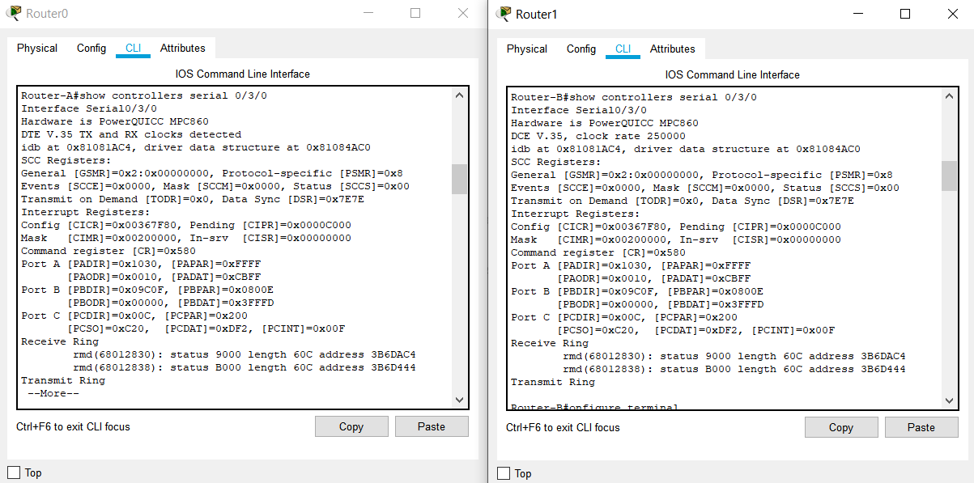



**2. Configure the routers with the following parameters**

**Router-B being the DCE, clock rate has to be configured on Router-B serial 0/3/0 interface**

**Router-B(config)#interface serial 0/3/0**

**Router-B(config-if)#clock rate 250000**

Then, configure HDLC encapsulation and IP address on Router-B serial 0/3/0 interface. **The encapsulation HDLC** configures HDLC protocol on the serial interface.

Router-B being the DCE side of the serial link, the 192.168.1.5/30 IP address is configured on Router-B serial 0/3/0 interface. Don’t forget to enable the interface with a **no shutdown** command.

**Router-B(config)#interface serial 0/3/0**

**Router-B(config-if)#encapsulation hdlc**

**Router-B(config-if)#ip address 192.168.10.5 255.255.255.252**

**Router-B(config-if)#no shutdown**

The show interfaces serial 0/0/0 confirms that HDLC encapsulation is enabled on the interface: *Encapsulation HDLC, loopback not set, keepalive set (10 sec)*

**Router-B#show interfaces serial 0/3/0**

**Serial0/3/0 is up, line protocol is up (connected)**

**Hardware is HD64570**

**Internet address is 192.168.10.5/30**

**MTU 1500 bytes, BW 1544 Kbit, DLY 20000 usec,**

**reliability 255/255, txload 1/255, rxload 1/255**

**Encapsulation HDLC, loopback not set, keepalive set (10 sec)**

**Last input never, output never, output hang never**

**[...]**

Finally, configure HDLC encapsulation and IP address on Router-A serial 0/0/0 interface. The link becomes up as both routers are correctly configured.

**Router-A(config)#interface serial 0/3/0**

**Router-A(config-if)#encapsulation hdlc**

**Router-A(config-if)#ip address 192.168.10.6 255.255.255.252**

**Router-A(config-if)#no shutdown**

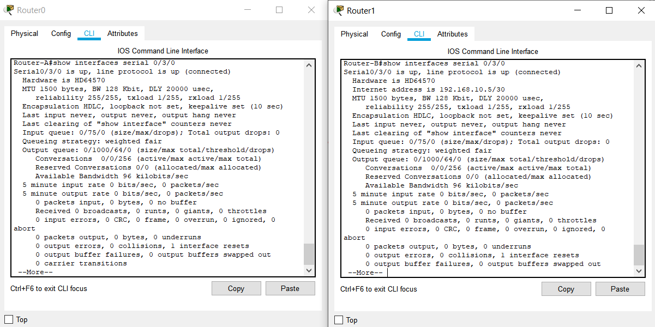



**3.**

**Check IP connectivity between the two routers using the ping command.**

Issue a ping from Router-A to Router-B to test network connectivity between the two routers.

**Router-A#ping 192.168.10.5**

**Type escape sequence to abort.**

**Sending 5, 100-byte ICMP Echos to 192.168.10.5, timeout is 2 seconds:**

**!!!!!**

**Success rate is 100 percent (5/5), round-trip min/avg/max = 3/3/4 ms**

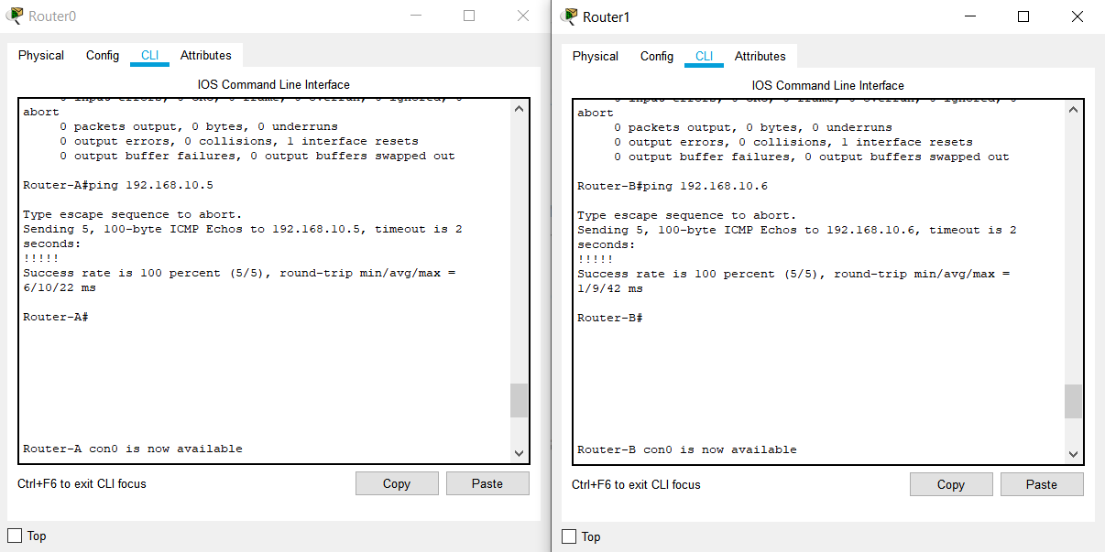



**Architecture of the Network implemented in Packet Tracer**

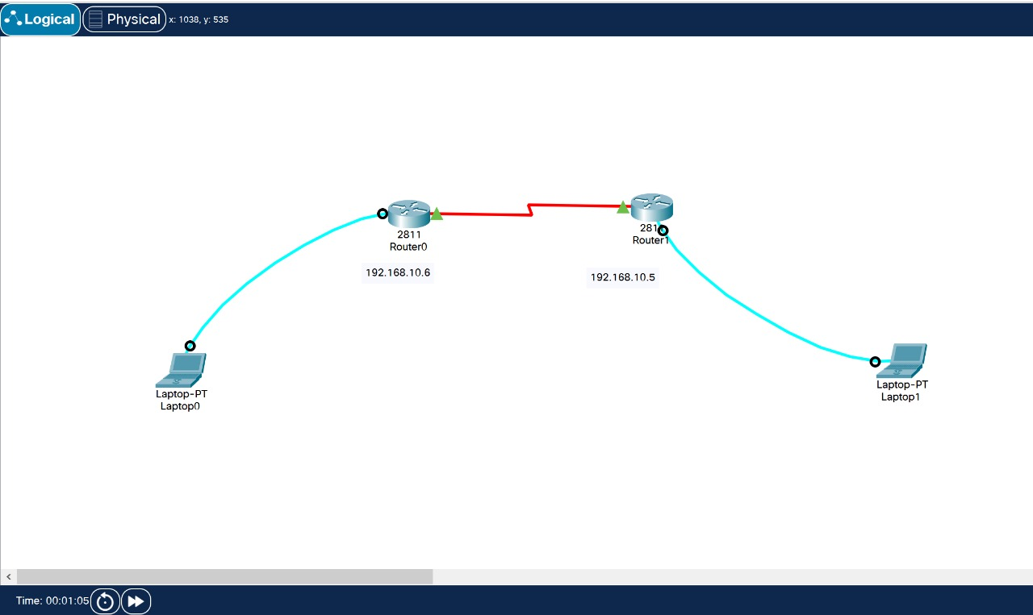

**RESULT:** HLDC Configuration is successfully implemented and demonstrated.