**DATABASE SCHEMA FOR GOCOMETS AIRLINE RESERVATION SYSTEM:**

USER

|  |  |  |  |  |
| --- | --- | --- | --- | --- |
| UserName | FirstName | LastName | Password | Dob |

AIRPORT

|  |  |  |
| --- | --- | --- |
| AirportId | CityName | State |

FLIGHT

|  |  |  |  |  |
| --- | --- | --- | --- | --- |
| FLIGHT# | ScheduledDeparture | ScheduledArrival | ***From_Airport_id*** | ***To_Airport_id*** |

FLIGHT INSTANCE

|  |  |  |  |  |  |
| --- | --- | --- | --- | --- | --- |
| InstanceId | ArriveTime | DepartTime | ArrivalDate | DepartureDate | ***Flight#*** |

RESERVATION

|  |  |  |  |  |
| --- | --- | --- | --- | --- |
| ReservationId | Amount | ***UserName*** | ***InstanceId*** | ***Payment*** |

AVAILABLE_SEATS

|  |  |  |  |
| --- | --- | --- | --- |
| Category_id | ***Instance_id*** | Availabilty | Total Seats |

PASSENGER

|  |  |  |  |
| --- | --- | --- | --- |
| Passenger_Id | Name | Age | Meal preference |

PASSENGER_RESERVATION

|  |  |
| --- | --- |
| ***Passenger_id*** | ***Reservation_id*** |

SEATS

|  |  |  |
| --- | --- | --- |
| Seat# | Seat_category | ***Reservation_id*** |

**Languages and frameworks used for implementation:**

HTML, CSS, Bootstrap, JavaScript, jQuery, Ajax, server side PHP.

**Screenshots for main functionalities:**

Home page:

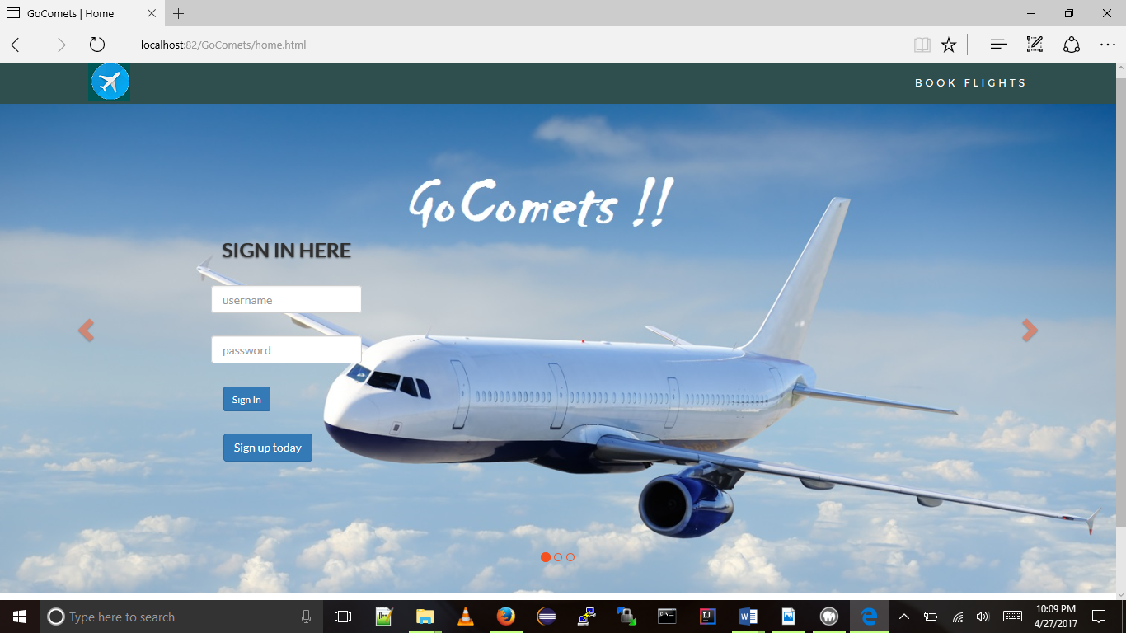

**Sign-Up:**

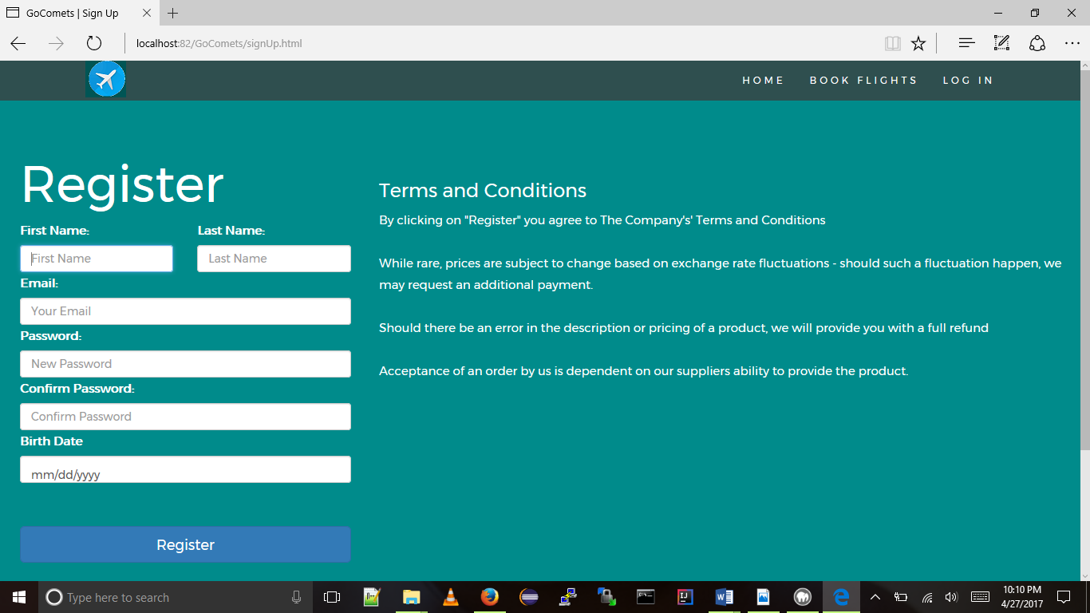

**MyTrips :**

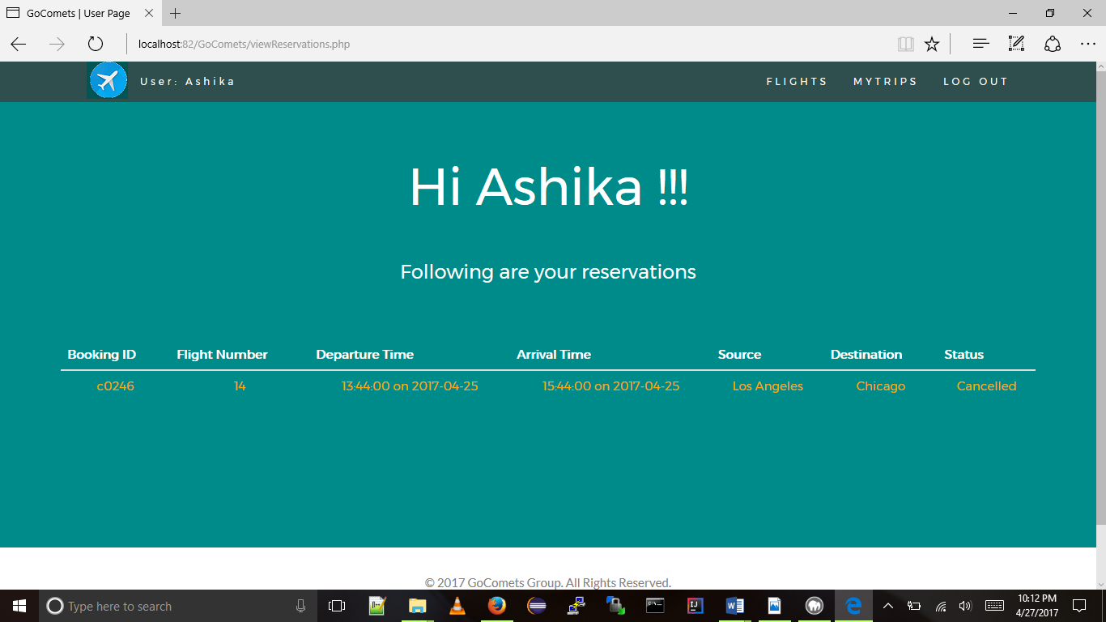

**Flights:**

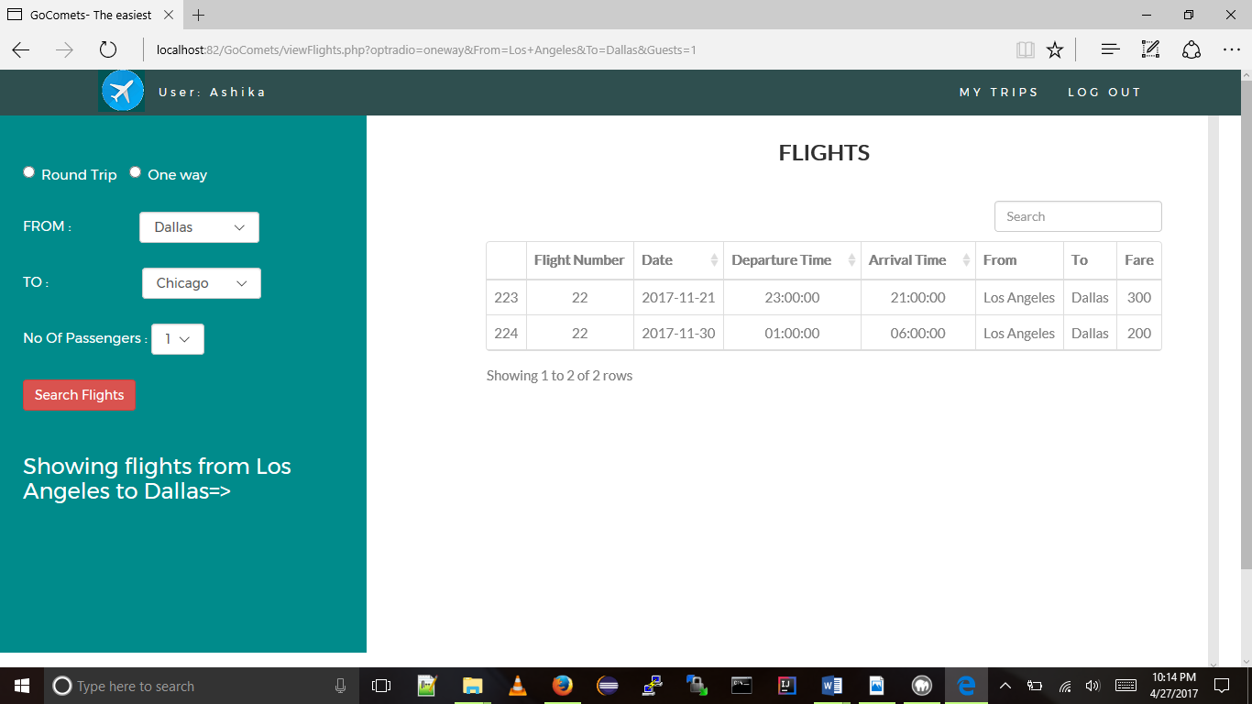

**Admin Home:**

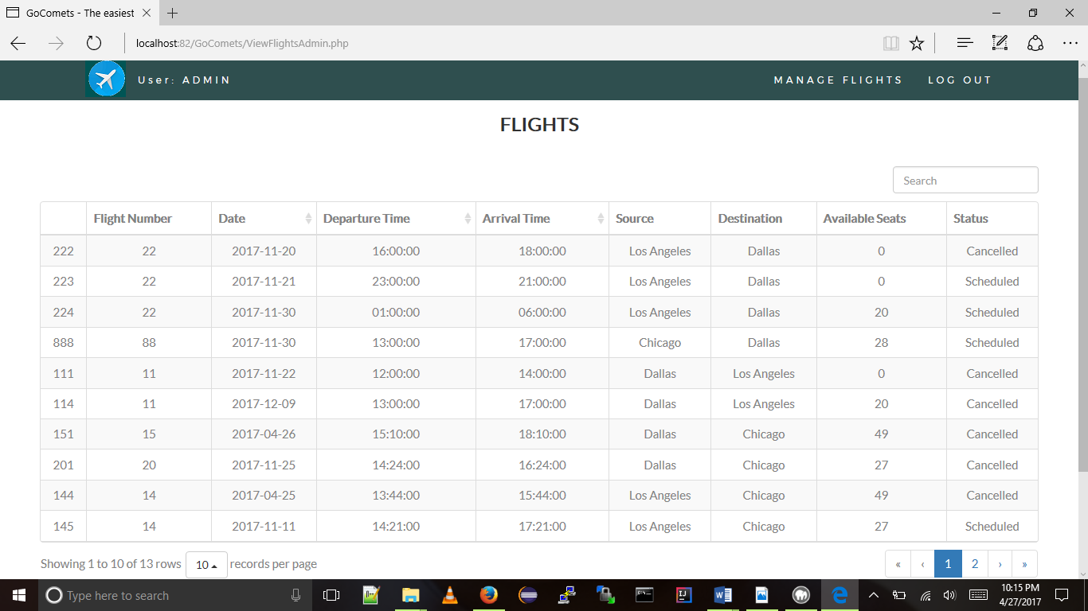

**Add Flights:**

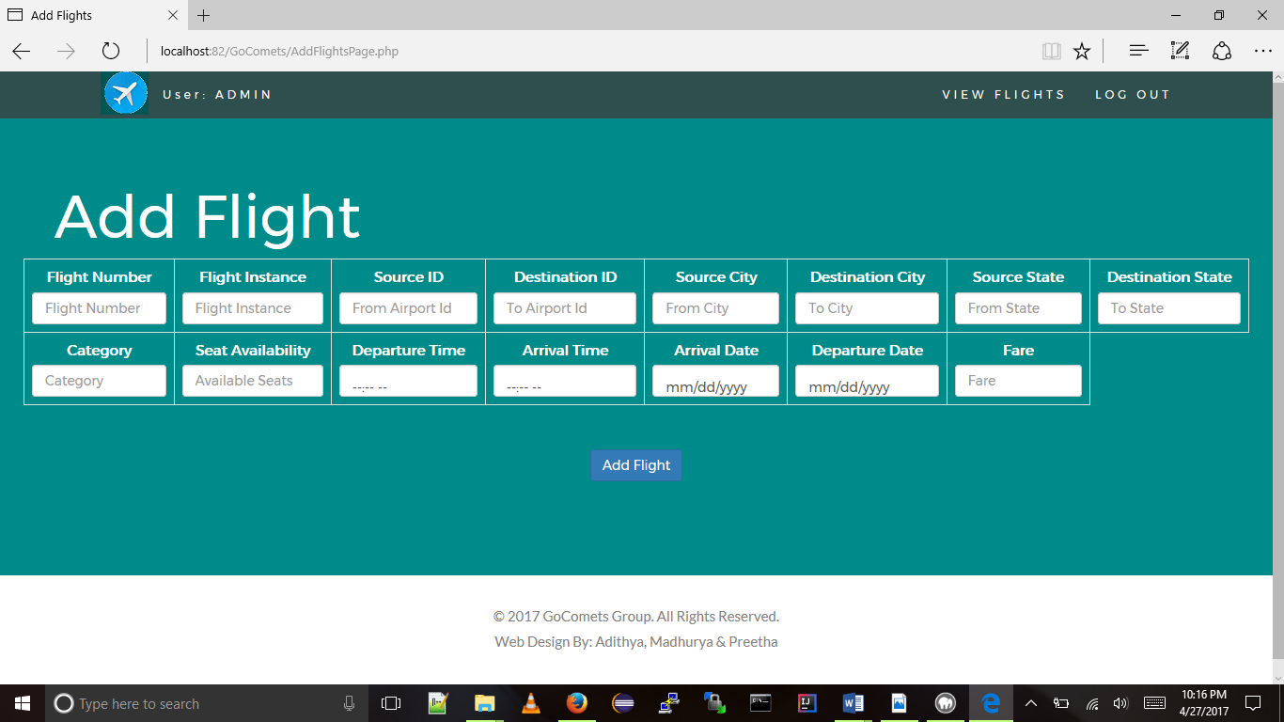

**Update Flight:**

