1.Create one user with the following configuration Name :- 530

Home directory:- /mnt/pps

I'd :- 2236

Canonical name :- Divya

And setting passwd for the user 530 as 530

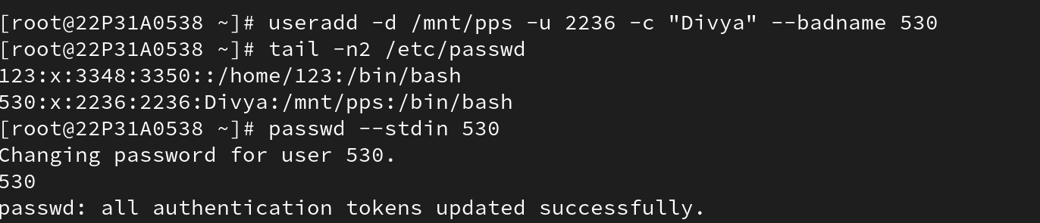

2.Use the chage and do the following changes for the user 530

Minmum days for password change :- 3

Maximum days :- 30

Warning :- 5

Inactive :- 1

