1.Sum, subtract and product the two numbers.

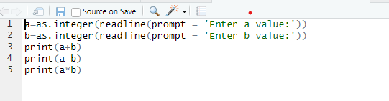

Output:

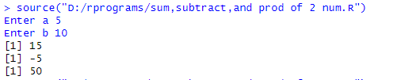

2.print “Hello world”

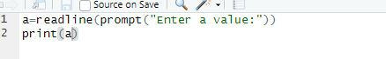

Output:



3.Display numbers from 1 to 50 where multiple of 5 is printed as X and multiple of is printed as Y and multiple of both 5 and 2 are printed as XY.

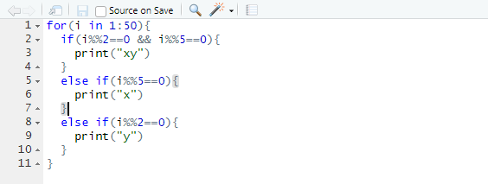

Output:

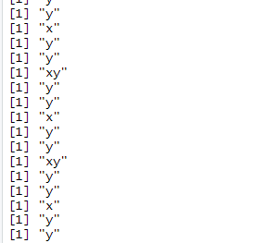

4.Create 4 vectors and convert them into matrix.

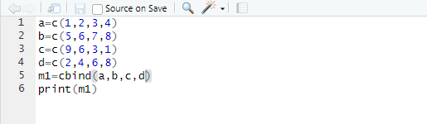

Output:

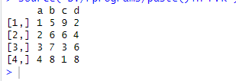

5.Print user input of name, age, gender and city and print version of R .

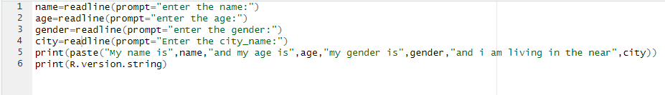

Output: 