Login to the user 530(password for user 530 is 530)

1. Create two new files with names as file1 , file 2

File1 should contain this content

"My name is file 1"

File2 should contain this content

"My name is file 2"

Create one more file with the name file3 and it should contain the following content

" Files contents"

-> copy the contents of file1 and file2 to the file3 without changing existing content ( use single command)

- rename file1 to newfile

-Change the timestamp of the file2

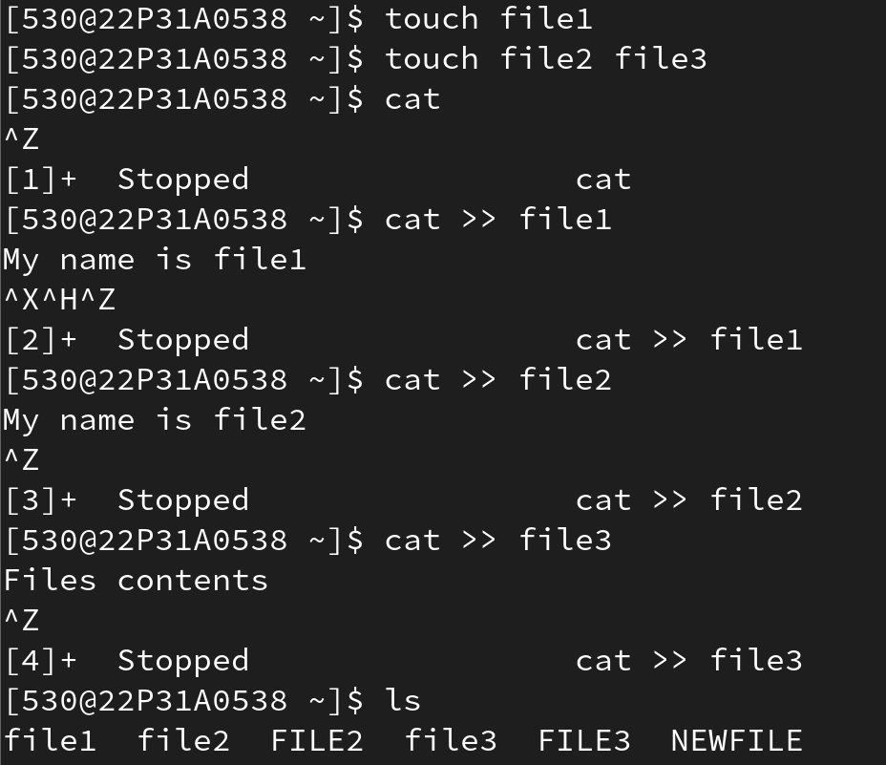

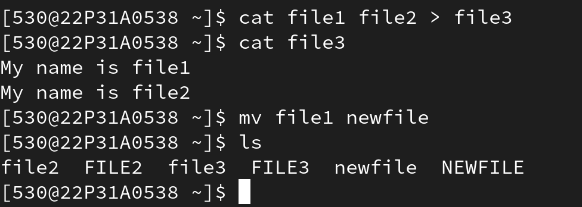

Shortcut :

