1. Create the following users, groups and group memberships:

a) A group named admin.



b) A user harrywho belongs to admin as a secondary group.

c) A user natasha who belongs to admin as a secondary group.

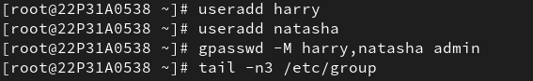

d) A user sarah who does not have access to an interactive shell on the system and who is not member of admin.



e) The users harry,natasha,sarah should all have password of password.

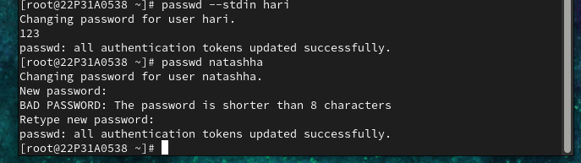

2. Create a collaborative directory /common/admin with the following characterstics:

a) Group ownership of /common/admin is admin.

. b) The directory should be readable,writable and accessible to members of admin, but not to any other user. (It is understood that root has access to all files and directories on the system.)

c) Files created in /common/admin automatically have group ownership set to the admin group.

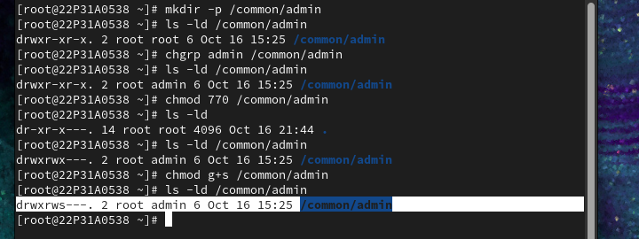

3.Find the string

a) Find a string "home" in /etc/passwd and searching string as been stored in /root/search.txt.

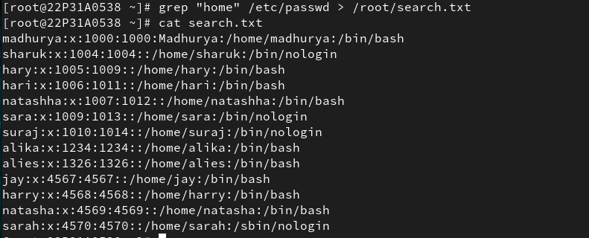

4. Create a user account

a) Create a new user with UID 1326 and user name as alies.  
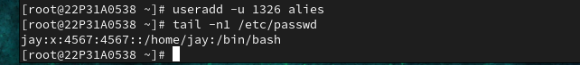

5. Set the Permission

a) All new creating files for user natasha as -r-------- as default permission.

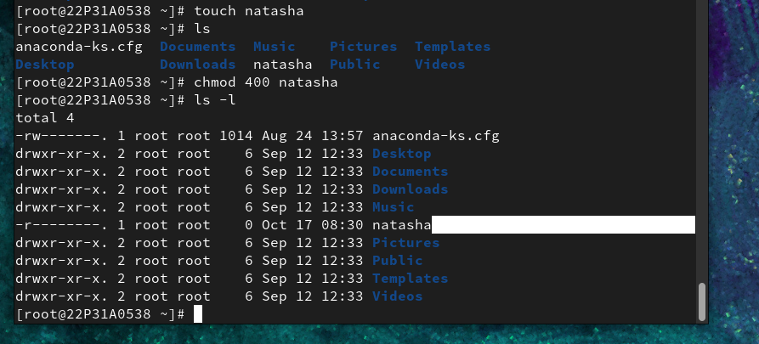

b) All new creating directories for user natasha as dr-x------ as default permission.

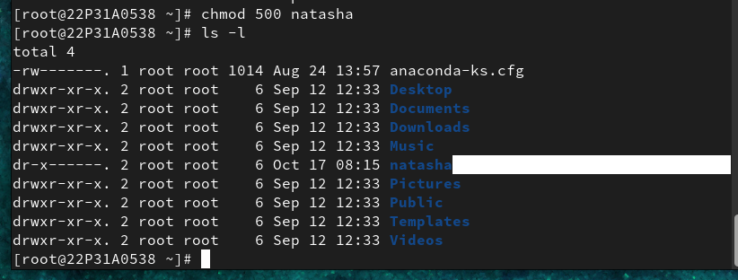

6. Set the Password expire date

a) The password for all new users in serverb.lab.example.com should expires after 20 days.

15.3 Assign Sudo Privilege

7. Assign Sudo Privilege Assign the Sudo Privilege for Group "admin" and Group members can administrate without any password.

8. Configure the application RHCSA as an alies user, When login it will show the message "Welcome to Advantage Pro".

9.Break the linux root password Assign root user password as northate.

Escape ,down arrow ,e

rd.break

ctrl+x

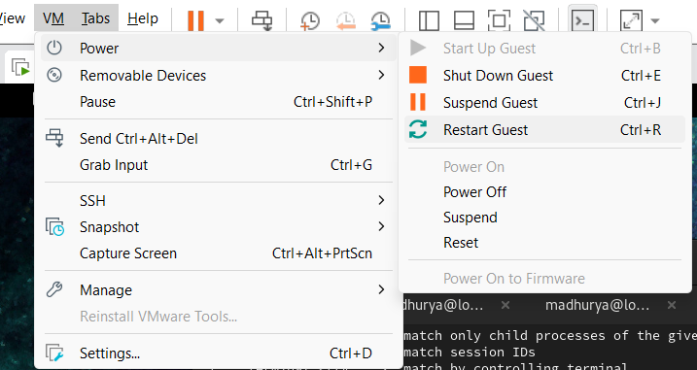

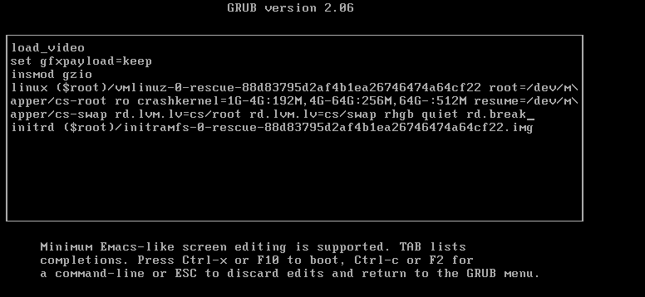

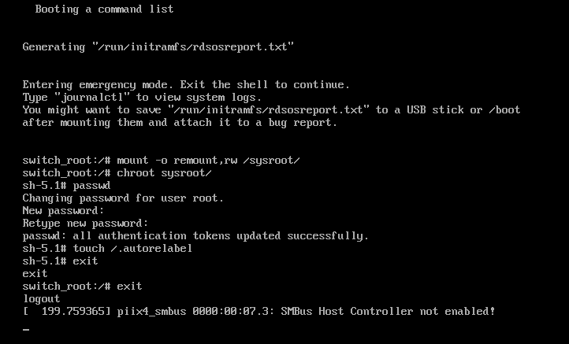

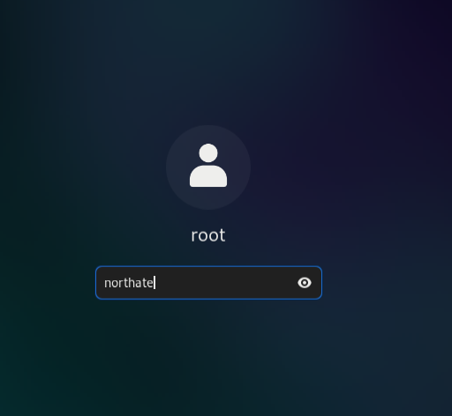

10. Create a swap partition 512MB size.

Creating an hard disk sda with the required G

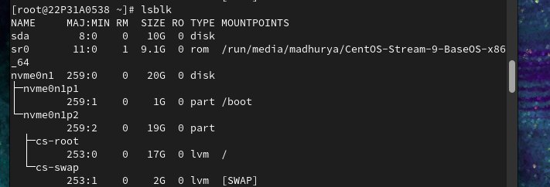

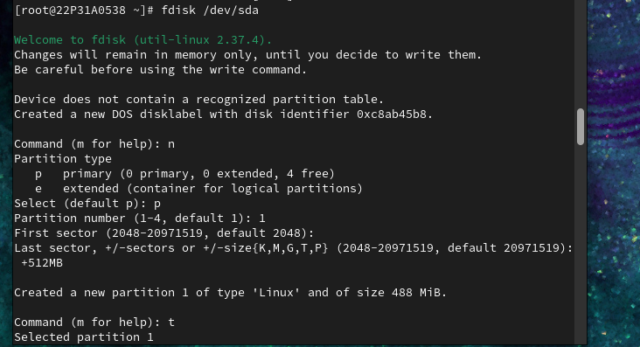

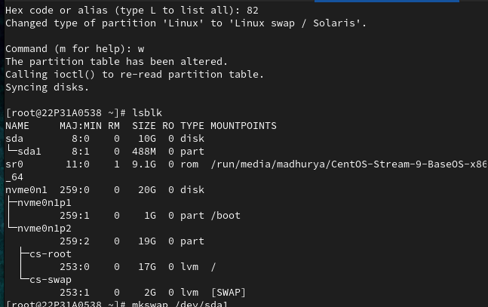

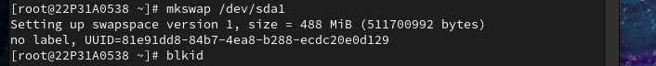

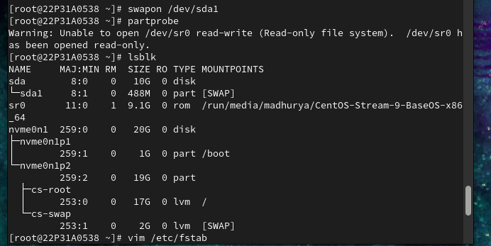

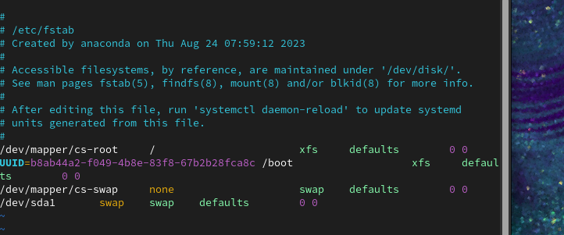

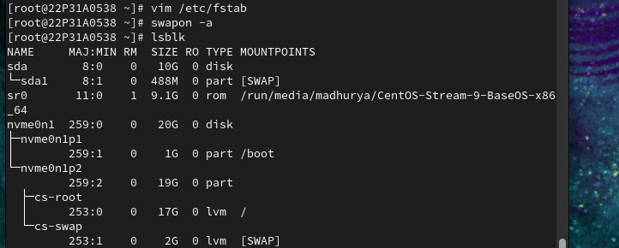

11.Create one logical volume named database and it should be on datastore volume group with size 50 extent and assign the filesystem as ext3.

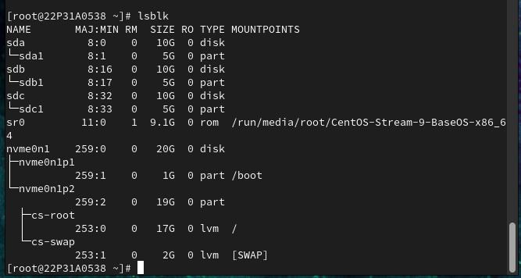

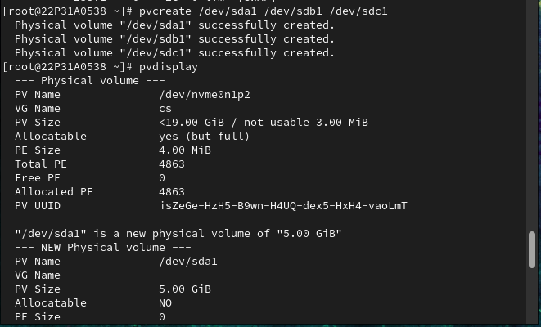

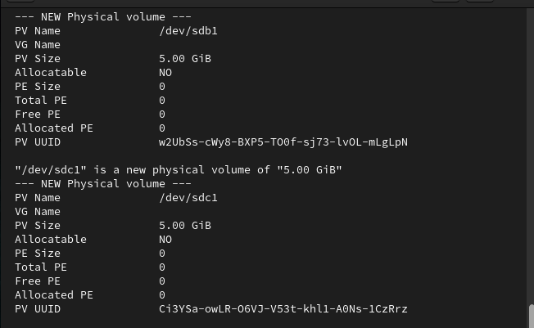

1. the datastore volume group extend should be 8MiB.

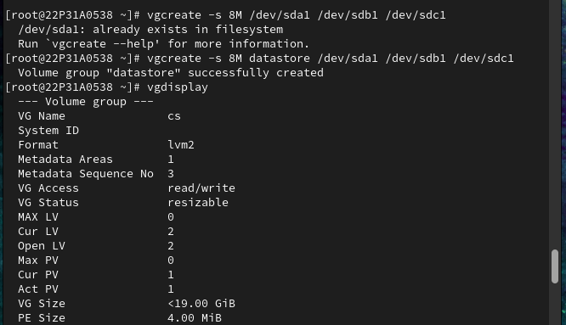

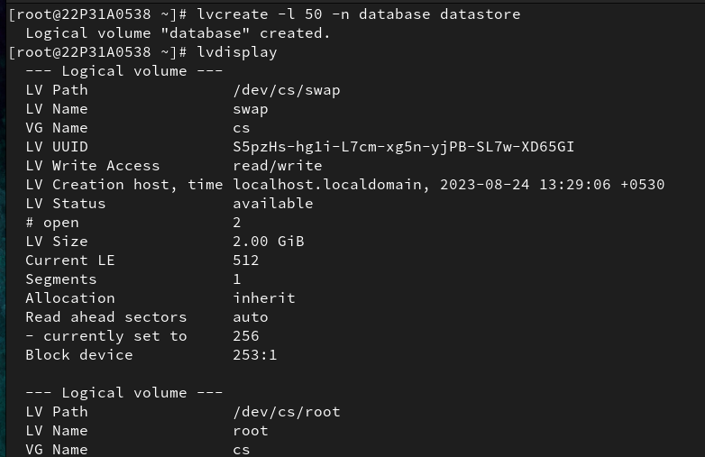

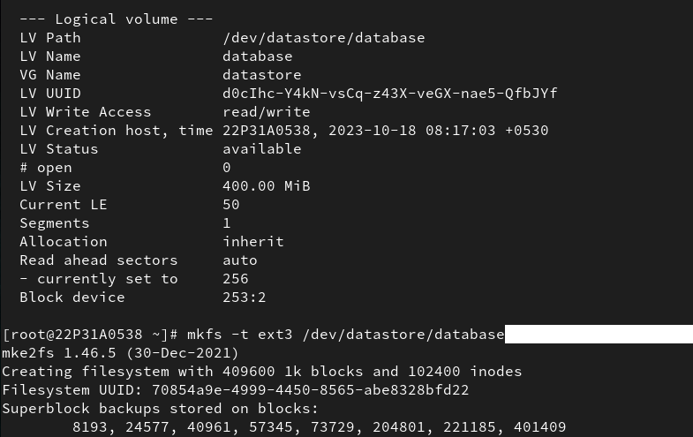

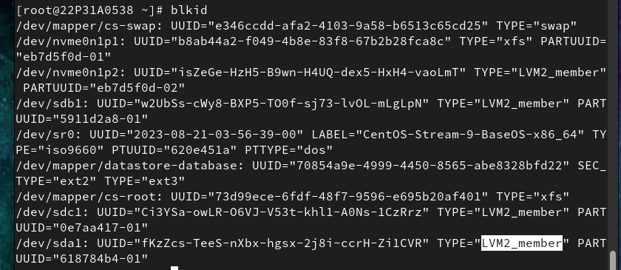

(ii)mount the logical volume under mount point /mnt/database.

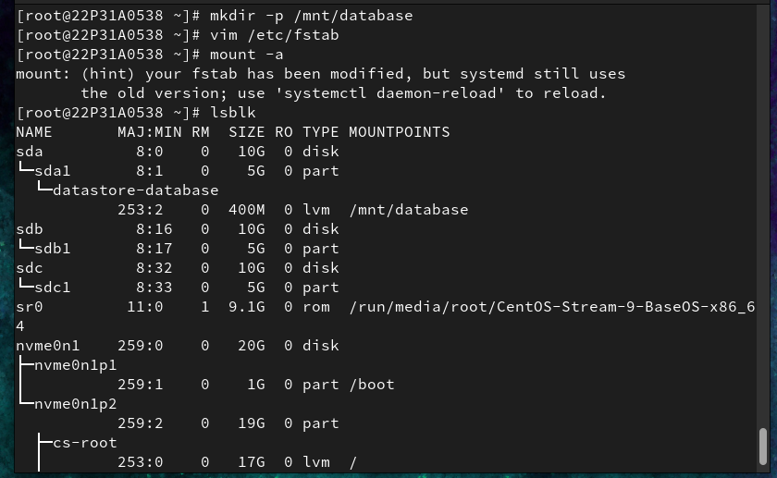

12.Resize the logical volume size of 100 extent on /mnt/database directory.

