Global Governance Indicators Analysis & Visualization
An End-to-End Data Analysis Project using Python & Power BI

MADHUMITHA S
APRIL - 2026
LinkedIn: madhumitha-s31


Motivation:
I chose this topic to explore how data analytics can make complex global policy data accessible and visually represent them with meaningful dashboards.
Challenges Faced:
- Wide-to-long format transformation was the trickiest preprocessing step
- Deciding which metric type (score vs estimate) to use required careful interpretation
- Designing the scatter plot to balance readability with insight

Objective:
The objective of this project is to analyse global governance indicators to understand how different countries perform across key governance dimensions such as political stability, government effectiveness, regulatory quality, and control of corruption.
The project aims to extract meaningful insights using data analysis techniques and present them through an interactive Power BI dashboard.

Dataset Description:
The dataset used in this project was sourced from the World Bank, specifically focusing on governance-related indicators within the global finance and public sector domain.
The data was filtered to include a selected set of 14 countries across the time period 2014 to 2025, ensuring a balanced and meaningful comparison rather than analysing a large number of random countries. The selected countries were shortlisted to ensure the diversity in governance levels and clear comparison across nations.
Governance Indicators Selected
The analysis is based on the following four core governance factors:
- Government Effectiveness
Measures the quality of public services, policy implementation, and the government's ability to deliver services efficiently.
- Political Stability
Reflects the likelihood of political instability, conflict, or violence affecting the functioning of government.
- Rule of Law
Indicates the extent to which citizens have confidence in and abide by the rules of society, including law enforcement and judicial systems.
- Voice and Accountability
Captures the extent to which citizens can participate in selecting their government, along with freedom of expression and media.

Tools & Technologies Used:
Python:
Python was used for the preprocessing and exploratory analysis to ensure the data was clean and ready for visualization.
Power BI:
Power BI allows interactive visualization and makes it easier for non-technical users to explore insights through dashboards.

Data Preprocessing:
The raw dataset obtained from the World Bank contained governance indicators in a wide format, with separate columns for each year.
Data Transformation:
- The dataset was initially structured with years as individual columns (2015–2024).
- To make the data suitable for analysis, it was reshaped into a long format using a melting technique.
This transformation converted:
- Multiple year columns → into a single “Year” column
- Corresponding values → into a “Value” column
This structure made the dataset more flexible for filtering, grouping, and visualization.
Handling Missing Values:
Missing values were identified across multiple columns:
- Country Name
- Country Code
- Series Name
- Value
Total missing values accounted for approximately 2.8% of the dataset.
Since this is less than 5%, the missing rows were removed to maintain data quality without significantly affecting the analysis.

Feature Engineering:
The “Series Name” column contained combined information about:
  - Governance metric
  - Measurement type
This column was split into two new features:
  - Metric → (e.g., Government Effectiveness, Political Stability)
  - Type → (e.g., Estimate scale or Score scale)
The “type” of the metric contains:
- Governance estimate (approx. -2.5 to +2.5)
- Governance score (0-100)
- Number of sources
Each with 560 data points.
- Only the Governance Score (0–100) was selected for analysis, while Governance Estimate (-2.5 to +2.5) was excluded due to its different scale and lower interpretability for direct comparison.
- The Number of Sources metric was removed as it represents data reliability rather than actual governance performance, making it irrelevant for analytical insights.
Final Structured Dataset:
After preprocessing, the dataset contained:
- Country Name
- Country Code
- Metric (Governance Indicator)
- Type (Measurement Scale)
- Year
- Value
This cleaned and structured format was then used for further analysis and visualization.

Exploratory Data Analysis (EDA):
Exploratory Data Analysis was performed to understand patterns, trends, and relationships within the governance data before building the dashboard.
Understanding Data Distribution:
The distribution of governance scores was analysed across different countries and indicators.
Variations in values helped identify:
- High-performing countries
- Low-performing regions
Country-wise Comparison:
Governance indicators were compared across the selected 14 countries.
This helped in identifying:
- Strong governance nations
- Countries with weaker governance metrics
Trend Analysis Over Time:
Governance indicators were analysed across the time period 2015–2024.
This revealed:
- Improvements or declines in governance performance
- Stability or fluctuations in specific indicators
Relationship Between Indicators:
Relationships between governance factors (e.g., effectiveness vs rule of law) were explored.
Initial observations suggested that:
- Countries with strong governance tend to perform consistently across multiple indicators

Dashboard Overview:
The Power BI dashboard provides an interactive and comprehensive view of governance performance across selected countries and indicators.
It includes multiple visualizations such as:
- Country-wise comparison charts
- Indicator-based analysis
- Time-series trends
- Summary KPI cards
Interactive features like filters and slicers allow users to explore governance metrics dynamically across different countries and years.
The dashboard is designed to present insights in a clear and structured manner, enabling easy comparison and interpretation of governance indicators.
Home Page:
KPI Cards:
New Zealand leads as the best-performing country, while Afghanistan sits at the lowest governance score. The global average stands at 63.65, with India's regional average at 56.66 — notably below the global benchmark. Australia stands out as the most stable country overall.
Average Governance Score by Indicator:
Government Effectiveness consistently scores the highest across all nations, followed closely by Political Stability and Rule of Law. Voice & Accountability lags slightly — suggesting democratic participation gaps persist globally.
Country-wise Governance Breakdown:
New Zealand, Australia, Germany, and Japan dominate the top tier across all four metrics. In contrast, Afghanistan and Ukraine show significantly compressed bars — reflecting governance crises and conflict-driven instability.
Global Governance Trend (2015–2024):
The global average declined from ~64.7 in 2015 to ~62.4 in 2024 — a slow but consistent downward trend, accelerating post-2019. This likely reflects the cumulative impact of COVID-19 disruptions, geopolitical conflicts, and democratic backsliding globally.

Analysis Page:
Year-wise Comparison of Governance Metrics:
Government Effectiveness remained the most resilient metric across the decade. Voice & Accountability showed the steepest decline — dropping from ~900 to ~830 — signalling a global erosion in civic freedoms and press freedom.
Governance Performance vs Stability Analysis:
Countries like Australia and Germany appear in the high-score, low-volatility quadrant — ideal performers. India and China sit in the mid-range with moderate stability. Afghanistan is a clear outlier — low score, high volatility — representing the most governance-challenged nation in this dataset.
Country-wise Summary Table:
New Zealand tops with a total governance score of 3,495 across all metrics. Japan scores exceptionally on Political Stability (859), while Germany leads on Government Effectiveness (862). The United States, despite its global standing, scores notably lower than peer democracies — particularly on Voice & Accountability (747).
Country Ranking by Overall Governance Score:
The ranking clearly separates two clusters — developed democracies (New Zealand to UAE) vs. emerging/conflict nations (South Africa to Afghanistan). The gap between rank 1 (New Zealand: ~3,495) and rank 14 (Afghanistan: ~1,004) is enormous, reinforcing the deep global governance divide.

Key Insights:
Global governance has been slowly declining over the past decade — from 64.7 in 2015 to 62.4 in 2024. The world is gradually getting worse at governing, not better.
Top & Bottom Performers:
- New Zealand is the best governed country overall — consistent across all 4 indicators
- Australia is the most stable — least fluctuation year over year
- Afghanistan is the lowest scorer — and the most volatile — driven by conflict and political collapse
Voice & Accountability dropped the most across all countries over 10 years — meaning citizens globally have less freedom of expression and political participation today than in 2015. That's a significant finding.
India's regional average of 56.66 is below the global average of 63.65 — room for significant improvement, especially in Rule of Law and Political Stability.
Governance Clusters Two clear groups emerge from the data — strong democracies (New Zealand, Australia, Germany, Japan) vs conflict/developing nations (Afghanistan, Ukraine, Philippines). The gap between them is massive — nearly 2,500 points in total score.

Screenshots of Dashboard:
Home Page:
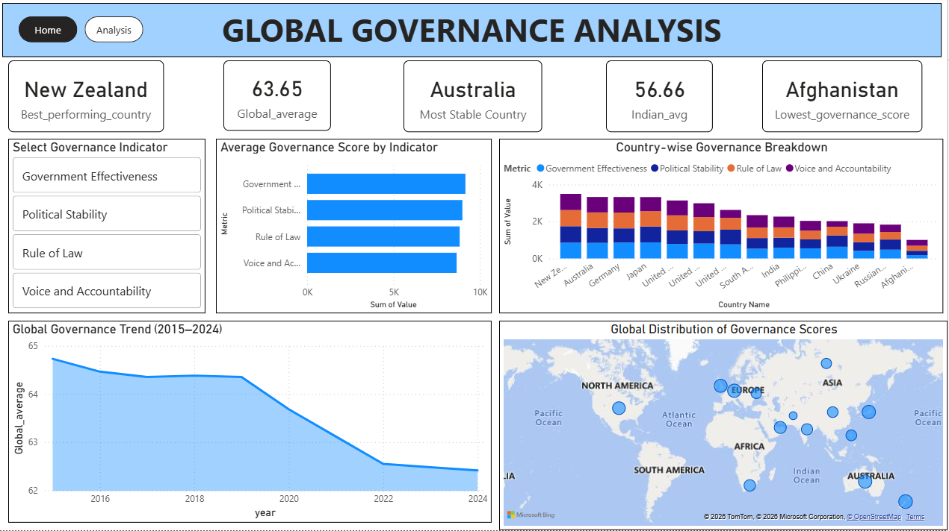
Analysis Page:
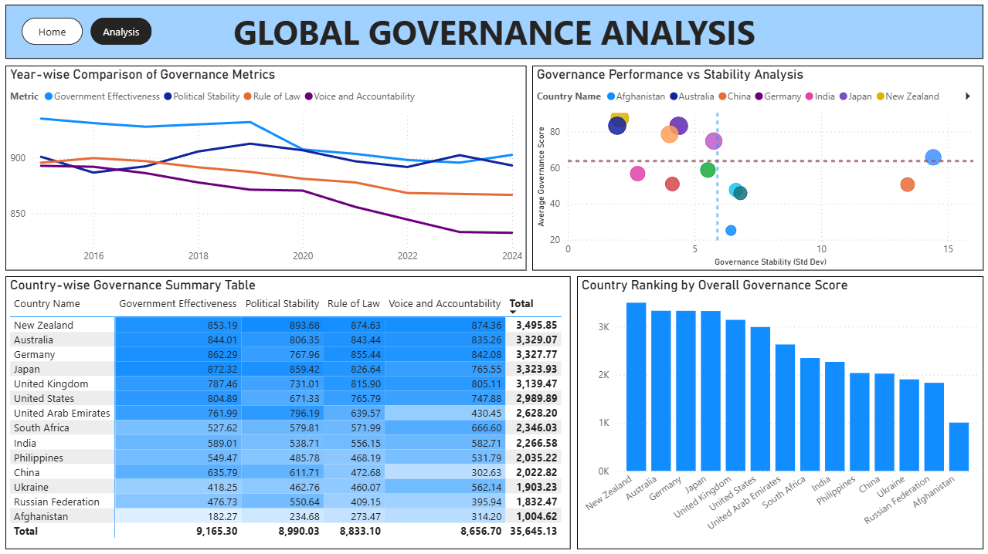

Conclusion:
This project successfully analysed global governance patterns across 14 countries using World Bank data. Through Python-based preprocessing and an interactive Power BI dashboard, it revealed that governance quality varies drastically across nations — with developed democracies consistently outperforming conflict-affected and developing countries. The global declining trend in Voice & Accountability is a standout finding that reflects broader real-world challenges in civic freedom and democratic participation.
Future Improvements:
- Expand the dataset to include more countries and regions for a truly global picture
- Incorporate additional indicators like Corruption Control and Regulatory Quality
- Add predictive modelling to forecast governance trends for the next 5 years
- Enable real-time data refresh by connecting directly to the World Bank API

