**Aim:** To understand the operation of TELNET by accessing the router placed in the server route from a PC in the IT office.

**Topology:**

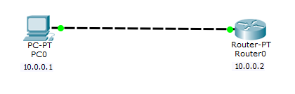

**Router command line:**

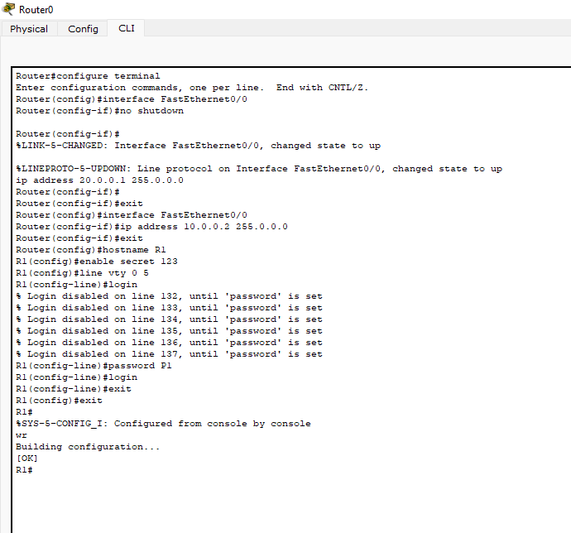

**PC CLI:**

