**Request** (The JSON request added in folder separately)

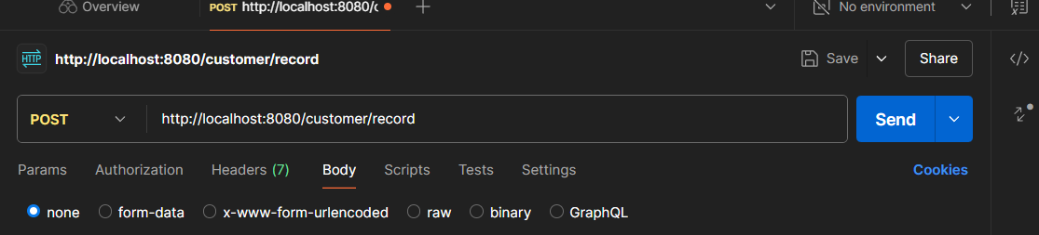

**Response** (The JSON response added in folder separately)

