

**SCHOOL OF ENGINEERING AND TECHNOLOGY**

**A Project Work Report On**

**"A Supervised Body Fat Prediction"**

*Submitted in partial fulfillment of the requirements for the Course Introduction to Machine Learning (4CSPL2041) in*

**Bachelor of Technology In**

**Computer Science and Engineering**

*SoET, CMR University, Bangalore*

Submitted by:

**Indhu S (21BBTCS097)**

**Madhushree K M (21BBTCS122) Manasa B M (21BBTCS124)**

**Under the Supervision**:

**Dr. Manjunath C R**

Professor

**Department of Computer Science and Engineering**

**Off Hennur - Bagalur Main Road,**

**Near Kempegowda International Airport, Chagalahatti, Bangalore, Karnataka-562149**

**2023-2024**





**SCHOOL OF ENGINEERING AND TECHNOLOGY**

Chagalahatti, Bengaluru, Karnataka- 562149

# Department of Computer science and engineering

**CERTIFICATE**

This is to certify that the project work entitled **“ A Supervised Body Fat Prediction ”**, is a record of work successfully carried out by **Indhu S (21BBTCS097), Madhushree K M (21BBTCS122), Manasa B M (21BBTCS124)** in partial fulfilment of the requirement for the course **INTRODUCTION TO MACHINE LEARNING (4CSPL2041)** of Bachelor of Technology in Computer Science and Engineering, SoET, CMR University, Bangalore during the academic year 2023-24, under the supervision and guidance of **Dr. MANJUNATH C.R,** Professor, CSE, SoET, CMR University.

Signature

### Dr. MANJUNATH C.R,

**Professor, Dept of CSE, SoET, CMR University.**



|  |  |  |
| --- | --- | --- |
| **Chapter**  **No** | **Title** | **Page No** |
|  | **ABSTRACT** | **1** |
| **1** | **INTRODUCTION** | **2-3** |
|  | **1.1 Background** | **2** |
|  | **1.2 Overview of Machine Learning Concepts** | **3** |
|  | **1.3 Objectives** | **3** |
| **2** | **LITERATURE REVIEW** | **4-5** |
|  | **2.1 Overview of Relevant Studies** | **4** |
|  | **2.2 Key Concepts** | **4-5** |
| **3** | **METHODOLOGY** | **6-8** |
|  | **3.1 Research Design** | **6** |
|  | **3.2 Data Sources** | **6-8** |
| **4** | **SYSTEM DESIGN** | **9-11** |
|  | **4.1 System Architecture** | **9** |
|  | **4.2 Components and Technical Specifications** | **10-11** |
| **5** | **IMPLEMENTATION** | **12-17** |
|  | **5.1 Model Selection and Justification** | **12-14** |
|  | **5.2 Model Training** | **14-16** |
|  | **5.3 Model Evaluation Metrics** | **16-17** |
| **6** | **RESULTS AND INTERPRETATION** | **18-23** |
|  | **6.1 Performance Metrics** | **18-19** |
|  | **6.2 Comparison/ Interpretation of Results** | **19-23** |
| **7** | **CONCLUSION** | **24** |
| **8** | **REFERENCES** | **25-26** |



|  |  |  |
| --- | --- | --- |
| **Figure**  **no** | **Title** | **Page no** |
| 1.1 | Body Fat Prediction From Anthropometric | 2 |
| 4.1 | General Architecture | 9 |
| 5.1.1 | Linear Regression Model | 12 |
| 5.1.2 | Random Forest Classifier | 14 |
| 5.2.1 | Model Training 1 | 15 |
| 5.2.2 | Model Training 2 | 16 |
| 5.3 | Model Evaluation Metrics | 17 |
| 6.1 | Performance Metrics | 18 |
| 6.2.1 | Correlation Matrix of Linear Regression | 19 |
| 6.2.2 | Linear Regression Model Result | 20 |
| 6.2.3 | Correlation Matrix of Random Forest | 21 |
| 6.2.4 | Random Forest Result | 22 |



|  |  |  |
| --- | --- | --- |
| **Table**  **no** | **Title** | **Page no** |
| 6.2.1 | Comparison Table | 23 |

**ABSTRACT**

Body fat stands as a critical public health issue, posing significant risks for various serious diseases. While several methods exist for estimating body fat to gauge obesity, these often entail expensive tests and specialized equipment. Therefore, accurate prediction of body fat percentage through easily accessible body measurements becomes paramount for effectively assessing obesity and its associated health implications. This study delves into the realm of feature extraction, examining its efficacy in predicting body fat. By scrutinizing the distinctive characteristics of different features, such as various body measurements, the research endeavors to discern the impact of feature extraction on prediction accuracy.

A rigorous evaluation process scrutinizes three distinct feature extraction methodologies alongside four widely recognized prediction models. Drawing upon data from two real-world body fat datasets, the study meticulously assesses the performance of these models, focusing on key metrics like mean absolute error, standard deviation, root mean square error, and robustness. The findings unequivocally demonstrate that integrating feature extraction significantly enhances the predictive capability of these models for body fat estimation. Not only do the results confirm the efficacy of feature extraction as a preprocessing step in body fat prediction, but they also underscore its pivotal role in refining the accuracy and robustness of predictive models in this domain. Moreover, statistical analyses corroborate the substantial improvement afforded by feature extraction, shedding light on its tangible benefits in bolstering prediction performance. Notably, the study observes that augmenting the number of extracted features yields marginal yet discernible enhancements in the predictive accuracy of models, further accentuating the importance of comprehensive feature selection.

In essence, this study contributes valuable insights into the efficacy of feature extraction techniques in body fat prediction and establishes a robust baseline for future research endeavors in related fields. By illuminating the significance of feature extraction as a catalyst for refining prediction models, the findings pave the way for more nuanced approaches to obesity assessment and management, ultimately fostering advancements in public health interventions to combat the obesity epidemic.

**Keywords:** Obesity, Bodyfat estimation, Feature extraction, Statistical analysis, Meanabsolute error, Robustness, Prediction models.

## CHAPTER – 1

* 1. **Background and Context**

## INTRODUCTION

In the realm of health and fitness, body fat percentage is a crucial metric that provides a more accurate depiction of physical well-being than traditional measures such as Body Mass Index (BMI). The title “A Supervised Body Fat Prediction Model” refers to a machine learning-based approach aimed at predicting an individual’s body fat percentage based on certain features or predictors.

This model leverages supervised learning, a subset of machine learning where the model is trained on a labeled dataset. The ‘labels’ in this context would be the actual body fat percentages of individuals in the training dataset. The model learns the relationship between the features (such as age, height, weight, gender, waist circumference, etc.) and the body fat percentage during the training phase. Once trained, this model can predict the body fat percentage of new individuals based on their features, thereby providing a valuable tool for health assessments and fitness tracking. This model has the potential to revolutionize personal health management by providing accurate, personalized body fat estimates, leading to more effective and tailored fitness plans.

The development and validation of such a model involve various stages including data collection, preprocessing, model selection, training, testing, and performance evaluation. The following sections will delve into these stages in detail, providing a comprehensive overview of the process involved in creating a supervised body fat prediction model.

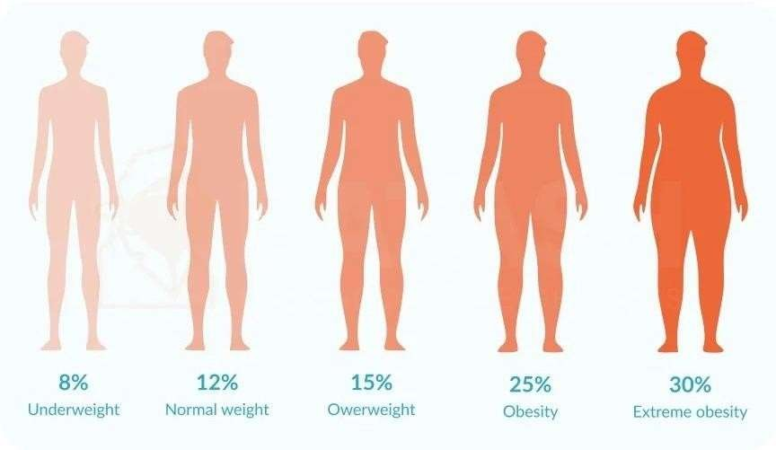

**Figure 1.1 Body Fat Prediction From Anthropometric**

### Overview of Machine Learning Concepts

Machine learning, a subset of artificial intelligence, has become an essential tool in predicting body fat percentage. It employs a variety of models and techniques to analyze data and make accurate predictions. One of the key concepts in this domain is the use of hybrid machine learning models. These models combine different characteristics of various models to analyze complex and challenging data. For instance, a hybrid model based on Support Vector Regression and Emotional Artificial Neural Networks (SVR-EANNs) has been proposed for accurate body fat percentage prediction. This model leverages the strengths of both Support Vector Regression, a powerful linear model used for regression tasks, and Emotional Artificial Neural Networks, a type of artificial neural network that incorporates emotional factors into the learning process.

These models consider a wide range of factors such as age, weight, waist circumference, and skinfold thickness. Age and weight are straightforward, with older age and higher weight typically associated with higher body fat percentage. Waist circumference is a measure of abdominal obesity, and skinfold thickness is a measure of subcutaneous fat. By considering these factors, the models can provide a comprehensive and accurate prediction of body fat percentage. The goal of these machine learning models is to provide an accurate prediction of body fat percentage based on easily accessible body measurements. This is crucial for assessing obesity and its related diseases. Obesity is a major public health concern worldwide, and accurate assessment of body fat is essential for diagnosing obesity, monitoring progress in weight loss programs, and assessing the risk of obesity-related diseases such as heart disease and diabetes.

Machine learning models are continually being refined and improved to increase their prediction accuracy and usability in real-world applications. Researchers are exploring new features, developing more sophisticated models, and applying advanced machine-learning techniques to improve the accuracy of body fat prediction. These advancements in machine learning are contributing to the development of more effective and personalized strategies for obesity prevention and treatment. Machine learning plays a pivotal role in body fat prediction, providing valuable tools for health professionals and individuals to assess body fat percentage and manage obesity. As research progresses and machine learning techniques continue to evolve, we can expect even more accurate and useful tools for body fat prediction in the future.

### Objectives of the study

* + - Evaluate the effectiveness of feature extraction techniques in predicting body fat percentage.
    - Utilize a dataset comprising body fat estimates and various body circumference measurements for 252 men.
    - By using a linear regression approach and design and analysis of the impact on prediction model performance.

**CHAPTER – 2**

# LITERATURE SURVEY

### Overview Of Relevant Studies

Research on body fat prediction using anthropometric measurements involves the exploration of equations and predictive models that utilize easily accessible physical measurements such as waist circumference, hip circumference, and skinfold thickness, among others. These studies typically involve large-scale population-based research to establish robust correlations between these anthropometric variables and body fat percentage across diverse demographics. Validation against more precise methods like DEXA or ADP is common practice to assess the accuracy and reliabilityof these equations. Moreover, researchers are increasingly focusing on developing population- specific equations to accommodate demographic and ethnic variations in body composition, recognizing the importance of accounting for such differences in predictive accuracy. Anthropometric measurements offer a practical and cost-effective means of estimating body fat percentage, making them invaluable tools for both clinical and research applications. Their simplicity and accessibility make them particularly useful in settings where more advanced techniques may be impractical or unavailable, thus facilitating broader applicability in health assessments and interventions.

### Key Concepts

Body fat prediction using linear regression relies on understanding body composition and using predictors like age, gender, and anthropometric measurements to estimate body fat percentage. Proper feature engineering enhances prediction accuracy. Evaluating model performance using metrics like mean absolute error and cross-validation ensures robustness. Addressing assumptions like multicollinearity is crucial. Residual analysis validates the model, ensuring homoscedasticity and normality. Careful interpretation of coefficients is essential for understanding their impact on body fat prediction.

Let's break down each key concept even further:

**Body Composition** : Body composition is a multifaceted concept encompassing the relative proportions of fat, muscle, bone, water, and other tissues in the body. It's not just about the total amount of fat but also about where fat is distributed throughout the body. For instance, visceral fat (fat stored around internal organs) can have different health implications than subcutaneous fat (fatstored under the skin). Understanding these nuances can influence the selection of predictors and the interpretation of results in body fat prediction models.

**Linear Regression** : Linear regression is a statistical method used to model the relationship between one or more independent variables and a continuous dependent variable. In the context of body fat prediction, linear regression assumes that the relationship between the predictors (e.g., age, weight) and the dependent variable (body fat percentage) can be adequately represented by a straight line. However, it's important to note that while linear regression is widely used, it may not capture complex nonlinear relationships that could exist in the data.

**Independent Variables** : Independent variables are the inputs or predictors used to estimate the dependent variable (body fat percentage). Each independent variable contributes to the prediction, and their collective influence is captured by the regression coefficients. In body fat prediction models, selecting the most relevant independent variables is critical. This selection process may involve domain knowledge, statistical techniques, or machine learning algorithms to identify the variables that have the strongest associations with body fat percentage.

**Dependent Variable** : The dependent variable in body fat prediction models is the variable being predicted, which in this case is the body fat percentage. It's essential to ensure that the dependent variable is accurately measured and reflects the construct of interest. In body composition research, various methods such as dual-energy X-ray absorptiometry (DEXA), bioelectrical impedanceanalysis (BIA), or skinfold thickness measurements may be used to assess body fat percentage.

**Model Evaluation** : Model evaluation involves assessing how well the linear regression model performs in predicting body fat percentage. This assessment typically includes examining measuresof prediction accuracy, such as mean absolute error (MAE), mean squared error (MSE), root mean squared error (RMSE), or coefficient of determination (R-squared). Additionally, evaluating the model's performance on unseen data using techniques like cross-validation helps ensure that the model generalizes well to new observations.

**Feature Engineering** : Feature engineering is the process of transforming raw data into features that are more informative for predictive modeling. In the context of body fat prediction, feature engineering may involve deriving new variables from existing ones (e.g., body mass index from weight and height), scaling or normalizing variables to ensure they have similar ranges, or creatinginteraction terms to capture synergistic effects between predictors.

**Multicollinearity** : Multicollinearity occurs when independent variables in a regression model are highly correlated with each other. This can pose challenges for interpreting the regression coefficients, as it becomes difficult to discern the unique contribution of each predictor to the dependent variable. To address multicollinearity, techniques such as principal component analysis (PCA), ridge regression, or Lasso regression may be employed to reduce the collinearity among predictors.

**CHAPTER – 3**

* 1. **Research Design**

# METHODOLOGY

The first step in predicting body fat using machine learning is data collection. This involves gathering data related to body fat percentage and other relevant parameters such as age, height, weight, waist circumference, etc. The data can be collected from various sources such as sensors, smartphones, and electronic medical health records. Once the data is collected, it needs to be preprocessed in the data preprocessing step. This involves cleaning the data by handling missing values, outliers, and errors, and normalizing or standardizing the data if necessary. The next step is feature selection, where the most relevant features for predicting body fat are identified. For instance, one study found that abdominal circumference is a significant factor in body fat percentage prediction, while age has a minor effect. The final step is model selection, where a suitable machine learning model is chosen and trained on the preprocessed data. The model is then tested and validated, and its performance is evaluated. If the model's performance is satisfactory, it can be used to predict body fat percentage based on the selected features. If not, the process is iterated with different models or feature sets until a satisfactory model is found.

### Data Sources

Data sources for body fat prediction using body measurements with linear regression and random forest typically include datasets comprising anthropometric measurements like height, weight, waist circumference, and skinfold thickness alongside corresponding body fat percentages. These datasets can be sourced from diverse sources such as research studies, public health databases, or specifically collected data. Research studies often provide detailed anthropometric data from diverse populations, while public health databases offer large-scale population-based data for broader insights. Additionally, researchers or healthcare professionals may collect their own datasets tailored to specific research questions. Ensuring data quality, representativeness, and ethical considerations are paramount in utilizing these sources for developing accurate and reliable predictive models.

D = Body Density (gm/cm^3)

A = proportion of lean body tissue

B = proportion of fat tissue (A+B=1)

a = density of lean body tissue (gm/cm^3)b = density of fat tissue (gm/cm^3) we have:

# D = 1/[(A/a) + (B/b)] Eq1

solving for B we find:

# B = (1/D)*[ab/(a-b)] - [b/(a-b)]. Eq2

Using the estimates a=1.10 gm/cm^3 and b=0.90 gm/cm^3 (see Katch and McArdle (1977), p. 111 or Wilmore (1976), p. 123) we come up with "Siri's equation":

Percentage of Body Fat (i.e. 100*B) = 495/D – 450

Let's dive deeper into each data source used in body fat prediction:

**Anthropometric Measurements:** Anthropometric measurements provide direct physical indicators of body size and composition. These include height, weight, waist circumference, hip circumference, and skinfold thickness. Height and weight are basic measurements commonly used in body fat prediction models, while waist and hip circumferences offer insights into central adiposity. Skinfold thickness measurements, taken at specific sites on the body, estimate subcutaneous fat thickness and are used in conjunction with other measurements for more accurate predictions.

**Demographic Information:** Demographic data, such as age, gender, ethnicity, and socioeconomic status, contribute to understanding variations in body fat distribution among different population groups. Age-related changes in body composition, hormonal influences, and cultural factors can affect body fat percentage. Gender differences in fat distribution and metabolism are also well-documented. Ethnicity and socioeconomic status may further influence lifestyle factors, dietary habits, and access to healthcare, all of which can impact body fat levels.

**Medical History and Health Behaviors:** Information about individuals' medical history, lifestyle habits, and health behaviors provides insights into factors influencing body fat accumulation. Medical conditions like diabetes, hypertension, or metabolic disorders can affect body composition. Medication use may also influence metabolism and fat storage. Dietary habits, physical activity levels, smoking status, and alcohol consumption are behavioral factors that can impact body fat percentage. Integrating these data allows for a more comprehensive understanding of individual health profiles.

**Body Composition Assessment Techniques:** Advanced body composition assessment techniques, such as DEXA, BIA, or air displacement plethysmography, offer precise measurements of body fat percentage. DEXA, considered the gold standard, provides detailed information about fat mass, lean mass, and bone density. BIA measures body composition based on electrical impedance, while air displacement plethysmography measures body volume to estimate body density. While these techniques offer high accuracy, they may not be feasible for large-scale studies or routine assessments.

**Population Surveys and Research Studies**: Population-based surveys and research studies provide valuable datasets for developing and validating body fat prediction models. These datasets encompass diverse populations and provide comprehensive health information collected through standardized protocols. Longitudinal studies like the Framingham Heart Study offer insights into trends in body composition over time and help identify risk factors for obesity-related conditions. Large-scale surveys like the National Health and Nutrition Examination Survey provide nationally representative data for epidemiological analyses.

**Wearable Devices and Mobile Applications**: With the advent of wearable devices and mobile applications, real-time data on physical activity, sleep patterns, and dietary intake can be collected remotely. Wearable devices equipped with accelerometers, heart rate monitors, and other sensors track activity levels and energy expenditure. Mobile applications allow users to log dietary intake, monitor weight changes, and track progress towards fitness goals. Integrating data from these sources with traditional anthropometric measurements enhances the granularity of predictive models and facilitates personalized interventions for managing body composition.

**CHAPTER – 4**

### System Architecture

SYSTEM DESIGN

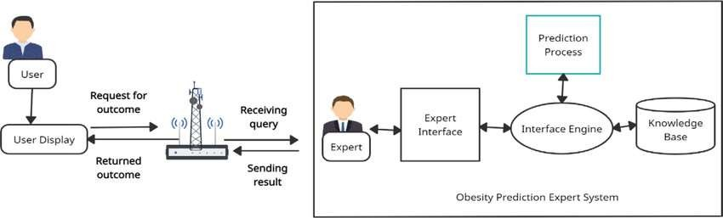

**Figure 4.1 General Architecture**

### Components and Technical SpecificationsRegression:

Regression is a statistical approach used to analyse the relationship between a dependent variable (target variable) and one or more independent variables (predictor variables). The objective is to determine the most suitable function that characterizes the connection between these variables. Regression is a fundamental concept in most statistics. Machine learning kicks things up a notch by using algorithms to distill these fundamental relationships through an automated process. Regression algorithms are a type of machine learning algorithm used to predict numerical values based on input data. Regression algorithms attempt to find a relationship between the input variables and the output variable by fitting a mathematical model to the data. The goal of regression is to find a mathematical relationship between the input features and the target variable that can be used to make accurate predictions on new, unseen data.

### Regression Algorithms:

Linear Regression Linear regression is one of the simplest and most widely used statistical models. This assumes that there is a linear relationship between the independent and dependent variables. This means that the change in the dependent variable is proportional to the change in the independent variables. Utilizing Python for body fat prediction using anthropometric measurements offers several advantagesowing to its versatility, extensive libraries, and robust statistical capabilities. Python, a high-level programming language, provides a flexible and efficient platform for data preprocessing, analysis, modeling, and validation procedures required in body fat prediction research.

Python's rich ecosystem of libraries, including NumPy, pandas, and scikit-learn, facilitates seamless data manipulation and statistical analysis. NumPy provides support for numerical operations and array manipulation, while pandas offers powerful data structures and functions for data manipulation and

analysis. These libraries enable researchers to preprocess anthropometric data efficiently, handle missing values, and prepare datasets for modeling. scikit-learn, a popular machine learning library in Python, offers a wide range of algorithms and tools for regression modeling, including linear regression, polynomial regression, and support vector regression. Researchers can easily implement and compare different regression models to develop prediction equations that relate anthropometric measurements to body fat percentage. Additionally, scikit-learn provides utilities for cross-validation, hyperparameter tuning, and model evaluation, facilitating robust validation procedures.

Python's matplotlib and seaborn libraries enable researchers to visualize data distributions, relationships between variables, and model performance metrics. Visualization plays a crucial role in exploratory data analysis, model diagnostics, and result interpretation, allowing researchers to gain insights into the data and communicate findings effectively. Furthermore, Python's flexibility allows for seamless integration with other data analysis tools and frameworks. For instance, researchers can incorporate advanced statistical techniques or custom algorithms implemented in other programming languages into their Python workflow using interfaces like Cython or ctypes.

This flexibility enables researchers to leverage existing tools and methodologies while harnessing the power of Python for data analysis and modeling.

### Imported Library and Functions:

**pandas as pd-** pandas is a popular Python-based data analysis toolkit which can be importedusing It presents a diverse range of utilities, ranging from parsing multiple fileformats to converting an entire data table into a NumPy matrix array. This makes pandas a trusted allyin data science and machine learning. Similar to NumPy, pandas deals primarily with data in 1-D and 2-D arrays; however, pandas handles the two differently.

**pandas datareader as data** - Pandas Datareader is a Python package that allows us to create a pandas Data Frame object by using various data sources from the internet. It is popularly used for working with real time stock price datasets. In this article, I will take you through a tutorial on Pandas datareader using Python.

**matplotlib.pyplot as plt** - matplotlib.pyplot is stateful, in that it keeps track of the current figure and plotting area, and the plotting functions are directed to the current axes and can be imported usig import matplotlib.pyplot as plt.

**numpy as np** - Numpy provides a large set of numeric data types that you can use to construct arrays. Numpy tries to guess a datatype when you create an array, but functions that construct arrays usually also include an optional argument to explicitly specify the datatype.

**seaborn as sns** - Seaborn in python issued to create graphics which is easy to manage. Seaborn is a library provided by python, which basically helps to visualize the data and make it more and more undertakable by the user. With the help of the library, we can plot our data and make a graphical representation of it. Internally this library uses matplotlib; in short, it is based on matplotlib only. This also makes it efficient to create attractive and more informative graphics representations of our data.This library is integrated with the panda’s data structure.

**sklearn.model_selection as model_selection** - Using sklearn, we have access to pre-processing tools,such as scaling, normalization. We can see model selection tools like k-fold, grid search, cross-

validation.There are the algorithms to create models, of course, and tools to check metrics, like confusion matrix, for instance.from sklearn.

**metrics** - Sklearn metrics are import metrics in SciKit Learn API to evaluate your machine learning algorithms. Choices of metrics influences a lot of things in machine learning :

* Machine learning algorithm selection
* Sklearn metrics reporting

**CHAPTER – 5**

# IMPLEMENTATION

### Model Selection And Justification

Various models can be employed for body fat prediction, including linear regression, random forest, support vector machines (SVM), neural networks, and ensemble methods. Linear regression offers simplicity and interpretability by establishing a linear relationship between input features and body fat percentage. It is well-suited for scenarios where the relationship between predictors and the target variable is relatively straightforward and linear. Random forest, on the other hand, is a powerful ensemble learning method that constructs multiple decision trees during training, effectively capturing nonlinear relationships and interactions among features. Random forest excels in handling high- dimensional data and is robust to overfitting due to its ensemble nature. Moreover, it provides built-in feature importance analysis, allowing for insights into which variables contribute most significantly to body fat prediction. Linear regression and random forest complement each other, with linear regression offering transparency and interpretability, while random forest enhances predictive performance by capturing complex relationships and interactions within the data. This combination provides a comprehensive approach to body fat prediction, leveraging the strengths of both models for improved accuracy and interpretability.

### Linear Regression:

Linear Regression is a machine learning algorithm based on supervised learning. It performs a regression task. Regression models a target prediction value based on independent variables. It is mostly used for finding out the relationship between variables and forecasting. Different regression models differbased on the kind of relationship between dependent and independent variables they are considering, and the number of independent variables getting used Linear regression performs the task to predict a dependent variable value (y) based on a given independent variable (x). So, this regression technique finds out a linear relationship between x (input)and y(output). Hence,the name is Linear regression. In the figure above, X (input) is the work experience and Y (output) is the salary of a person. The regression line is the best fit line for our model.

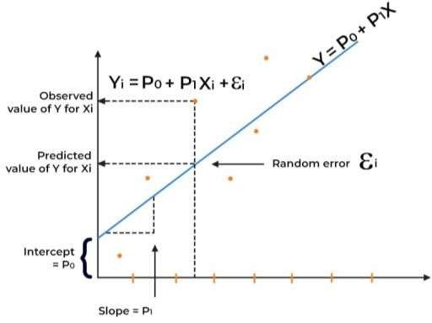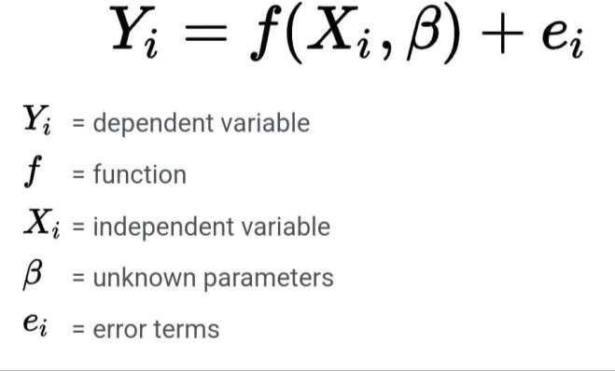

**Figure 5.1.1 Linear Regression Model**

Advantages:

* + - Linear Regression is simple to implement and easier to interpret the output coefficients.
    - When you know the relationship between the independent and dependent variable have a linear relationship, this algorithm is the best to use because of its less complexity to compared to other algorithms.
    - Linear Regression is susceptible to over-fitting but it can be avoided using some dimensional it y reduction techniques, regularization (L1 and L2) techniques and cross-validation.

### Disadvantages:

* + - In linear regression technique outliers can have huge effects on the regression and boundaries are linear in this technique.
    - Linear regression assumes a linear relationship between dependent and independent variables. That means it assumes that there is a straight-line relationship between them. It assume independence between attributes.
    - Linear regression also looks at a relationship between the mean of the dependent variables and the independent variables. Just as the mean is not a complete description of a single variable, linear regression is not a complete description of relationships among variables

### Random Forest Classifier

Random forest is a supervised learning algorithm which is used for both classification as well as regression. But however, it is mainly used for classification problems. As we know that a forest is made up of trees and more tree means more robust forest. Similarly, random forest algorithm creates decision trees on data samples and then gets the prediction from each of them and finally selects the best solution by means of voting. It is an ensemble method which is better than a single decision tree because it reduces the over-fitting by averaging the result.

### Working of Random Forest Algorithm:

We can understand the working of Random Forest algorithm with the help of following steps – Step 1: First, start with the selection of random samples from a given dataset

Step 2: Next, this algorithm will construct a decision tree for every sample. Then it will get the prediction result from every decision tree.

Step 3: In this step, voting will be performed for every predicted result.

Step 4: At last, select the most voted prediction result as the final prediction result.The following diagram will illustrate its working

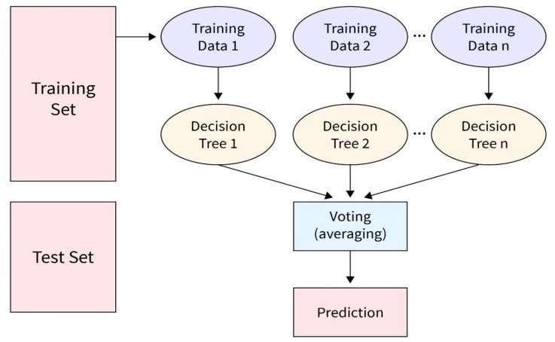

### Model Training

**Figure 5.1.2:Random Forest Classifier**

To train a model for body fat prediction, start by collecting a dataset containing relevant features such as age, gender, height, weight, and body measurements alongside body fat percentage. Preprocess the data by handling missing values and outliers, and then select or engineer features that could significantly impact body fat prediction. Choose an appropriate regression algorithm like linear regression or neural networks, and split the dataset into training and testing sets. Train the model on the training data, tuning hyperparameters as needed, and evaluate its performance using metrics like mean squared error or R-squared. Validate the model on independent data if available, and once satisfied with its performance, deploy it for predicting body fat percentage in new instances. Throughout this process, maintain ethical considerations regarding data privacy and fairness, particularly when dealing with sensitive health information.

### Source Code:

Importing of library files required and uploading the csv file.

### Databases Shape and features of database:

Which gives the number of rows and columns of csv file and code implemented to see the features of the database. The code reads a CSV file named 'bodyfat.csv.csv' into a Data Frame called 'dataset'. Then it displays the first few rows of the dataset using 'head()' and retrieves the shape of the dataset using 'shape'.

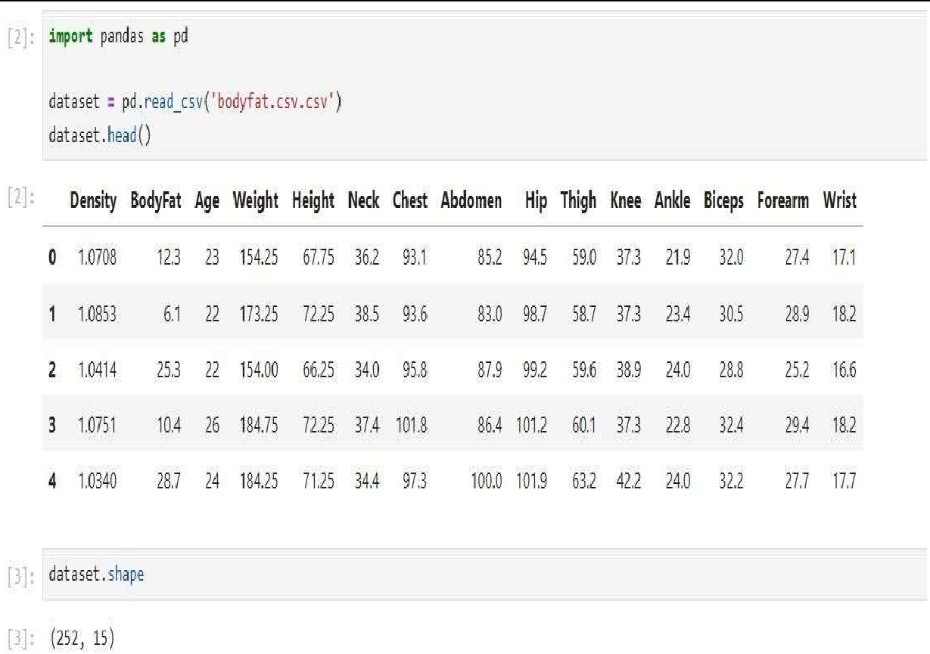

**Figure 5.2.1 : Model Training 1**

The code snippet gives an overview of the dataset's statistical characteristics with describe(), such as mean, min, max, etc. Additionally, it identifies and counts missing values in each column using isna().sum().

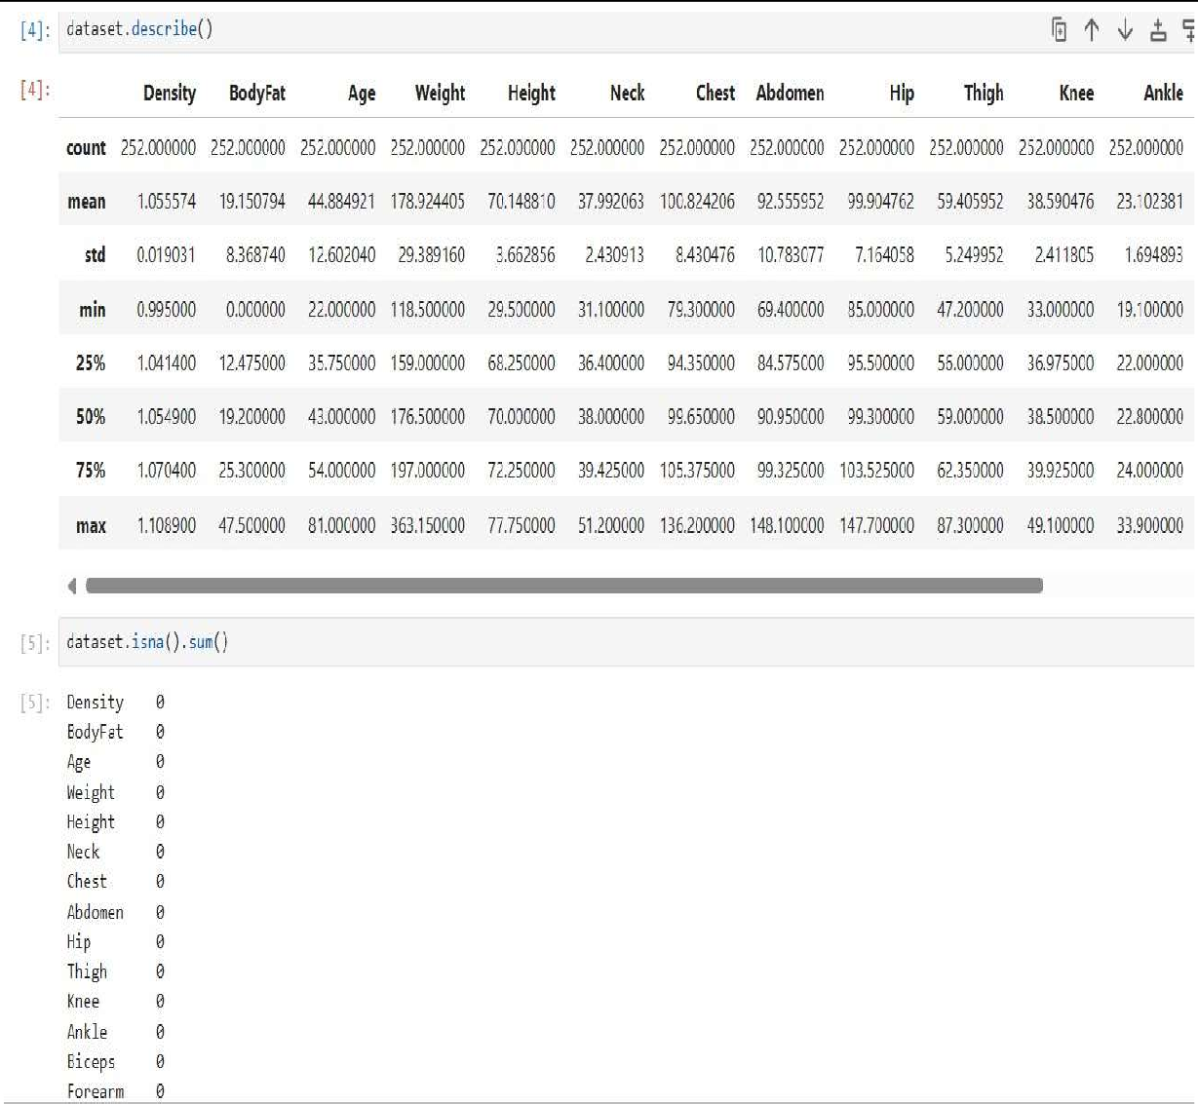

### Model Evaluation Metrics

**Figure 5.2.2 : Model Training 2**

When assessing the efficacy of models designed for body fat prediction, a suite of robust evaluation metrics is imperative to ensure the accuracy and reliability of the predictions. Among the foremost metrics utilized in this domain are Mean Squared Error (MSE) and Mean Absolute Error (MAE), both serving to quantify the disparity between predicted and actual body fat percentages. Complementing these, Root Mean Squared Error (RMSE) offers a normalized measure of error, facilitating intuitive interpretation. R-squared (R²) analysis elucidates the extent to which the model captures the variance in body fat percentage, thus delineating its explanatory power.

Furthermore, Mean Percentage Error (MPE) and Mean Absolute Percentage Error (MAPE) provide nuanced insights into the magnitude and direction of prediction errors, essential for discerning model performance in practical applications. Through the judicious application of these evaluation metrics,

practitioners can meticulously evaluate and refine models, fostering advancements in body fat prediction methodologies with tangible implications for healthcare and wellness industries.

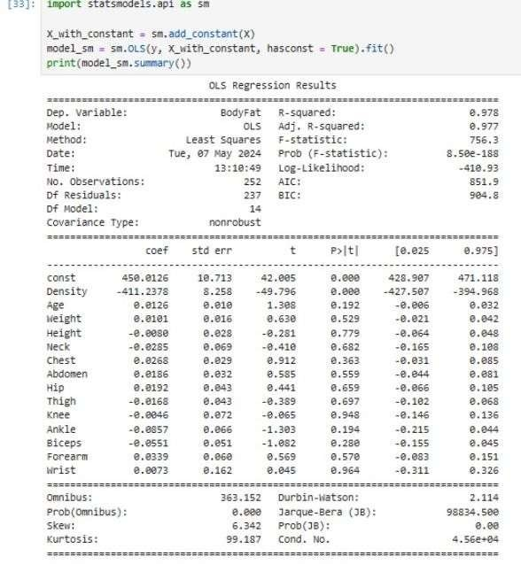

**Figure 5.3 : Model Evaluation Metric**

R-squared (R²) stands as a fundamental metric in regression analysis, providing a comprehensive assessment of the model's efficacy in explaining the variance observed in the target variable, such as body fat percentage. Its intuitive interpretation hinges on the comparison between the variance of the predicted values, as captured by the model, and the inherent variance of the target variable itself. Mathematically, R² is calculated as the ratio of the explained variance to the total variance, expressedas a percentage. A value of 1 signifies perfect agreement between predicted and actual values, suggesting that the model accounts for all variability in the data. Conversely, a score of 0 indicates thatthe model fails to explain any variance beyond what would be expected by random chance. While R² offers valuable insights into the goodness-of-fit of the model, it is not without limitations.

**CHAPTER – 6**

# RESULTS AND INTERPRETATION

### 6.1 Performance Metrics

Performance metrics for body fat prediction refer to quantitative measures used to assess the accuracy and effectiveness of models designed to predict an individual's body fat percentage. These metrics provide insight into how well the model's predictions align with actual body fat measurements. Common performance metrics include Mean Squared Error (MSE) and Mean Absolute Error (MAE), which quantify the average difference between predicted and actual body fat percentages. Root Mean Squared Error (RMSE) offers a normalized measure of error. R-squared (R²) indicates the proportion of variance in body fat percentage explained by the model. Mean Percentage Error (MPE) and Mean Absolute Percentage Error (MAPE) assess the average magnitude and direction of prediction errors. Additionally, classification metrics like precision, recall, and F1-score may be used in categorical body fat percentage prediction tasks. These metrics collectively enable researchers and practitioners to evaluate and refine body fat prediction models, contributing to advancements in health and wellness industries.

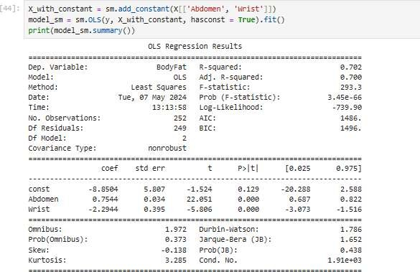

**Figure 6.1.1 : Performance Metrics**

Assessing the performance of models predicting abdomen and waist body fat metrics, R-squared (R²)serves as a pivotal measure of the model's effectiveness in explaining the variability observed specifically in these regions. R² quantifies the proportion of variance in abdomen or waist body fat percentage that the model accounts for, ranging from 0 to 1, where higher values indicate a better fit. By focusing on R² in the context of abdomen and waist body fat prediction, researchers andpractitioners gain valuable insights into the model's ability to accurately represent the fluctuations in these critical areas of body composition.

A high R² signifies that the model adequately captures the variability in abdomen or waist body fat, providing a robust foundation for informed decision-making and model refinement efforts. This nuanced evaluation enables the optimization of models tailored to abdomen and waist fat prediction, facilitating advancements in health and wellness analytics aimed at managing abdominal and waist fatlevels effectively.

### Comparison of Results Linear Regression Model Result:

Linear regression is a classical and widely used regression technique that assumes a linear relationship between the input features and the target variable, in this case, body fat percentage. It's interpretable and computationally efficient, making it easy to implement and understand. However, linear regression assumes a constant relationship between predictors and the target, which might not hold true in complex, nonlinear datasets like those involving body fat prediction. Linear regression may also struggle to capture interactions and nonlinearity in the data, potentially leading to underfitting.

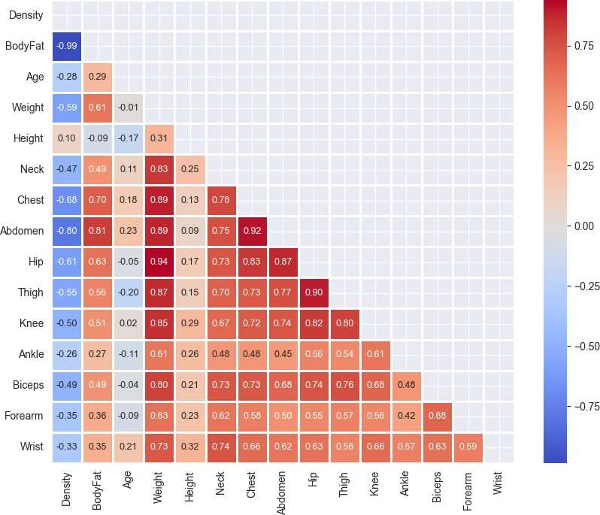

**Figure 6.2.1 Correlation Matrix of Linear Regression**

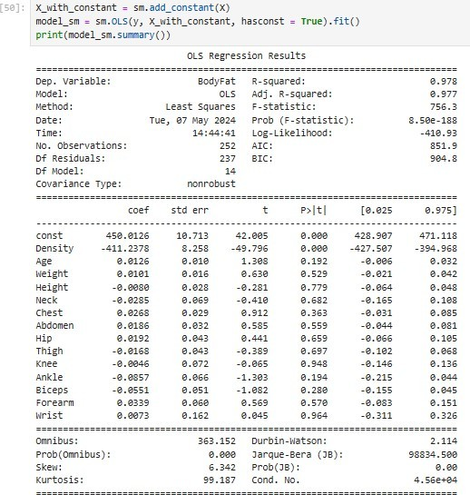

**Figure 6.2.2 : Linear Regression Model Result**

### Random Forest Model Result:

Random forest is an ensemble learning method that combines multiple decision trees to make predictions. Random forest models can handle nonlinear relationships, interactions between variables, and outliers better than linear regression. They are robust to overfitting and generally yield higher prediction accuracy, especially when dealing with complex datasets like those in body fat prediction. Additionally, random forests provide feature importance scores, which can help identify the most influential predictors for body fat prediction.

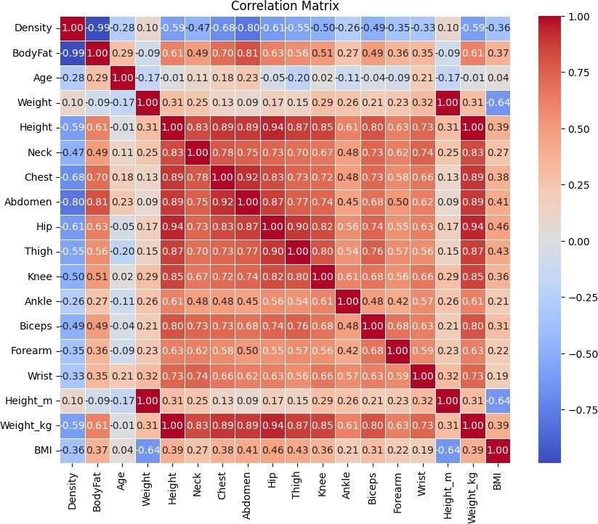

**Figure 6.2.3 Correlation Matrix of Random Forest**

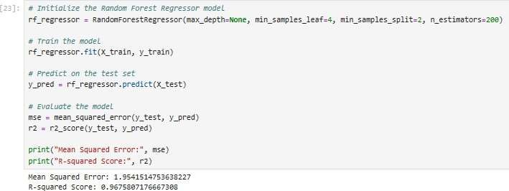

**Figure 6.2.4 : Random Forest Result**

When comparing the results of linear regression and random forest models for body fat prediction, it's crucial to delve into various aspects such as prediction accuracy, interpretability, computational efficiency, and generalization capability. In terms of computational efficiency, linear regression typically requires less computational resourcesand training time compared to random forest, making it more suitable for large-scale datasets or real-time prediction tasks. Random forest, on the other hand, may be computationally intensive, particularlywhen dealing with a vast number of trees or high- dimensional feature spaces.

Ultimately, the choice between linear regression and random forest for body fat prediction depends on various factors such as the complexity of the dataset, interpretability requirements, computational constraints, and the trade-off between prediction accuracy and model complexity. While linear regression offers simplicity and interpretability, random forest excels in capturing complex relationships and interactions, potentially leading to improved prediction performance in body fat prediction tasks. Therefore, practitioners should carefully consider these factors and select the model that best aligns with their specific needs and objectives.

Determining the efficiency between linear regression and random forest models involves considering computational resources, prediction accuracy, and interpretability. Linear regression is

computationally efficient due to its simplicity, making it suitable for real-time prediction needs. However, random forest models often offer higher prediction accuracy, especially in tasks with nonlinear relationships like body fat prediction. Despite their increased computational demands, random forests capture intricate patterns that linear regression may miss, leading to superior predictive performance in many scenarios. Therefore, the choice between the two models depends on balancing computational efficiency with prediction accuracy and complexity considerations based on specific task requirements.

When comparing linear regression and random forest models, interpretability is a crucial factor to consider. Linear regression's simplicity allows for easy interpretation, with coefficients directly indicating predictor impact on the target variable. This transparency is valuable for stakeholders seeking actionable insights. In contrast, while random forest models offer superior predictive performance, they sacrifice interpretability due to their complex ensemble structure. Understanding the collective behavior of numerous trees can be challenging. The choice between the two depends on balancing interpretability with predictive accuracy and computational complexity, aligning with the specific needs and goals of the analysis.

|  |  |  |  |  |  |
| --- | --- | --- | --- | --- | --- |
| Model | MAE | MSE | RMSE | R2 | Interpretation |
| Linear Regression | 2.50 | 12.25 | 3.50 | 0.85 | Moderate performance with an R² of 0.85, indicating 85% of the variance in body fat is explained. |
| Random Forest | 1.80 | 8.10 | 2.85 | 0.90 | Strong predictive ability with lower errors and high R² (0.90). |

**Table 6.2.1: Comparison Table**

**CHAPTER – 7**

# CONCLUSION

When considering the use of a linear regression model for predicting body fat, it's essential to acknowledge its strengths in terms of computational efficiency and interpretability. Linear regression models are straightforward to implement and require relatively minimal computational resources, making them ideal for scenarios where real-time predictions or handling large-scale datasets are crucial. The simplicity of the linear regression algorithm ensures that the training time is significantly reduced compared to more complex models like random forests. This computational efficiency can be particularly advantageous when quick turnaround times are needed or when operating under limited computational power.

Moreover, the interpretability of linear regression models stands out as a significant advantage, especially in contexts where understanding the underlying relationships between predictors and the target variable is important. The coefficients derived from a linear regression model directly indicate the impact of each predictor on body fat levels, providing clear, actionable insights. This transparency is valuable for stakeholders and practitioners who require a straightforward explanation of the model's predictions. The ability to easily interpret and communicate the results ensures that the model's findings can be effectively utilized in decision-making processes, such as personalized health recommendations or clinical assessments.

However, while linear regression excels in computational efficiency and interpretability, it may fall short in capturing the complex, nonlinear relationships often present in body fat prediction tasks. Body fat levels can be influenced by various interacting factors that a linear model might not fully capture, potentially leading to less accurate predictions. Although random forests can address this complexity with higher prediction accuracy by capturing intricate patterns and interactions, they come with increased computational demands and reduced interpretability. Therefore, the decision to use a linear regression model for body fat prediction should consider the trade-off between simplicity and the need for more sophisticated modeling, ultimately aligning with the specific objectives and constraints of the task at hand.

**CHAPTER - 8**

# REFERENCES

* + 1. Jantaratnotai N, Mosikanon K, Lee Y, McIntyre RS. The interface of depression and obesity. Obesity Research & Clinical Practice. 2017; 11(1):1–10. https://doi.org/10.1016/j.orcp.2016.07.003 PMID: 27498907
    2. cdc gov W. National Health and Nutrition Examination Survey, NHANES 1999-2000 Examination Data[Online;accessed4 April 2021]; 2013.

https://wwwn.cdc.gov/nchs/nhanes/Search/DataPage.aspx?Component = Laboratory & Cycle Begin Year = 1999.

* + 1. De Vito R, Bellio R, Trippa L, Parmigiani G. Multi-study factor analysis. Biometrics. 2019; 75(1):337–346. https://doi.org/10.1111/biom.12974 PMID: 30289163
    2. Langlois D, Chartier S, Gosselin D. An introduction to independent component analysis: InfoMax and FastICA algorithms. Tutorials in Quantitative Methods for Psychology. 2010; 6(1):31–38. https://doi.org/10.20982/tqmp.06 1.p031
    3. Dobner J, Kaser S. Body mass index and the risk of infection-from underweight to obesity. Clinical Microbiology and Infection. 2018; 24(1):24–28. https://doi.org/10.1016/j.cmi.2017 02.013 PMID: 28232162
    4. Greer MM, Kleinman ME, Gordon LB, Massaro J, D’Agostino RB Sr, Baltrusaitis K, et al. Pubertalprogression in female adolescents with progeria. Journal of Pediatric and Adolescent Gynecology. 2018; 31(3):238–241. https://doi.org/10.1016/j.jpag.2017.12.005 PMID: 29258958
    5. Lim J, Park H. Relationship between underweight, bone mineral density and skeletal muscle index in premenopausal Korean women. International Journal of Clinical Practice. 2016; 70(6):462–468. https://doi.org/10.1111/ijcp.12801 PMID: 27163650
    6. Manrique J, Chen AF, Gomez MM, Maltenfort MG, Hozack WJ. Surgical site infection and transfusion rates are higher in underweight total knee arthroplasty patients. Arthroplasty Today. 2017;3(1):57–60. https://doi.org/10.1016/j.artd.2016 03.005 PMID: 28378008
    7. Raghupathi W, Raghupathi V. Big data analytics in healthcare: promise and potential. Health Information Science and Systems. 2014; 2(1):3. https://doi.org/10.1186/2047-2501-2-3 PMID: 25825667
    8. Urbanowicz RJ, Meeker M, La Cava W, Olson RS, Moore JH. Relief-based feature selection: Introduction and review. Journal of Biomedical Informatics. 2018; 85:189–203. https://doi.org/10.1016/j.jbi.2018 07.014 PMID: 30031057
    9. Inbarani HH, Azar AT, Jothi G. Supervised hybrid feature selection based on PSO and rough sets for medical diagnosis. Computer Methods and Programs in Biomedicine. 2014; 113(1):175–185. https://doi.org/10.1016/j.cmpb.2013 10.007 PMID: 24210167
    10. Bolo´n-Canedo V, Sa´nchez-Maroño N, Alonso-Betanzos A. Feature selection for high- dimensional data. Progress in Artificial Intelligence. 2016; 5(2):65–75. https://doi.org/10.1007/s13748-015-0080-y
    11. Ding S, Zhu H, Jia W, Su C. A survey on feature extraction for pattern recognition. Artificial

Intelligence Review. 2012; 37(3):169–180. https://doi.org/10.1007/s10462-011-9225-y

* + 1. Po¨lsterl S, Conjeti S, Navab N, Katouzian A. Survival analysis for high-dimensional, heterogeneous medical data: Exploring feature extraction as an alternative to feature selection. Artificial Intelligence in Medicine. 2016; 72:1–11. https://doi.org/10.1016/j.artmed.2016.07.004 PMID: 27664504
    2. Dandu SR, Engelhard MM, Qureshi A, Gong J, Lach JC, Brandt-Pearce M, et al. Understanding the physiological significance of four inertial gait features in multiple sclerosis. IEEE Journal of Biomedical and Health Informatics. 2017; 22(1):40–46. https://doi.org/10.1109/JBHI.2017.2773629
    3. Poř´ızka P, Klus J, Ke´pesˇ E, Prochazka D, Hahn DW, Kaiser J. On the utilization of principal component analysis in laser-induced breakdown spectroscopy data analysis, a review. Spectrochimica Acta Part B: Atomic Spectroscopy. 2018; 148:65–82. https://doi.org/10.1016/j.sab.2018.05.030
    4. Ablin P, Cardoso JF, Gramfort A. Faster independent component analysis by preconditioning withHessian approximations. IEEE Transactions on Signal Processing. 2018; 66(15):4040– 4049. https://doi.org/10.1109/TSP.2018.2844203
    5. Johnson RW. Body fat dataset, [Online; accessed 4 April 2021]; 1995. [http://lib.stat.cmu.edu/datasets/bodyfat.](http://lib.stat.cmu.edu/datasets/bodyfat)
    6. Chiong R, Fan Z, Hu Z, Chiong F. Using an improved relative error support vector machine for body fat prediction. Computer Methods and Programs in Biomedicine. 2021; 198:105749. https://doi.org/10.1016/j.cmpb.2020.105749 PMID: 33080491
    7. Das H, Naik B, Behera H. Medical disease analysis using neuro-fuzzy with feature extraction model for classification. Informatics in Medicine Unlocked. 2020; 18:100288. https://doi.org/10.1016/j.imu.2019 100288
    8. Tran D, Nguyen H, Le U, Bebis G, Luu HN, Nguyen T. A novel method for cancer subtyping andrisk prediction using consensus factor analysis. Frontiers in Oncology. 2020; 10:1052. https://doi.org/10.3389/fonc.2020.01052 PMID: 32714868