Chatbot Deployment with IBM Cloud Watson Assistant:

Creating a helpful virtual guide using IBM Cloud Watson Assistant for messaging platforms like Facebook Messenger and Slack involves several steps. Here’s a high-level overview of how you can design and implement such a virtual guide:

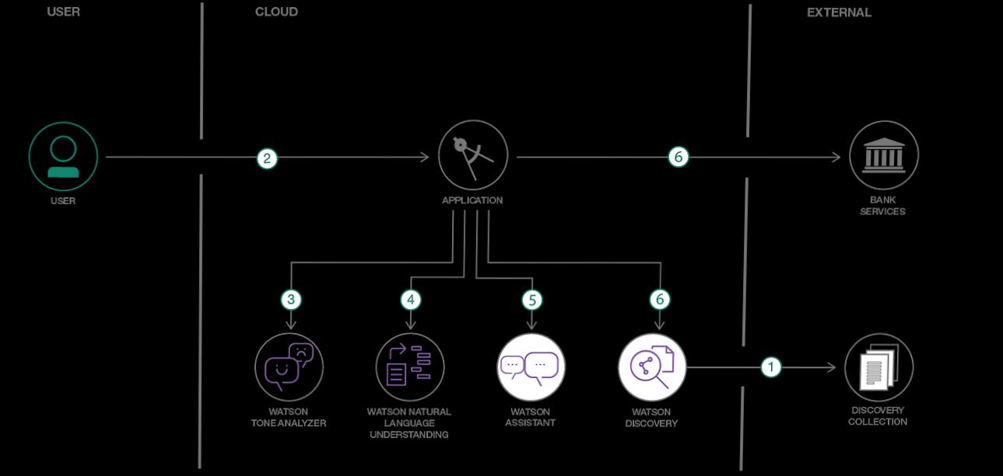

THE COMPLETE STEP FOR THE DESIGN:

Step 1: Define the Purpose and Goals

•Clearly define the purpose of your virtual guide. What problems will it solve for users, and what goals will it achieve?

•Identify the target audience and the specific questions or issues they may have.

Step 2: Set Up IBM Cloud Watson Assistant

•Create an IBM Cloud account if you don’t have one.

•Create a new instance of Watson Assistant and configure it.

Step 3: Design Conversation Flows

•Plan out the conversation flows based on user intents and possible interactions.

•Consider using IBM Watson’s Natural Language Understanding (NLU) to improve intent recognition.

•Create a welcome message to greet users and set the tone for the conversation.

Step 4: Train the Assistant

•Train the virtual guide by providing sample user queries and defining appropriate responses.

•Use intents, entities, and dialog nodes to capture different topics and scenarios.

•Continuously improve and train the assistant based on user interactions and feedback.

Step 5: Integration with Messaging Platforms

•For Facebook Messenger and Slack, you will need to set up integrations. Each platform has its own developer portal for creating chatbots.

•Follow the platform-specific documentation to integrate your Watson Assistant with Facebook Messenger and Slack.

Step 6: Implement FAQs and Information Retrieval

•Create dialog nodes for frequently asked questions (FAQs) and provide accurate answers.

•Implement a search feature using Watson Discovery or a similar service to retrieve information from documents or databases.

Step 7: Rich Media and Interactions

•Enhance user experience by supporting rich media like images, videos, and interactive elements.

•Create dialog nodes that can handle multimedia content and interactions.

Step 8: Error Handling and Escalation

•Implement error handling to gracefully handle user queries that the assistant can’t understand.

•Provide a way for users to escalate to a human agent when needed, such as a live chat option.

Step 9: Test and Iterate

•Test the virtual guide thoroughly to ensure it provides accurate responses and a smooth user experience.

•Collect user feedback and analytics to identify areas for improvement and iterate on the conversation flows.

Step 10: Launch and Promote

•Once your virtual guide is ready, launch it on Facebook Messenger and Slack.

•Promote the availability of the virtual guide to your target audience through various channels.

Step 11: Monitor and Maintain

•Continuously monitor the performance of your virtual guide.

•Use analytics to track user interactions, identify popular queries, and make improvements accordingly.

•Keep the content up to date to ensure that users receive accurate information.

By following these steps, you can create a helpful virtual guide using IBM Cloud Watson Assistant that offers a friendly conversational experience, empowers users with quick access to information, and fosters meaningful connections through messaging platforms like Facebook Messenger and Slack

Project Design for Virtual Guide on Facebook Messenger and Slack:

Objective:

Develop a virtual guide that provides effective assistance to users.

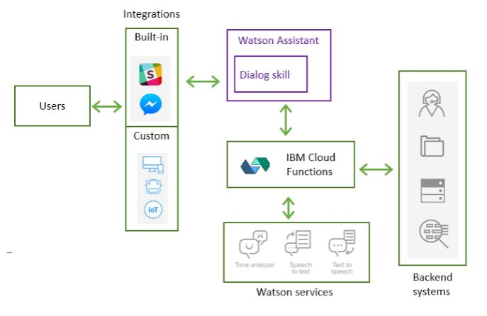

Platform Scope:

The virtual guide will be accessible on popular messaging platforms: Facebook Messenger and Slack.

Functionalities:

1. Information Delivery:

The virtual guide will be capable of providing valuable and relevant information to users. This includes general information, explanations, updates, and more.

1. FAQ Handling:

The virtual guide will address frequently asked questions (FAQs) and provide clear and concise responses. It should also be able to guide users to relevant resources if needed.

1. Conversational User Experience:

The chatbot will engage users in a conversational and friendly manner, creating a positive and user-centric experience.

Architecture:

The project’s architecture will consist of the following components:

1. IBM Cloud Watson Assistant:

Watson Assistant will serve as the core of the virtual guide, handling natural language understanding and dialog management.

1. Knowledge Base:

A comprehensive knowledge base will be created, containing FAQs, informational content, and responses.

1. Platform Integration:

Integration with Facebook Messenger and Slack will be implemented following platform-specific guidelines.

1. User Interface:

A user-friendly interface will be designed to facilitate user interactions and provide a visually appealing experience.

User Flow:

Users will initiate conversations with the virtual guide on Facebook Messenger or Slack.

The virtual guide will understand user intents and provide relevant responses based on the knowledge base.

In cases of FAQs, it will respond with answers or direct users to relevant resources.

The conversation will be designed to feel conversational, engaging, and user-friendly.

Testing and Feedback:

Extensive testing will be conducted to identify and address any issues.

A feedback loop will be established to gather user feedback and make iterative improvements.

Scaling and Maintenance:

The project will be designed to handle increased traffic as the user base grows.

Regular updates will be made to keep information and responses up-to-date.

Completion:

The project will be considered complete when the virtual guide effectively assists users on Facebook Messenger and Slack, providing valuable information and addressing FAQs in a conversational manner.

This design provides a comprehensive overview of the project’s objectives, functionalities, architecture, and user interactions, ensuring that the virtual guide is user-centric and efficient in assisting users on messaging platforms.