**Group 5 Team 4: Sensor Manager Module**

**Report**

## What we have built

### Connecting to OneM2M

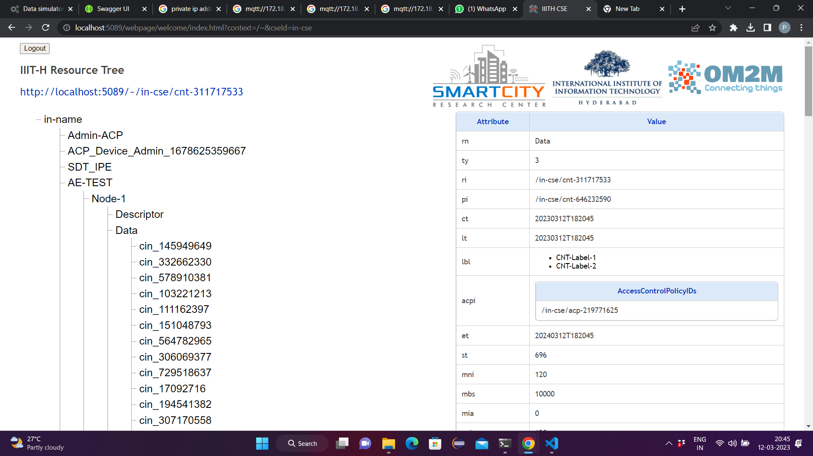

### Taking Data from ThingsBoard

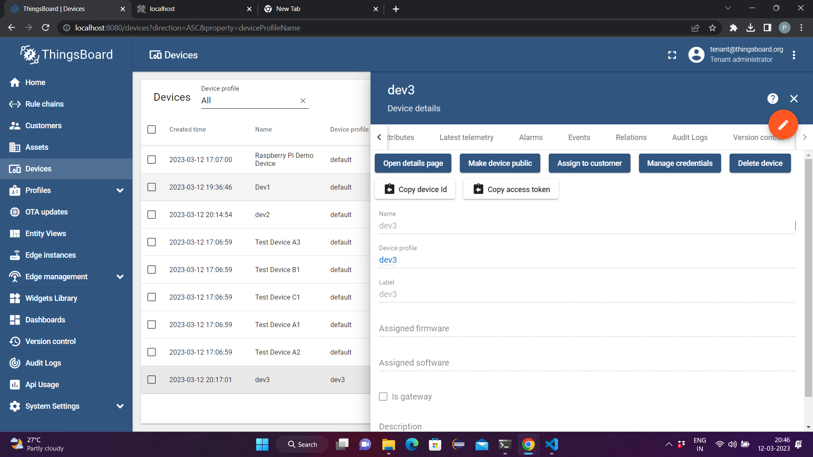

### APIs:

1. **/upload_sensor/sensor_type :** uploading sensor type
   1. Method: POST
   2. BODY

**{**

**"app_id": "app_1",**

**"sensor_type": [**

**{**

**"sensor_type": "temperature",**

**"sensor_type_id": 1**

**},**

**{**

**"sensor_type": "humidity",**

**"sensor_type_id": 2**

**},**

**{**

**"sensor_type": "air_pressure",**

**"sensor_type_id": 3**

**}**

**]**

**}**

1. **/create_sensor_instance:** registering sensors and their fields
   1. Method: POST
   2. BODY:

**{**

**"sensor_id": "cin_3860158",**

**"fields": [**

**"fieldA",**

**"fieldB",**

**"fieldC"**

**]**

**}**

1. **/upload_sensor_instance:** uploading sensor instance
   1. Method: POST
   2. BODY:

**{**

**"sensor_id": "app1_sensor_1",**

**"sensor_data": [**

**{**

**"sensor_id": "app1_sensor_1",**

**"epoch": "1678626404",**

**"data": "dummy_data"**

**},**

**{**

**"sensor_id": "app1_sensor_1",**

**"epoch": "1678626517",**

**"data": "dummy_data"**

**},**

**{**

**"sensor_id": "app1_sensor_1",**

**"epoch": "1678626505",**

**"data": "dummy_data"**

**},**

**{**

**"sensor_id": "app1_sensor_1",**

**"epoch": "1678626505",**

**"data": "dummy_data"**

**}**

**]**

**}**

1. **/upload_onem2m_data:** uploading data from oneM2M for respective sensor instance
   1. Method: POST
   2. Body:

**{**

**"m2m:cin" : {**

**"rn" : "cin_3860158",**

**"ty" : 4,**

**"ri" : "/in-cse/cin-386015862",**

**"pi" : "/in-cse/cnt-311717533",**

**"ct" : "20230312T191413",**

**"lt" : "20230312T191413",**

**"lbl" : [ "Node-1" ],**

**"st" : 0,**

**"cnf" : "text",**

**"cs" : 20,**

**"con" : "[1678628653, 1, 354]"**

**}**

**}**

**After the mapped sensor data is added**

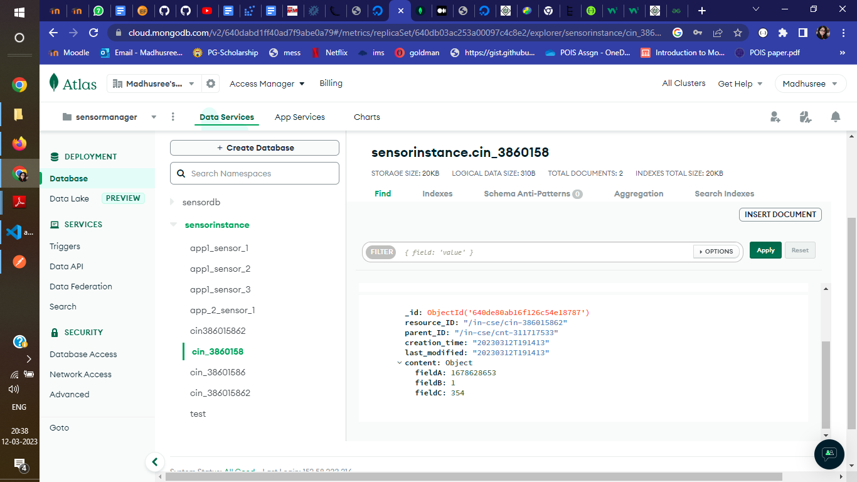

## What did you miss & what is the reason behind it

We created a OM2M instance and Deployed ThingsBoard using Docker on local ,but were not able to establish connectivity between OM2M and ThingsBoard

Approaches we tried

* We used a device simulator implemented using the Mobius M2M implementation. It used mosquitto for MQTT. The sensor data was available but it was not possible to upload on thingsboard.
* We used the smart city lab’s implementation of a simulated device built using Eclipse OM2M. The data was not uploaded to thingsboard. We sent it directly to the platform sensor manager using developed APIs.

Reason:

* Configuring and installing OM2M and Thingsboard instances on local took a long time.
* Could not understand how Thingsboard could be used as a service for relaying data in this scenario.

## Issues you faced

* Configuring OM2M and Installation of Thingsboard on local. It took a long time
* Could not establish Connectivity between things board and OM2M even after trying multiple approaches

## Any Remedial plan, you thought of?

* Creating a dummy sensor instance and sending it’s data to things board using MQTT
* Instead of considering the possibility of a new device registration by user we will be only considering devices which are already registered on thingsboard
* The Platform will be fetching the data from thingsboard using kafka topics
* The registry submodule will only register devices enquired by user which are already registered on Things board