## **GROUP 5 TEAM 4: SENSOR MANAGER**

### **Activities completed (80%)**

1. Setting up OneM2M

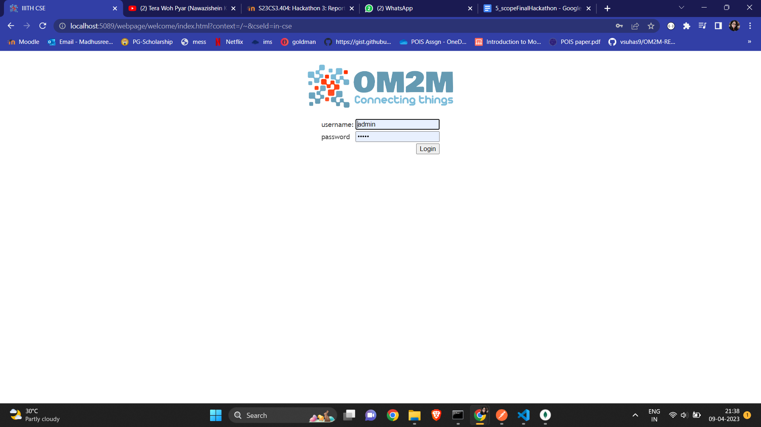

1. Creating devices metadata for the available locations and storing it in database

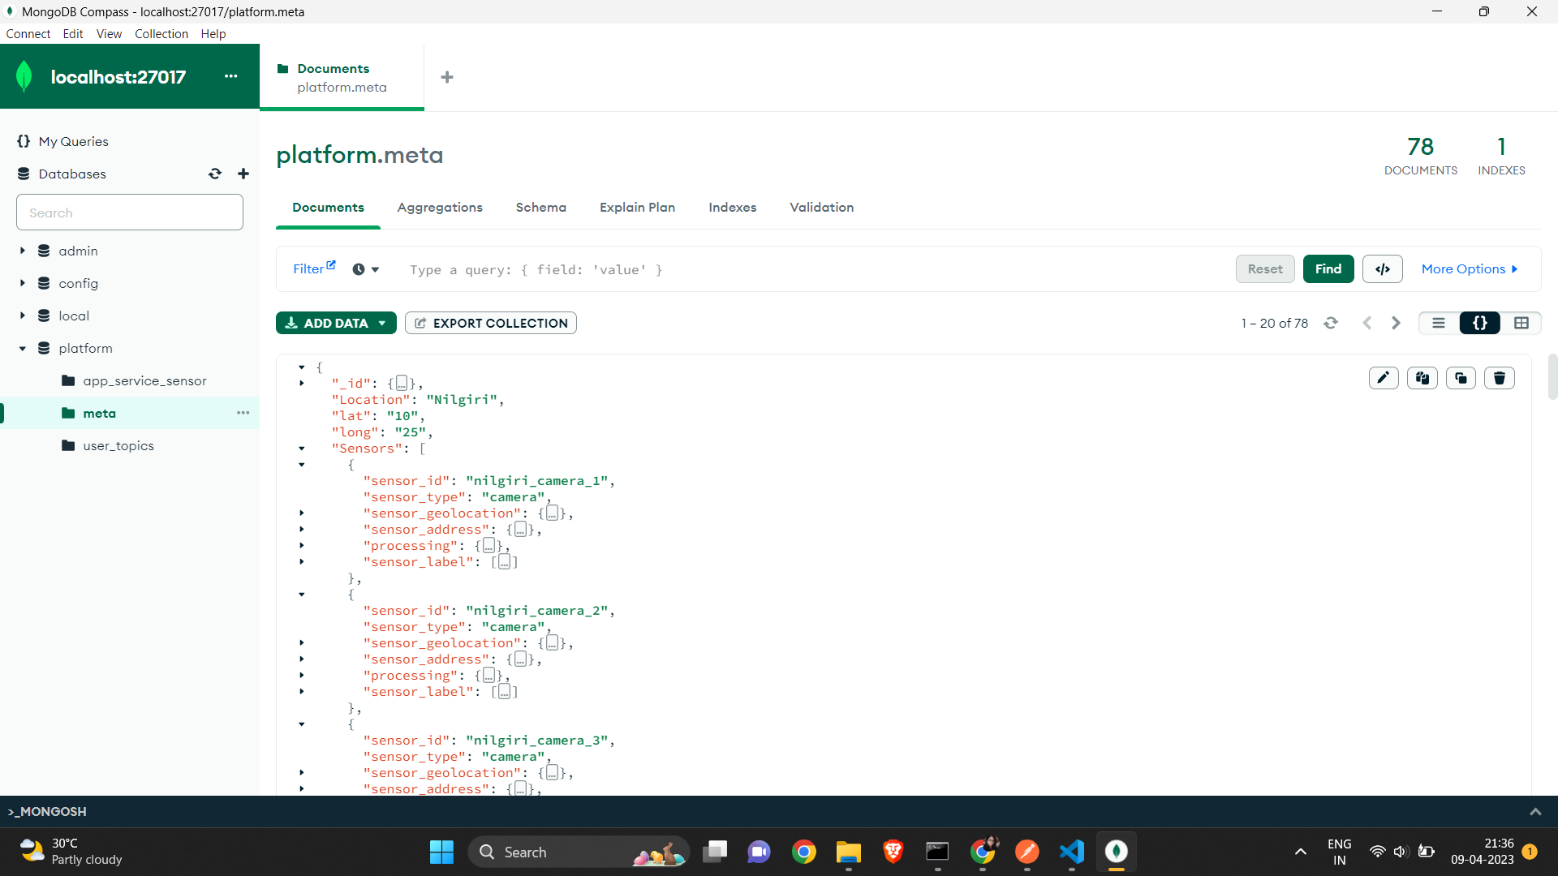

1. Creating the devices accordingly in OneM2M

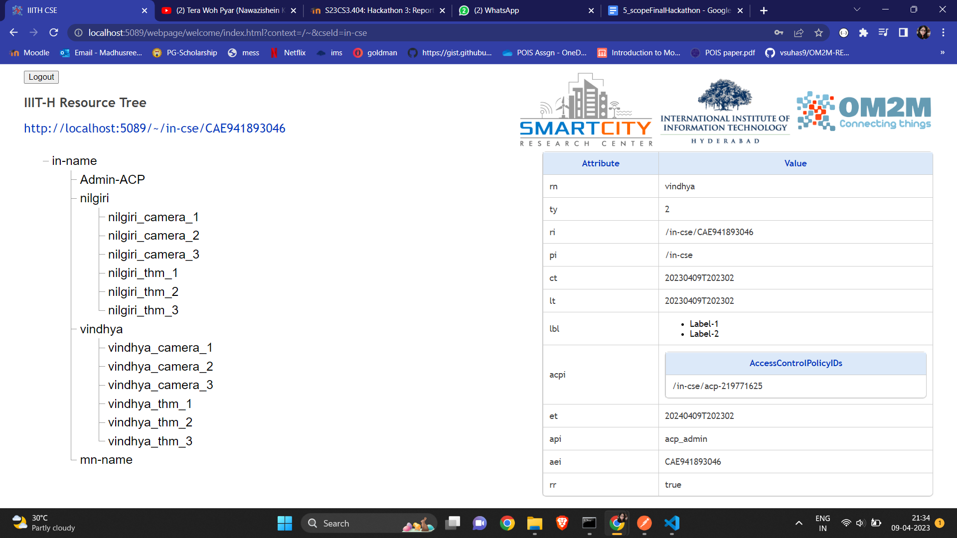

1. Registering sensors sent as json file from App Controller, and allocating sensor instances to the application and storing in database

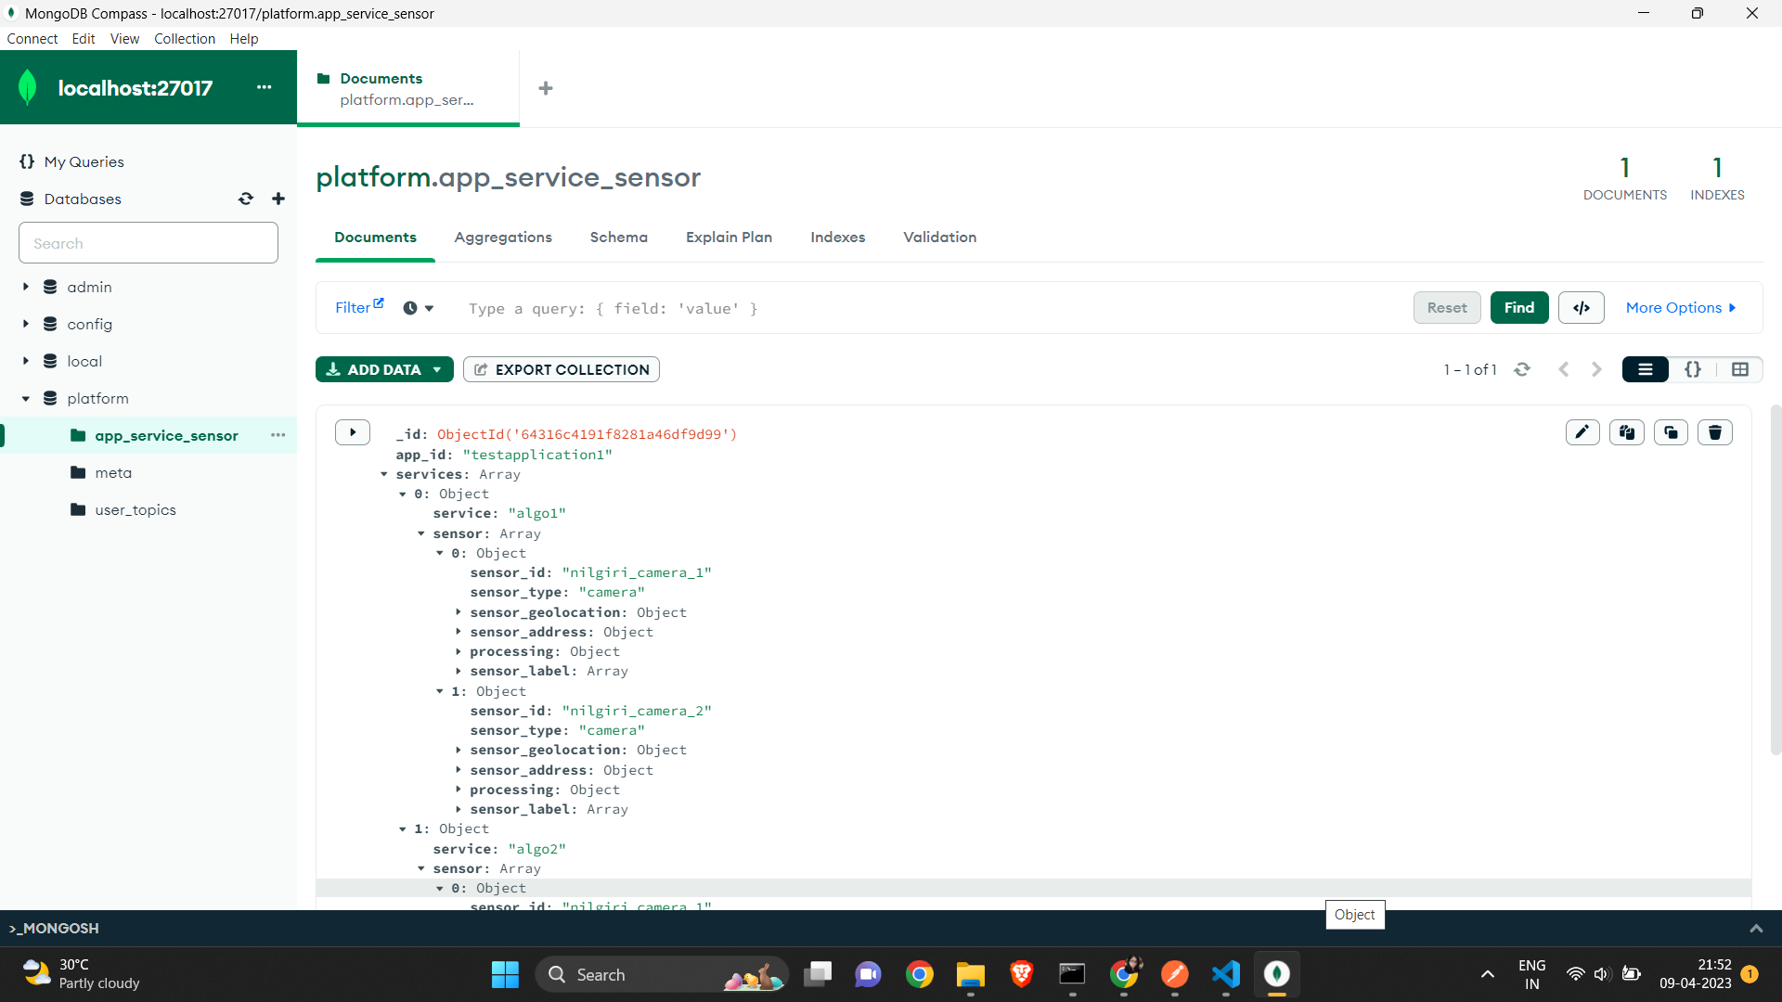

1. Generating mock data and feeding to the devices created in OneM2M

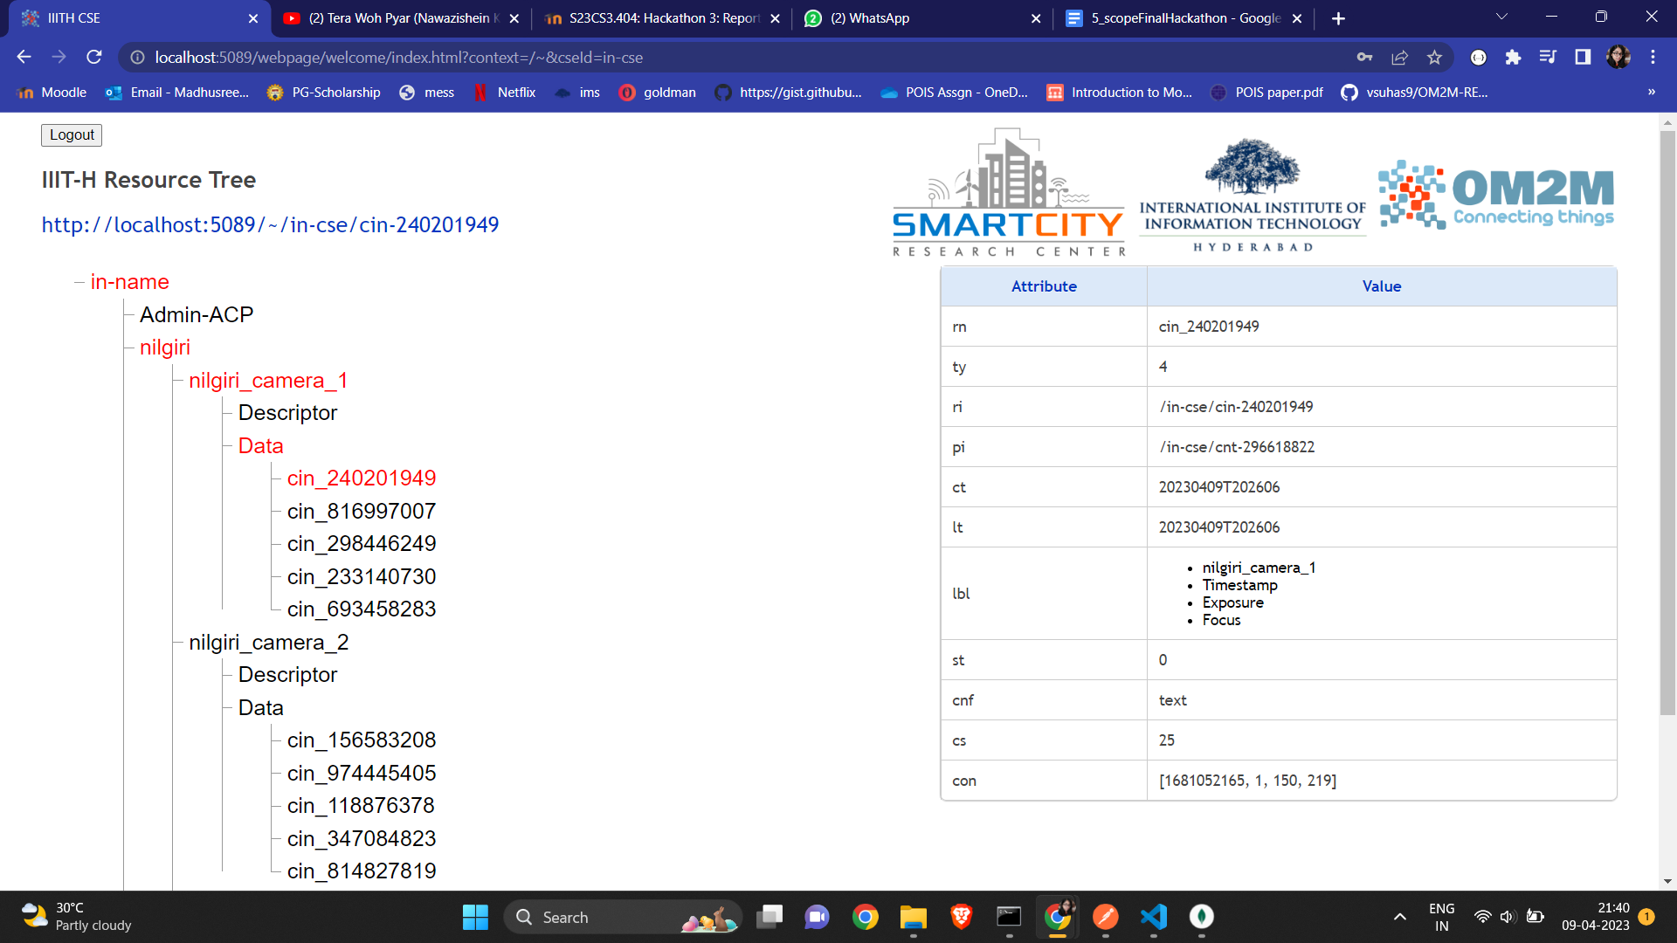

1. Upon feeding data to OneM2M, publishing it in Kafka

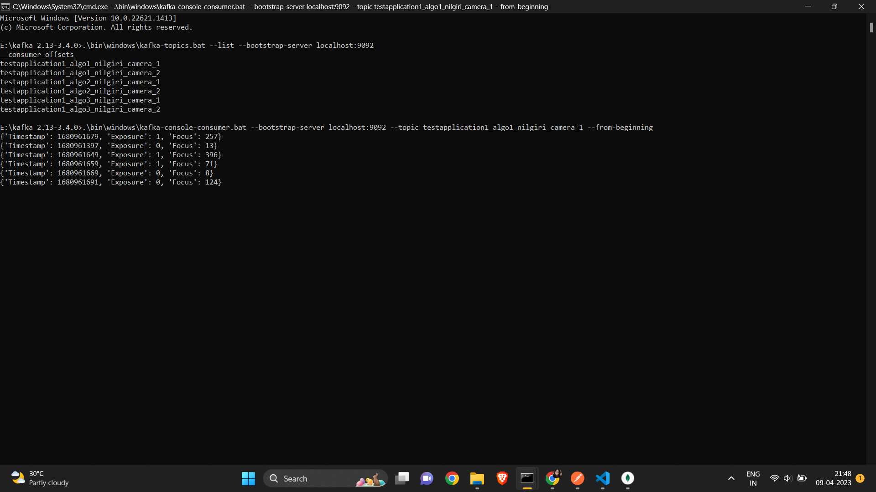

1. Generating live sensor data

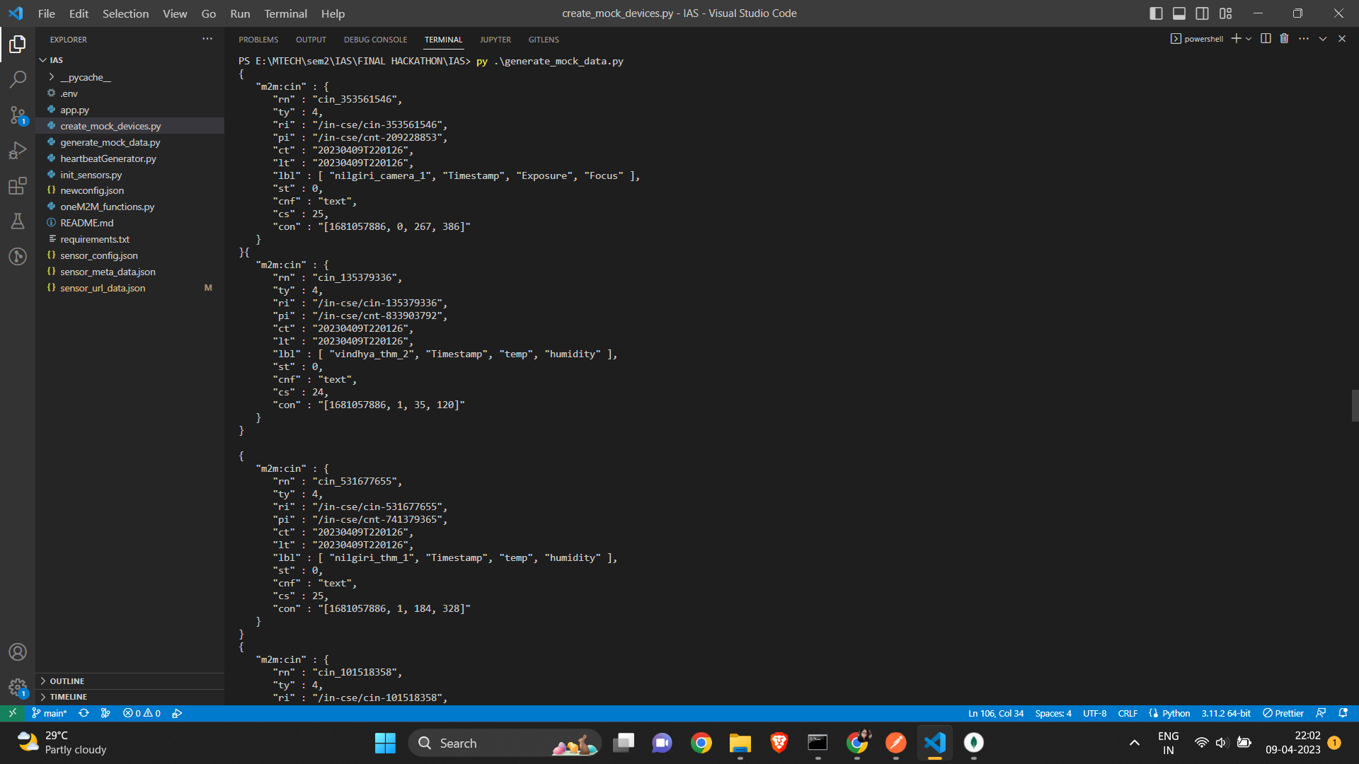

1. Storing sensor data in sensor repository

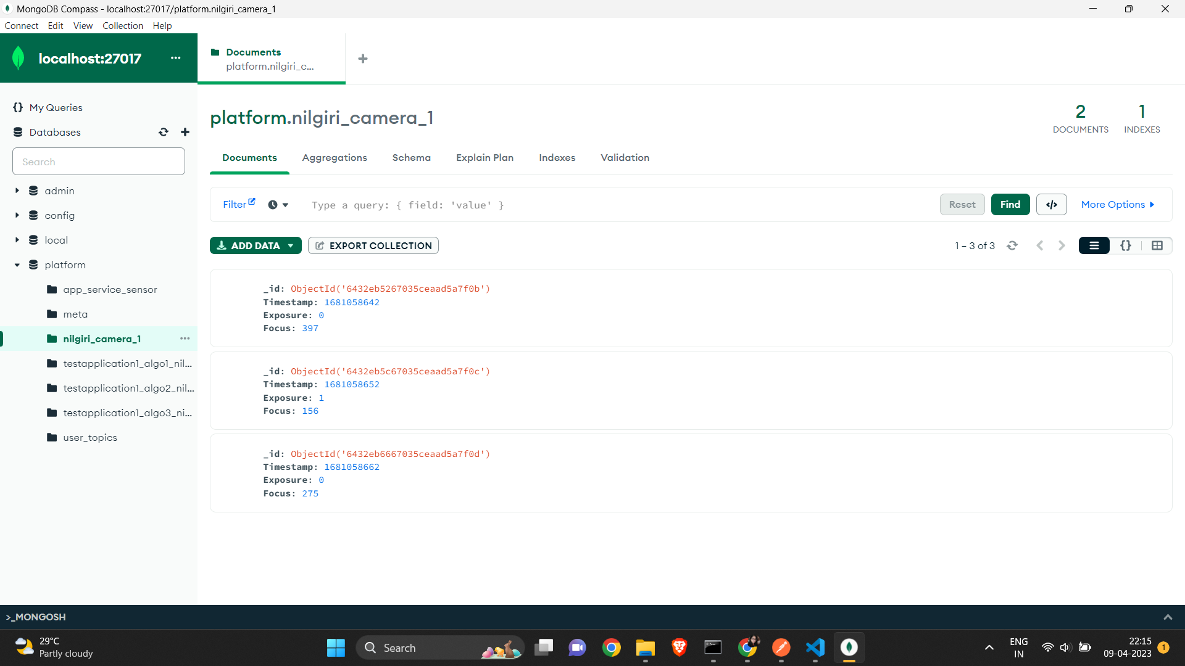

### **Architecture Diagram**

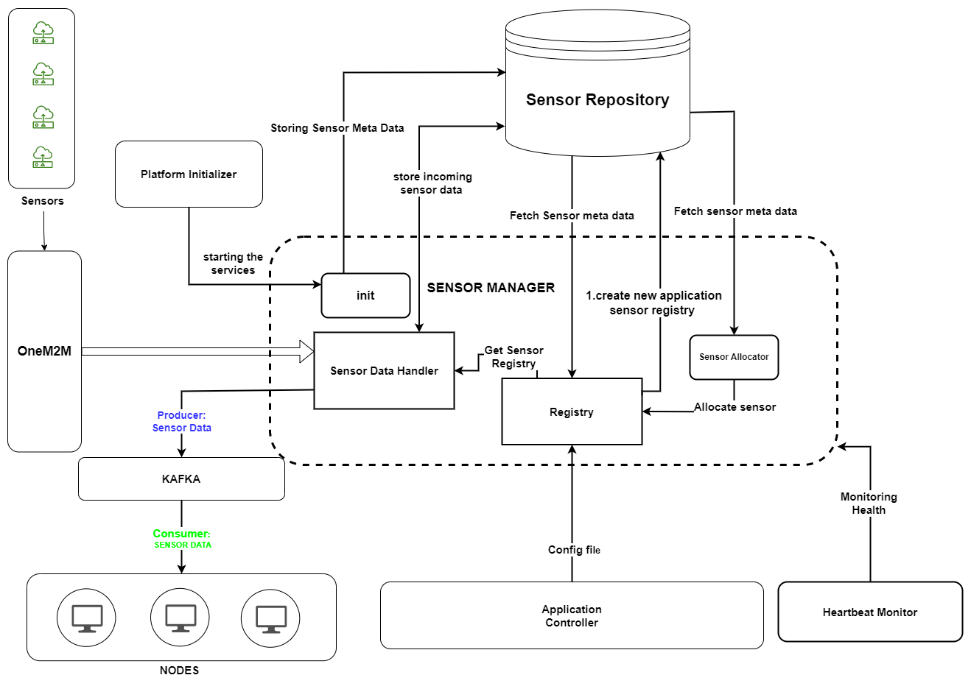

### **Technology Stack**

1. OneM2M
2. Kafka
3. Zookeeper
4. Python
5. MongoDB
6. Flask

### **Issues/ Challenges**

1. Integration with application controller and initializer
2. Confusion in allocating sensors according to nearest geolocation or room number.