# Group 5 Team 4: Sensor Manager Module

## Activities completed: (1/3rd)

1. Setting up the required environment
   1. Docker
   2. OneM2M
   3. ThingsBoard with Kafka and Zookeeper
2. Created Mock Devices using python script
3. Creating resources in OneM2M using API calls
4. Created devices in ThingsBoard and sent dummy data using python script
5. Created APIs
   1. /upload_sensor/sensor_type
   2. /upload_onem2m_data

## II. Module Architecture

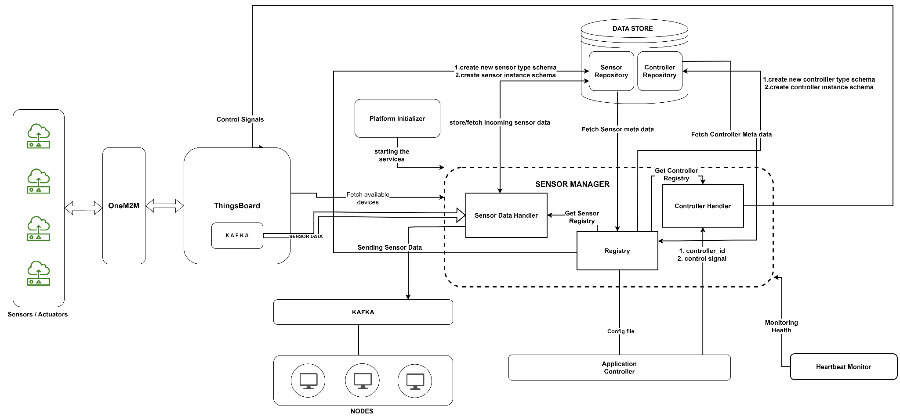

## 

## III. Technology Stack

1. OneM2M
2. Docker
3. ThingsBoard
4. Python
5. Kafka
6. Zookeeper
7. Flask
8. MongoDB

## IV. Week wise plan

| Week 1 - (27.03 to 02.04) | Connecting ThingsBoard and Sensor Manager via Kafka |
| --- | --- |
| Week 2 - (03.04 to 09.04) | Sensor Registration, Processing sensor data, storing in Sensor Registry, Publishing the sensor data in Platform’s Kafka |
| Week 3 - (10.04 to 16.04) | Integrating Sensor Manager with Application Controller, Initializer, Heartbeat Monitor |
| Week 4 - (17.04 to 23.04) | Testing the module, pre-final demo |
| Week 5 - (24.04 to 30.04) | Debugging and final integration |
| Week 6 - (01.05 to 07.05) | Final Demo |

## V. Issues/ Challenges

1. Setting up OneM2M on our device as it has strict requirement of Java 1.8, and faced many errors in setting up in OS other than Windows. start.sh file was throwing errors that we were unable to solve.
2. Sending sensor data from OneM2M to ThingsBoard is challenging as we do not have any prior experience in IOT sensors and handling such data
3. Device incompatibility for installing ThingsBoard as it needs Docker that runs on Windows OS build 18303+