# Group 5 Team 4: Sensor Manager Subsystem

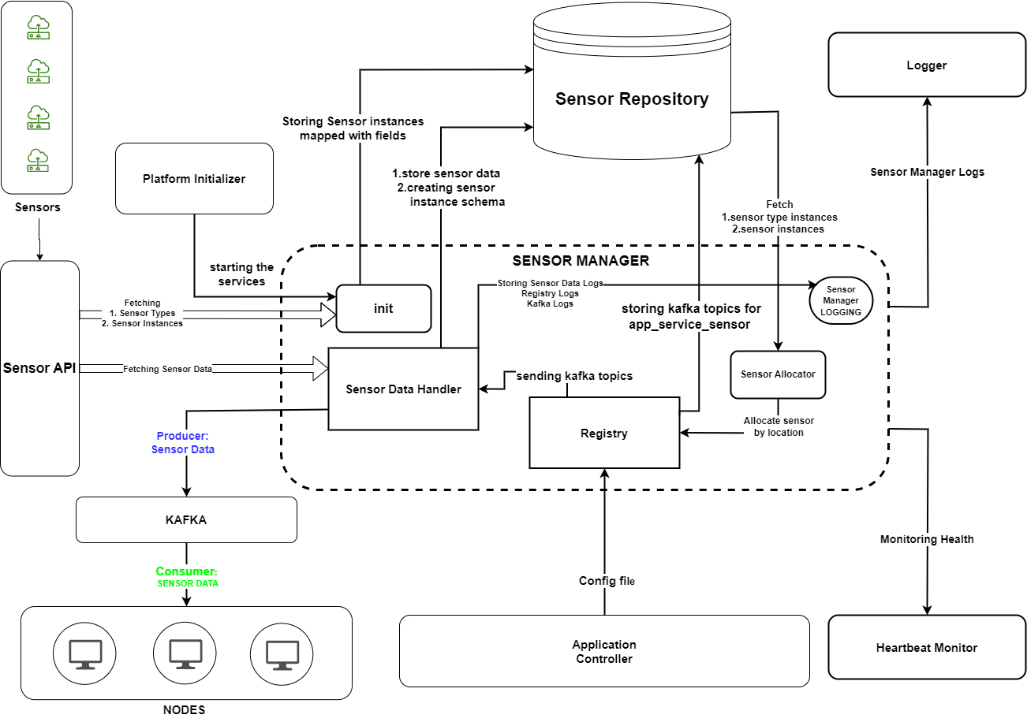

**Subsystem Diagram**