9.Implement word embeddings for IMDB dataset.
Aim
To implement and evaluate word-embedding approaches for sentiment classification on the IMDB dataset. This document demonstrates: (1) training task-specific embeddings from scratch using a Keras Embedding layer, and (2) using pretrained GloVe embeddings as an embedding matrix.
Objective
- Preprocess IMDB text data (tokenize, sequence pad).
- Train a neural text classifier using an embedding layer.
- Evaluate classification performance (accuracy, loss) on test set.
- Show how to integrate pretrained GloVe vectors.
Procedure
- Load IMDB dataset (or raw files). Use a vocabulary size vocab_size and keep top vocab_size words.
- Tokenize and convert texts to integer sequences (if using raw text). If using Keras IMDB loader, it returns integer sequences already.
- Pad sequences to a fixed maxlen.
- Build a simple neural classifier with: Embedding layer -> Bidirectional(LSTM) or Conv1D -> Dense output.
- Train with binary crossentropy and monitor validation accuracy.
- (Optional) Replace the embedding layer's weights with a pretrained GloVe embedding matrix and freeze or fine-tune.
- Evaluate and report results.
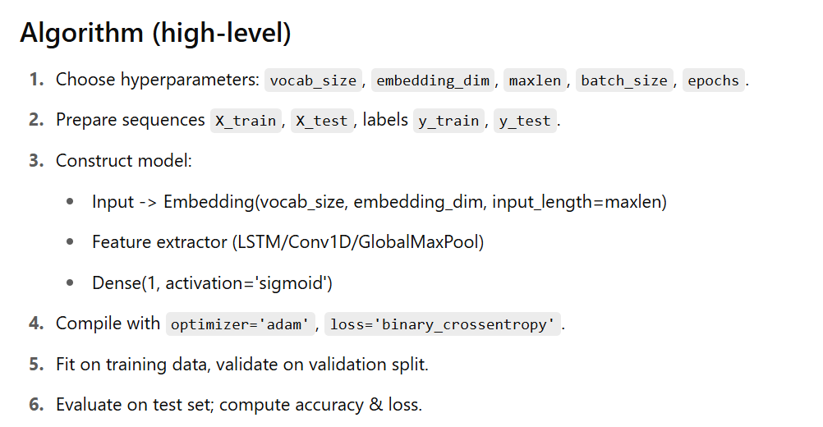

Program:-
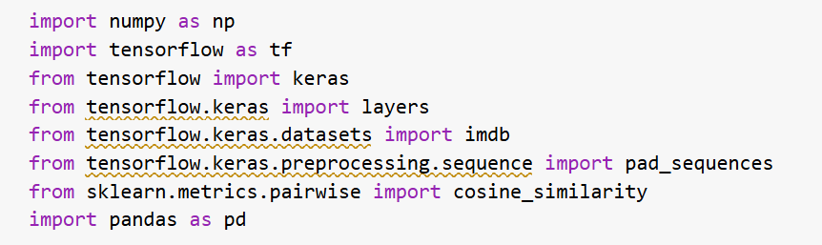
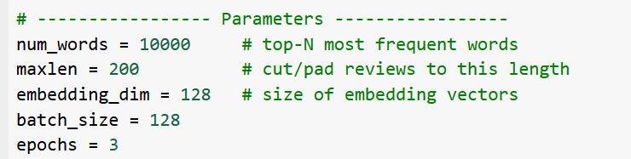
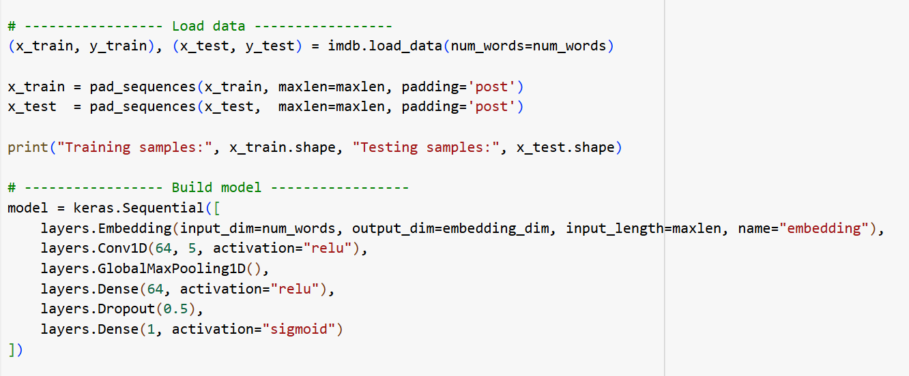
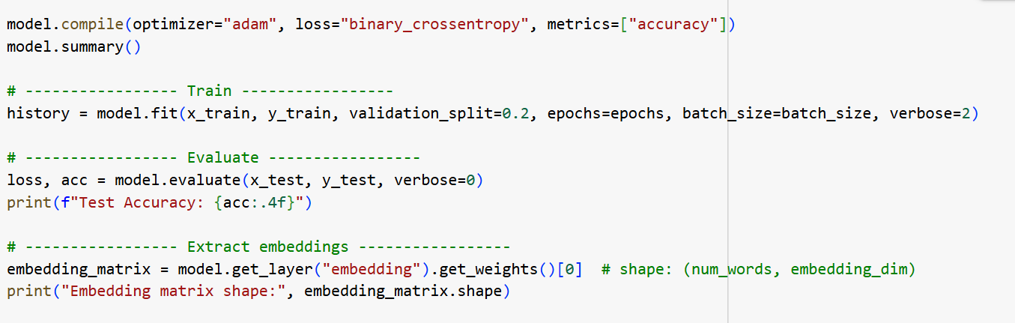
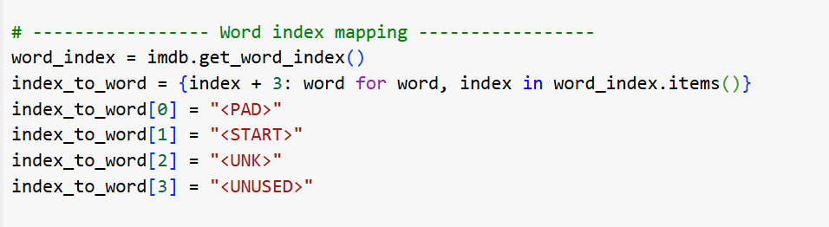
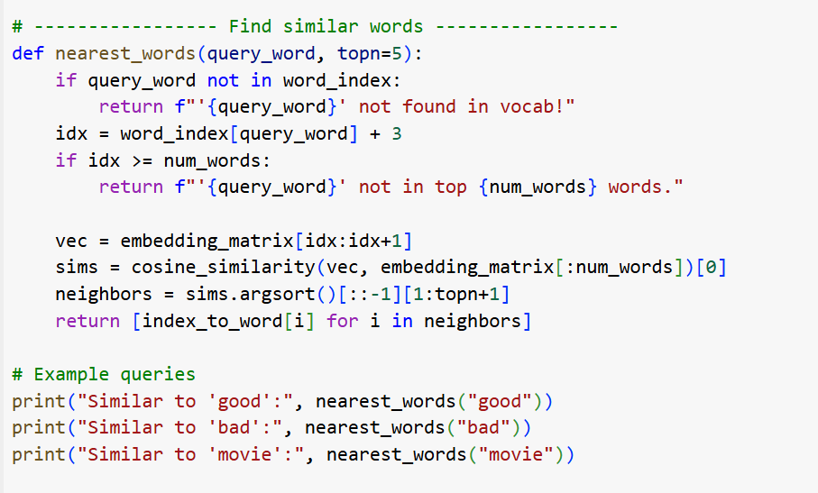

Output:
