1.COVERT LIST OF STRING INTO UPPERCASE:

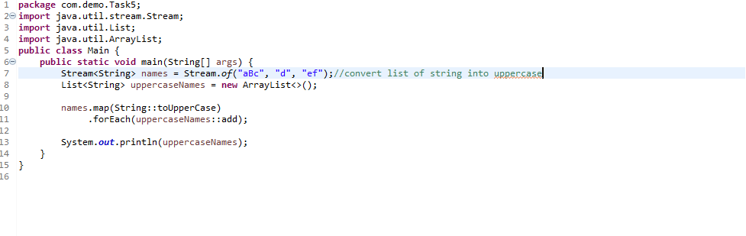

OUTPUT:

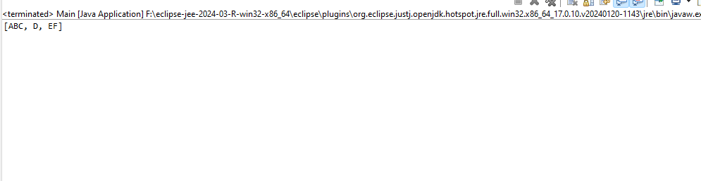

2.CHECK STRING IS EMPTY OR NOT

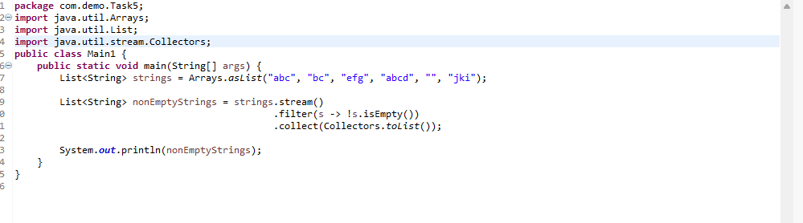

OUTPUT:

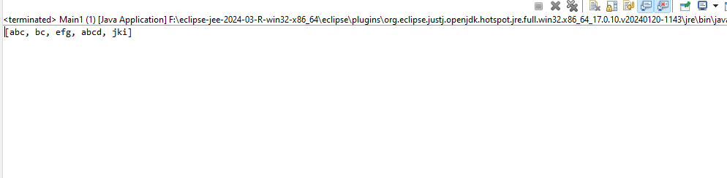

3.STUDENT SPECIAL GIFT

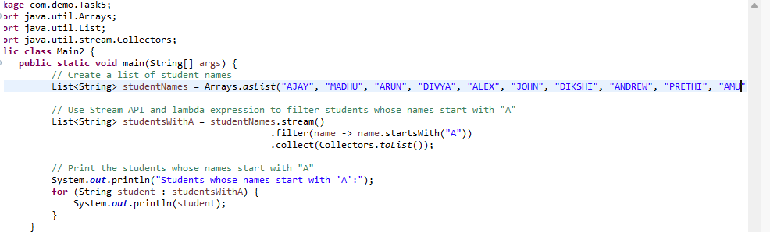

OUTPUT:

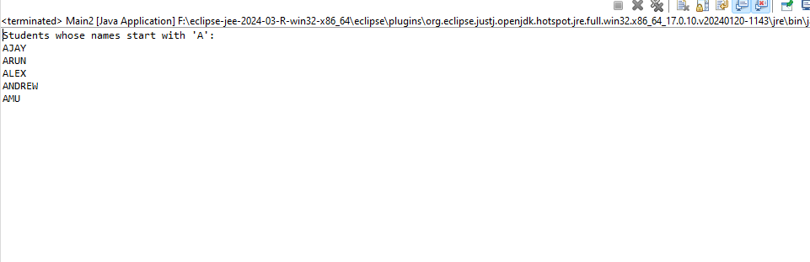

4.APP TO GET AGE USING DOB

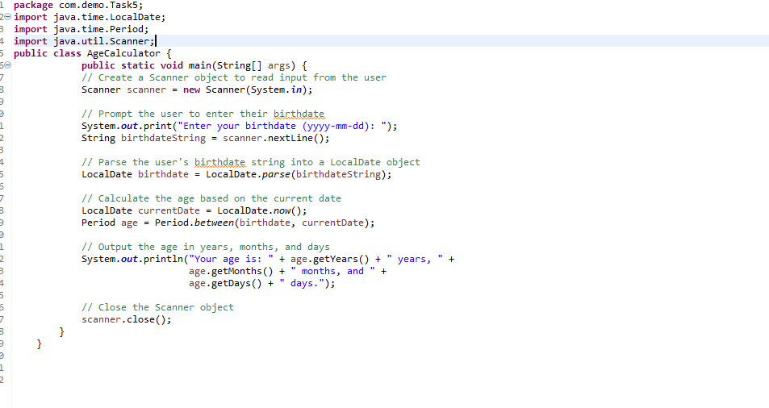

OUTPUT:

