1.BUG FINDING

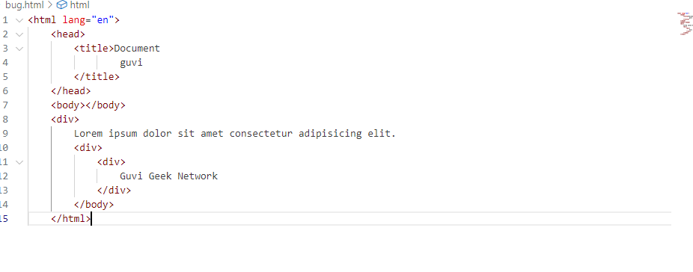

OUTPUT:

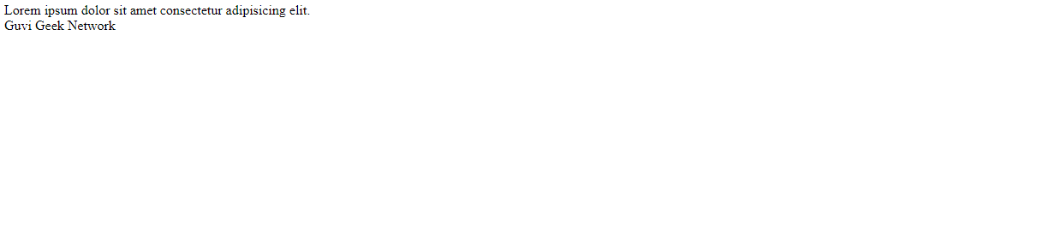

2.BUG FINDING

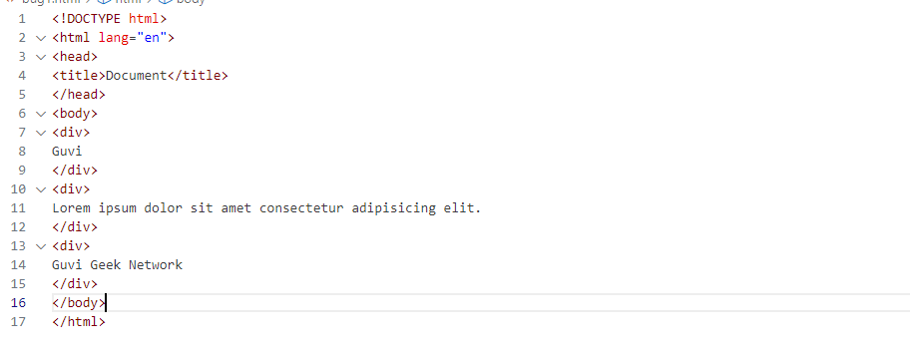

OUTPUT:

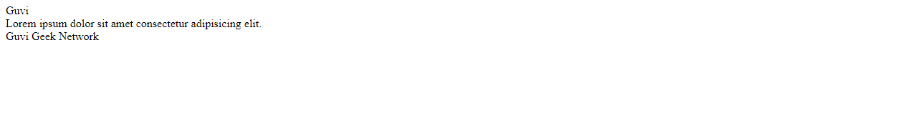

3.CONTACT US

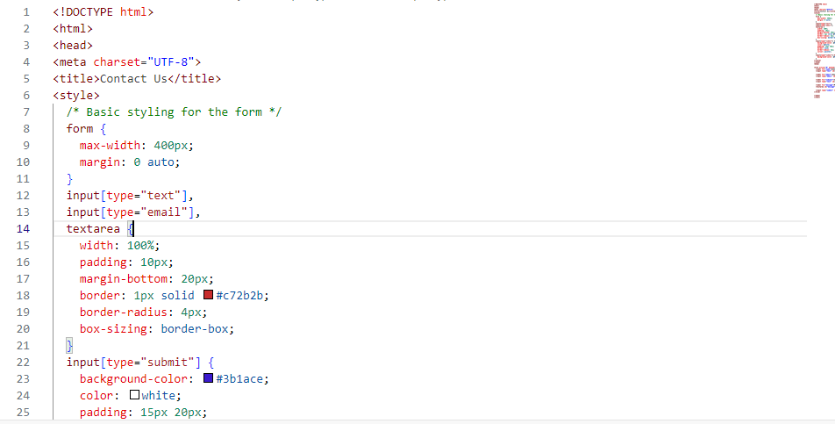

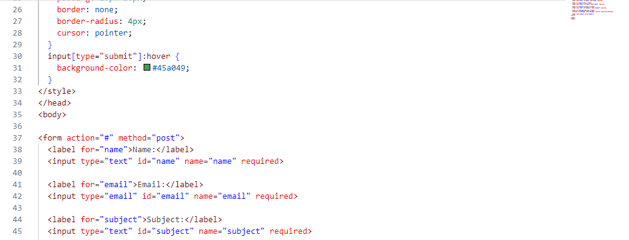

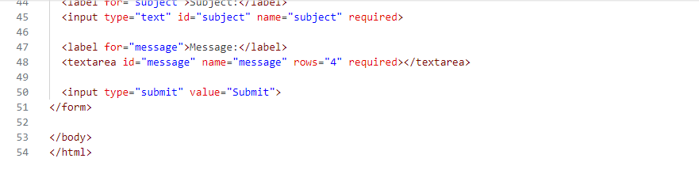

OUTPUT:

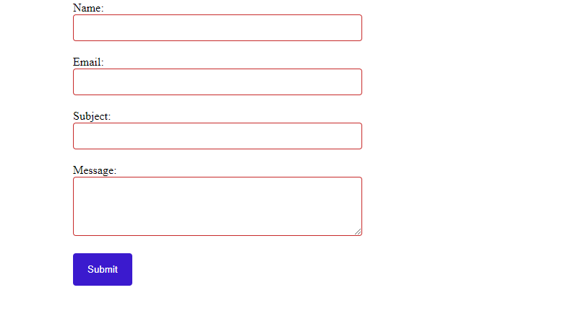

4.HTML ELEMENTS

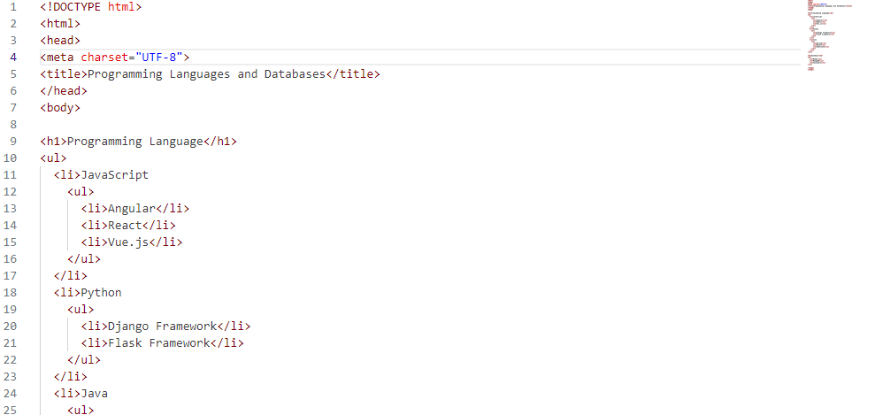

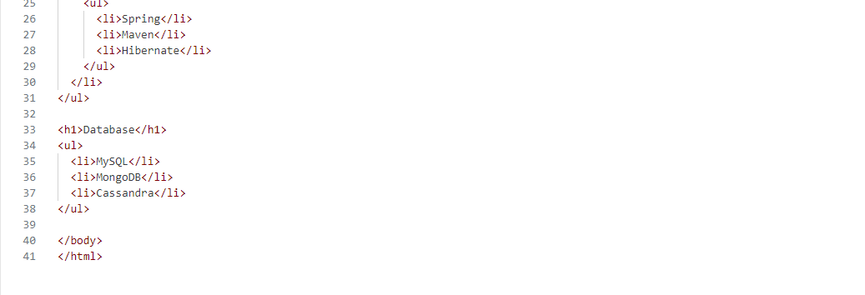

OUTPUT:

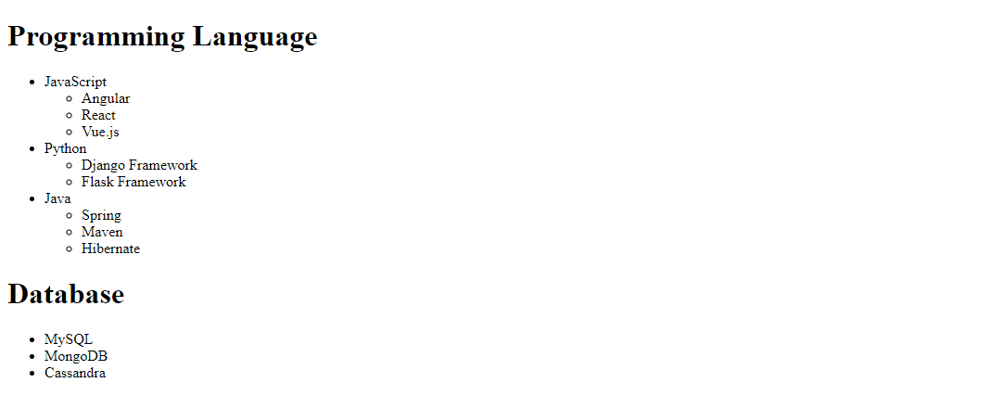

5.GOOGLE

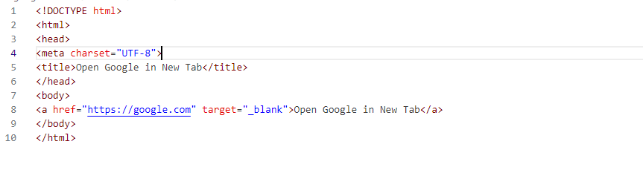

OUTPUT:

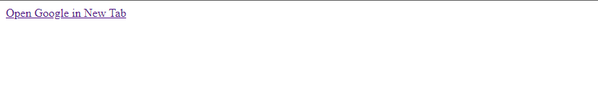

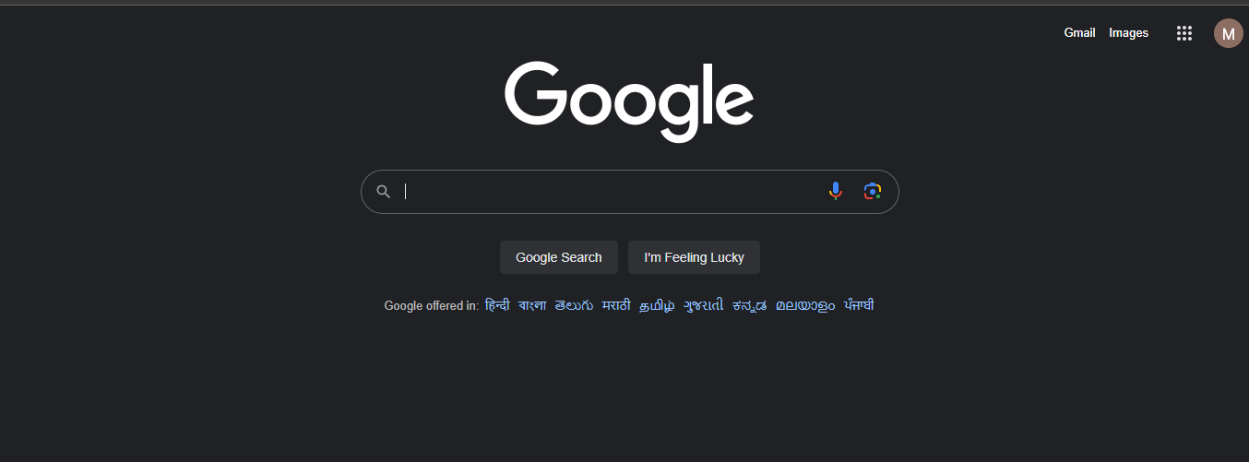

6.EMPLYOEE TYPE

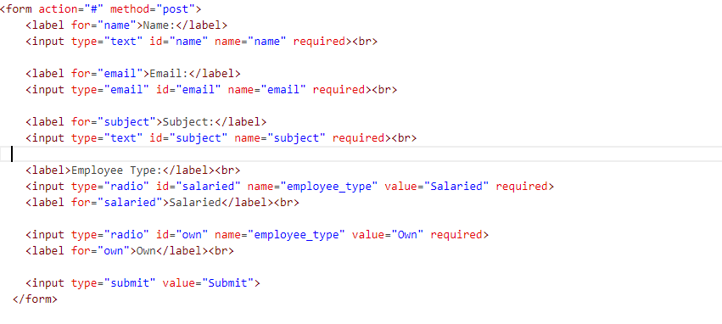

OUTPUT:

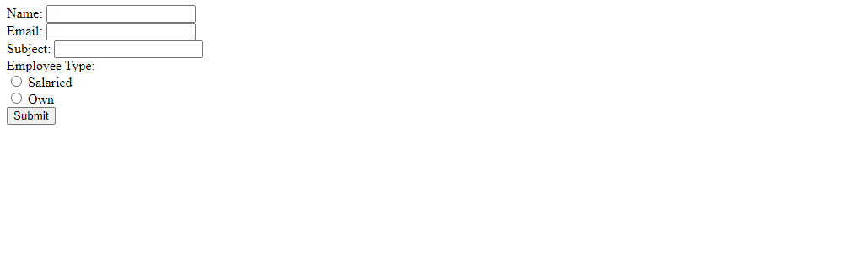

7.FORM

---- FOR THIS PROBLEM I CAN’T ABLE TO VIEW THE IMAGE WHEN I CLICK THE LINK----

8.TABLE TAG

---- SAME WAY I CAN’T ABLE TO OPEN LINK IN LAPTOP----

9.HTML INPUT TAG SNIPPET

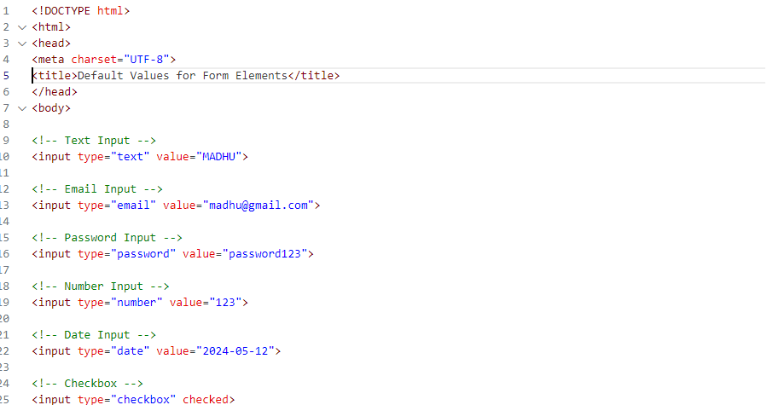

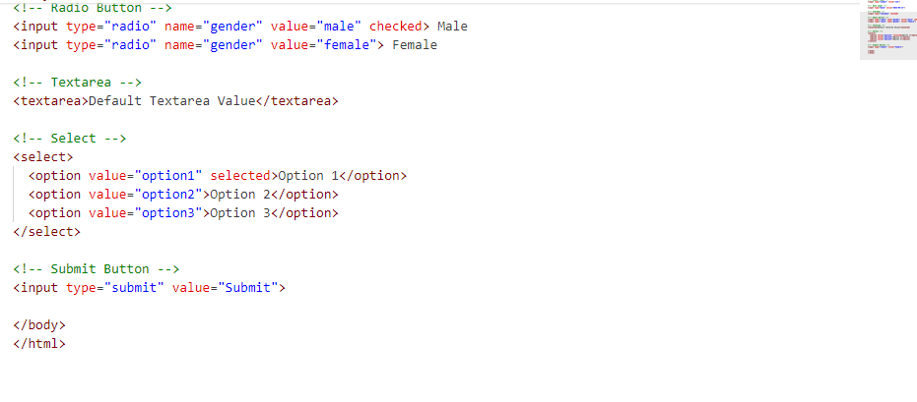

OUTPUT:



10.HIGLIGHT THE TEXT

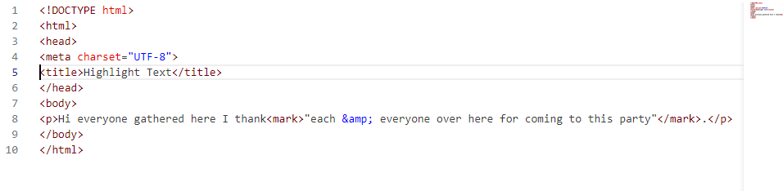

OUTPUT:



11.HTML PAGE WITH ALL ELEMENTS

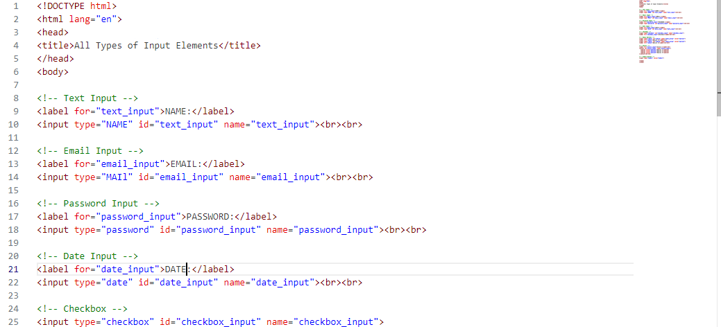

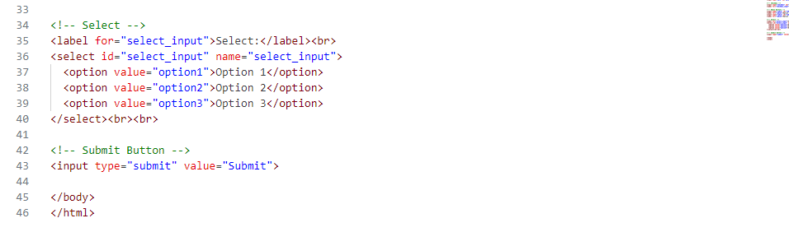

OUTPUT:

