Step 1: Create a Vivado project using the below script “design_creation.tcl”.
Script loation: “/home/einfochips/Finisar_projects/Eden/ps_pl_design/design_creation.tcl”

Step 2: from the step 1 it will create full vivado project using block design and from sythensis to bitstream generation.

Step 3: open the project in the Vivado GUI mode
a) Remove the zynq processing sytem from the block design diagram.
b) Make the Clock, reset and AXI4 slave as external ports.

Step 4: create wrapper for the block design by assigning the address to the AXI memory.

Step 5: Generate ouptut products in the source window on the project block design.

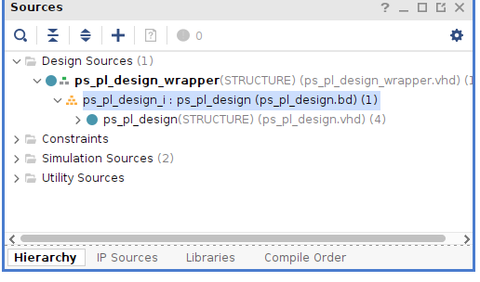
The ouput of the above step is, it will generate the RTL library files into the below folder
“ Project directory path/project_name..ip_user_files/sim_scripts/ps_pl_design/modelsim”

step 6: In the Tcl console of Vivado GUI mode enter the below command for generating the compile libraries for the Xilinx IP’s for the modelsim.

“compile_simlib \
-simulator modelsim \ ( Provide the required simulator )
-directory /home/einfochips/xilinx_simlibs \ ( Provide the destination folder to store the compiled libs)
-family zynq\ (FPGA Family as per your need)
-simulator_exec_path /home/einfochips/intelFPGA/2020.1/modelsim_ase/bin
(provide the simulator installation location)”

Step 7: add the below commands in the compile.do file which is located in the below path
“ Project directory path/project_name..ip_user_files/sim_scripts/ps_pl_design/modelsim”
vlib /home/einfochips/xilinx_simlibs/unisim
vlib /home/einfochips/xilinx_simlibs/unimacro
vlib /home/einfochips/xilinx_simlibs/secureip
vmap unisim /home/einfochips/xilinx_simlibs/unisim
vmap unimacro /home/einfochips/xilinx_simlibs/unimacro
vmap secureip /home/einfochips/xilinx_simlibs/secureip

Step 8: Cross check the paths in the compile.do file. If any changes are needed in the paths please update.

Step 9: add the sim_script.tcl file into the above location where compile.do is available.

Step 10: Cross check the paths in the sim_script.tcl file. If any changes are needed in the paths please update.
Becasue in this script based on compiled simulator libraries path there might be path updates.

Step 11: open the modelsim and change the working directory to
“Project directory path/project_name..ip_user_files/sim_scripts/ps_pl_design/modelsim”

Step 12: Run do compile.do . If any errors please create a folder with name “modelsim_lib” in the current working directory.

Step 13: Run do sim_script.tcl

