DEBUGGING & OPTIMISATION TASK
Name:N.Prasad
Reg no:192425302

Q1. Debugging Maximum Element Search Code

1. Problem Understanding & Context Analysis
Problem Statement: The given program is intended to find the maximum element in an array. However, the initialization and comparison condition are incorrect, causing the algorithm to produce incorrect results.
Purpose of the Program
- Find the largest element present in an array.
- Traverse the array and compare each element with the current maximum.
Expected Input: arr = [10, 25, 5, 40, 15]
Expected Output: 40
Algorithm Concept Involved: Linear Search

2. Root Cause Analysis
Original Code:
def find_max(arr):
max_val = 0
for i in range(len(arr)):
if arr[i] < max_val:
max_val = arr[i]
return max_val
Error | Type | Explanation
max_val = 0 | Logical Error | Fails when all array elements are negative
arr[i] < max_val | Logical Error | Finds smaller values instead of larger values
range(len(arr)) | Optimization Issue | First element is unnecessarily compared with itself

Why the Error Occurs
The condition updates max_val when a smaller element is found. Therefore, the algorithm moves toward the minimum instead of the maximum.

3. Debugging Process
- Check the initialization of max_val.
- Initialize it with the first array element.
- Change < to >.
- Start the loop from index 1.
Corrected Logic:
max_val = arr[0]
for i in range(1, len(arr)):
if arr[i] > max_val:
max_val = arr[i]

4. Corrected & Optimized Code
def find_max(arr):
if len(arr) == 0:
return None
max_val = arr[0]
for i in range(1, len(arr)):
if arr[i] > max_val:
max_val = arr[i]
return max_val
arr = [10, 25, 5, 40, 15]
print("Maximum Element:", find_max(arr))
Output:
Maximum Element: 40

5. Time Complexity Analysis
- Best Case: O(n)
- Average Case: O(n)
- Worst Case: O(n)
- Space Complexity: O(1)
Final Conclusion: The initialization was incorrect, the comparison operator was reversed, and starting from index 1 removes an unnecessary comparison. The corrected algorithm successfully finds the maximum element.

Execution:
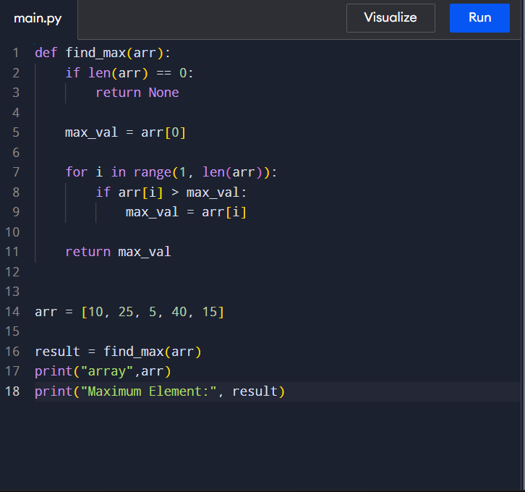Output:

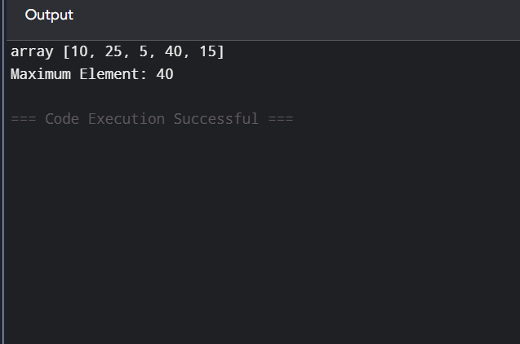

Q2. Debugging Pair Sum Code – Brute Force

1. Problem Understanding & Context Analysis
Problem Statement: The given program is intended to find two elements whose sum equals the target value. The main issue is the loop structure, which checks the same pair more than once.
Purpose of the Program
- Find two different elements whose sum equals the target.
- Return their indices if a valid pair exists.
Expected Input: arr = [2, 7, 11, 15], target = 9
Expected Output: (0, 1)
Algorithm Concept Involved: Brute Force

2. Root Cause Analysis
Original Code:
def pair_sum(arr, target):
for i in range(len(arr)):
for j in range(len(arr)):
if i != j and arr[i] + arr[j] == target:
return (i, j)
return None
Error | Type | Explanation
range(len(arr)) for j | Optimization Issue | Checks duplicate pairs
i != j | Unnecessary Condition | Can be avoided by starting j at i + 1
return None | Correct | Returned after all pairs are checked

Why the Error Occurs
The original code checks both (0,1) and (1,0). They represent the same pair, so unnecessary comparisons are performed.

3. Debugging Process
- Check the nested-loop structure.
- Start the second loop from i + 1.
- Remove the unnecessary i != j condition.
- Return the pair when the target sum is found.
Corrected Logic:
for i in range(len(arr)):
for j in range(i + 1, len(arr)):
if arr[i] + arr[j] == target:
return (i, j)

4. Corrected & Optimized Code
def pair_sum(arr, target):
"""
Find two elements whose sum equals the target.
Returns their indices if a pair exists.
"""
for i in range(len(arr)):
for j in range(i + 1, len(arr)):
if arr[i] + arr[j] == target:
return (i, j)
return None
arr = [2, 7, 11, 15]
target = 9
result = pair_sum(arr, target)
if result:
print("Pair found at indices:", result)
else:
print("No pair found")
Output:
Pair found at indices: (0, 1)

5. Time Complexity Analysis
- Best Case: O(1)
- Average Case: O(n²)
- Worst Case: O(n²)
- Space Complexity: O(1)
Final Conclusion: The original code checks duplicate pairs. Starting the second loop from i + 1 removes duplicate comparisons. The corrected brute-force solution checks every unique pair and has O(n²) worst-case time complexity.

