VULNERABILITY ASSESSMENT AND PENETRATION TESTING (VAPT) REPORT

1. Executive Summary:

Between November 1 and November 3, 2026, a comprehensive Vulnerability Assessment and Penetration Testing (VAPT) engagement was conducted on the web application. The goal of this test was to identify security weaknesses before malicious hackers could exploit them.
Major Findings & Business Risk: During the assessment, a Critical security flaw known as SQL Injection (SQLi) was discovered. This vulnerability allows an unauthorized attacker to bypass security controls and directly access, steal, or manipulate sensitive business data stored in the underlying MySQL database. Because this represents a severe risk of data breach, immediate remediation is required.
Testing Overview: The assessment was conducted using SQLMap, an automated SQL Injection testing tool, within the approved testing scope. During the engagement, our testing activities successfully demonstrated the ability to:
- Identify the Database Management System (MySQL).
- Enumerate hidden databases, tables, and columns.
- Expose and extract sensitive database records.
This report provides the technical details, proof of concept, risk analysis, potential business impact, and remediation recommendations necessary for the IT and development teams to secure the application.

2. scope details:

The scope of this targeted engagement was limited to the following web application endpoint and its underlying database infrastructure:
- Target URL: [http://csi-india.org/news/index.php] (http://csi-india.org/news/index.php)
- Target Parameter: The id parameter within the URL (e.g., id=18).
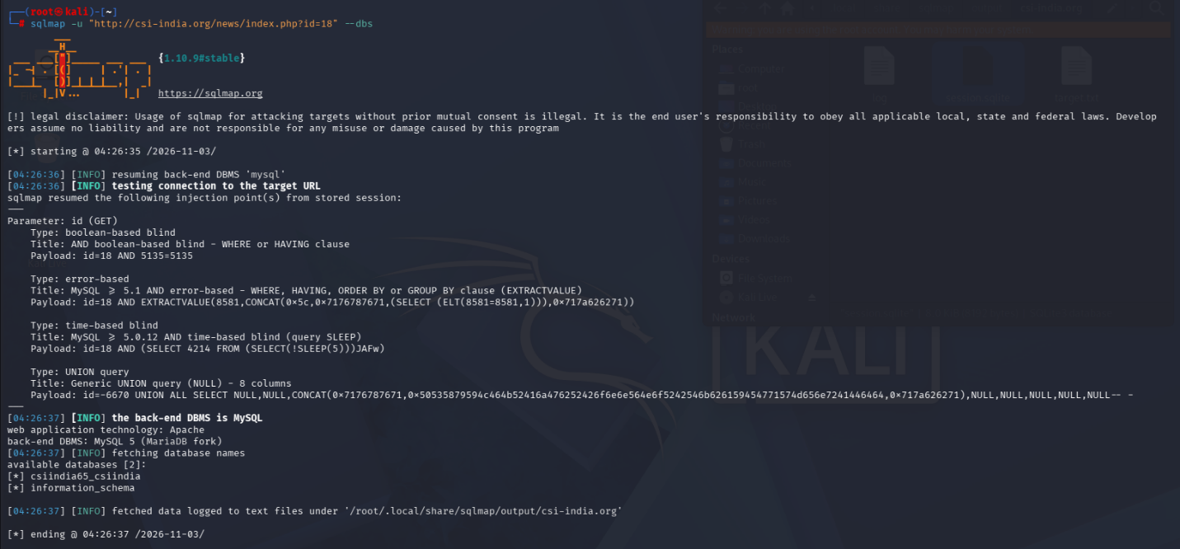
- Infrastructure Context: The application is hosted on an Apache web server and utilizes a MySQL 5 (MariaDB fork) database backend. Out-of-scope systems included the wider web hosting infrastructure and other domains not explicitly listed above. The testing was strictly focused on verifying the presence and impact of input validation vulnerabilities on the specified endpoint.
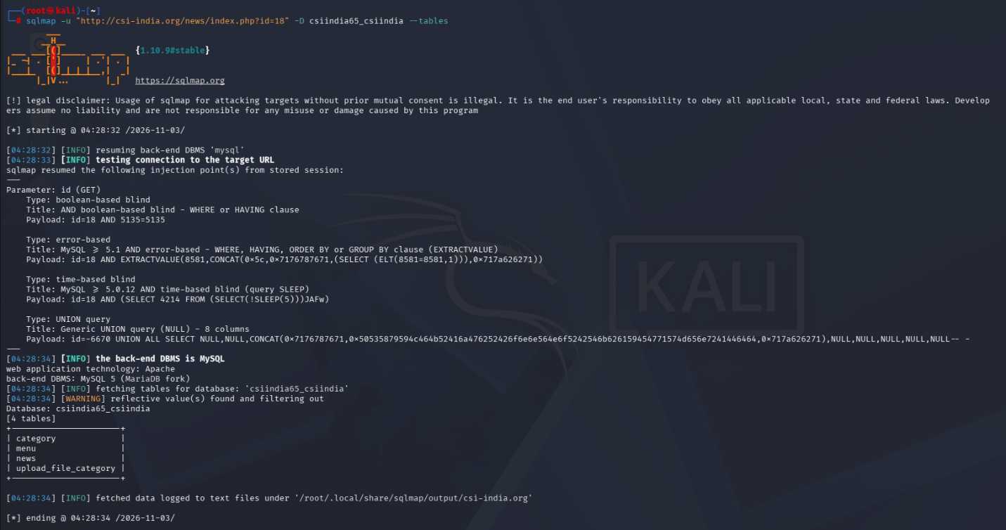

3. methodol ogy:

The testing was performed using sqlmap, an industry-standard automated penetration testing tool designed to detect and exploit SQL injection flaws.
The attack narrative proceeded as follows:
- Identification: The id parameter in the target URL was fed various mathematical and logical payloads to observe how the web application responded.
- Verification: The tool confirmed that the backend database was processing these payloads as executable commands rather than plain text.
- Exploitation: Multiple injection techniques were successfully executed to bypass normal application logic:
  - Boolean-based blind: Asking the database true/false questions to extract data character by character.
  - Error-based: Forcing the database to generate an error message that unintentionally reveals stored data.
  - Time-based blind: Forcing the database to pause (e.g., using a SLEEP command) to confirm the vulnerability exists even when no errors are displayed.
  - UNION query: Merging the results of the attacker's query with the legitimate application query to extract full data tables.

4. Data Extraction: Once access was established, the tool was used to map the database structure and extract live data to demonstrate the critical impact of the vulnerability.
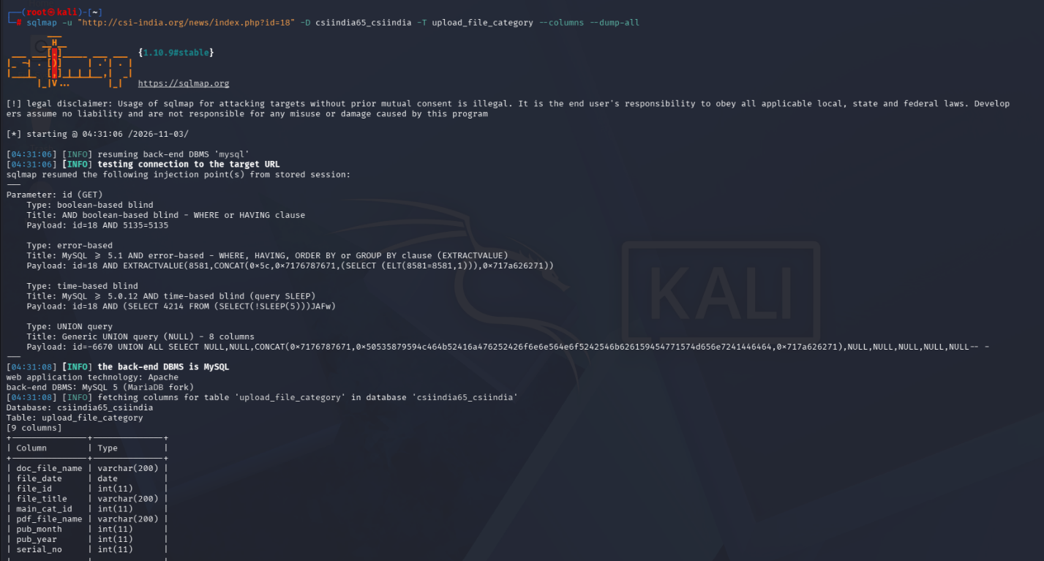
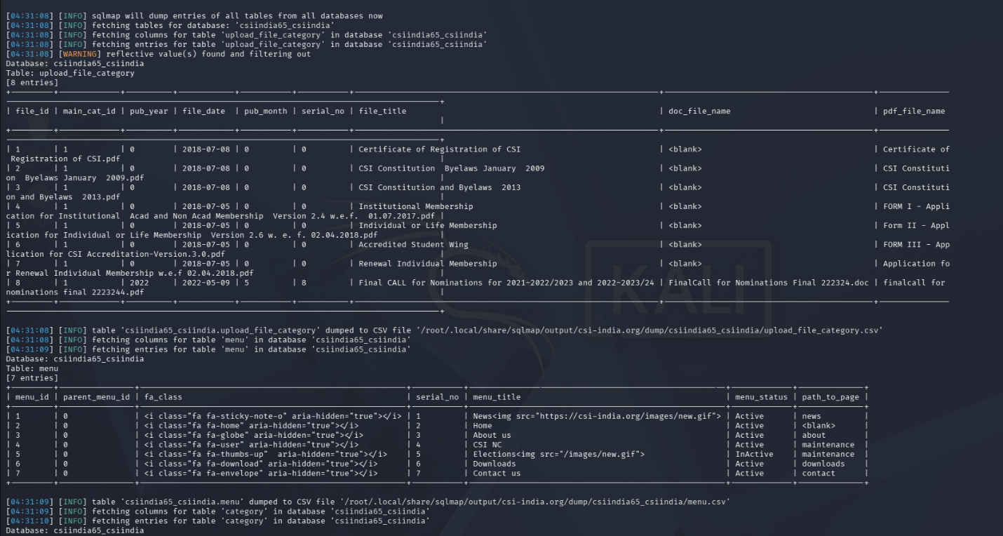

FINDINGS:

Vulnerability Name: SQL Injection (SQLi)
Location: The id parameter on [http://csi-india.org/news/index.php](http://csi-india.org/news/index.php). Severity: Critical (Estimated CVSS Score: 9.8 / 10)

Explanation and Impact:
An SQL Injection occurs when user input is not properly sanitized or filtered before being sent to the database. In non-technical terms, the application is taking untrusted user input and treating it as an executable command.
By exploiting this vulnerability, an attacker can completely bypass the application's intended behavior. During the test, the following impact was demonstrated:
- Database Mapping: The attacker was able to identify the core database named csiindia65_csiindia.
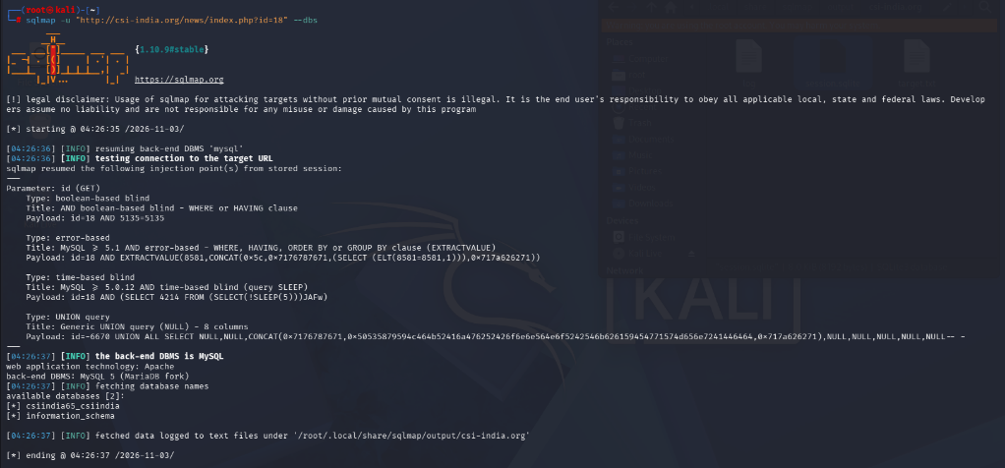
- Table Discovery: Within this database, four distinct tables were discovered: category, menu, news, and upload_file_category.
- Data Theft (Exfiltration): The attacker successfully extracted the internal structure (columns) of these tables and downloaded their actual contents. For example, the news table contained dates, titles, and file paths, while the menu table contained the application's navigation structure and status details.
The potential impact is catastrophic for data confidentiality. A malicious actor could leverage this flaw to read, modify, or permanently delete any information stored in the database, potentially leading to website defacement, data breaches, or complete system compromise.

REMEDIATION:

To mitigate this critical vulnerability, the following actions must be taken by the software development and IT technical teams:
- Implement Parameterized Queries (Prepared Statements): This is the most effective defense against SQL injection. Instead of dynamically combining user input with SQL commands, developers should use parameterized queries. This ensures the database strictly treats user input as data, not as executable code.
- Input Validation and Sanitization: Enforce strict allow-lists for user input. If the id parameter is only ever supposed to be a number, the application should reject any input containing letters, symbols, or spaces before the database ever processes it.
- Apply the Principle of Least Privilege: Ensure the database user account connected to the web application only has the minimum permissions necessary to function. It should not have administrative rights to drop tables or access other databases on the server.
- Deploy a Web Application Firewall (WAF): As a temporary compensating control, implement a WAF with strict rules to detect and block common SQL injection payloads (such as UNION SELECT, SLEEP (), or EXTRACTVALUE ()) from reaching the web server.

CONCLUSION:

The penetration test revealed a critical SQL injection vulnerability in the CSI India web application. Because the id parameter does not properly secure user input, an attacker can directly query the MySQL database, completely compromising the application's data layer. The ability to extract tables such as news, menu, and upload_file_category was successfully proven. It is imperative that the development team implements parameterized queries immediately to close this security gap and protect the organization's data.

