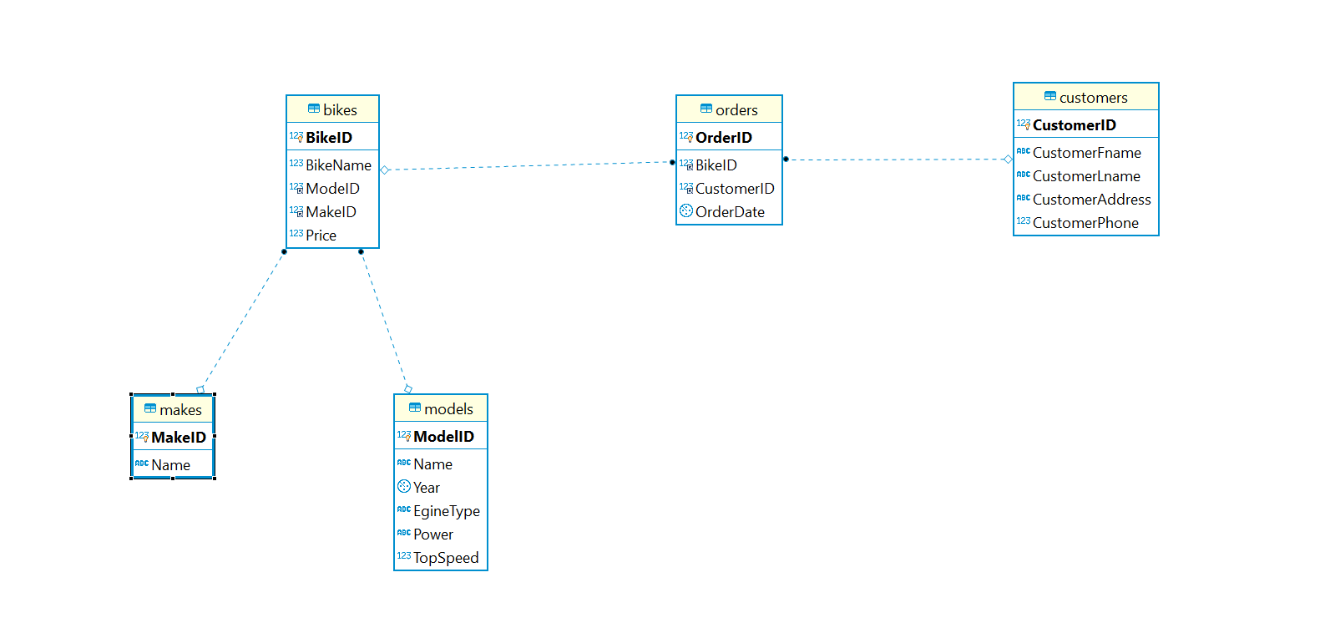

**Bikes:**

Bikes table has all the list of bikes that are available in the store

Bikes table has one to many relationship with makes table and models table since bikes can be made by different companies and bikes table has different models of bikes from different companies.

**Makes:**

Makes table has the list of all bike make companies

**Models:**

Models table has all the models that are available from different bike makes

**Orders:**

Orders table has the list of all orders made by different customers

Orders table has many to many relationships since one customer can order many bikes and one model of bike can be ordered by different customers.

**Customers:**

Customers table has list of all the costumers who had purchased the bike