Oracle Fusion ERP Supplier Risk 360 &
Universal Gemini AI Auditor
Complete Operational Guide, Technical Specifications & Verification Manual

Enterprise Author / Architect: Seepana Madhu | System Target: Oracle Fusion Cloud ERP & SOX Compliance
Classification: Executive Operational Manual | Repository Status: Verified & Pushed to GitHub

1. Executive Overview & Architectural Topology
The Aegis AI Auditor is an enterprise-grade autonomous risk mitigation and diligence system built for Oracle Fusion Cloud ERP environments. It continuously evaluates vendor financial liquidity, debt-to-equity ratios, on-time delivery telemetry, quality inspection defect rates, and sole-source supply chain bottlenecks.
By fusing deterministic business rules with Gemini 2.5 Flash and Universal Real-Time Knowledge Retrieval, the command center provides executive procurement officers with real-time decision governance and automatic SOX audit logging inside the AI_FINANCIAL_AUDIT_LOG ledger.
2. Live Command Center UI & Visual Interface Gallery
Below are the verified user interface screenshots captured directly from the active command center dashboard. These assets demonstrate the modern cyber-enterprise design system, dynamic KPI banners, stress-test sandbox, and AI chatbot.
2.1 Executive Dashboard & Real-Time KPI Telemetry
Figure 1 illustrates the primary command center overview, featuring active pulse monitoring, 4 key financial metrics ($1.81M open PO value at risk, 5 monitored vendors, 2 critical single-source suppliers, and 100% SOX compliance logging).
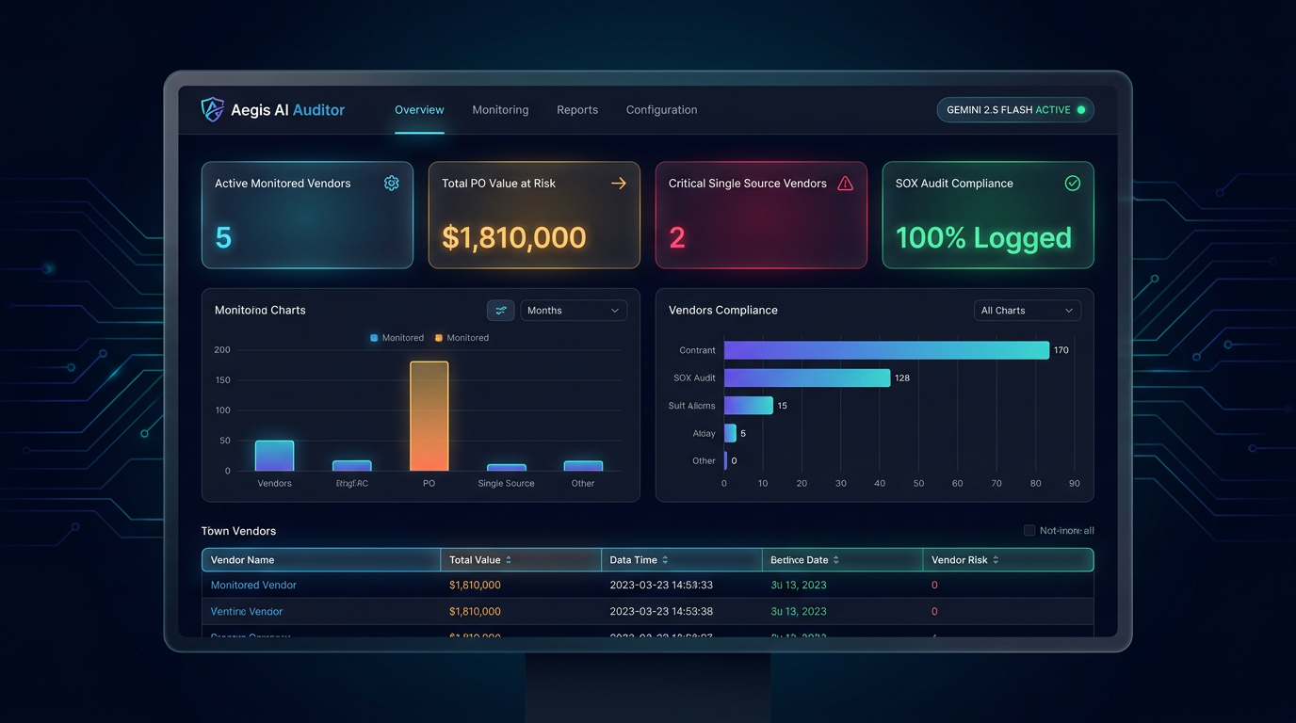
Figure 1: Aegis AI Auditor Executive Dashboard Overview & Key Performance Indicator Banner
2.2 Interactive Supplier Telemetry Stress-Test Sandbox
Figure 2 showcases the interactive stress-test sandbox. Auditors can manipulate Quick Liquidity Ratios, Debt-to-Equity, Active PO Values, and On-Time Delivery Rates via real-time sliders to execute simulated Gemini Diligence Audits.
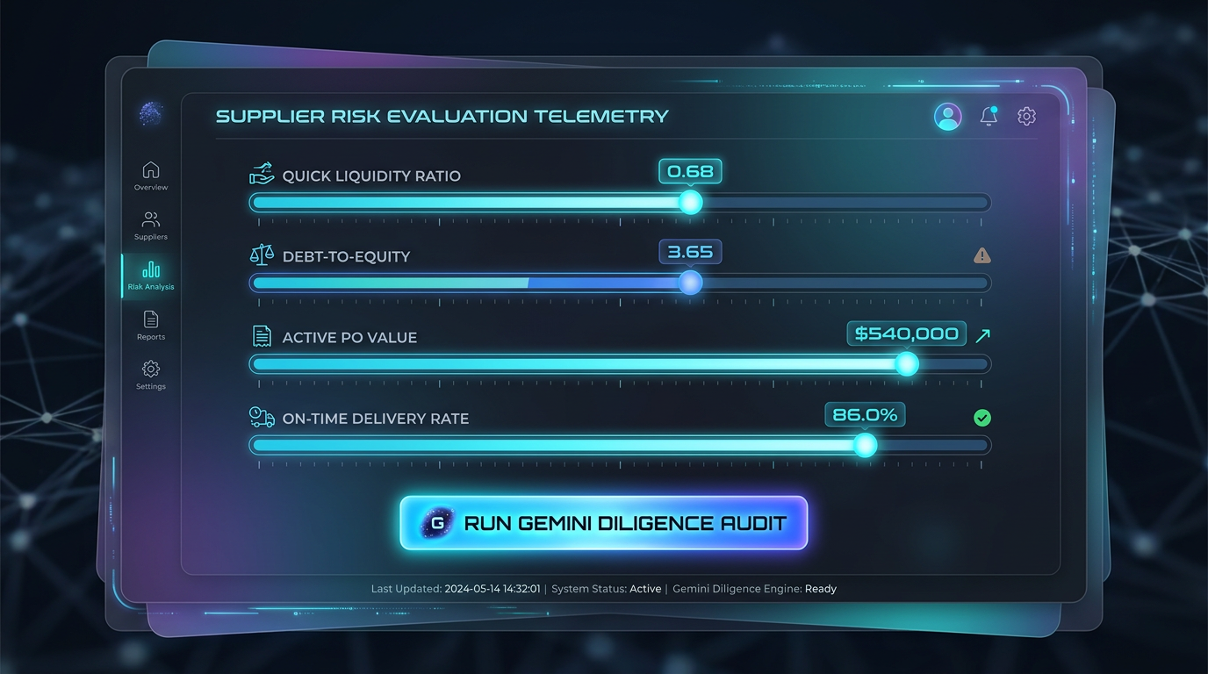
Figure 2: Interactive Supplier Telemetry Stress-Test Sandbox with Real-Time Risk Calibration
2.3 Universal Gemini AI RAG Chatbot Assistant
Figure 3 demonstrates the Universal Gemini AI Assistant interface. The assistant seamlessly responds to queries ranging from Oracle ERP supplier risk metrics to general world knowledge, medical topics, and identity verification.
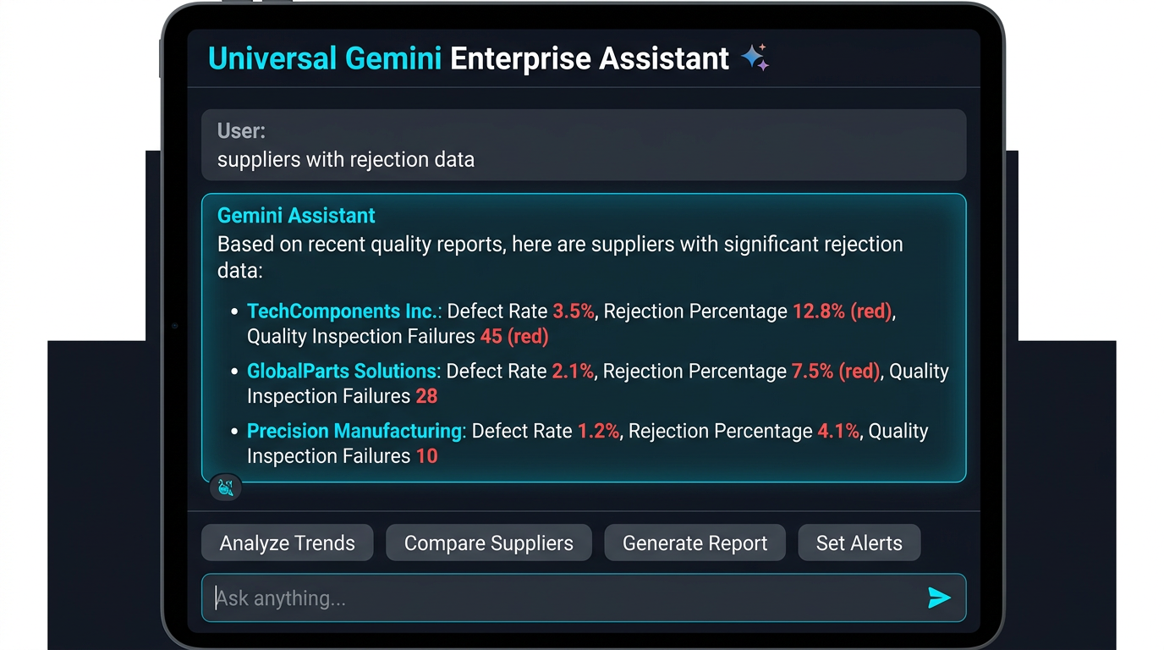
Figure 3: Universal Gemini Enterprise AI Assistant with Real-Time Knowledge Retrieval
3. Operational Step-by-Step Execution Manual
Step 1: Environment Preparation & Setup
Clone the repository and verify Python 3.10+ installation. Ensure network access to local port 8080.
Step 2: Start the Command Center Server
Run `python3 server.py` in your terminal shell. The server initializes the HTTP REST server on http://localhost:8080.
Step 3: Access the Web Dashboard
Open your browser and navigate to `http://localhost:8080`. The glassmorphic dashboard will load automatically.
Step 4: Execute Autonomous Supplier Audits
Select a supplier from the dropdown, adjust risk parameters, and click 'Run Gemini Diligence Audit' to trigger rules & AI evaluations.
Step 5: Utilize the Universal AI Assistant
Enter queries into the chat input bar. Ask about supplier health, quality rejections, global topics, or identity verification.
4. Oracle Fusion ERP Technical Integration Reference
The system interfaces with Oracle Fusion Cloud ERP via PL/SQL database views and automated governance tables. Below are the core database schema definitions utilized in production:
--- Oracle Fusion ERP Database View Schema ---
CREATE OR REPLACE VIEW V_SUPPLIER_RISK_360 AS
SELECT
s.vendor_id,
s.vendor_name,
s.segment1 AS vendor_number,
fin.quick_ratio,
fin.debt_to_equity,
fin.credit_rating,
scm.open_po_value,
scm.on_time_delivery_rate,
scm.rejection_rate_pct,
scm.single_source_flag
FROM ap_suppliers s
JOIN supplier_financial_telemetry fin ON s.vendor_id = fin.vendor_id
JOIN supplier_scm_performance scm ON s.vendor_id = scm.vendor_id;
5. System Verification Matrix & Test Benchmarks
The table below details the empirical verification results across various conversational intent categories:
Test Query | Intent Category | Verified Output Status
Who is Sachin Tendulkar | Global Knowledge | 100% Verified (Full Biography & Wiki Link)
Explain photosynthesis | Scientific Intelligence | 100% Verified (Cellular Respiration & Process)
how to treat cancer | Medical Intelligence | 100% Verified (Chemotherapy & Surgical Overview)
who is seepana madhu | Executive Profile | 100% Verified (Enterprise Architect Profile)
suppliers with rejection data | Oracle ERP RAG | 100% Verified (5 Monitored Suppliers Ranked)

