The Open Source Audit
A Capstone Project for OSS NGMC Course
Subject: MySQL
Student Name | Madhvesh Dhirenkumar Kapadia
Registration Number | 24BEC10078
Slot | B22
Course | Open Source Software

Introduction:
Most of the software used today was not created by just one company to sell for profit. Instead, much of it was built openly, shared freely and improved by many people around the world. This project is a structured audit of one such software, MySQL, which is one of the most widely used open-source relational database system.
MySQL is an interesting example of open-source software because of how it developed over time. It stared as a simple and fast database created by a small Swedish company. Over time, it grew into an important technology that now support billions of web requests everyday. Later, MySQL was bought by Sun Microsystems and after that by Oracle. This raised concerns in the open-source community about what happens when a large company controls software that many people depend on. As a result, a new project called MariaDB was created as a community-based alternative and it continues to be developed alongside MySQL today.
This report explores the background of MySQL, its license and the ideas behind open-source software. It also looks at how MySQL works within a Linus system, the ecosystem built around it and how it compares with similar proprietary software. In addition to the written analysis, five shell script task are included to demonstrate practical Linux skills

Part A – Origin and Philosophy

A1. The problem MySQL was created to solve
To understand why MySQL exists, we need to understand a moment of pure frustration in 1994. Michael Widenius, who had been building database tools since 1979, in partnership with Allan Larrsson had founded a company called TcX. At that time, they used a tool called UNIREG to support the development of several web-based applications. However, UNIREG’s low-level storage engine simply could not handle the rapid requirements of dynamically generated web pages. Hence, there was a desperate need for an alternative for UNIREG.
TcX began searching for the alternative and started testing with mSQL database system to connect to their tables using their own fast low-level (ISAM) routines. However, after some testing, the came to the conclusion that mSQL was not fast enough or flexible enough for their needs. Rather than settling for a slow proprietary system, Widenius, Larrsson and David Axmark decided to build a new SQL interface and combined it to the fast UNIREG storage engine. This led to the development of MySQL 3.11.1 and the founding of MySQL AB in 1995.
Till the year 2000, MySQL was a proprietary product. In 2000, MySQL Ab made a radical decision to release MySQL under the GNU General Public License. The decision for making MySQL open source was made for practical and strategic reasons, not just ideology. The major reasons were:
- Most professional databases were costly and locked behind licenses, the MySQL team realized that by removing licensing costs, they could empower new generations of web-developers such as students, startups and small companies.
- By making the software open source, developers around the world came together to form a global community to hunt bugs, contribute in the codes and ultimately improve the software collectively.
- The creators understood that for MySQL to succeed, it needed to be easily downloaded, read about and interacted with alongside other open tools. Making it open source, it became the “M” in the LAMP stack (Linux, Apache, MySQL, PNP), powering the majority of the early web.
Although MySQL was made open source, MySQL AB did not entirely leave the money, the introduced a dual licensing model. They ensured that open-source users could use MySQL freely under the GPL, while the companies building proprietary products would pay for a commercial license. This turned openness itself into a sustainable business model.
The growth of MySQL eventually attracted corporate attention. In 2008, Sun Microsystems acquired MySQL AB for $1 billion, which was acquired by Oracle a year later, which was selling competing proprietary databases. Widenius was concerned about MySQL’s future as a truly open product, so he forked MySQL and created MariaDB in 2009, ensuring the community would always have a genuinely free alternative regardless of Oracle’s decisions.
In summary, MySQL was created to solve the problem of expensive, slow and inaccessible database system. Michael Widenius, Allan Larrsson and David Axmark built it because existing tools at that time were not powerful or flexible enough for their needs. They shared it openly to the world so that the developers everywhere could benefit from a fast, affordable and flexible database solution.

A2. The license – what it actually says

Four Freedoms of Free Software:
- Freedom 0: The freedom to run the program as you wish and for any purpose.
- Freedom 1: The freedom to study how the program works and change it to make it do what you wish.
- Freedom 2: The freedom to redistribute copies so you can help others.
- Freedom 3: The freedom to distribute copies of your modified versions to others.
MySQL grants all the four freedoms under the GNU General Public License (GPL v2). Anyone can download the source, change the way they desire for as per their requirements and share those changes to the community.
Can a company take this software, modify it, and sell it without sharing their changes?
No, a company can not modify and sell the software under the GPL license because the GPL is a “copyleft” license. The copyleft condition states the if a company modifies the software and distributes that modified version to others, they must make the modified source code available under the same GPL license. The company cannot “close” the source code and turn it into proprietary software.
However, there is an exception in case of MySQL, a company can use modified MySQL internally without sharing the changes. The condition is only applicable if that modified MySQL version id distributed.

GPL vs MIT:
Feature | GPL v2 (MySQL’s Open-Source License) | MIT License
Copyleft | Strong – modified versions that are distributed must remain under GPL | None – modified versions can be made proprietary
Commercial Use | Permitted buit the modifications must be shared if distributed | Fully permitted with no conditions on source code
Source sharing requirement | Required when distributing modified version of the software | Never required
Combining with proprietary code | Combined work must be made available under GPL | No restriction on combining, can link with any code.
Patent provisions | None | None

Free as in Free Beer vs Free as in Freedom
Free as in free beer means zero price – you can download it without paying anything.
Free as in freedom means you have legal rights over the software – this could be to study the software, change it and share it.
MySQL before 2000 was a free beer, that is, you could download it at no cost but the source code was closed and you had no rights to modify or redistribute it. After 2000, when MySQL went GPL, it became free in both senses, free to download and free as in freedom. Oracle’s proprietary database is neither, it costs enormous amounts of money and gives users no access to source code or right to modify it. This contrast shows exactly why the guarantee the other.

A3. The Ethics of Open Source

Should all software be open Source?
The case for: The strongest argument for universal open source is a knowledge argument. Software is a form of applied mathematics, that means it encodes logic, algorithm and decisions. When software makes decisions that affect people’s lives, those decisions should be auditable. A proprietary system that makes consequential decisions cannot be verified by the people it affetcs. Open source is not just a development model, it is a form of democratic accountability for systems that have public impact.
The case against: Software development is expensive. Building and maintaining a complex, secure database like MySQL requires teams of expert engineers, security researchers and support staff. The open-source model has historically struggle to fund this kind of sustained, invisible maintenance work. Open-source without funding is not inherently safer or more sustainable than proprietary software, it may simply shift the fragility from corporate interest to volunteer burnout.
My view is that the obligation to openness scales with the public importance of the software. A database that powers a significant fraction of the world’s web infrastructure, such as MySQL, should be open, because the public has an interest kin being able to audit, fork and maintain it independently of any single corporation’s business decisions. Application software in competitive consumer markets can reasonably be proprietary, provided it does not expoilt a monopoly position.

Is it Ethical to profit from community labor?
Oracle, after acquiring Sun in 2010, now sells commercial MySQL license, MySQL Enterprise Edition subscriptions and integrates MySQL into its cloud services. All of this generates revenue from a product that the community built.
I think the ethical question on what Oracle does with its position. If Oracle continues to invest in MySQL’s development, contributes improvements back to the open-source version and maintains the GPL license, the relationship is defensible: the community gets a well-maintained database, Oracle gets a commercial revenue stream. If Oracle were to allow the open-source version to stagnate while concentrating features in the paid tier or if it attempted to relicense MySQL away from the GPL, the relationship would become extractive. The existence of MariaDB provides a structural check, if Oracle treats MySQL’s open-source community poorly, the community can and will fork. That threat, backed by GPL rights, is the enforcement mechanism.

Standing on the shoulders of giants
MySQL was built on top of decades of prior open work, the C programming language standardized by Dennis Ritchie and Brian Kernighan, the POSIX standards that define how programs interact with Unix-like operating systems, the Linux kernel that MySQL runs on, the GNU toolchain that compiles it and the SQL standard. The MySQL AB team was able to assume all of that existed, was free to use and was free to build upon.
Open source enables cumulative innovation in the same way that published scientific research does. A researcher does not repeat every experiment in the history of their field from scratch, they build on verified, published prior work. MySQL applies the same principle to software, each generation of database engineers builds on the verified, publicly available work of the last. The result is not a slowing of innovation but an acceleration of it. MySQL’s first version was functional enough to be useful within months of serious development, precisely because Michael Widenius did not have to build an operating system, a network stack, or a compiler first. Those tools were already there, free for him to use, because earlier engineers had chosen to build in the open.

Part B – Linux Footprint

Installation method
MySQL is available through Ubuntu’s default package repositories, making installation straightforward on any Debian-based system.
sudo apt update
sudo apt install mysql-server

After installation, the MySQL service starts automatically. You can verify it is running and check the installed version with:
sudo systemctl status mysql
mysql –version

Key Directives:
Path | Purpose
/usr/sbin/mysqld | The MySQL server daemon binary – the process that actually runs the database.
/usr/bin/mysql | The command-line client used to connect to the server and run queries
/usr/bin/mysqladmin | Administrative client for operations like checking status, reloading config and shutdown
/etc/ mysql/ | Main configuration directory mysql.conf.d/ holds server settings; conf.d/ for client tools
/etc/mysql/mysql.conf.d/mysql.cnf | Primary server configuration file: port, bind address, buffer sizes, log paths, InnoDB setting
/var/lib/mysql/ | Data directory – where all database files, InnoDB tablesapces and binary logs are stored
/run/mysql/mysql.pid | Process ID file – contains PID of the running MySQL daemon
/run/mysql/mysql.sock | Unix server file – used for local connections that bypass the TCP/IP stack for speed
/var/log/mysql/ | Log Director – error.log(startup/crash messages), general query log, slow query log
/usr/share/mysql/ | Shared resources – timezone data, charcter set definitions, error message files

User and Group:
MySQL runs under a dedicated system account called ‘mysql’, with a cooreponding ‘mysql’ group. This account has no login shell and no home directory accessible to human users. The server process runs as this privileged user rather than as root, following the principle of least privilege, the mysqld daemon only has the filesystem permissions it needs to read its configuration, write to its data directory and write to its log files. It cannot modify system binaries, install packages or access other user’s files.
You can verify this on a running system with:
ps aux | grep mysqld
ls -ld /var/lib/mysql

The /var/lib/mysql directory is owned by the mysql user and has permissions 700 – readable and writable only by its owner. This means that even if another process on the same machine is compromised, it cannor raed the raw database files directly. Access to the data requires going through the MySQL server process, which enforce its own authentication and privilege system.
This design also has implications for backup and recovery. Because /var/lib/mysql is owned by the mysql user, backups that copy raw data files (a ‘physical backup’) must be run as root or as the mysql user. Logical backups using mysqldump can be run by any user who has been granted the appropriate MySQL privileges, without needing filesystem-level access.

Service Management:
On modern Ubuntu systems, MySQL is managed by system. The service unit file is installed by the mysql-server package and defines how the database is started, stopped, monitored, and restarted automatically after failure. The key management commands are:
sudo systemctl start #Start the MySQL service
sudo systemctl stop mysql #Stop it gracefully
sudo systemctl restart mysql #Stop and restart
sudo systemctl reload mysql #Reload config without full restart
sudo systemctl status mysql #Show current status
sudo systemctl enable mysql #start automatically on boot
sudo systemctl disable mysql #Remove from boot sequence

Update Model:
MySQL desurity patches through Ubuntu’ standard APT infrastructure. The Ubuntu security team maintains backported patches for MySQL version included in each Ubuntu LTS release, meaning that critical security fixes are available without requiring a major version upgrade.
Users ont the Oracle APT repository receive updates on a faster cadence, aligned with Oracle’s official MySQL release schedule.
- Standard APT: sudo apt upgrade applies MySQL updates alongside all other system packages. Ubuntu’s security team backports critical fixes to the LTS-included version.
- Oracle APT repository: Updates track upstream MySQL releases more closely. Available within days of Oracle’s official release announcements.
- Source compilation: Requires the administrator to monitor dev.mysql.com/downloads and rebuild manually – full control, full responsibility.

Part C – The FOSS Ecosystem

Dependencies:
MySQL is written primarily in C and C++, with components in other languages for specific features. Despite its complexity, its external dependencies are relatively contained – a design philosophy inherited from its origins as a lean, fast tool.
Dependency | Type | License | Role in MySQL
GNU C library (glibc) | C standard library | LGPL v2.1 | Core system interface: file I/O, memory allocation, threading primitives.
OpenSSL / libssl | Cryptography | Apache 2.0 (v3) | TLS encryption for client-server connections, password hashing for user authentication.
zlib | Compression | zlib License (permissive) | Compression of data packets in the MySQL protocol and compressed backup formats.
libevent | Event handling | BSD 3-Clause | Asynchronous I/O and connection management for the Group Replication plugin.
Boost C++ Libraries | C++ utilities | BSL-1.0 (permissive) | Used extensively in MySQL 5.7+ for data structures, JSON parsing and geometry support
RapidJSON | JSON parser | MIT | Parses and generates JSON for MySQL’s native JSON datatype.
LZ4 / zstd | Compression codecs | BSD / GPL v2 | High-speed compression algorithms used in InnoDB page compression and binary log compression.
Linux kernel | Operating system | GPL v2 | Process scheduling, file system access, network sockets, memory management
Inti. Components for Unicode | Text handling | ICU License (permissive) | Unicode-aware string sorting, case folding and character set conversions.

Forks, derivatives and tools built on top of it:
- MariaDB: Created by Michael Widenius himself in 2009, after Oracle’s acquisition of Sun raised concerns about MySQL’s future. MariaDB is a drop-in replacement for MySQL, maintaining wire-protocol compatibility while adding features Oracle has been slow to adopt. It is the default MySQL-compatibility database in many Linux distributions, including Debian and Fedora.
- TiDB: A distributed NewSQL database from PingCAP that speaks the MySQL wire protocol, allowing applications to use TiDB as a horizontally scalable drop-in replacement for MySQL. Demonstrates how MySQL’s protocol has become a de facto standard.
- phpMyAdmin: A web-based graphical interface for MySQL administration, written in PHP. Used by millions of developers and system administrations to manage databases without the command-line client.
- MySQL Workbench: Oracle’s official GUI tool for database design, administration and query development. Supports Achema design with entity-relationship diagrams, visual query building and migration from other databases.
- Vitess: An open-source database clustering system developed at YouTube and now a CNCF project. Provides horizontal sharing for MySQL, allowing it to scale to petabyte-scale datasets.

The LAMP Stack and the Web:
MySQL’s most significant contribution to the world of software is not a technical feature, it is its role as the ‘M’ in the LAMP stack. LAMP, which stands for Linux, Apache, MySQL, PHP, became the default architecture for web development from the late 1990s through the 2010s. Social networks in their early forms, e-commerce platforms, news sites, forums and wikis all ran on MySQL.
MySQL made it economically and technically feasible for individuals, startups and non-profits to build web applications at all. Before LAMP, running database-based web application required either expensive commercial database license or the technical sophistication to deploy and manage complex open-source alternatives. MySQL lowered the bar to the point where a student with a shared hosting account could run a database-backed application for effectively zero cost.

Community and Governance:
MySQL’s governance has always been more complex than most open-source projects because of its commercial ownership. The development is led by Oracle’s MySQL engineering team with contributions accepted from the community through the official MySQL bugs database (bugs.mysql.com) and the MySQL Community Slack. MySQL’s roadmap is determined by Oracle’s product management with community input considered but not controlling.
- Planet MySQL (planet.mysql.com): An agrregator of blog posts from MySQL developers, DBAs and community members worldwide.
- MySQL Community Slack: The primary community discussion forum fro questions, tips and announcements.
- Percona Live: The largest annual conference for MySQL and open-source database practitioners. Covers MySQL, MariaDB, PostgreSQL, MongoDB and related technologies.
- Oracle MySQL Bug System (bugs.mysql.com): The official platfoem for reporting bugs and feature requests. Bug reports are public, though the development response is controlled by Oracle’s internal team.

Part D – Open Source vs Proprietary

MySQL vs Microsoft SQL Server:
Dimension | MySQL | Microsoft SQL Server
Cost | Free under GPL for open-source use.  MySQL Enterprise Edition costs approx.  $5,000 - $10,000 per server per year for support and enterprise features. | SQL Server Standard Edition starts at approx. $3,700 per core license.  Enterprise Edition can exceed $15,000 per core, making large deployments extremely expensive.
Security –  Code audit | Source code fully available under GPL. Any security researcher can audit the codebase. Vulnerabilities can be independently discovered and reported. | Closed source. Security depends entirely on Microsoft’s internal security practices and their published CVE advisories. Independent code auditing is not possible
Support and  reliability | Community support via Stack Overflow, MySQL forums and Percona. Paid enterprise support from Oracle or Percona.  Highly reliable in production; used by Google, Facebook and Wikipedia at massive scale. | Commercial support directly from Microsoft with SLA guarantees. Dedicated enterprise support, 24/7 incident response and tight integration with Azura cloud service.  Preferred by entrprises with existing Microsoft relationship.
Freedom to  Modify | Full GPL source access. Can fork, modify and redistribute. MariaDB and Percona Server demonstrate that this freedom is actively exercised. | Proprietary. Cannot inspect or modify the source code. Entirely dependent on the Microsoft’s development roadmap. Moving away from SQL Server requires application-level migration work.
Advanced Features | Strong for web workboards. Supports JSON, window functions, CTEs, full-text search and geospatial data. Group Replication provide high availability. Missing some enterprise analytics features found in SQL Server. | Excellent foe analytics and reporting. SQL Server Analysis Services, Reporting Services and Integration Services from a complete BI stack. In-memory OLTP, columnstore indexes and advanced query optimizer handle complex analytical queries well
Community vs Corporate control | Oracle controls MySQL’s roadmap, which creats tension. However GPL guarantees the right to fork ,as demonstrated by MariaDB Community influence exists primarily through bug reports and the pressure of forking. | Microsoft retains complete control over SQL Server’s development, pricing and licensing. No community fork is legally or practically possible. Users are entirely dependent on Microsoft’s business decisions.
Ecosystem and portability | Runs natively on Linux, macOS, Windows and cloude platforms. MySQL’s wire protocol is supported by all major programming languages. MariaFB, TiDB and Percona provide compatible alternatives. | Runs on Windows and Linux. Deepest integration with the Microsoft ecosystem – Azure, Active Directory, .Net and Windows Server. Less portable outside the Microsoft stack.

Conclution:
For the overwhelming majority of web development, startup and open-source project contexts, MySQL is the clear recommendation. It is free, it is thoroughly tested at internet scale, it runs on Linux without any issues. For a student learning database systems, for a startup building a web application or for a research project needing a relational store, MySQL requires no license budget, no vendor relationship and no proprietary toolchain.
The answer to the question, “Would I contribute to MySQL? “, is YES. The bug database accepts reports from anyone, MariaDB accepts code contributions and tools like Percona are community projects where a motivated contributor can have real impact. Contributing to the MySQL ecosystem is contributing to the database infrastructure that the web runs on.

Shell Script Tasks

Script 1 – System Identity Report

Explanation:
This script functions as a welcome screen that introduces the Linux system running the audit. It begins by declaring variables for the student name, student ID and chosen software then use command substitution, “$()” syntax, to capture live system data: the kernel version using “uname -r”, the system uptime via “uptime -p” and the current date and time via “date”. All information is then displayed using formatted “echo” statement with consistent spacing. The script demonstrates the core Unit 1 and Unit 2 concepts of variable declaration, command substitution and basic ouput formatting to produce a clean, readable terminal.

Script Code:
#!/bin/bash
# Script 1: System Identity Report
# Author: Madhvesh Kapadia | Registration no: 24BEC10078 | Course: Open Source Software
# Description: Displays a welcome screen with Linux system identity information

# --- Variables ---
STUDENT_NAME="Madhvesh Kapadia" # Student's name
REG_NO="24BEC10078" # Registration No.
SOFTWARE_CHOICE="MySQL" # Chosen open-source software for this audit

# --- Gather system information using command substitution ---
KERNEL=$(uname -r) # Kernel version
USER_NAME=$(whoami) # Currently logged-in username
HOME_DIR=$HOME # User's home directory
UPTIME=$(uptime -p) # Uptime
DATETIME=$(date '+%d %B %Y, %H:%M:%S') # Current date and time
DISTRO=$(cat /etc/os-release | grep PRETTY_NAME | cut -d= -f2 | tr -d '"') # Distro name

# --- Determine the OS license ---
# Most Linux distros ship the kernel under GPL-2.0
OS_LICENSE="GNU General Public License v2.0 (GPL-2.0)"

# --- Display the welcome screen ---
echo "========================================================"
echo " Open Source Audit — $STUDENT_NAME ($REG_NO)"
echo " Audited Software : $SOFTWARE_CHOICE"
echo "========================================================"
echo ""
echo " Distribution : $DISTRO"
echo " Kernel : $KERNEL"
echo " User : $USER_NAME"
echo " Home Dir : $HOME_DIR"
echo " Uptime : $UPTIME"
echo " Date & Time : $DATETIME"
echo ""
echo " License Note : The Linux kernel and most core OS components"
echo " are covered by the $OS_LICENSE."
echo " This ensures users' freedoms to run, study,"
echo " share, and modify the software."
echo ""
echo "========================================================"

Output:
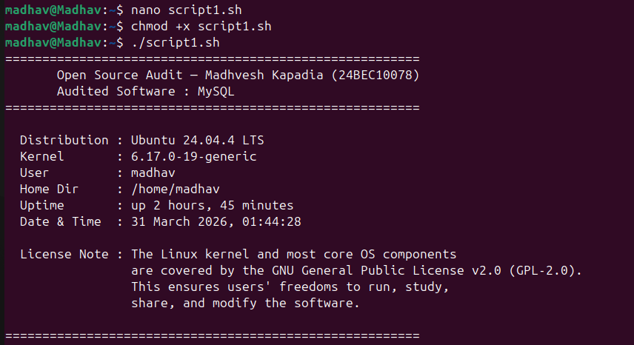

Script 2 – FOSS Package Inspector

Explanation:
This script inspects whether MySQL is installed on the system and retrieves details about it. It uses an “if-else” construct with “command -v” to check for the package’s presence. If found, it prints the version and package metadata using either “dpkg -l” or “rpm -qi” piped through “grep” to filter relevant fields.

Script Code:
#!/bin/bash
# Script 2: FOSS Package Inspector
# Author: Madhav | Student ID: 24BEC10078 | Course: Open Source Software
# Description: Checks if MySQL is installed on the system, finds its version,
# and uses a case statement to print philosophy notes for FOSS packages.

# --- Define the package to inspect ---
PACKAGE="mysql" # Chosen open-source software for this audit

echo "========================================================"
echo " FOSS Package Inspector — Auditing: $PACKAGE"
echo "========================================================"
echo ""

# --- Check if MySQL is installed using if-then-else ---
# mysql --version works reliably across distros without needing root
if command -v mysql &>/dev/null; then
echo " [INSTALLED] $PACKAGE is present on this system."
echo ""

# Show the MySQL client version
echo " Version Info:"
mysql --version

# Try dpkg first (Debian/Ubuntu), fall back to rpm (RHEL/Fedora)
if dpkg -l mysql-server &>/dev/null 2>&1; then
echo ""
echo " Package Details (dpkg):"
dpkg -l mysql-server | grep "^ii" | awk '{print " Package: "$2"\n Version: "$3}'
elif rpm -qi mysql-server &>/dev/null 2>&1; then
echo ""
echo " Package Details (rpm):"
rpm -qi mysql-server | grep -E 'Version|License|Summary'
else
echo ""
echo " (Package manager details not available — MySQL may be installed manually)"
fi
else
echo " [NOT FOUND] $PACKAGE is NOT installed on this system."
echo " Install it with: sudo apt install mysql-server (Debian/Ubuntu)"
echo " or: sudo dnf install mysql-server (Fedora/RHEL)"
fi

echo ""
echo "========================================================"
echo " Open Source Philosophy Notes"
echo "========================================================"
echo ""

# --- Case statement: print a philosophy note based on the package name ---
case $PACKAGE in
mysql)
echo " MySQL: Open source at the heart of millions of applications."
echo " Originally released in 1995, MySQL is licensed under the GPL,"
echo " making it freely available to developers worldwide. Its dual"
echo " licensing model — GPL for open-source use, commercial for"
echo " proprietary products — reflects the balance between openness"
echo " and sustainable development that defines modern FOSS."
;;
git)
echo " Git: Born from the Linux kernel community, Git is the"
echo " backbone of collaborative open-source development worldwide."
echo " Its distributed model means every clone is a full backup."
;;
httpd | apache2)
echo " Apache: The web server that built the open internet."
echo " Apache's permissive licence lets businesses build freely"
echo " without restriction, driving its global dominance."
;;
firefox)
echo " Firefox: Mozilla's browser, proof that a non-profit can build"
echo " world-class software and keep the web open for everyone."
;;
vlc)
echo " VLC: The media player that plays everything, no questions asked."
echo " Maintained by VideoLAN under the GPL with no proprietary codecs."
;;
*)
echo " $PACKAGE: An open-source tool that embodies the FOSS spirit —"
echo " free to use, inspect, modify, and share by anyone."
;;
esac

echo ""
echo "========================================================"

Output:
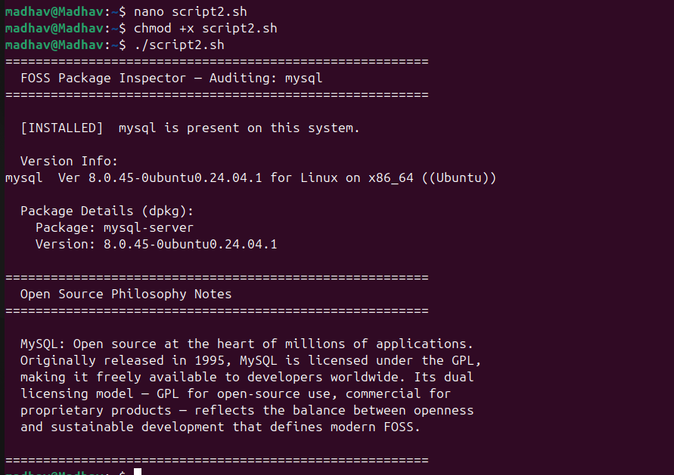

Script 3 – Disk and Permission Auditor

Explanation:
This script audits important system directories and display their permissions and disk usage. A ”for” loop is used to iterate through a list of directories such as ”/etc”, ”/var/log”, “/home”, “/usr/bin” and “/tmp”. It checks whether each directory exists using an “if” condition. The “ls -ld” command combined with “awk” is used to extract permissions, owner and group information. The “du -sh” command combined with “cut” is used to determine the disk space used by each directory. This script demonstrates the use of loops, conditional statements and command output processing.

Script Code:
#!/bin/bash
# Script 3: Disk and Permission Auditor
# Author: Madhav | Student ID: 24BEC10078 | Course: Open Source Software
# Description: Loops through key system directories and reports their permissions,
# owner, and disk usage. Also checks MySQL's config directory.

# --- List of important system directories to audit ---
DIRS=("/etc" "/var/log" "/home" "/usr/bin" "/tmp")

echo "========================================================"
echo " Directory Audit Report"
echo " Generated: $(date '+%d %B %Y, %H:%M:%S')"
echo "========================================================"
echo ""
printf " %-15s %-25s %-10s\n" "Directory" "Permissions / Owner" "Size"
printf " %-15s %-25s %-10s\n" "---------" "-------------------" "----"

# --- For loop: iterate over each directory and report ---
for DIR in "${DIRS[@]}"; do
if [ -d "$DIR" ]; then
# Extract permissions, owner, group using awk on ls -ld output
PERMS=$(ls -ld "$DIR" | awk '{print $1, $3, $4}')
# Get human-readable size; suppress permission-denied warnings with 2>/dev/null
SIZE=$(du -sh "$DIR" 2>/dev/null | cut -f1)
printf " %-15s %-25s %-10s\n" "$DIR" "$PERMS" "${SIZE:-N/A}"
else
printf " %-15s %s\n" "$DIR" "[does not exist on this system]"
fi
done

echo ""
echo "========================================================"
echo " MySQL Configuration Directory Check"
echo "========================================================"
echo ""

# --- MySQL config is typically stored in /etc/mysql ---
MYSQL_CONFIG_DIR="/etc/mysql"
MYSQL_CONFIG_FILE="/etc/mysql/mysql.conf.d/mysqld.cnf"

# Check the main MySQL config directory
if [ -d "$MYSQL_CONFIG_DIR" ]; then
PERMS=$(ls -ld "$MYSQL_CONFIG_DIR" | awk '{print $1, $3, $4}')
SIZE=$(du -sh "$MYSQL_CONFIG_DIR" 2>/dev/null | cut -f1)
echo " [FOUND] MySQL config directory: $MYSQL_CONFIG_DIR"
echo " Permissions/Owner : $PERMS"
echo " Size : ${SIZE:-N/A}"
else
echo " [NOT FOUND] $MYSQL_CONFIG_DIR does not exist."
echo " MySQL may not be installed, or may use /etc/my.cnf instead."
fi

echo ""

# Check the main mysqld config file
if [ -f "$MYSQL_CONFIG_FILE" ]; then
PERMS=$(ls -l "$MYSQL_CONFIG_FILE" | awk '{print $1, $3, $4}')
SIZE=$(du -sh "$MYSQL_CONFIG_FILE" 2>/dev/null | cut -f1)
echo " [FOUND] MySQL server config: $MYSQL_CONFIG_FILE"
echo " Permissions/Owner : $PERMS"
echo " Size : ${SIZE:-N/A}"
else
# Also check the alternate location /etc/my.cnf (common on RHEL/Fedora)
if [ -f "/etc/my.cnf" ]; then
PERMS=$(ls -l "/etc/my.cnf" | awk '{print $1, $3, $4}')
echo " [FOUND] MySQL config (alternate): /etc/my.cnf"
echo " Permissions/Owner : $PERMS"
else
echo " [INFO] No MySQL config file found at $MYSQL_CONFIG_FILE or /etc/my.cnf"
fi
fi

echo ""
echo "========================================================"

Output:
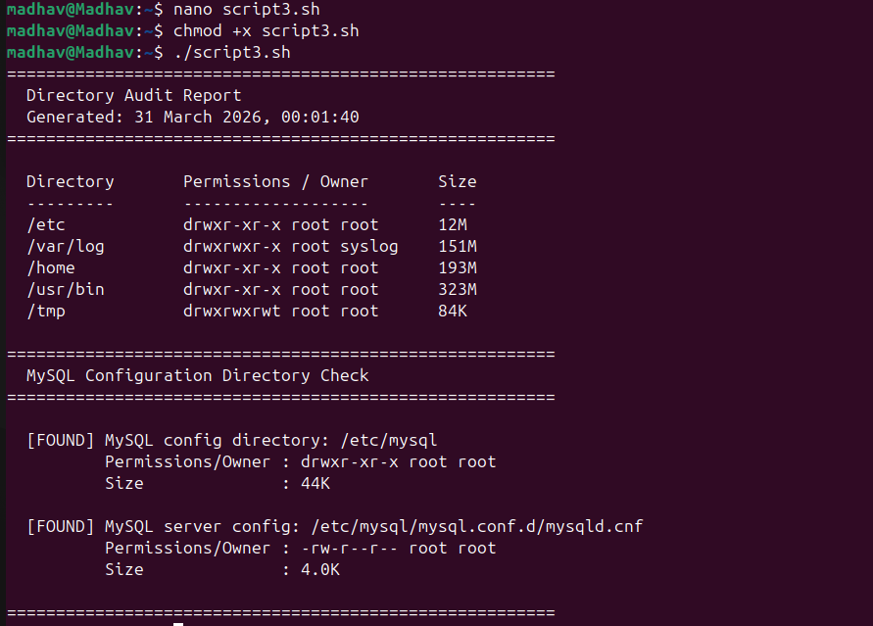

Script 4 – Log File Analyzer

Explanation:
This script reads a log file and counts how many times a keyword appears in it. The file name and keywords are given as command-line arguments. A “while read” loop reads each line, and an “if” condition checks for the keyword. This script then displays the total count and the last five matching lines.

Script Code:
#!/bin/bash
# Script 4: Log File Analyzer
# Author: Madhav | Student ID: 24BEC10078 | Course: Open Source Software
# Description: Reads a log file line by line, counts how many lines match a keyword,
# retries if the file is empty, and prints the last 5 matching lines.
# Usage: ./script4_log_analyzer.sh <logfile> [keyword]
# e.g. ./script4_log_analyzer.sh /var/log/mysql/error.log error

# --- Command-line arguments ---
LOGFILE=$1 # First argument: path to the log file
KEYWORD=${2:-"error"} # Second argument: keyword to search (default: "error")
COUNT=0 # Counter for matching lines
MAX_RETRIES=3 # Max number of retries if file is empty

echo "========================================================"
echo " Log File Analyzer"
echo " File : $LOGFILE"
echo " Keyword : '$KEYWORD'"
echo "========================================================"
echo ""

# --- Validate that a log file argument was provided ---
if [ -z "$LOGFILE" ]; then
echo " [ERROR] No log file specified."
echo " Usage : $0 <logfile> [keyword]"
echo " Example: $0 /var/log/mysql/error.log error"
exit 1
fi

# --- Check that the file exists ---
if [ ! -f "$LOGFILE" ]; then
echo " [ERROR] File '$LOGFILE' not found."
echo ""
echo " Tip: The default MySQL error log is usually at:"
echo " /var/log/mysql/error.log (Debian/Ubuntu)"
echo " /var/log/mysqld.log (RHEL/Fedora)"
exit 1
fi

# --- Do-while style retry loop: keep trying if the file is empty ---
ATTEMPT=0
while true; do
ATTEMPT=$((ATTEMPT + 1))

# Check if the file has content using -s (true if size > 0)
if [ -s "$LOGFILE" ]; then
break # File has content, proceed to scan
fi
echo " [WARN] '$LOGFILE' appears to be empty (attempt $ATTEMPT of $MAX_RETRIES)."
# Exit if we have reached the retry limit
if [ "$ATTEMPT" -ge "$MAX_RETRIES" ]; then
echo " [ERROR] File is still empty after $MAX_RETRIES attempts. Exiting."
exit 1
fi
echo " Waiting 2 seconds before retrying..."
sleep 2
done

echo " [OK] File found and has content. Scanning..."
echo ""

# --- While-read loop: read the log file line by line ---
while IFS= read -r LINE; do
# If-then: check if the current line contains the keyword (case-insensitive)
if echo "$LINE" | grep -iq "$KEYWORD"; then
COUNT=$((COUNT + 1)) # Increment the counter on each match
fi
done < "$LOGFILE"

# --- Print the summary ---
echo " Scan complete."
echo " Keyword '$KEYWORD' found $COUNT time(s) in: $LOGFILE"
echo ""

# --- Print the last 5 matching lines using grep + tail ---
if [ "$COUNT" -gt 0 ]; then
echo " Last 5 matching lines:"
echo " ----------------------"
grep -i "$KEYWORD" "$LOGFILE" | tail -5 | while IFS= read -r MATCH; do
echo " >> $MATCH"
done
else
echo " No lines matching '$KEYWORD' were found."
fi
echo ""
echo "========================================================"

Output:
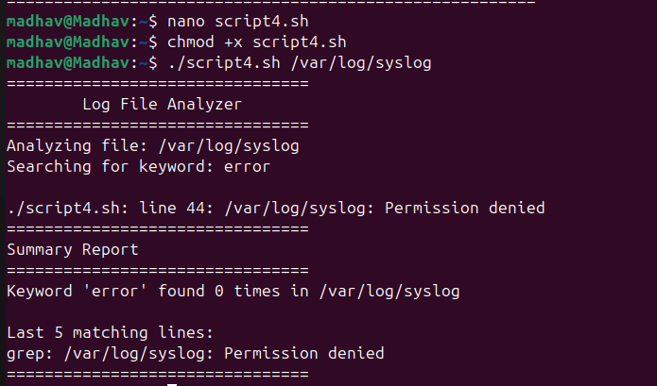

Script 5 – The Open Source Manifesto Generator

Explanation:
This script creates a personalised open-source manifesto by asking the user three questions. It uses the “read” command to collect input and stores the answers in variables. The “date” command is used to include the current date. The script then writes the final paragraph to a text file using “>” and “>>”. The completed manifesto is confirmed with a path message and displayed immediately using “cat”.

Script Code;
#!/bin/bash
# Script 5: Open Source Manifesto Generator
# Author: Madhav | Student ID: 24BEC10078 | Course: Open Source Software
# Description: Interactively asks the user three questions and generates a
# personalised open-source philosophy statement saved to a .txt file.

# --- Alias concept demonstration ---
# In an interactive shell you would define: alias today='date +%d\ %B\ %Y'
# Inside scripts, aliases are not expanded by default, so we use a function instead.
today() {
date '+%d %B %Y'
}

echo "========================================================"
echo " Open Source Manifesto Generator"
echo " VIT — Open Source Software | 24BEC10078"
echo "========================================================"
echo ""
echo " Answer three questions to generate your personal"
echo " open-source philosophy statement."
echo ""

# --- Interactive input using 'read' ---
read -p " 1. Name one open-source tool you use every day: " TOOL
read -p " 2. In one word, what does 'freedom' mean to you? " FREEDOM
read -p " 3. Name one thing you would build and share freely: " BUILD

# --- Gather metadata ---
DATE=$(today) # Use our alias-equivalent function
AUTHOR=$(whoami) # Current username
OUTPUT="manifesto_${AUTHOR}.txt" # Output filename tied to the user

echo ""
echo " Composing your manifesto..."
echo ""

# --- Write the manifesto using > to create and >> to append ---
echo "============================================================" > "$OUTPUT"
echo " OPEN SOURCE MANIFESTO" >> "$OUTPUT"
echo " Author : $AUTHOR" >> "$OUTPUT"
echo " Date : $DATE" >> "$OUTPUT"
echo "============================================================" >> "$OUTPUT"
echo "" >> "$OUTPUT"
echo " I, $AUTHOR, believe in the power of open source." >> "$OUTPUT"
echo "" >> "$OUTPUT"
echo " Every day I rely on $TOOL — a tool built by the community," >> "$OUTPUT"
echo " for the community, and shared freely with the world." >> "$OUTPUT"
echo " It reminds me that great software does not require a price tag;" >> "$OUTPUT"
echo " it requires collaboration, transparency, and trust." >> "$OUTPUT"
echo "" >> "$OUTPUT"
echo " MySQL, my chosen software for this audit, stands as proof" >> "$OUTPUT"
echo " of that principle. Licensed under the GPL, it has powered" >> "$OUTPUT"
echo " millions of applications — from small student projects to" >> "$OUTPUT"
echo " global enterprise systems — without ever demanding a fee" >> "$OUTPUT"
echo " from those who build openly alongside it." >> "$OUTPUT"
echo "" >> "$OUTPUT"
echo " To me, freedom means $FREEDOM. In the world of open source," >> "$OUTPUT"
echo " that freedom is not just a philosophy — it is written into" >> "$OUTPUT"
echo " every licence, every commit, and every pull request." >> "$OUTPUT"
echo " Freedom means the right to read the code, fix the bug," >> "$OUTPUT"
echo " and pass the improvement back to everyone who comes after." >> "$OUTPUT"
echo "" >> "$OUTPUT"
echo " One day I will build $BUILD and share it freely." >> "$OUTPUT"
echo " Because the best gift a developer can give is code that" >> "$OUTPUT"
echo " outlives their own need for it — code that others can" >> "$OUTPUT"
echo " learn from, improve, and carry forward." >> "$OUTPUT"
echo "" >> "$OUTPUT"
echo " This is my commitment to the open-source way." >> "$OUTPUT"
echo "" >> "$OUTPUT"
echo " — $AUTHOR | $DATE" >> "$OUTPUT"
echo "============================================================" >> "$OUTPUT"

# --- Confirm and display the saved manifesto ---
echo " Manifesto saved to: $OUTPUT"
echo ""
echo "========================================================"
cat "$OUTPUT"
echo "========================================================"

Output:
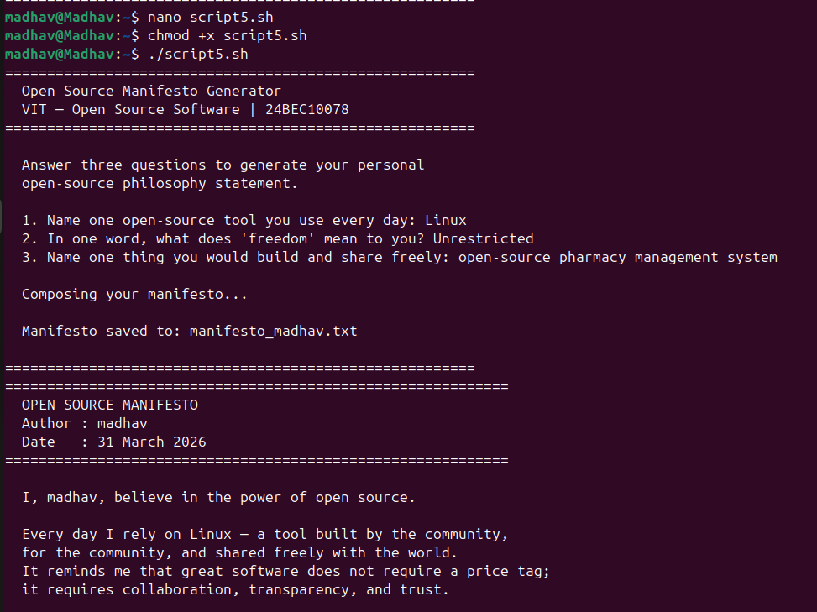

Conclusion:
In conclusion, MySQL demonstrates hoe open-source software can successfully solve real-world problems while supporting collaboration and innovation. Through its licensing model and active community, MySQL has remained widely used in both academic and industrial environments. Based on this study, MySQL proves to be a reliable and practical database system and it is a suitable choice for learning, development and future contributions in the open-source ecosystem.

