**COVID – 19 Tracing Application & Analysis**

Code written by Madi Binyon, Rudy Keopuhiwa, and Levi Russel, Whitworth University

**Purpose:**

We aimed to code and implement the backend design of a COVID-19 tracing app to display the effectiveness and complexity of these apps that have been popping up rapidly in the last few months. Our original plan was to attempt to “hack” the WA Notify app, but we found the contents were protected by Bluetooth and extremely secure; this only further proves the effectiveness of these applications. In the end, this project will hopefully demonstrate the safety and usefulness of contact tracing app in slowing the spread of COVID-19, and encourage our classmates/others to download WA Notify to help our community.

**Goals:**

* Gather an in-depth understanding of the WA Notify app and how contract tracing works in order to display why these apps are useful
* Simulate real world events for the following:
  + Transfer of COVID-19 virus
  + Close-encounter interactions that may garner infection
  + Effective quarantine measures
  + Temporary immunity due to antibodies
* Educate!

**Running the Program:**

We provide the code with several variables to get started, including a population size, number of daily interactions, spread rate, percent of app usage, percent of day zero COVID-19 cases, and an amount of simulation days. These are described below

PopulationSize gives the algorithm an initial number of people in the test case. With our algorithm, we can change this number as we please to analyze the effectiveness of the app in different test group sizes.

InteractionAmount represents the daily amount of interactions between people in the population. This is intended to simulate CDC defined close-contact, or within six feet of someone more for than 15 minutes with out without PPE. We modify this amount to show how COVID would spread in populations that follow strict isolation guidelines all the way to populations that don’t quite follow those guidelines closely.

SpreadRate is a constant obtained from www.bbc.com/news/health-52473523

AppPercentUsage represents the number of people in a given population that have exposure notifications installed on their smartphone/mobile device. This system is described in the **Exposure Notifications** block below.

CovidPercentStart is the total percent of the population that begins the simulation already infected with COVID-19. This is designed to demonstrate a real life situation that would be observed.

SimDays defines how long the simulation will run. On day n, the simulation will output the percent of population members who caught COVID-19 throughout the simulation.

After inputting these values, we let the code run until it is finished and gather the data for graphing.

The data is gathered from a file output from the program. The filename can be changed in the python simulation.py file as well as all the other parameters except the app percent usage as that is a passed in value to the simulation function, which is done for multithreading purposes.

**Understanding Exposure Notifications:**

The WA Notify app utilizes anonymous exposure notifications to let users know if they have come in contact with COVID-19 recently. When two users are in close contact with each other for more than 15 minutes, their phones share a randomly generated Bluetooth key that is stored on their devices. This key is stored for up to 14 days. When a Person A enters into the app that they tested positive for COVID-19, all of the keys stored on their phone are notified that they have come in contact with a person that was positive. In this situation, person B can then automatically quarantine, rather than possibly spreading infection to others.

**Assumptions:**

We start with the assumption that everyone involved in this process understands or is willing to understand the importance of this technology in slowing the spread of COVID-19. Many of our numbers (COVID spread rate, COVID percent start) come from average data from the CDC. We understand that not all data will always rely on averages, but this was the best way for us to simulate a realistic scenario.

**Code Description:**

Using the key variables described above, our program runs through a simulation of day by day population interaction. The following process will happen every “day” of the simulation: we first interact, like the WA Notify app, to exchange keys between users randomly. In that same scenario, if certain users have COVID-19, there is a percentage chance it will spread to the other users they are interacting with. In the case that these spreaders do not utilize the WA Notify app, they will continue to spread for a random amount of days in the range of 2-14 (to account for symptoms showing in varying intervals from person to person). All the users involved in this process will be pushed to different lists like HasCovid, Quarantine, Immune to represent their current position in the simulation, and we track the total number of people in each list as we go.

**Results and Conclusion:**

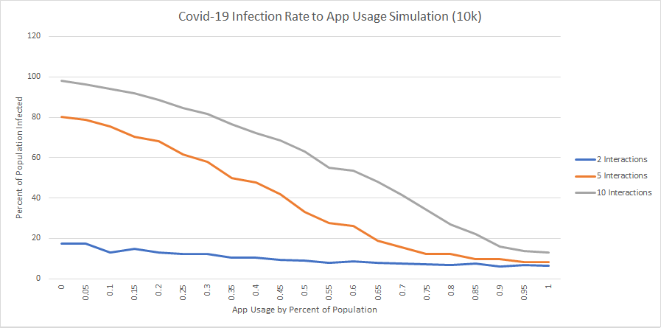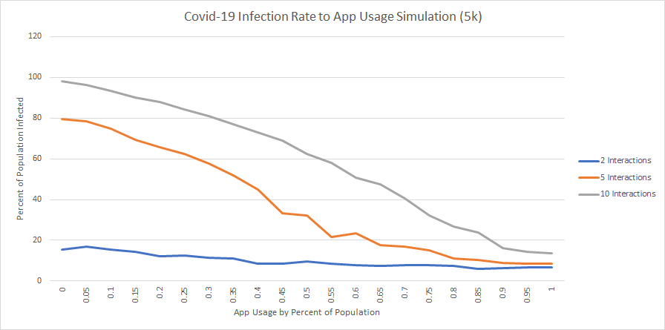

Using these graphs and our previous assumptions as evidence, our team can confidently reinforce the effectiveness of contract tracing to slow the spread of disease in a community. In every situation where 100% of the population utilized a contract tracing app, the results show that total cases of COVID-19 were well below 20%. Contact tracing is extremely relevant to life in our society as we know it, and will continue to, in some capacity, aid in returning us to a familiar state of normalcy.

**Works Cited:**

Gallagher, James. “Coronavirus: What Is the R Number and How Is It Calculated?” *BBC News*, BBC, 27 Nov. 2020, www.bbc.com/news/health-52473523.

“Emergencies.” *Washington State Department of Health*, 2020, www.doh.wa.gov/Emergencies/COVID19/WANotify.

“Spouses, Adults Most Likely to Get COVID-19 Infection from Household Member.” *Contagion Live*, 2020, www.contagionlive.com/view/spouses-adults-covid-19-infection-household-member.