Отчет по лабораторной работе (Vivado / VHDL)
Проект: CPO1
Автор модели: Маданият Мади
Вариант: 18

1. Логическая схема
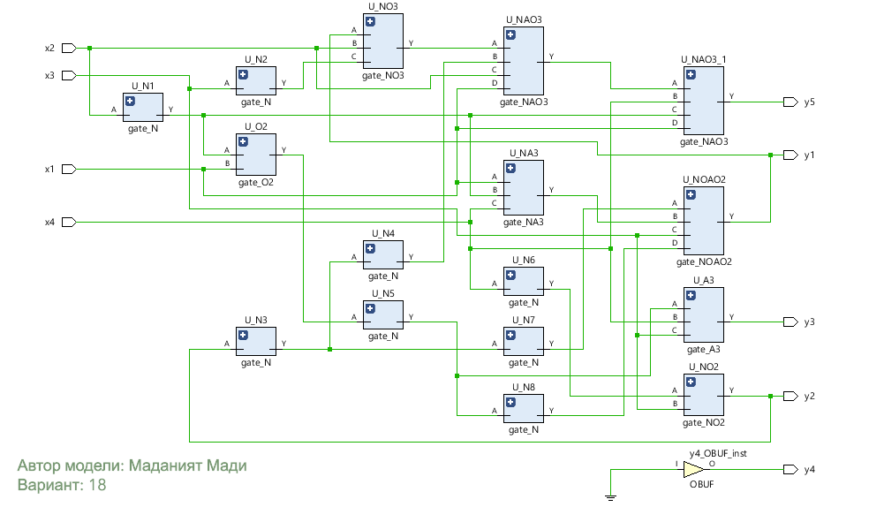

2. Система логических функций
- y4 = 0
- y2 = x4 · ¬x3
- y1 = x3 · (x1 + ¬x2)
- y3 = x2 · x3 · x4 · ¬x1
- y5 = x1 + x2 + ¬x4
Обозначения: ¬ — НЕ, · — И, + — ИЛИ.

3. Таблица истинности
x1 | x2 | x3 | x4 | y1 | y2 | y3 | y4 | y5
0 | 0 | 0 | 0 | 0 | 0 | 0 | 0 | 1
0 | 0 | 0 | 1 | 0 | 1 | 0 | 0 | 0
0 | 0 | 1 | 0 | 1 | 0 | 0 | 0 | 1
0 | 0 | 1 | 1 | 1 | 0 | 0 | 0 | 0
0 | 1 | 0 | 0 | 0 | 0 | 0 | 0 | 1
0 | 1 | 0 | 1 | 0 | 1 | 0 | 0 | 1
0 | 1 | 1 | 0 | 0 | 0 | 0 | 0 | 1
0 | 1 | 1 | 1 | 0 | 0 | 1 | 0 | 1
1 | 0 | 0 | 0 | 0 | 0 | 0 | 0 | 1
1 | 0 | 0 | 1 | 0 | 1 | 0 | 0 | 1
1 | 0 | 1 | 0 | 1 | 0 | 0 | 0 | 1
1 | 0 | 1 | 1 | 1 | 0 | 0 | 0 | 1
1 | 1 | 0 | 0 | 0 | 0 | 0 | 0 | 1
1 | 1 | 0 | 1 | 0 | 1 | 0 | 0 | 1
1 | 1 | 1 | 0 | 1 | 0 | 0 | 0 | 1
1 | 1 | 1 | 1 | 1 | 0 | 0 | 0 | 1

4. Логические элементы
- gate_N: Y = ¬A
- gate_O2: Y = A + B
- gate_A3: Y = A · B · C
- gate_NO2: Y = ¬(A + B) (NOR2)
- gate_NO3: Y = ¬(A + B + C) (NOR3)
- gate_NA3: Y = ¬(A · B · C) (NAND3)
- gate_NAO3: Y = ¬(A · B · C) + D
- gate_NOAO2: Y = ¬(A + B) + (C · D)

