1 THEORETICAL PART

* 1. Introduction

Today, in the field of pharmaceutical and medical services, there is a lot of scientific and economic data for the general presentation of these areas. Since the project solves the problems of these areas, various solutions and analysis of already existing problems must be translated in order for the project to be able to meet the requirements of public and market demand. And also, the need to analyze already existing software solutions in order to obtain the necessary information about the existing order of things that have developed in the development of projects with a similar or similar topic. However, it is possible to create new solutions, which can increase the demand for the project and add some uniqueness to it over other solutions. Following these criteria, the development team compiled an analysis and review of all literature related to the project topic, as well as a comparison of existing software solutions.

* 1. Literature inspection of problem
     1. Introduction

There are many scientific works related to the field of pharmaceuticals and medicine. It contains a lot of data related to problems in society, as well as examples of how to solve these problems. Therefore, applying these scientific works, the development team will have an idea of various problems and the ability to add their own solutions and internalize these solutions to the project.

1.2.2 “ФАРСАР” review

First is a “ФАРСАР” study **[n]** in Russian cities. This study examines the problem and prevalence of self-medication among various age groups of the adult population in Russian cities and their attitude to self-medication. The study was conducted in the form of a survey of the population of cities.

Self-medication is spreading in modern society due to the dissemination of information via the Internet and the media. Self-medication in case of simple situations like headache, heartburn or heartburn may be warranted. But in the case of clinical symptoms and chronic diseases, it can be uncontrolled, inappropriate use of drugs and neglect or incorrect treatment can lead to major health problems. However, self-medication all plays an important role in health care because as knowledge increases in the population, it becomes a necessity in some cases.

In result, 3798 respondents were interviewed, among whom women predominated - 65.8%. 35.9% of respondents were under the age of 25, 37.9% - 25-55 years old and 26.2% - over 55 years old. Self-medication rates averaged 63.1%, and of these, 2/3 were partially or completely successful. OTC drugs use was 62.1%, non-steroidal anti-inflammatory drugs were 34.2% and herbal remedies were 24.9%. Gastrointestinal problems were common reasons for self-medication was tract, headache, preventive taking drugs, acute respiratory viral infections and pains of various localization. The majority of respondents studied information about drugs independently, using sources such as the Internet and the media, and the percentage of people who took into account the advice and recommendations of doctors is 0.8%.

This indicates that self-medication is common in the population of Russia and also possibly in the population of most CIS countries. Therefore, in order to lessen the harmful effects of self-medication in population, the project tries to provide the most truthful information that is available in the public.

1.2.3 “Analysis of Drug Name Confusion in Medicine Labels” review

Second is a study “Analysis of Drug Name Confusion in Medicine Labels” **[n]** done by Vincent Huff and Dan Nathan-Roberts from San Jose State University, California, USA.

Purpose of the research is to study the problem of labeling and names due to confusion and misunderstanding in some names and also the problems of the human errors that increase the misunderstanding as well as possible methods and solutions to this problem.

According to statistics by the Institute of Medical Health in 2000 reported that at minimum 44,000 to upwards of 98,000 Americans die each year in hospitals from medical errors each year. The widespread use of prescription drugs in the United States has grown from people using one or more drugs to using five or more drugs. In 2010 about 2.6 billion drugs prescribed in the US and it will only increase. In 2001 the Joint Commission on Accreditation of Healthcare Organizations estimated that 10,000 patients were suffered each year due to drug label name confusion.

This is one of the reason why it is necessary to increase the fight against human errors and pay special attention to this on the part of health care. For instance, if a person uses 2 or more drugs and one of them is not correctly prescribed, then this can lead to health complications or even death. Usually people do not pay attention to which prescribed drugs they are using. Because of this, many patients do not know how to handle situations when an error occurs. Healthcare professionals do not have appropriate protocols to prevent and inform patients about an error that can lead to death. There are many ways these errors appear. For example, it may be a misspelled drug name or the name was written in a very incomprehensible handwriting. Furthermore, different medicines may have the same name, which may lead to the fact that the patient, instead of taking painkillers, takes psychotropic drugs. The error mitigation must be a priority for healthcare. Reducing the number and impact of errors can save both industry money and patient health.

On December 5, 2014 a 65-year-old woman named Loretta Macpherson passed away due to the fact that she confused the names of the drugs. She underwent brain surgery and was prescribed the wrong medication by the hospital staff. Instead of Zarotin which is an anticonvulsant medication, she took Zemuron which is a paralyzing muscle relaxant, which led to the mixed up of drugs. This is a good example of how a small misspelling of a drug can be fatal. Because of this, the hospital suffered losses in money and her family members also lost her. This problem did not arise simply because one person made a mistake in choosing two drugs. The main reason is that the current hospital system allows this to happen.

As noted above, drug naming problems are a very dangerous thing, as they can lead to fatal outcomes. However, it is possible to mitigate this problem. From the research, the development team decided to pick up the idea that the name is very important not to be confused. Therefore, the project will rely on the accuracy of the spelling of the names of drugs and also enables the medical staff from hospitals to use our site as links to certain drugs in order to reduce the possible occurrence of errors in the spelling of drugs and, if possible, show additional information about the drug to the patient.

1.2.4 “Health information behavior of rare disease patients: seeking, finding and sharing health information” review

Third is a study “Health information behavior of rare disease patients: seeking, finding and sharing health information” **[n]** by Snjezana Stanarevic Katavic from Croatia, University of Osijek.

The aim of study is to describe distinctive aspects of health information behavior of rare disease patients and specific challenges they face when seeking health information. The methods of study is conducting semi-structured interviews among fifteen respondents that suffering from three different rare diseases.

The prevalence of information technology has made health information and drugs more accessible. However, there are groups of people with rare diseases who find it difficult to find information about their diseases and the drugs for them. Rare diseases are diseases where the number of patients does not exceed 5 patients out of 10,000 in Europe and 5% of patients out of 6,250 in the United States.

Lack of medical knowledge is a common problem. However, patients with rare diseases are more likely to seek and value non-medical advice used in everyday life. Patients need an independent search for medical information, as the information received from medical staff was often insufficient. Patients in search of the necessary information faced the difficulty of the search for more accurate and useful information. Pauer et al. found that the quality of information on rare drugs on the internet is rather poor. However, the support groups had very valuable information. Rare disease information retrieval analysis is showing increasing interest in clinical research and people want to supplement and exchange information with healthcare providers to make it easier for patients to search.

The study results revealed a lot of things about finding information about rare diseases.

First, the highest search intensity was after getting the diagnosis.

Second, the problem is to find more specific information related to the disease, since most of the information was generalized and scarce in detail. Lack of information about the condition of the disease in everyday life.

Third, the ability to find new information is not easy, since possible sources containing information can be found in specialized medical sources to which ordinary people do not have access. There is also the problem of finding information in Croatian.

Last, difficulty in finding drugs and lack of information from doctors. Moreover, much of the information was not available in Croatian and there was no description of side effects and drug interactions.

To sum up, this information from the study was useful in order to clarify the situation with people suffering from rare diseases and the problem of finding information about diseases and drugs. Moreover, it shows the problem of inaccessibility of information on the example of the Croatian language, thus the team would like to provide all kinds of information in different languages, such as Kazakh, Russian, and English for a complete understanding in Kazakhstan.

1.2.5 “The use of internet and social media for drug information services in pharmacies in Yogyakarta province: a study if Asthma care” review

Fourth is a study “The use of internet and social media for drug information services” **[n]** done by Fajar Ira Juwita, Aris Widayati and Enade Perdana Istyastono from Universitas Sanata Dharma, Yogyakarta, Indonesia.

The aim of the study is to investigate pharmacists' perceptions of using the internet to provide drug information services and deliver these services to asthma patients. The research method was interviews with confirmed professional judgment.

ICT use has risen rapidly. The development of ICT has led to the emergence of e-health, which is also rapidly developing. Furthermore, this affected pharmaceutics where ICT is mainly used in the procurement and storage of drugs and this is called e-pharmacy. Therefore ICT can improve patient adherence to the correct regimen. For example, Canada used social media to connect patients with each other with the help of a healthcare professional as a guide.

For people with chronic conditions, the internet can improve their quality of life. People with chronic illnesses require special attention and treatment, they generally take more than two drugs during long-term treatment. Therefore, the Internet can be used to monitor the use of medicines by patients. Asthma is an increasing chronic disease in Indonesia, but the use of ICT in the treatment of the disease has been rare.

As a result of the interview, many themes emerged.

First theme, the capabilities of pharmaceuticals using the Internet to maintain services. All respondents answered that they use social networks, especially WhatsApp, Instagram and Facebook communicate with patients. In addition, they also use them to find and improve knowledge by finding specific information from other pharmaceuticals in other countries.

Second theme difficult in transformation of roles of pharmacists in e-pharmacy. Some respondents say that patients are more likely to search for information on the Internet than to turn to professional pharmaceuticals, however, they consider this a disadvantage, since information on the Internet can be unreliable and can also lead to big delusions. Moreover, they noted that the pharmacist is obliged to ensure that information on the Internet must be accurate and up-to-date.

Third topic is the relevance of regulation in e-pharmacy. The majority of respondents stated that online pharmacies sell not only over-the-counter drugs, but also prescription drugs, which is an example of the lack of supervision of authorized persons to control drug sales. And the fact that the regulation of such pharmacies is a necessity.

Fourth theme is related to ICT improvement. The respondents who worked at the Primary Health Center said that the main obstacles to the introduction of ICT and the Internet are unstable Internet connections and suboptimal work of services. Additionally, many rural areas are not connected to the internet.

Fifth theme about contribution of pharmacist in on people’s e-health literacy. The respondents argue that pharmacists can increase the literacy of people using the internet and social media. They expect that by using the Internet, the patient will become easier to treat and increase knowledge about drugs.

To conclude, this study allowed the team to look at the situation of the prevalence of ICT in other countries as well as the problems and possible benefits of Internet interconnection for pharmacists and their patients. The team believes that the project can partially provide information for patients and pharmaceuticals who need drugs, especially for people with chronic diseases. In addition, this work pushed the team to implement a system into the project that will show the location of drugs in local pharmacies, which will help increase user satisfaction.

1.2.6 “How Do Patients Expect Apps to Provide Drug Information?” review

Fifth is a study “How Do Patients Expect Apps to Provide Drug Information?” **[n]** done by Anton Grube, Tobias Dehling, Ali Sunyaev from University of Kassel, Germany.

Patients seek information about drugs from a variety of sources. And one of them is mobile apps. When using mobile applications, patients experience a lack of functionality that is more useful than that provided by healthcare professionals.

This study identified 33 features that patients expect to see in mobile apps. Patients are more interested in personalizing the information provided by applications. The current situation in health information systems shows an attachment to big data. The generalization of patients' personal information leads to a decrease in the display of the personal needs of patients. However, healthcare is shifting more towards personalization and patient-centeredness rather than generalization of all information. Patients' lack of adherence to treatment results in increased treatment rates, increased disease rates and poor treatment outcomes. Patients may refuse or forget to take medications altogether. To prevent this, actively remind the patient of the medication regimen and provide more information about the medication. This is critical to the success of the treatment.

The development of mobile technologies is increasing the personalization of information for patients. The availability of information has led to a decrease in non-adherence to medication. For example, this information can be transmitted both through databases and by text messages or reminders. But at the same time, application requirements are based on the expectations of healthcare professionals. Therefore, it affects developers who develop applications based on these requirements. But this leads to the fact that patients are not satisfied with the information that mobile applications provide them with, as well as the presence of unnecessary functionality.

As a result, the research has brought out 33 features that can help increase usability for patients and also show developers what functionality should be in their applications. These functions are divided into four groups: information provision features, graphical user interface features, search and sort features and features providing additional functionality:

1. Check drugs for adverse drug reactions;
2. Well-arranged presentation of drug information;
3. Search drugs by name;
4. Display dosage information based on other factors than age;
5. Simple user interface design;
6. Provide information whether a drug unit can be split;
7. Display dosage information for a drug in different units;
8. Compare two or more drugs;
9. Search drugs by application area/medical condition;
10. Provide information on drugs which may be taken to alleviate side effects;
11. Provide information on how to enhance the effect of a taken drug;
12. Filter and search for side-effects;
13. Provide information if a drug can be dissolved in a fluid;
14. Filter search results by users' personal characteristics;
15. Provide the possibility to store drugs users are taking;
16. Provide a tutorial on how to use the application;
17. Provide information how a drug acts in your body;
18. Provide the ability to store users' personal information;
19. Search drugs by active ingredient;
20. Allow users to comment on their experiences with a drug;
21. Provide additional information for the technical terms or abbreviations;
22. Provide functionality to identify drugs;
23. Provide information on follow-up drugs;
24. Provide functionality to print out selected information;
25. List all other drugs with same active ingredient as currently displayed drugs;
26. Search drugs by a unique local identifier;
27. Filter for requirement of prescription;
28. List all other drugs for the same application area/medical condition as currently displayed drugs;
29. Integrate images/pictograms to illustrate drug information;
30. Search drugs by company/manufacturer;
31. Provide image of drug package;
32. Provide information on homespun remedies;
33. Customizable user interface.

The first five functions are essential, as without them it is impossible to create an adequate application for patients. The sixth to twenty-seventh functions are functions that patients would like to have as they increase the usability and personalization of information. And functions from twenty-eighth to thirty-third are convenient features that would be nice to have in an application, but still they are not so important to most users.

To sum up, this research is very useful information for developers who are developing applications related to information about the drugs. This will make it possible to make a more user-oriented web application, which will undoubtedly increase its need and demand. The development team will rely on this information to provide specifications for the project being developed.

1.2.7 Conclusion

In conclusion, most of the information from these scientific papers and studies has proven useful to the development team. Moreover, it has determined the direction in which web applications will be developed, as well as determine which functions will be in demand for users.

* 1. Market analysis
     1. Introduction

Market analysis is a very important part of choosing a project direction, analyzing user satisfaction and information about the current state of the selected market. This subsection provides brief information about the pharmaceutical market, how valuable the market is and how much it affects the public. In addition, it provides an analysis of market research for its main features and possible resulting market problems. It is also necessary to identify large companies that greatly influence on the market. In addition, after analyzing the development of the market, it will be possible to see what the market opportunities are for increasing or decreasing its size.

* + 1. Brief analysis from the internet

Today, the pharmaceutical market is estimated at around 1.3 trillion [n]. The key companies in the pharmaceutical market are [n]:

1. Johnson & Johnson;

2. Pfizer;

3. Roche;

4. Novartis;

5. Merck & Co.;

7. Sanofi;

8. AbbVie;

9. Takeda;

10. Shanghai Pharmaceuticals Holding.

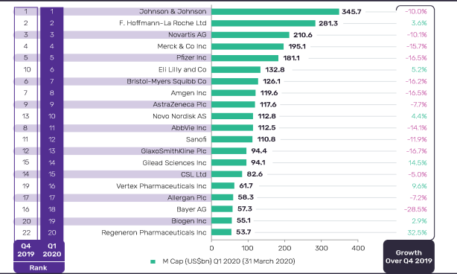

Figure 1.1 [n] – Market cap of biggest pharmaceutical companies in Q1 2020.

As we can see in Figure 1.1, many companies declined their market caps between Q4 2019 and Q1 2020. COVID 19 has caused a lot of damage to the global market. However, this did not have a strong impact on the pharmaceutical market as in other markets.

According to statistics from www.statista.com[n] in global international market of pharmaceutical products grown from 2001 when value of market was 390 billion dollars to 2019 where value of market was 1.25 trillion dollars.

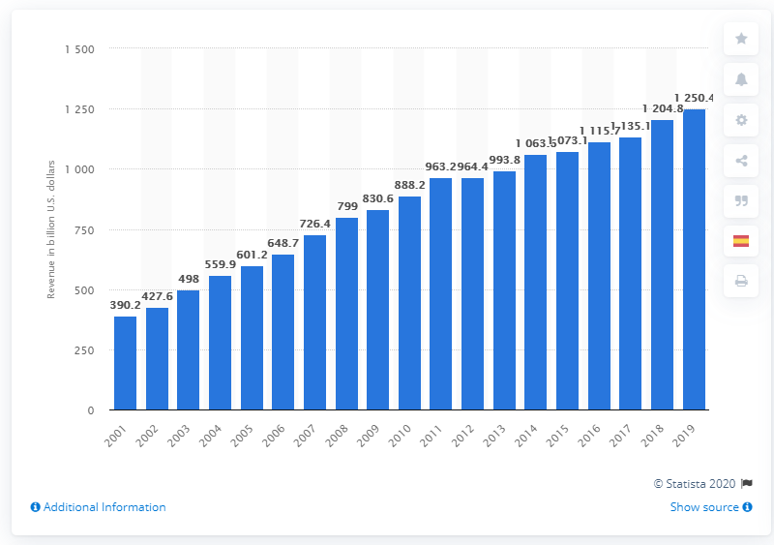

Figure 1.2 [n] – The pharmaceutical market development from 2001 to 2019.

In Kazakhstan, the volume of the pharmaceutical market is 180 billion tenge [n]. In April 2020, about 203 million packages of medicines were sold.

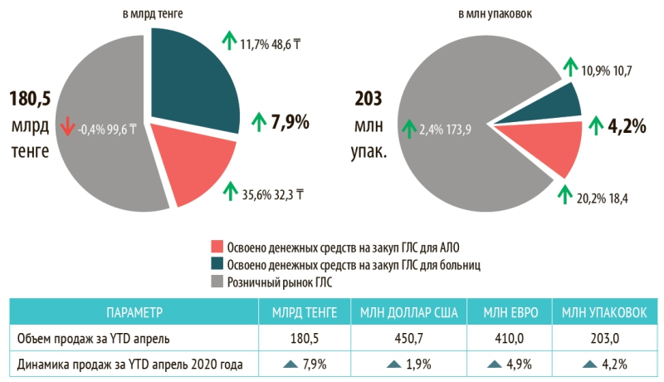

Figure 1.3 [n] – The volume of the retail drug market of Kazakhstan in April 2020.

As noted above, the pharmaceutical market is a very large and emerging market in the global economy. COVID 19 has greatly affected the economy of the entire world for the worse. However, some pharmaceutical companies are doing well and are seeing increased profits.

* + 1. Research on the Pharmaceutical market

Following the research "Main tendencies of the Global Pharmaceutical Market" **[n]**, the pharmaceutical market is a dynamic and fast developing market, especially in developing countries. This is due to the rapid increase in the range of different drugs. Between 2013 and 2017, the market volume increased by 2-6% every year. The chart below shows the market size for each inhabited continent and Japan.

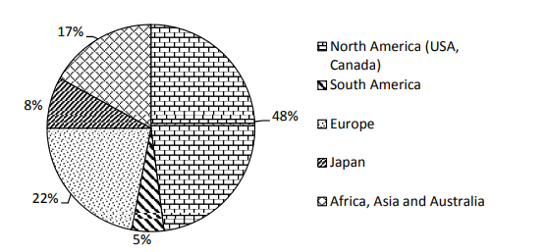

Figure 1.4 - Drug sales in the World Pharmaceutical Market

As shown in Figure 1.3, North America has the largest volume of market is 48%, second is Europe with 22% of market, third is Africa, Asia and Australia together with 17% of market, Japan with 8% and South America with 5% of market. North America is largest because 25 million people in this region suffers from diabetes and 80 million in prediabetes stage. Europe is second due to the spreading of infections in 28 countries, with 76% of local transmission of infection.

The main threat in the pharmaceutical market is the expiration of many patented drugs and can lead to a so-called "patent cliff", which means that patented drugs with large market sales after patent expiration can drastically reduce overall market profits.

* + 1. Conclusion

To conclude, the pharmaceutical market has a large volume in the global economy, and at the same time it is increasing every year. But due to the COVID 19 virus, many pharmaceutical companies lost profits, however, some were able to increase their profitability. This information is useful for studying the state of the market, which will later be used for project design.

* 1. Analysis and comparison of existing software solutions
     1. Introduction

For the chosen theme for the project, there are software solutions that to some extent solved this problem. By analyzing these solutions, the development team will be able to pick up ideas for the project being created and also see what other ideas have not been embodied in the software that we can provide for users. Check what projects exist for specific regions and countries. In addition, the analysis can help with what patterns already exist for creating drug dictionaries and in what form they are best embodied.

* + 1. MedElement review

MedElement [n] is a project aimed at improving the quality of medical services for the population through various online services. For patients has a search for the service of doctors and clinics from Russia, Kazakhstan, Belarus and Uzbekistan. For doctors and specialists, it has a drug dictionary and standards for the diagnosis and treatment of diseases.

When visiting the directory, we see the main page on which there is an input field for searching for a medicine by name, as well as a filter by one parameter, which includes four options. Also on the same page, there is a tab ATC classification, which contains the Anatomical-therapeutic-chemical classification by application such as cardiovascular system, dermatology, etc. The description of the medicine itself contains all the information about the medicine, as well as the field where you can send stuck files about the medicine to your email. One useful thing about information accessibility is switching the language from Russian to Kazakh and vice versa. The approximate purchase price per unit of drug is also indicated.

* + 1. Vidal review

Vidal [n] is a reference guide to drug information for workers and students in healthcare services.

This site has a search engine that includes such parameters as name, alphabet, ATC, Nosology index, clinical and pharmacological index, disease, manufacture, pharmacotherapeutic groups. Drug description consist of general description of drug, contradictions, age and pregnancy restrictions, availability and related drugs, package information, type of pill and etc. Furthermore, details contains order the drug from “Ютека” where prices is provided.

The site contains a medical encyclopedia, which presents medical devices, types of various diseases and disease prevention. Moreover, there is additional information for specialists.

The site has registration and login for specialists. The site has only Russian language support.

* + 1. Drugs.com review

Drugs.com[n] is a drug dictionary site aimed at providing accurate information about medicines for medical personnel in the United States. They want to provide up-to-date information that will be trusted resource of drug information.

It also have a mobile application associated with the site.

The site represented as drug dictionary for USA and English language users. Site are divided into four sections: drugs, side effects, disease and condition, and pill identifier. In addition, site provides the news from pharmaceutical field in USA and worldwide.

Sections of site:

Drugs section is the main section where there search by drug name is presented as well as search in alphabetical order which divided in consumer leaflets and professional monographs. Drug details have information such as description of a drug, warnings, dosage, brief side effects, interactions and popular FAQ. Moreover, details contains could contain images of drug, classification of drug, related drugs, manufacturer, drug status which shows availability of drug and pregnancy restrictions, users reviews of a drug. Manufacturer could have a details that shows information about manufacturer and drugs which him produce. In addition, site has drug interaction where you can input the drugs and system will show that the drug components will mixed which lead to poisoning.

Side effects section is a more informative continuation of information about the side effects of certain drugs. Search by side effects is present only in the form of searching by name. Side effect details contains description, a list of side effects that do not require attention and that require medical attention and additional information for professionals.

Disease section has information about various diseases, allergies and conditions. Disease could be searched by name and by alphabetic order. Disease details contains information such as general description of disease, health guide, disease references, care notes, medication list and Q&A.

Pill identifier is search of drug by pill characteristics, such as shape of the pill, color and number printed in the pill.

Site has authentication system where user can register and login to system. User profile has elements as add illness or allergy that is change the filter on searching drug. Furthermore, user profile has reminder of which pill you need to consume and in which time.

* + 1. rlsnet.ru review

rlsnet.ru [n] is a site of register of medicines in Russia, which has various services and information for specialists and encyclopedic knowledge. The site has a search for all products by name and alphabetically. The site is divided by six sections: drugs and substances, biological active additives, pharmacies and prices, news, product and services, library.

Drugs and substances section contains subsections by manufacturer, ATC classification, disease dictionary, pointer of drugs and etc. Drug details contains general description of drug, manufacturers, quantity of drug in the package, composition, etc. In addition, the user can leave a comment on the drug.

Biological active additives section is a repository of information about biological active additives for dietary, preventive and cosmetic effects.

Pharmacies and prices section contains the regional prices for specific drugs in Russia and list of pharmacies in Russian cities.

News involve last news from the field of Russian pharmacy and news of site.

Product and services section contains information and prices of services of this site such as database of drugs, books and software. In addition, it contains shop where you can order some books and software from register of medicines in Russia.

All information of this site is provided only in Russian language.

* + 1. i-teka.kz review

i-teka.kz is a medical portal for cities in Kazakhstan, providing services and information about pharmacies, doctors, clinics and drug delivery and drug information. The site supports two languages: Russian and Kazakh. The site is intended for patients and consumers. The site has five sections such as pharmacies, drugs, medical centers, doctors and medical services.

Section of drugs involves the list of various drugs and searching of drug by name. Drug details contains instructions for use, similar drugs, drug content and prices in pharmacies. Apart from this, it is possible to order the delivery of the drug from the selected pharmacy.

Section of pharmacies contains the information about pharmacies from Kazakhstan cities and map where is the nearest pharmacy is located. In pharmacy details shown the schedule, contacts and location of pharmacy. In addition, it is possible to search for the drug in the selected pharmacy.

Section of medical centers contains the list of medical centers and searching them by name. In addition, it is possible to filter the search by category of medical center. Each medical center has information about the location of center, list services it is provides, schedule and list of doctors working in it.

Section of doctors involves the list of doctors with their location, search by name and search by specialties of a doctor. Each doctor has information about schedule, location and contracts.

Section of medical services shows the list of services and search by name. Each service has location where it can be provided.

* + 1. rxlist.com review

rxlist.com [n] is a medical dictionary of prescription drugs. All medical terms from MedTerms are written by US pharmaceuticals. The site is provided in English language.

The main page of the directory site has an alphabetical search for drugs and a search by name. There is also a list of popular medical terms. From the main page you can go to the following sections: Drugs A-Z, Pill identifier, Supplements, Symptom checker, Diseases, Dictionary and Media.

Drug A-Z page is involves an alphabetical search for medicines and a list of all medicines grouped in alphabetical order. Each drug has professional description, consumer description and side effects. Professional description has detailed information of the drug as the chemical composition of the medicine with formulas, indications, dosage, warnings and etc. Consumer description contains the general information about the drug such as what is a drug, how consume, images, side effects and what avoid when consuming the drug. Side effects description has an additional information about the drug’s side effects and their divided in common effects and effects that required medical help.

Pill identifier page contains drug search by shape, color and number printed on the drug and drug search by brand. Moreover, there is a slider with images of popular drugs by pill, the top 10 prescription drugs and drugs by side effect in the USA, and an example of commonly abused prescription drugs.

Supplements page is a section about vitamins, herbs and dietary supplements. Page contains search by alphabetic order and list of popular supplements. Supplement details have general information.

Symptom checker page has the symptomcheker by WebMD, list of common and popular symptoms.

Disease page section contains detailed information about diseases, conditions and their classifications. Disease page has search by alphabet and list of diseases classifications. Classification page has filled with details of classification, for example, allergy definition. Disease details has facts, causes, treatment of disease.

Dictionary page is a list of general terms in medicine and search by name of term. Media page has images of different diseases, abuses, conditions and advices. Furthermore, it has quizzes of medical terms.

In addition to the listed pages, there are also tools for the user. First, is a tool for drug interactions, which shows the do the two drugs can mixed composition and if it would be poisonous. Second, is a tool which shows the location of pharmacies in USA.

* + 1. Results

Based on the results of the analysis of six projects, a table 1.1 was made on which the functional features of each project were indicated. Each project is checked for the following functionality: support for two or more languages (Different languages), search and its complexity (Searching), login and registration (Login), user profile, drug information (Drug information), the presence of a product store on the site or a list of pharmacies (Shop and/or list of shops), availability of drugs in other stores (Product in other shops) and prices for drugs (Prices).

Table 1.1 Comparison of projects

|  |  |  |  |  |  |  |  |  |
| --- | --- | --- | --- | --- | --- | --- | --- | --- |
| Name | Different languages | Searching | Login | User profile | Drug information | Shop and/or list of shops | Product in other shops | Prices |
| drugs.com | - | +++ | + | +++ | +++ | - | - | - |
| Vidal | - | + | + | - | ++ | - | - | + |
| MedElement | + | + | + | + | ++ | + | - | + |
| rlsnet.ru | - | + | - | - | ++ | ++ | - | + |
| i-teka.kz | + | + | + | + | + | + | + | + |
| rxlist.com | - | ++ | - | - | ++ | + | - | - |

Following table 1.1, the development team decided that more in the priority of functionality and information content, we would follow the drug.com project. However, we also want to add the function of presenting goods in pharmacies and also allow the user to change the language. From the unrealized functionality, the team decided to implement the search for drugs by regional and international names. This can help users find the medicine they need, since in a region such as Kazakhstan there may be names of medicines that do not coincide with international names, which can lead to confusion.

2 SOFTWARE DESIGN PART

2.1 Introduction

Software design is one of the most important and key stages of software development. It includes planning, an abstract representation of the problem and a set of methods that can be used to solve the given problem. Following the theoretical analysis given in the previous part, the development team will use this information to present the problem in the form of various diagrams, textual descriptions and flowcharts. In addition, the team will draw up a development plan where a time frame will be set for each important development stage. Furthermore, this part will analyze the choice of tools, the choice of framework and the main programming language.

2.2 Formation of requirements

2.2.1 Requirements gathering

Requirements gathering was carried out through the analysis of scientific works related to the topic of the project. Furthermore, the requirements gathering was carried out by reviews of existing projects related to theme of the project. However, the team conducted a survey among users related to the color palette used for the interface on the site. This will help to find out which colors are most suitable for the drug dictionary interface and which ones are preferred by our target user.

2.2.2 Roles

The project must have roles to define functionality for certain individuals. The project should have four roles:

1. User. It is the default and all users have it. Its functionality is limited within the framework of using the functionality on the site as a search for various drugs or viewing information about them. To open additional opportunities, the user can register on the system. That will give him the opportunity to get the role of a registered user;
2. Registered user. The role assigned to registered users in the project system. In addition to the capabilities of an unregistered user, he may have additional functionality such as writing a review for a drug or adding chronic diseases or allergies to the user's list of diseases;
3. Moderator. It is the site maintenance role. The capabilities of the moderator include operations on the database such as creating and modifying tables. In addition, the moderator can “mute” users who violate the rules on the site;
4. Administrator. This is the main role of project control. The administrator has the ability to fully manage the database through the admin panel. Can assign moderators among registered users. Moreover, has all the features as all the previous roles;

2.2.3 Highlighting the target user

To designate a specific target user for a project related to information about medicine is a little puzzling since all segments of the population use medicines. However, the development team can bring potentially incoming groups of people to the target users:

1. Patients in hospitals or other healthcare facilities;
2. Doctors in hospitals or other healthcare facilities;
3. People with chronic diseases or allergies;
4. Self-medicating people.

2.2.4 Functional requirements

The project should be a site on which there should be four main sections, an admin panel and pages with additional information.

Sections:

1. Drug section contain search by drugs and details of drugs.
2. Side effects section where user searching and see the details of side effects.
3. Diseases section where user searching and see the details of side effects.
4. Manufacturers section contain descriptions for drug companies and search by manufacturers.
5. Admin panel contains pages for adding, changing and deleting information from the database and offices over users registered on the site
6. Pages with additional information contain information about the site and the project like a page about us, contacts, instructions, etc.

1. Drug section:

1. Site has authorization system where user can login and register;
2. User can add in profile his information such as user diseases and/or allergies;
3. Searching specific drug search through an alphabet of one or two letters;
4. Searching by name or description text of a drug;
5. Searching could filter drugs by user allergies;
6. Search algorithm should capable to search some drugs by using its alternative or local names;
7. Drugs details consist titles of drugs, description, general side effects, diseases, age and pregnant restrictions, dosage, acceptance restrictions, special instructions, drug interactions, composition;
8. Shows related or familiar drug by drug group, drug disease propose and drug category;
9. Shows the presence of drugs in certain shop;
10. User could write review for specific drug, could delete written reviews;
11. Each review contains rating of drug and comment;
12. Moderator and admin could delete comments;
13. Moderator and admin could “mute” user for a certain time;

2. Side effects section:

1. Site has searching algorithms that capable searching by: side effect by text in name and description;
2. Side effect details consist title of side effect, description, drug contain this side effect;

3. Diseases section:

1. Site has searching algorithms that capable searching by: side effect name in alphabetic order, drug by text in name and description;
2. Disease details consist title, description, list of drugs contain this disease, category, related diseases by category;

4. Manufacturer section:

1. Site has searching algorithms that capable searching by: manufacturer name in alphabetic order, manufacturer by text in name and description;
2. Manufacturer details consist title, description, year of foundation, year of termination, list of drugs produced by manufacturer;

5. Admin panel:

1. Admin panel consist the pages database control for drug, disease, manufacturer, links for drug, drug categories, disease categories;
2. Drugs database control page should has list of drugs with pagination, drug search by name, category filter, link for create page, link for edit page and delete page;
3. Create page for drugs consist of form where admin or moderator could add titles for a drug, choice a category for the drug, choice a disease for the drug, choice a drug which is related to the drug, checkbox if drug has contradictions for children, checkbox if drug has contradictions for pregnant, list of diseases for contradiction, list of manufacturers, links for pharmacies;
4. For each drug admin or moderator could add images;
5. Each drug could has description, composition, side effects, dosage, composition, special instructions, drug interactions;
6. Each drug in create page could has side effect with description, general effect and doctor attention effects;
7. Each drug in create page could has contradiction with description;
8. Admin or moderator could edit each drug with same parameters as in create page. Admin could delete drug;
9. Diseases database control page should has list of diseases with pagination, diseases search by name, category filter, link for create page, link for edit page and delete page;
10. Create page for diseases consist of form where admin or moderator could add titles for a drug, choice a category for the diseases;
11. Admin or moderator could edit each disease with same parameters as in create page. Admin could delete disease;
12. Manufactures database control page should has list of manufactures with pagination, manufactures search by name, link for create, edit and delete pages;
13. Create page for manufacturers contains form where admin or moderator could add title, description, year of foundation, year of termination and description of manufacturer;
14. Edit page for manufacturer has a form with same parameters as in create page form. Admin could delete manufacturers;
15. Disease and drug categories database control pages should have list of categories of diseases and drugs, links for create, edit and delete pages;
16. Create page for diseases and drugs must contain a form with parameters such as title of category.
17. Admin or moderator could edit each categories with same parameters as in create page. Admin could delete categories;

6. Pages with additional information:

1. Page “About us” has information about the project, its purpose, main functions and information about the members of the development team;
2. Page “Contacts” contains information about contacts of a project such as phone numbers, location, links to social media and form to contact development team;
3. Page “Pharmacies” has information about online pharmacies that used in project;
4. Page “Instruction” contains instructions on how to use the basic functionality of the site.

2.2.4 Non-functional requirements

The project must contain the following non-functional requirements:

1. Security. The project should provide an acceptable way to protect user information and the project itself. In addition, ensure the site's performance in case of hacker attacks;
2. Performance. The project should provide a quick response to user requests and also provide a quick response;
3. Localization. The project should support multiple languages and allow users to change the language. There should be at least three languages: Russian, Kazakh and English. Moreover, consider multiple languages for use in the admin panel;
4. Personalization. The project should have personalization of search algorithms through the user's choice of their diseases and allergies.
5. Accuracy of information. The information in the project must be satisfactorily accurate and reliable for use by both ordinary users and specialists.
6. Simple User interface. User interface of the project should be simple enough to use and at the same time pleasant for users.
7. Ease of testing and finding bugs. The project should be easy to use testing for errors and also output all possible errors.
8. Robustness. The project should handle some possible scenarios where there may be errors in the use of the functionality by the user. Moreover, handle database errors when adding information to it.
9. Usability. The project should provide convenient use of the functionality by both ordinary users and administrator.

2.3 Risks

2.3.1 Risks analysis and mitigation

Risks are one of the strongest reasons for the failure of many projects. Risks are potential problems that can arise during development, implementation, and use. Risks vary from projecting risks to business risks, but the main ones for us are predictable and unpredictable risks. Predictable risks are risks that we can detect early and can be reduced the likelihood of their occurrence. Unpredictable risks can no longer be detected earlier and therefore they can only be solved during the very appearance.

To highlight many of the risks that may appear during the development of our project, an Excel table was compiled on which the risks, their characteristics and possible solutions were indicated. Each member of the team put forward possible risks with which it is possible to meet and a solution to prevent their occurrence. Each risk has its own level of importance and difficulty of elimination, techniques for mitigation, and whether the risk can be reduced or not.

2.3.2 Results

During the discussion, the development team put forward the following possible risks that may appear as during development. The results for each risk are given in the form of the following parameters: risk name, description, importance in points from 1 to 5, difficulty in points from 1 to 5, risk level in sum of importance and difficulty divided by 2, methods of mitigation. There are five potential risks:

1. Risk name: Parsing data from various online drug shops;

Description: this risk may appear during development and it is connected with whether it will be possible to implement this functionality. Parsing information from various sites is demanding on the load of the system and on the response time, since additional pages are being loaded from other sites during this process;

Importance: 4;

Difficulty: 3;

Risk Level: 3.5;

Methods of mitigation:

1. Use libraries for GitHub or others public resources. The team can use publicly available libraries with functionality to solve this problem.
2. Use the cURL class. cURL is a ready-made class in the PHP programming language and is used to parse pages from sites. If the team chooses the PHP programming language as the main language, then it is possible to use it.
3. Risk name: Searching algorithms for drugs;

Description: due to the specifics of the project and its requirements, there is a risk of the problem of implementation of the search algorithm for drugs due to such features as the support of several languages in the project and changes in the search query when used by a user with chronic diseases;

Importance: 5;

Difficulty: 3;

Risk Level: 4;

Methods of mitigation: absent because the specifics of the project do not allow to take ready-made solutions. Therefore, this risk will require a lot of time from the development team to solve this problem.

1. Risk name: Deadline risk;

Description: The time frame can put the team on the assumption that the project may not be completed in time. Because of this, it is possible that some functionality may not work or even be removed from the project;

Importance: 3;

Difficulty: 2;

Risk Level: 2.5;

Methods of mitigation: With good planning and division of work among all members of the development team, as well as timely completion of tasks will help to avoid this risk.

1. Risk name: Poor security;

Description: Poor security can cause many problems when maintaining a project, such as leaking user information, disrupting the site's performance and losing data from the database. The problem of implementing good security is that the team does not have specialists trained in system security and has no experience in creating protective systems;

Importance: 3;

Difficulty: 3;

Risk Level: 3;

Methods of mitigation:

1. Use libraries for GitHub or others public resources. The team can use publicly available libraries with functionality to solve this problem;
2. Using frameworks with implemented security will help avoid security problems and make things easier for the development team.
3. Risk name: Lack of experience;

Description: This is the first time the development team is engaged in projects with such a topic, and therefore there are problems with the implementation of some functionality as well as with the description of the necessary components for the project. In addition, lack of experience can lead to an increase in the occurrence of the risks described in this subsection;

Importance: 4;

Difficulty: 2;

Risk Level: 3;

Methods of mitigation: Additional training on working with the creation of sites, as well as a detailed analysis of the literature associated with the creation of projects on a similar theme can reduce the likelihood of this risk.

1. Risk name: Bad optimization;

Description: bad project optimization can lead to poor functionality of the functionality, which will entail great inconvenience in using the project;

Importance: 3;

Difficulty: 4;

Risk Level: 3.5;

Methods of mitigation:

1. When developing the program code, focus on optimizing the code execution and checks for execution time;
2. Use of ready-made solutions with good optimization.

2.4 Choice of software development life cycle

Software development life cycle are business methods and standards used to plan, develop and implement software using various techniques. Usually, the stages of the life cycle are divided into six to eight parts: planning, requirements, design, build, document, test, deploy and maintain. Table 1.1 shows the examples of life cycles, and their advantages and disadvantages.

Table 1.1 Life cycle comparisons

|  |  |  |  |
| --- | --- | --- | --- |
| **Model** | **Description** | **Advantages** | **Disadvantages** |
| Waterfall | A model where all stages of development go one after the other and there is no way to back. | 1. Easy to understand and well documented;  2. Can be easy to planned;  3. Good for small projects. | 1. Hard to go back in last stages. |
| V Model | A model in which each stage has a corresponding testing. | 1. Good for small projects;  2. Good quality control. | 1. Hard to go back in last stages. |
| Iterative | A model in which the development and specification of a program is done in part and supplemented during development. | 1. Create high-level design of application before building the product.  2. Good track of defects. | 1. Good for big projects. |
| Prototype | A model where we create working software with limited functionality and test with the end user. | 1. Quick feedback.  2. Good for online systems.  3. Quick implementation of functional software. | 1. Incomplete application may not be used in a full-fledged project. |
| Table 1.1 continuation | | | |
| RAD | A model in which priority is given to the collection of requirements and user testing and the project itself is divided into modules. | 1. Quick development time.  2. Good feedback. | 1. Require a high skilled developer;  2. Require a strong team. |
| Incremental | A model in which the development of program divided into modules that are developed consistently and increasing the functionality of the program. | 1. Easy to risk mitigation.  2. Feedback of customer for each module.  3. Easy to test. | 1. Need good planning.  2. Cost is higher than waterfall. |
| Spiral | Model which similar to waterfall model but has a very high emphasis on risk analysis. | 1. Better risk management. | 1. Complex management.  2. Large documentation. |
| Big Bang | A model where  developers do not follow specific processes or procedures and make a program without a specific requirement and without in-depth analysis. | 1. Simple usage.  2. Require less resources.  3. Flexible. | 1. High risks and uncertainty.  2. Bad for complex projects. |
| XP | Model that aims to produce higher quality software, and higher quality of life for the development team. | 1. Good quality of software.  2. Good for continuous projects. | 1. Require a good skilled developer;  2. Depend team coach.  3. Bad prediction and planning. |
| Table 1.1 continuation | | | |
| Kanban | Model which requires real-time communication of capacity and full transparency of work. | 1. Good quality of software. | 1. Require a good skilled developers;  2. Depend team coach.  3. Bad prediction and planning. |
| Scrum | Model where projects progress via a series of sprints. In keeping with an agile, sprints are time boxed to no more than a month long, most commonly two weeks. | 1. Good quality of software. | 1. Require a good skilled developers;  2. Depend team coach.  3. Bad prediction and planning. |

According to table 1.1, development team decided to take waterfall model, because it is good documented which help us to work out the system even before the start of implementation and it will be easy to plan.

2.5 Use case diagram

To show how our users interact with our system and what functionality is available to a certain type of user, we made a use case diagram. The diagram has elements such as actors who are users of the system or third-party systems, ovals represent the use cases of actors and box represents bounds of system and lines from actors to use case represents the relation.

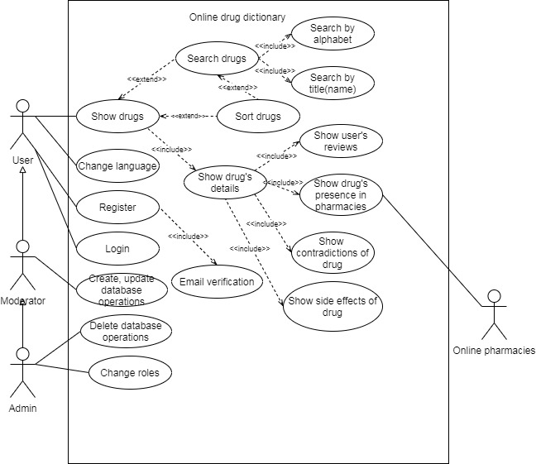

Figure 1.2 Use case diagram

2.6 Calendar plan

In this section, we have created a plan that can still be finalized over time. However, the main criteria and processes for developing our project have already been highlighted at this stage. We made a plan following the SMART concept. S stands for specific which means what goals we need to reach. M stands for measurable, for example, we measure speed of page loading that shows quality of our code. A stands for achievable which means that the goals we need to reach is adequate and we can handle them. R stands for relevant, it needs because tasks in our project should be fully usable in our project. T stands for time-based what considered as starts and deadline time of our tasks. Below is our timetable with marking who will do what work. Our team is made up of software developers, so it is easy for us to assign all team members to the same task.

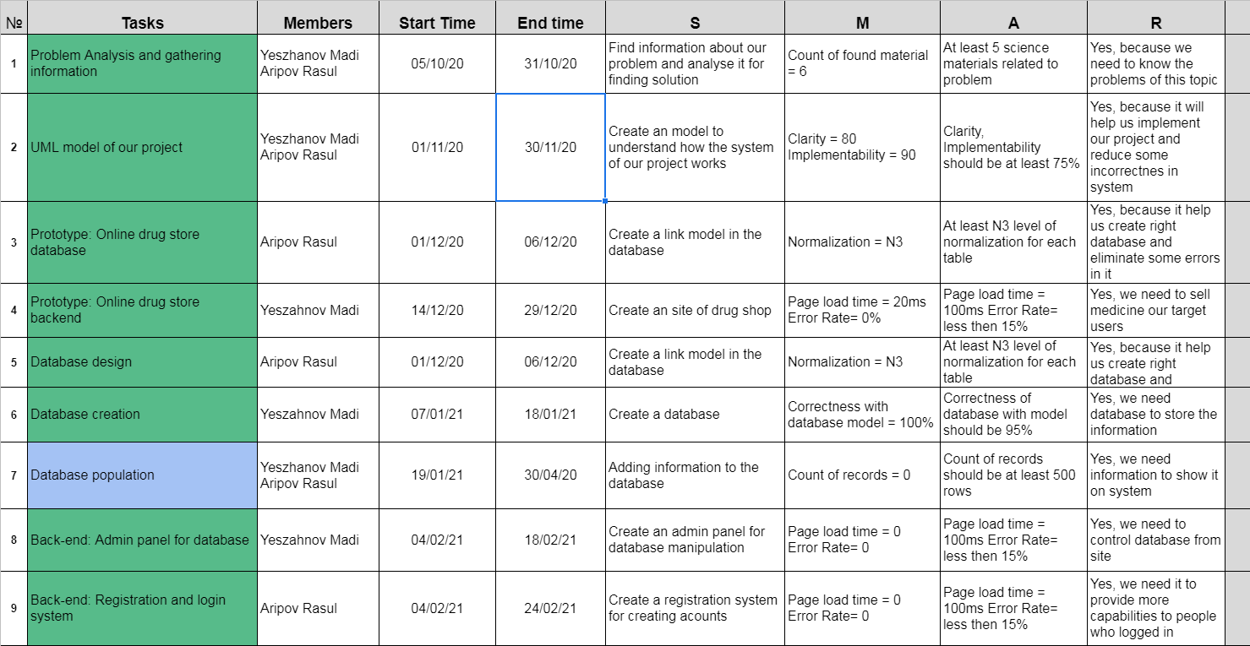

Figure 2.3 Calendar plan first part

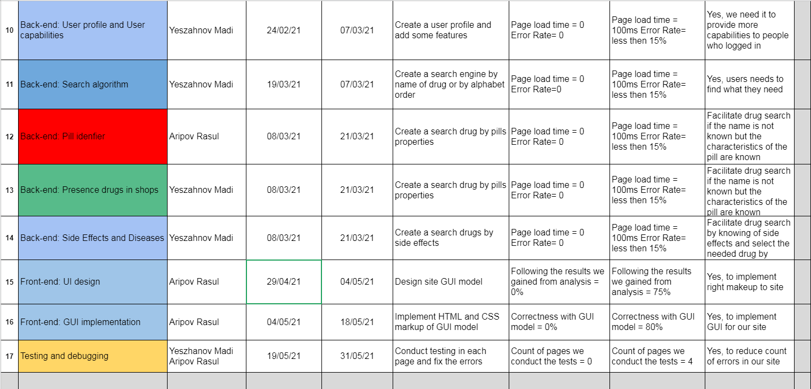

Figure 2.3 Calendar plan second part

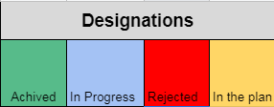

Figure 2.3 Calendar plan designations

2.7 Database design

Now, let's take a look at the initial design of the database for the project. Firstly, an entity relationship diagram was developed that shows the relationship between tables. The database has been compiled so that it can support multiple languages, which is one of the requirements for our project.

ER-diagram elements: PK – primary key, FK – foreign key, “Crow feet” – many relation, empty line – one relation.

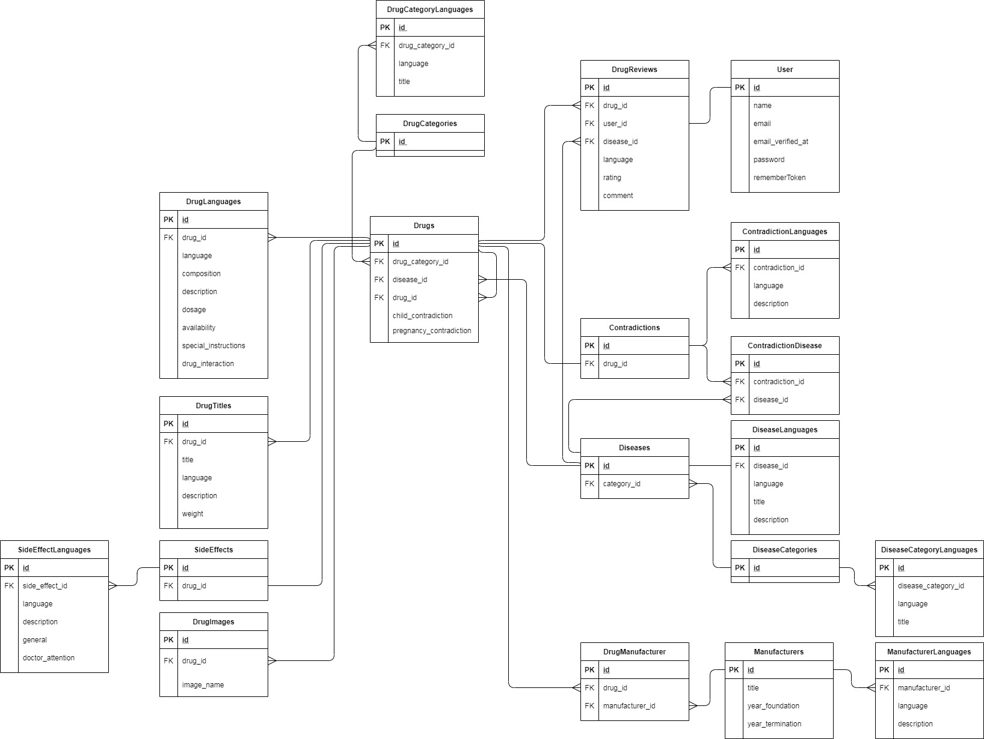

Figure 1.4 ER-diagram.