

AMITY INSTITUTE OF INFORMATION TECHNOLOGY

Course Code : CSE2052

“Introduction to AIML”

LABORATORY RECORD

Fall Semester - 2025

SUBMITTED TO:
Dr Madhu Bhan
SUBMITTED BY:
Name: Madiha mufassira
SEN: A86904824018
BCA
Sl. No. | Date | Program | Page No.
1 | 24/09/25 | Simple Rule-Based Agent
2 | 24/09/25 | Simple Rule-Based Agent
3 | 08/10/25 | Problem representation
4 | 08/10/25 | Simple Rule-Based Agent
5 | 15/10/25 | Goal based agent
6 | 29/10/25 | Breadth First Search
7 | 12/11/25 | Depth First Search
8 | 19/11/25 | Propositional Logic
9 | 19/11/25 | Predicate Facts
10 | 26/11/25 | Mean, Mode, Median and Standard Deviation
11 | 26/11/25 | Dataset
12 | 03/12/25 | Simple Imputer
13 | 10/12/25 | Z-Score
14 | 10/12/25 | Train test
15 | 24/12/25 | Normalization
16 | 31/12/25 | Simple Linear Regression
17 | 07/01/26 | The best-fit regression line
18 | 21/01/26 | Decision tree classifier
19 | 28/01/26 | Logistic Regression

Program 1:Simple rule based agent.
Write a Python program where agent decides an action based on conditions.

weather=input("Enter the weather(sunny,rainy,cloudy,cold):").lower()
if weather=="sunny":
print("Wear sunglasses")
elif weather=="rainy":
print("Carry an umbrella")
elif weather=="cloudy":
print("It might rain,better take a light jacket")
elif weather == "cold":
print("Wear a warm coat")
else:
print("No specific advice, enjoy your day!")

OUTPUT:

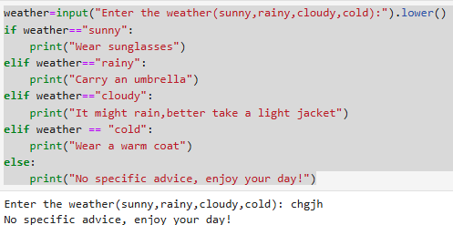

Program 2 :Simple rule based agent.
Write a Python program where agent decides an action based on Temperature.

temperature=input("Enter the temperature(10,20,30,40):").lower()
if temperature=="10":
print("Low temperature")
elif temperature=="20":
print("Modem temperature")
elif temperature=="30":
print("High temperature")
elif temperature== "40":
print("Too High temperature")
else:
print("Temperature not detected")

OUTPUT:

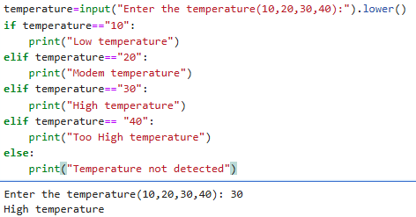
Program 3:Problem Representation.
Write a python program 8_puzzle ,8_puzzle state representation. Display as a 3x3 matrix.
initial_state = [1, 2, 3, 4, 5 ,6, 7, 8, -1]
goal_state = [2, 4, 6, 8, 14, 16, 10, 12, 1]
print("Initial State:")
for i in range(0, 9, 3):
print(initial_state[i:i+3])

print("\nGoal State:")
for i in range(0, 9, 3):
print(goal_state[i:i+3])

if initial_state == goal_state:
print("The two states are same")
else:
print("The two states are different")

OUTPUT:

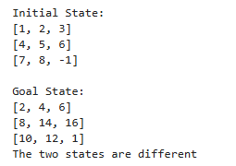
Program 4:Simple rule based agent.
Write a Python program to simulate a Vacuum cleaner
Agent that cleans two locations.

def vacuum_agent():
environment = {}
environment['A'] = input("Current status of Room A (Dirty/Clean): ").lower()
environment['B'] = input("Current status of Room B (Dirty/Clean): ").lower()
vacuum_location = input("Enter initial location of vacuum cleaner (A/B): ").upper()
print("\nInitial Environment State:")
print(f"Room A: {environment['A']}")
print(f"Room B: {environment['B']}")
print(f"Vacuum Cleaner at Room: {vacuum_location}")

if environment[vacuum_location] == 'dirty':
print(f"\nRoom {vacuum_location} is dirty. Cleaning")
environment[vacuum_location] =='clean'
print(f"Room{vacuum_location} is cleaned.")
else:
print(f"\nRoom {vacuum_location} is already clean. Move to next Room.")

next_room = 'B' if vacuum_location == 'A' else 'A'
if environment[next_room] == 'dirty':
print(f"\nRoom {next_room} is dirty. Cleaning")
else:
print(f"\nRoom {next_room} is already clean.")
print("\nFinal Environment State:")
print(f"Room A: {environment['A']}")
print(f"Room B: {environment['B']}")
print("All Rooms are now clean!")

vacuum_agent()

OUTPUT:

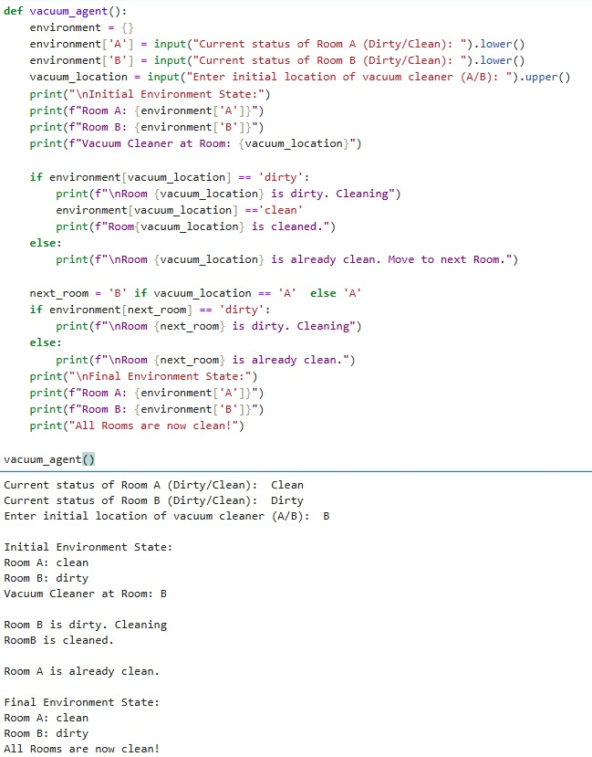

Program 5: Goal based agent.
Write a Python Program to simulate an Autonomous Car Agent .
def autonomous_car_agent(traffic_light, obstacle, road_condition):
print("Traffic Light:", traffic_light)
print("Obstacle Detected:", obstacle)
print("Road Condition:", road_condition)
if traffic_light.lower() == "red":
action = "Stop the car"
elif traffic_light.lower() == "yellow":
action = "Slow down and prepare to stop"
elif obstacle.lower() == "yes":
action = "Stop — obstacle ahead"
elif road_condition.lower() == "slippery":
action = "Drive slowly and carefully"
elif traffic_light.lower() == "green" and obstacle.lower() == "no":
action = "Move forward safely"
else:
action = "Stay alert and maintain current state"

print("Decision:", action)
print(" Scenario 1 ")
autonomous_car_agent("Red", "No", "Clear")

print("\n Scenario 2 ")
autonomous_car_agent("Green", "Yes", "Clear")

print("\n Scenario 3 ")
autonomous_car_agent("Green", "No", "Slippery")

OUTPUT:

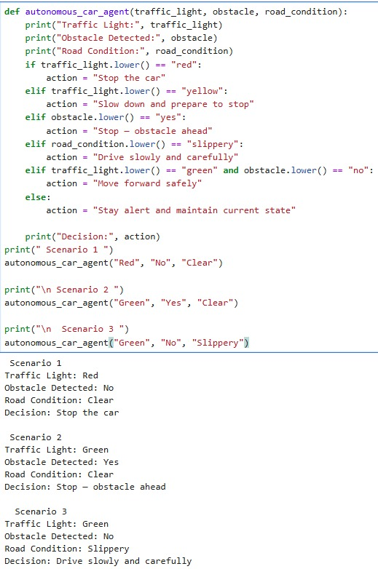

Program 6: Write a Python program that accepts an adjacency list of a graph as input and performs Breadth First Search (BFS) starting from a given source node.

n = int(input("Enter the number of nodes: "))
nodes = []
print("Enter the node names:")
for i in range(n):
name = input(f"Node {i+1} name: ")
nodes.append(name)
graph = {}
print("\nEnter the adjacent nodes for each node (separated by space or comma):")
for node in nodes:
raw = input(f"Neighbors of {node}: ")
raw = raw.replace(",", " ")
neighbors = raw.split()
graph[node] = neighbors
print("\nAdjacency List Representation:")
for node in graph:
print(node, "->", ", ".join(graph[node]))
start = input("\nEnter the starting node for BFS: ")
if start not in graph:
print("\nError: Starting node not found in graph!")
exit()
visited = []
queue = []
visited.append(start)
queue.append(start)
print("\nBFS Traversal Order:", end=" ")
while queue:
node = queue.pop(0)
print(node, end=" ")
for neighbor in graph[node]:
if neighbor not in visited:
visited.append(neighbor)
queue.append(neighbor)
print()

OUTPUT:

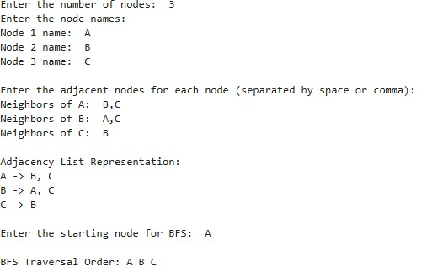

Program 7: Write a Python program that accepts an adjacency list of a graph as input and performs Depth First Search (DFS) starting from a given source node.

n = int(input("Enter the number of nodes: "))
nodes = []
print("Enter the node names:")
for i in range(n):
name = input(f"Node {i+1} name: ")
nodes.append(name)
graph = {}
print("\nEnter the adjacent nodes for each node (separated by space):")
for node in nodes:
neighbors = input(f"Neighbors of {node}: ").replace(",", " ").split()
graph[node] = neighbors
print("\nAdjacency List Representation:")
for node in graph:
print(node, "->", ", ".join(graph[node]))
start = input("\nEnter the starting node for DFS: ")
visited = []
stack = [start]
print("\nDFS Traversal Order:", end=" ")
while stack:
node = stack.pop()
if node not in visited:
print(node, end=" ")
visited.append(node)
for neighbor in reversed(graph[node]):
if neighbor not in visited:
stack.append(neighbor)

print()

OUTPUT:

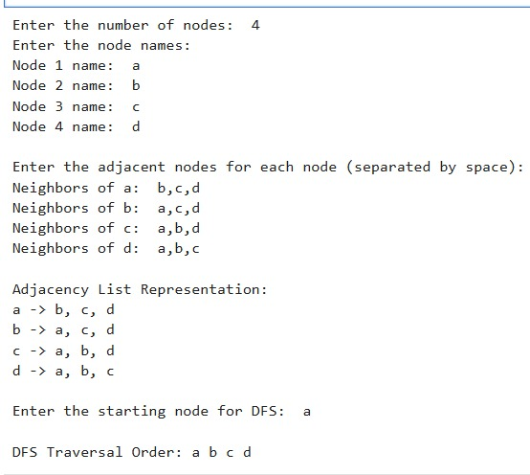

Program 8: Write a Python program to evaluate basic Propositional Logic expressions. The user should enter truth values (True/False) for propositions P and Q.

print("enter the truth values for P and Q (true/false):")
P = input("enter P (true/false): ")
Q = input("enter Q (true/false): ")
if P.lower() == "true":
P = True
else:
P = False

if Q.lower() == "true":
Q = True
else:
Q = False
and_result = P and Q
or_result = P or Q
not_result = not P
implication_result = (not P) or Q
biconditional_result = (P and Q) or ((not P) and (not Q))

print("\n--- results ---")
print("P AND Q =", and_result)
print("P OR Q =", or_result)
print("NOT P =", not_result)
print("P -> Q =", implication_result)
print("P <-> Q =", biconditional_result)

OUTPUT:

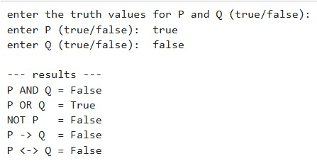

Program 9: Write a Python Program that stores a few predicate facts (like parent, brother, teacher) using simple lists.

parent_facts = [("John","Marry"), ("Ravi","Amit")]
brother_facts = [("Amit","Rohan"), ("Rohan","Amit")]
teacher_facts = [("Seema","Class5"), ("Arun","Class3")]

print("Enter a Query like : Parent(John, Mary)")
query = input("Query: ")

parts = query.split("(")
predicate = parts[0]

args = parts[1].replace(")","")

arg1, arg2 =args.split(",")

arg1 = arg1.strip()
arg2 = arg2.strip()

fact_exists = False

if predicate == "Parent":
if (arg1, arg2) in parent_facts:
fact_exists = True

elif predicate == "Brother":
if (arg1, arg2) in brother_facts:
fact_exists = True

elif predicate == "Teacher":
if (arg1, arg2) in teacher_facts:
fact_exists = True

if fact_exists:
print("Fact exists in the knowledge base.")
else:
print("Fact does NOT exist in the knowledge base. ")

OUTPUT:

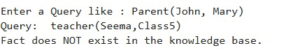

Program 10: Find Mean, Mode, Median and Standard Deviation of a given dataset speed=[99,86,87,88,111,86,103,87,94,78,77,85,86].

import numpy
from scipy import stats
speed=[99,86,87,88,111,86,103,87,94,78,77,85,86]
x=numpy.mean(speed)
y=numpy.median(speed)
z=stats.mode(speed)
p=numpy.std(speed)
print("Mean is",x)
print("Median is",x)
print("Mode is",x)
print("Standard Deviation is",x)
OUTPUT:

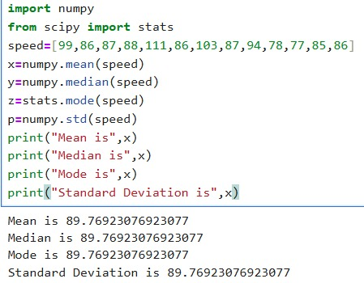
Program 11: Write a Python Program to demonstrate the concept of a dataset and features . Create a small dataset, identify the features and target values ,and display them separately.

import numpy as np
X=np.array({1,2,3,4})
y=np.array({10,20,30,40})
print("Features before reshape(1-D):")
print(X)
print("Shape:",X.shape)
X=x.reshape(-1,1)
print("/nFeature aftert reshape (2-D):")
print(X)
print("Shape:",X.shape)
y= y.reshape(-1,1)
print("\nLabel after reshape(2-D):")
print(y)
print("Shape:",y.shape)
OUTPUT:
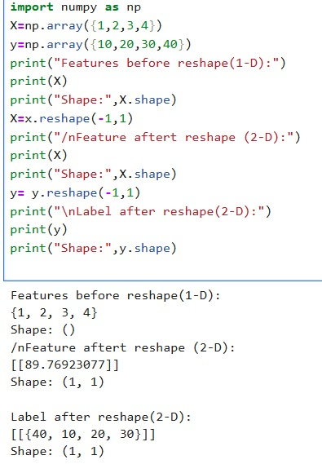

Program 12: Design a Python program to demonstrate the use of Simple imputer class for filling the missing values.
MEDIAN:
import numpy as np
from sklearn.impute import SimpleImputer
data = np.array([
[10, 2],
[15, np.nan],
[np.nan, 4],
[20, 5]
])
print("Original Data:")
print(data)
imputer = SimpleImputer(strategy='median')
imputed_data = imputer.fit_transform(data)
print("\nData After Imputation:")
print(imputed_data)
OUTPUT:

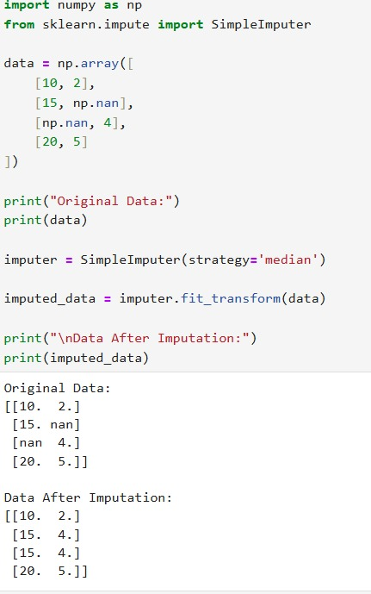
MOST FREQUENT:
import numpy as np
from sklearn.impute import SimpleImputer
from scipy import stats
data = np.array([
[10, 2],
[15, np.nan],
[np.nan, 4],
[20, 5]
])
print("Original Data:")
print(data)
imputer = SimpleImputer(strategy='most_frequent')
imputed_data = imputer.fit_transform(data)
print("\nData After Imputation:")
print(imputed_data)

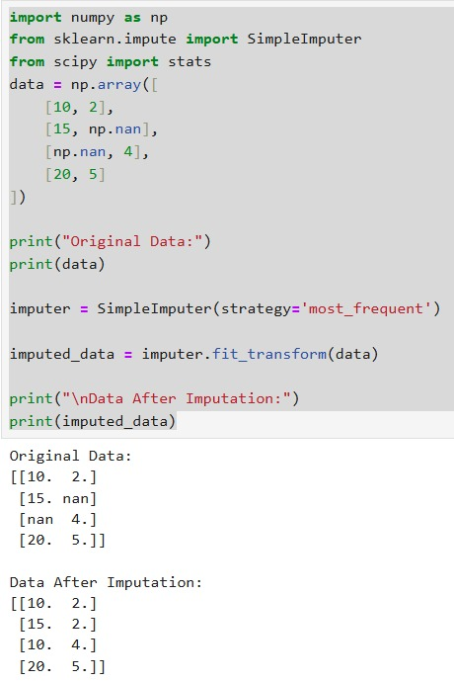
MEAN:
import numpy as np
from sklearn.impute import SimpleImputer
from scipy import stats
data = np.array([
[10, 2],
[15, np.nan],
[np.nan, 4],
[20, 5]
])
print("Original Data:")
print(data)
imputer = SimpleImputer(strategy='mean')
imputed_data = imputer.fit_transform(data)
print("\nData After Imputation:")
print(imputed_data)
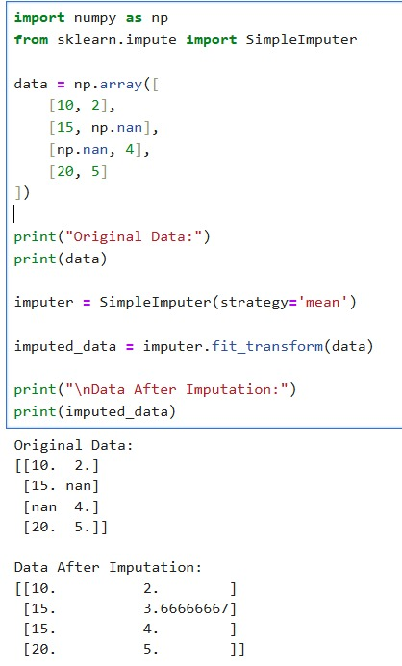

Program 13: Write a Python program to find outliers using Z-score.

import numpy as np
from scipy import stats
data = [10, 12, 14, 15, 16, 18, 20, 22, 24, 100]
z_scores = stats.zscore(data)
threshold = 3
outliers = []
for i in range(len(data)):
if abs(z_scores[i]) > threshold:
outliers.append(data[i])
print("Data:", data)
print("Z-scores:", z_scores)
print("Outliers:", outliers)

OUTPUT:

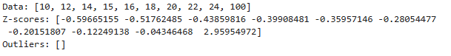

Program 14:Design a Python program to demonstrate how a dataset is divided into training data and testing data using the train_test_split() function from the scikit learn library.

import numpy as np
from sklearn.model_selection import train_test_split
x=np.array([800,1000,1200,1500,1800]).reshape(-1,1)
y=np.array([120,150,180,210,250])
x_train,x_test,y_train,y_test=train_test_split(
x,y,test_size=0.2,random_state=42)
print("x_train:",x_train)
print("y_train:",y_train)
print("x_test:",x_test)
print("y_test:",y_test)

OUTPUT:

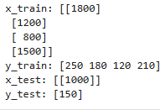
Program 15:Given the following dataset representing marks scored by students:[10,12,14,15,16,18,20,22,24]. Write a Python program to perform y Min-Max Normalization to scale the data between 0 and 1.(min_max)
import numpy as np
data = np.array([10, 12, 14, 15, 16, 18, 20, 22, 24])
data_min = np.min(data)
data_max = np.max(data)
normalized_data = (data - data_min) / (data_max - data_min)
print("Original Data:", data)
print("Minimum Value:", data_min)
print("Maximum Value:", data_max)
print("Normalized Data:", normalized_data)

OUTPUT:

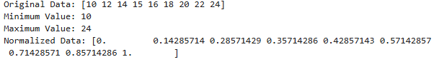

Program 16: This program is used to implement Simple Linear Regression using Python and scikit-learn to predict house prices based on house size.
import numpy as np
from sklearn.model_selection import train_test_split
from sklearn.linear_model import LinearRegression

# Step 1: Create dataset
X = np.array([800, 1000, 1200, 1500, 1800]).reshape(-1, 1)
y = np.array([120, 150, 180, 210, 250])

# Step 2: Split data into training and testing sets
X_train, X_test, y_train, y_test = train_test_split(X, y, test_size=0.2, random_state=42)

# Step 3: Create Linear Regression model
model = LinearRegression()

# Step 4: Train the model
model.fit(X_train, y_train)

# Step 5: Predict on test data
y_pred = model.predict(X_test)
y_pred1 = model.predict([[300]])

# Step 6: Display results
print("Test Data (X_test):", X_test)
print("Actual Price (y_test):", y_test)
print("Predicted Price (y_pred):", y_pred)

# Step 7: Display model parameters
print("Slope (Coefficient):", model.coef_)
print("Intercept:", model.intercept_)
print("Price value for area 300 sqft:", y_pred1)

OUTPUT:
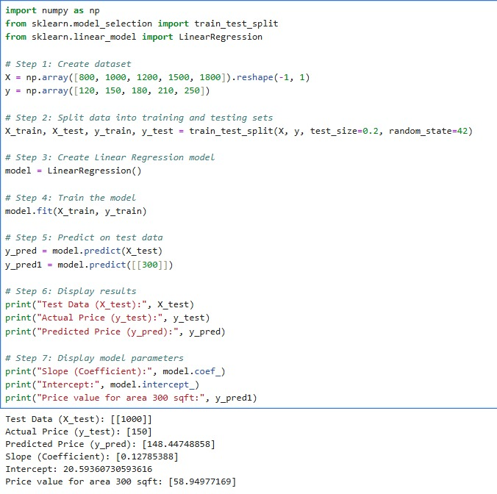
Program 17: This program is used to draw the best-fit regression line for a given dataset using linear regression.

import numpy as np
import matplotlib.pyplot as plt
from scipy import stats

x = [1, 2, 3, 4, 5, 6]
y = [0.4, 1.0, 1.7, 2.0, 2.2, 3.0]

slope, intercept, r, p, std_err = stats.linregress(x, y)
print(slope)
print(intercept)

def myfunc(x):
return slope * x + intercept
mymodel = list(map(myfunc, x))

plt.scatter(x, y)
plt.plot(x, mymodel)
plt.show()

OUTPUT:

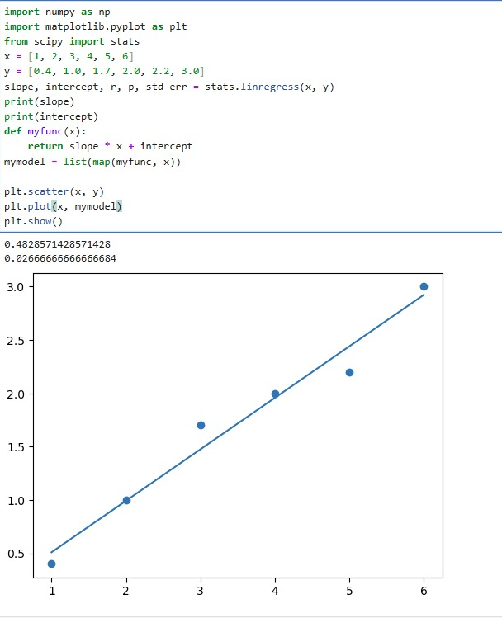

Program 18: Design and develop a python program that uses a decision tree classifier to predict diabetes outcomes.

import pandas as pd
from sklearn.tree import DecisionTreeClassifier, export_text
from sklearn.model_selection import train_test_split
from sklearn.metrics import accuracy_score
from sklearn import metrics
from pandas import DataFrame
pima = pd.read_csv("C:/Users/student/Desktop/diabetes.csv")

print("Dataset Preview:")
print(pima.head())
x = list(pima.columns)
x = pima.drop("Outcome",axis = 1)
y = pima["Outcome"]
print("\nPredictor Attributes : ")
print(x.columns.tolist())
x_train,x_test,y_train,y_test = train_test_split(x,y,test_size = 0.3,random_state = 1)
clf = DecisionTreeClassifier()
clf = clf.fit(x,y)
y_pred = clf.predict(x_test)
accuracy = accuracy_score(y_test,y_pred)
print("\nModel Accuracy : ",accuracy)

OUTPUT:
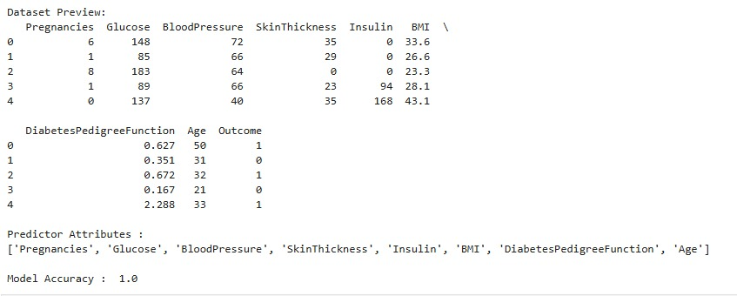

Program 19: Write a python program to implement logistic regression for binary classification problem that predicts whether a student passes or fails based on the number of hours studied.

OUTPUT:

