**ABSTRACT**

Cracks can occur on different surfaces such as buildings, roads, aircrafts, etc. The manual inspection of cracks is time‐consuming and prone to human error. Machine vision has been used for decades to detect defects in materials in production lines. However, the detection or segmentation of cracks on a randomly textured surface, such as marble, has not been sufficiently investigated. This work provides an up‐to‐date systematic and exhaustive study on marble crack segmentation with color images based on deep learning (DL) techniques. The results indicate the importance of selecting the appropriate Loss function and backbone network, underline the challenges related to the marble crack segmentation problem, and pose an important step towards the robotic automation of crack segmentation in marble‐processing plants.

**Introduction**

Natural rock is an extremely inhomogeneous material from which tiles are cut. No tile is like another even if cut from the same slab. Due to this fact, the selection of the tiles which are going to be installed on a surface is a task that requires special dexterity, if a high aesthetic value is expected. Although many parts of the production line have been automated over the years, this important task is still done manually by highly experienced workers at the quality control table. Fatigue, changing light conditions, and different shift workers can lead to very important flaws in this selection procedure.This will make it easier to select the right tiles for a homogenous installation and therefore rise customer satisfaction.

**Objectives**

The process of classification of marble slabs has an important place in terms of construction sector and demands. Despite the advanced mines and construction equipment in Pakistan and the world, the separation of cut marble process is a problem that has not been solved yet. The lack of a standard for the classification of marbles and the use of human factors for this process lead to erroneous and inefficient determinations. In this study, the components obtained from Deep Learning layers have been examined and the success of classification has measured.

**Scope of Work**

**The Physiology of Cracks in Marble**

Marble is a metamorphic, i.e., heated and compressed, rock originating from sedimentary limestone. Marble is quarried naturally and contains mainly calcium. In some cases, magnesium can prevail, and then the rock is called dolomite [31]. Marble is quarried in blocks of 3 × 2 × 5 m. From these blocks, slabs are cut, usually in the size of 3 × 2 m with thickness ranging from 2 to 4 cm. Slabs are further cut into tiles of various sizes, depending on the needs of the construction. The schematic procedure of marble from the quarry into tile is illustrated in Figure 1.

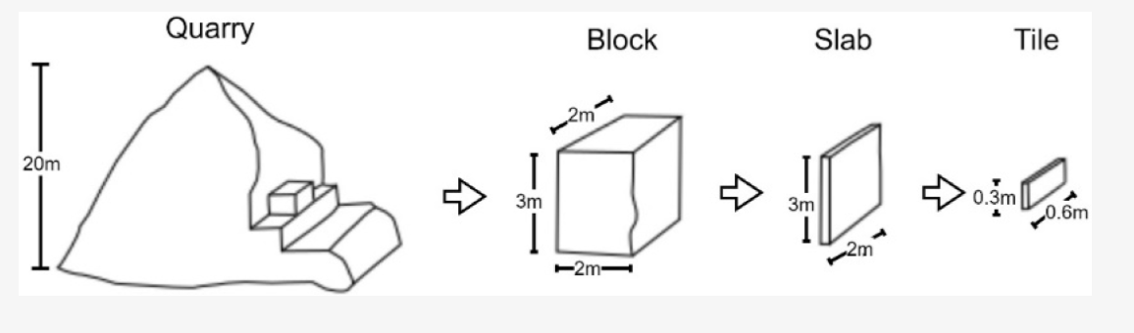

Figure 1 Schematic representation of marble processing from quarry to tile

The detection of flaws using computer vision is a difficult task due to the complex textures on many marble types marketed today. Due to their optical similarity to cracks, marble texture pose a significant problem to the automatic recognition of cracks.

|  |  |
| --- | --- |
| page6image1318049520 | page6image1318049856 |
| Figure 2 (a) Textured marble without cracks. The line resembling a crack at the left–bottom section of the image | Figure2 (b) textured marble with cracks. Two parallel cracks at the right–bottom section of the image |

Due to the improvements in building industry and increasing demands in terms of aesthetics throughout the world, interest and demand in marble varieties such as travertine, onyx, and granite increase simultaneously. When a human eye looks at objects that have the same colour and type, it gets tired and its selectivity decreases biologically. Therefore, classification failure due to the man skills is usually faced at the businesses and thereby production and productivity decline.

**Methodolgy**

**About Dataset**

Publicly available datasets were analyzed in this study. The used dataset was a reformation of the dataset for marble surface anomaly detection 2, provided by Aman Rastogi. The developed Dataset and annotations can be found here: [https://www.kaggle.com/datasets/wardaddy24/marble-surface-anomaly-detection].

The dataset folder has two folders train and test. In train and test folders there are 4 classes namely: **crack**, **dot**, **good** and **joint**.  
There are a total of 2249 files in the train folder and 688 files in the test folder. The images are 256 x 256 in dimension.  
The images are cropped from the original [dataset](https://www.kaggle.com/wardaddy24/marble-surface-anomaly-detection). There is no overlapping among the cropped images and the aspect ratio is maintained while generating the crops. The dataset is in GoogleNet format. ImageNets weights are used and transfer learning is done.

**Image Data Generator**

It generates batches of tensor image data with real-time data augmentation. We built our Image Data Generator which will be used to generate train and valid tests directly from the main directory by using [Flow From Directory](https://keras.io/api/preprocessing/image/#flowfromdataframe-method). We also applied some image augmentation to our generator. Rotation range of 20 degrees — rotates images randomly, set Horizontal and Vertical flip to be True, shifts in width and height, and the fill mode to be nearest. After initializing the generator, we set the target size of each image to be 48x48(WxH). Each image is required in color so we then set the color mode to be ‘RGB’. Batch size is the number of extractions from each subfolder. We fit this generator for both sets i.e. train and valid.

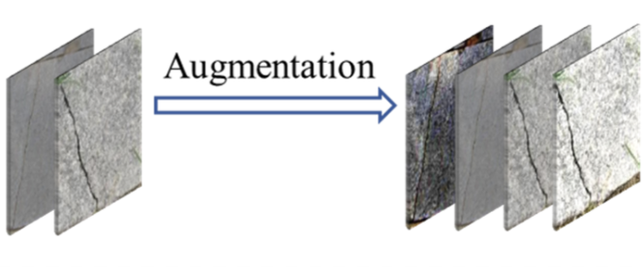

Figure 3 Data augmentation in network training

**Model Architecture**

The model contain:

1. Two Conv2d layers
2. Two Dense Layers
3. Two MaxPoolinig and Dropout Layers

Conv2d layers will extract features from the images in pieces, Dense layer will tune up the weights for them. MaxPooling2D layer will reduce the dimensionality for easier computation and Dropout layers will avoid the overfitting of the model.

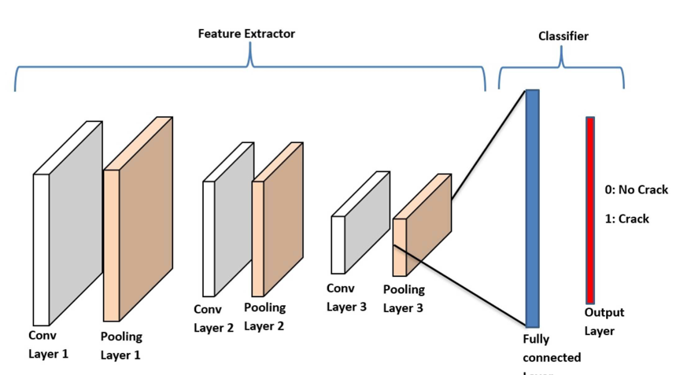

Figure 4 workflow

Categorical cross-entropy was used as loss function because the task is multi-class classification. We also used EarlyStopping callback to call the function back if it doesn’t improve after some epochs. We did this by passing patience as a parameter to the callback.

Following is the accuracy curve of the model on the validation dataset.

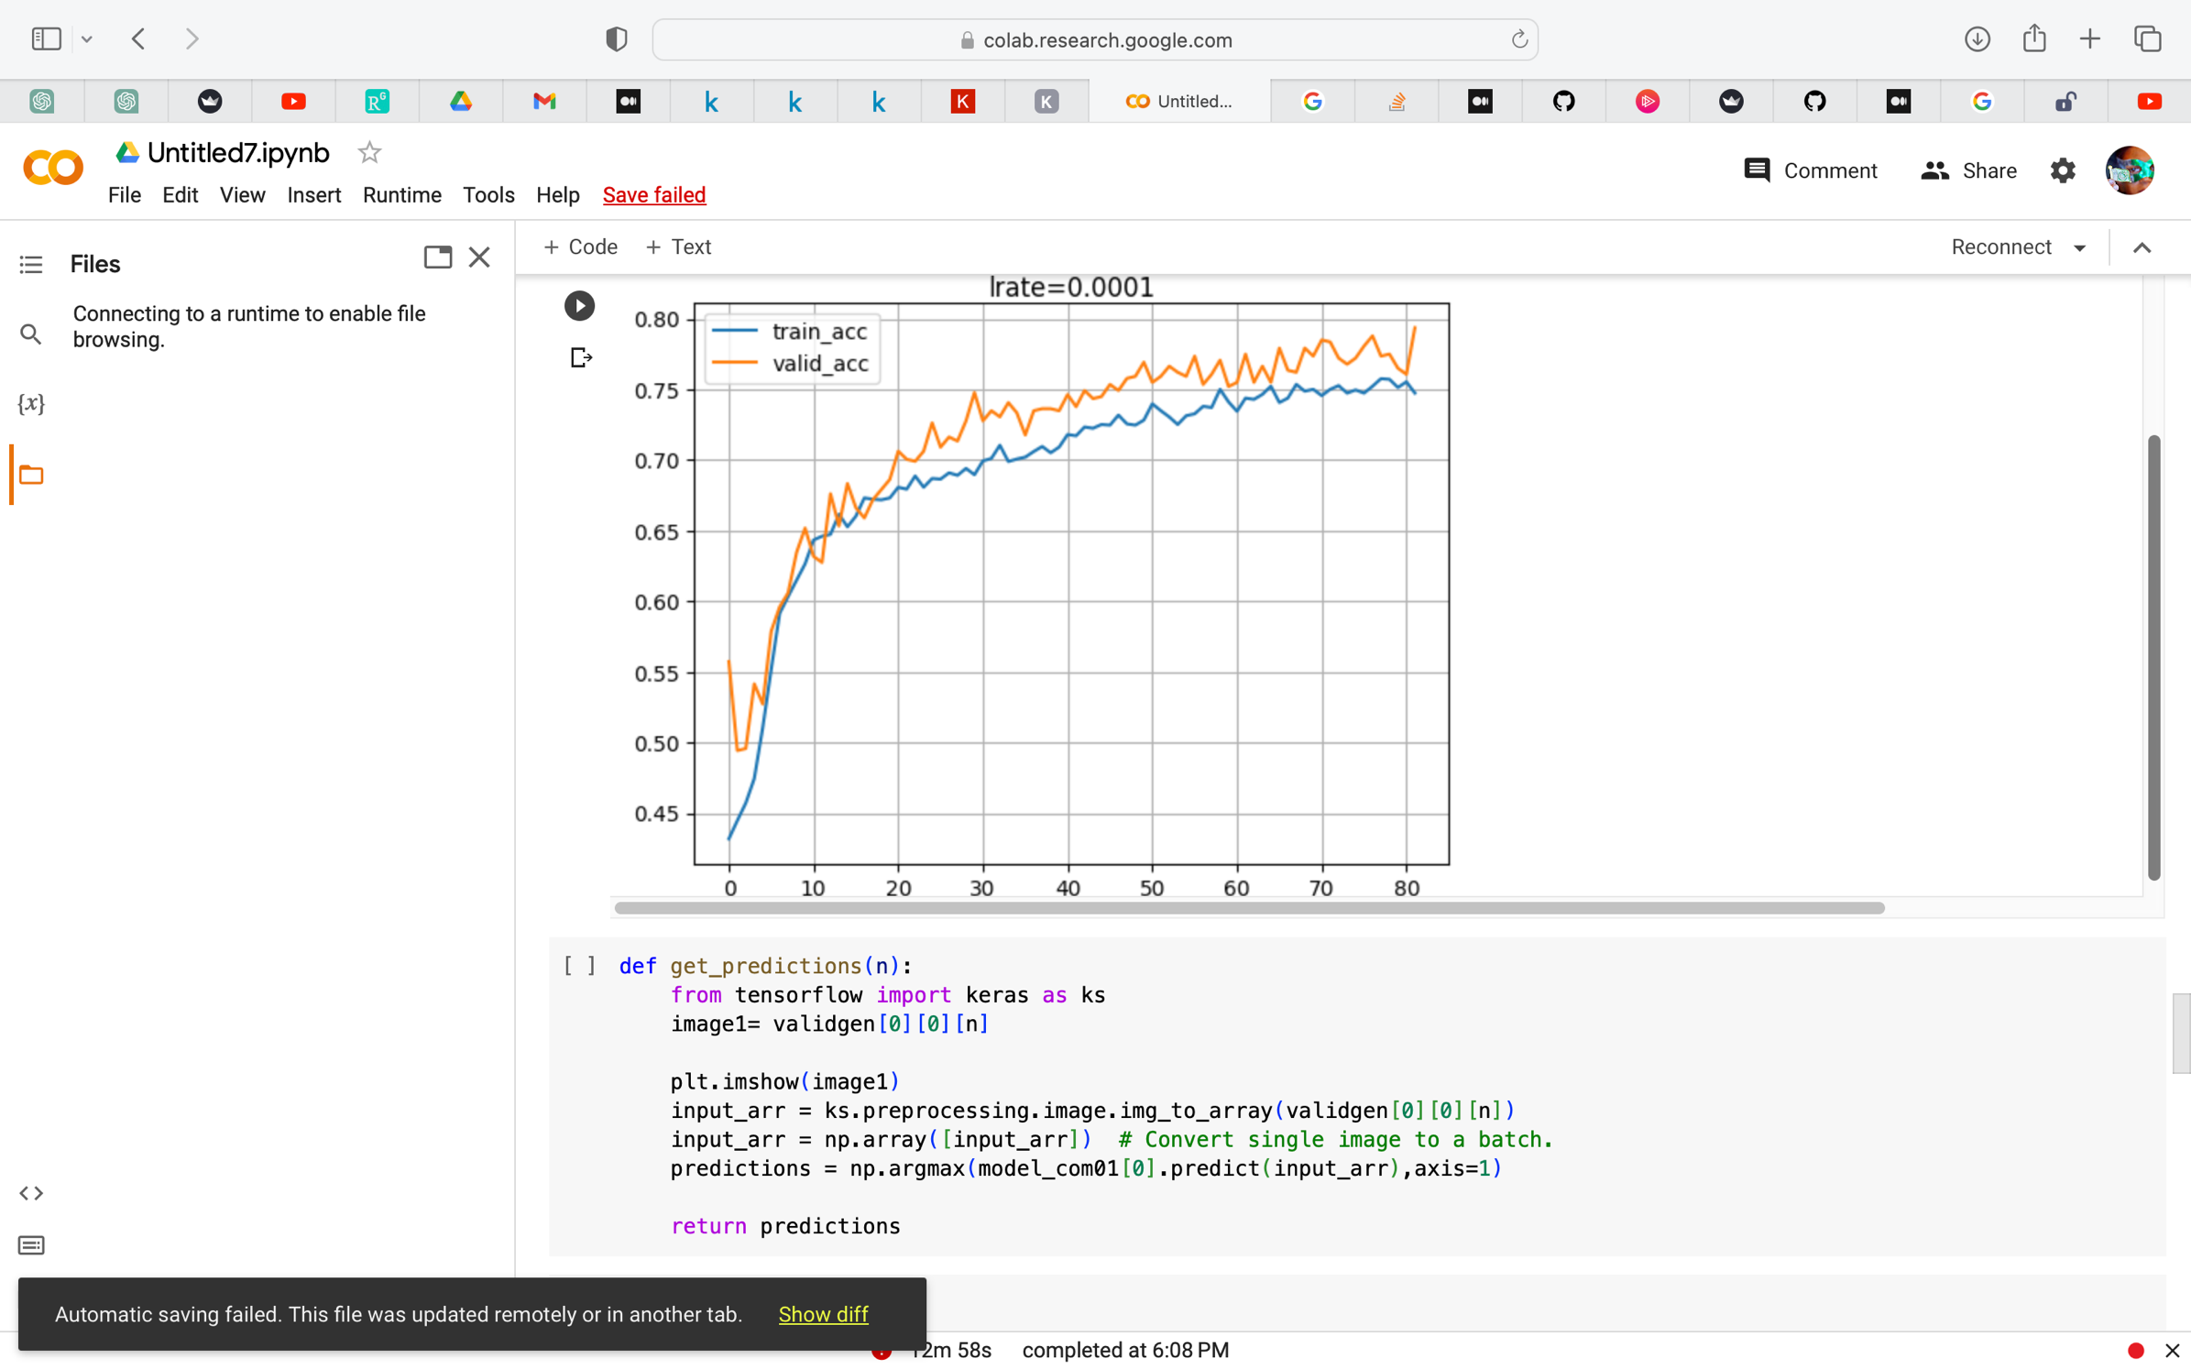

**Findings**

This work revealed that, for a small and imbalanced dataset, there are efficient DL architectures able to provide marble crack segmentation with high accuracy. This work poses the first step towards the implementation of the first automation grading for marble slabs in marble‐processing plants in Pakistan.

Loss functions are also crucial for the determination of a DL model’s performance. For complex tasks such as image segmentation, the Loss function needs to be decided based on the properties of the training data (distribution, skewness, boundaries, etc.). Since a universal Loss does not exist, in this work, a unified Loss function was investigated for enhanced performances. It should be mentioned here that several experiments were conducted before deciding on the selected Loss; binary cross‐entropy, Focal Loss and Dice Loss were investigated separately, but led to lower performances and were, therefore, abandoned. The significant differences in the models’ performance by utilizing a different Loss function underlines its great importance in class‐imbalanced image segmentation tasks.



Figure 5 Screenshot of the project

**Conclusions**

Natural stones that are one of the import and export products for the countries are used in many fields and preferred in terms of aesthetics and also necessity. Marble and its derivatives are used for many materials such as building sector, historical ruins and souvenir. To determine the marble veins and then to cut marble blocks is carried out in a short or long period of time. However, to make the cut marble blocks thinner as plates and then to classify them is still a complicated problem. When the classification of marble slabs is examined, it is seen that there are few studies in this field and current methods are not applied even in the literature. For this reason, information flow has not reached to the mining enterprises yet and marbles are still tried to be classified by the workers with the naked eye at the workplaces. It is regarded as necessity to make the manual selection process automatic and to carry out by using popular methods within the scope of Industry.

In this study Deep Learning method, one of the today’s successful and popular artificial intelligence methods, was applied on the marbles for the first time and then component outputs of the network layers were able to be examined. Successful classification results obtained reveals the practicability of Deep Learning to the marble industry and it is shown that the method can be used for marble cutting and selection processes. Furthermore, a basis of Deep Learning network for a potential marble database that can be standardized in the future has been established.

In the future, we plan to exploit better strategies to merge representative feature extraction networks to DL models and examine more DL architecture combinations. More images of marble crack regions will be added to the current database so as to make it more comprehensive. Additional Loss functions will be tested, and unified Loss functions will be proposed. However, the main focus of future work will be on the design and development of the overall system with the aim to be used practically in marble‐processing plants.

**Recommendations**

In the future studies a detail parameter and achievement analysis of Deep Learning network to be suggested for the classification of marble slabs with more labels will be carried out. Moreover, the relevant components will be obtained before output layer of deep network and will be used as features for k-nearest neighbour algorithm and classic artificial neural networks. Thereby it is estimated to achieve to increase the success of classification. The best learning method and parameters planned to be obtained will be tested by using cross verification method and then Deep Learning network that can classify the marbles successfully will be constituted. The proposed system may consist of the following three main parts:

1. The visual‐inspection part. This will include:

* A diffusion box to ensure the uniform and consistent lighting of all slabs;
* A high‐resolution (HR) RGB camera for the best possible visualization of the cracks;
* A thermal camera for displaying the thermal distribution on the surface of the slab, in the form of a thermal image, for better distinguishing cracks possibly not visible with RGB imaging;

1. Auxiliary parts. This will include:

* A conveyor belt that will move the marble slabs one by one into the basic system part, the visual‐inspection part and the robotic resin application part;
* An electric heating device/source underneath the diffusion box to thermally excite the surface of the marble slabs for thermal imaging;
* A high‐performance computer to speed up the execution of the DL segmentation algorithms and process all other system‐supporting algorithms.



**References**

[1]  I. Chatzipanagis and D. Bougioukas, “The significance of the lithostratigrafic and the tectonic deformation for locating and exployting the dolomitic marbles of Falacron Mountain. (in greek),” *Bulletin of the Geological Society of Greece vol. XXXVI, 2004*, 2004, [Online]. Available: https://www.openarchives.gr/aggregator- openarchives/edm/geosociety/000068- geosociety_article_view_16570

[2]  K. Laskaridis, M. Patronis, C. Papatrechas, N. Xirokostas, and S. Flippou, *Directory of Greek Ornamental & Structural Stones*. Hellenic Survey of Geology & Mineral Exploration, 2015.

[3]  G. K. Sidiropoulos, A. G. Ouzounis, G. A. Papakostas, I. T. Sarafis, A. Stamkos, and G. Solakis, “Texture Analysis for Machine Learning Based Marble Tiles Sorting,” *IEEE*, 2021.

[4]  A. Ouzounis, G. K. Sidiropoulos, Papakostas, George A.., I. T. Sarafis, A. Stamkos, and G. Solakis, “Interpretable Deep Learning for Marble Tiles Sorting,” *2nd International Conference on Deep Learning Theory and Applications*, 2001.

[5]  V. G. Hernandez, P. C. Perez, L. G. G. Perez, L. M. T. Balibrea, and H. Puyosa Pina, “Traditional and neural networks algorithms: applications to the inspection of marble slab,” in *1995 IEEE International Conference on Systems, Man and Cybernetics. Intelligent Systems for the 21st Century*, Vancouver, BC, Canada, 1995, vol. 5, pp. 3960–3965. doi: 10.1109/ICSMC.1995.538408.

[6]  J. Martínez-Cabeza-de-Vaca-Alajarín and L. Tomás-Balibrea, “Marble slabs quality classification system using texture recognition and neural networks methodology,” *undefined*, 1999. /paper/Marble- slabs-quality-classification-system-using-Mart%C3%ADnez- Cabeza-de-Vaca-Alajar%C3%ADn-Tom%C3%A1s- Balibrea/371b2875a024c6b58d97abb6801f202e219e326d (accessed Jan. 09, 2021).

[7] M. Lopez, J. Martinez, J. M. Matia, J. Taboada, and J. A. Vilan, “Functional classification of ornamental stone using machine learning techniques,” *Journal of Computational and Applied Mathematics*, no. 234, pp. 1338–1345, 2010, doi: https://doi.org/10.1016/j.cam.2010.01.054.

[8] A. Ferreira and G. Giraldi, “Convolutional Neural Network approaches to granite tiles classification,” *Expert Systems with Applications*, vol. 84, pp. 1–11, Oct. 2017, doi: 10.1016/j.eswa.2017.04.053.

[9] K. Simonyan and A. Zisserman, “Very Deep Convolutional Networks for Large-Scale Image Recognition,” *arXiv:1409.1556 [cs]*, Apr. 2015, Accessed: Jan. 07, 2021. [Online]. Available: http://arxiv.org/abs/1409.1556

[10] X. Liu, H. Wang, H. Jing, A. Shao, and L. Wang, “Research on Intelligent Identification of Rock Types Based on Faster R-CNN Method,” *IEEE Access*, vol. 8, pp. 21804–21812, 2020, doi: 10.1109/ACCESS.2020.2968515.