TESTING REPORT

Insulation Resistance test

|  |  |  |  |  |  |  |  |  |  |  |  |  |  |  |
| --- | --- | --- | --- | --- | --- | --- | --- | --- | --- | --- | --- | --- | --- | --- |
| Location | Parent Location | Facility Area | No. Poles | SPD Applicable | Nominal Circuit Voltage (V) | Measurement Terminals | Test Voltage (V) | Conductor Type | Conductor Size (sq. mm) | Number of Runs | Insulation Type | Leakage Capacitance (nF) | Insulation Resistance (MO) | Result |
| MCB 1 | Feeder 2 | LT Panel Room | single | No | 230 | L1-E | 500.0 | Copper | 6 | 1 | PVC | 10.0 | 10.0 | Satisfactory |
| MCB 4 | Feeder 3 | Workshop MCC | single | No | 230 | L1-E | 500.0 | Aluminium | 4 | 2 | XLPE | 10.0 | 1.88 | Satisfactory |

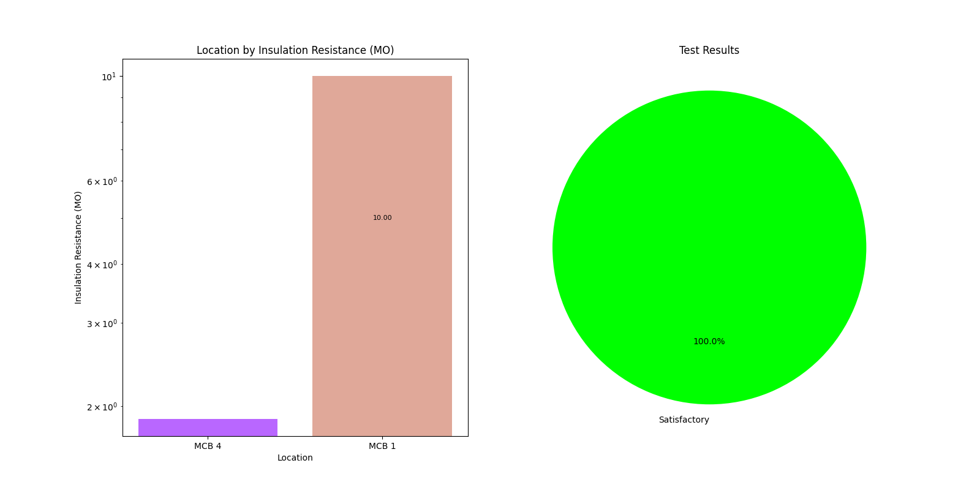

Floor wall Resistance test

|  |  |  |  |  |  |  |  |  |  |
| --- | --- | --- | --- | --- | --- | --- | --- | --- | --- |
| Location | Parent Location | Facility Area | Distance from previous test location (m) | Nominal Voltage to Earth of System (V) | Applied Test Voltage (V) | Measured Output Current (mA) | Resistance (kO) | Effective Resistance | Result |

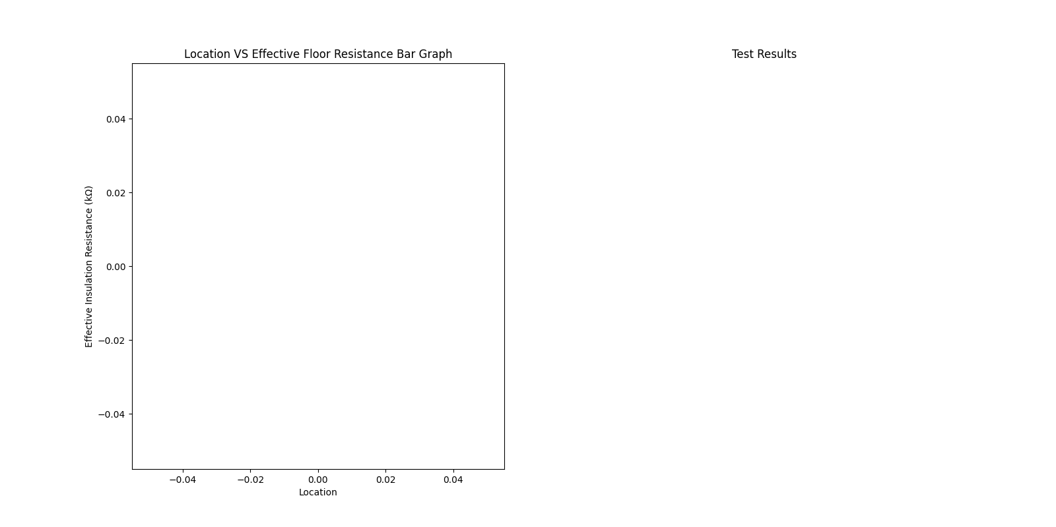

Resistance conductor test

|  |  |  |  |  |  |  |  |  |  |  |  |  |  |  |  |  |
| --- | --- | --- | --- | --- | --- | --- | --- | --- | --- | --- | --- | --- | --- | --- | --- | --- |
| Location | Parent Location | Facility Area | Conductor Location - From | Conductor Location - To | No of runs of Conductor | Conductor Type | Conductor Size (sq. mm) | Conductor Length (m) | Conductor Temperature (°C) | Is Continuity found? | Lead Internal Resistance (Ω) | Continuity Resistance (Ω) | Corrected Continuity Resistance (Ω) | Specific Conductor Resistance (MO/m) at 30°C | Specific Conductor Resistance (MΩ/m) at 30°C | Result |
| Main ACB | MLTP 1 | LT Panel Room | Main ACB | MLTP-1 | 2 | Copper | 16 | 10.0 | 32.0 | Yes | 0.1 | 1.1 | 1.0 | 9.91e-08 | NAN | Pass |

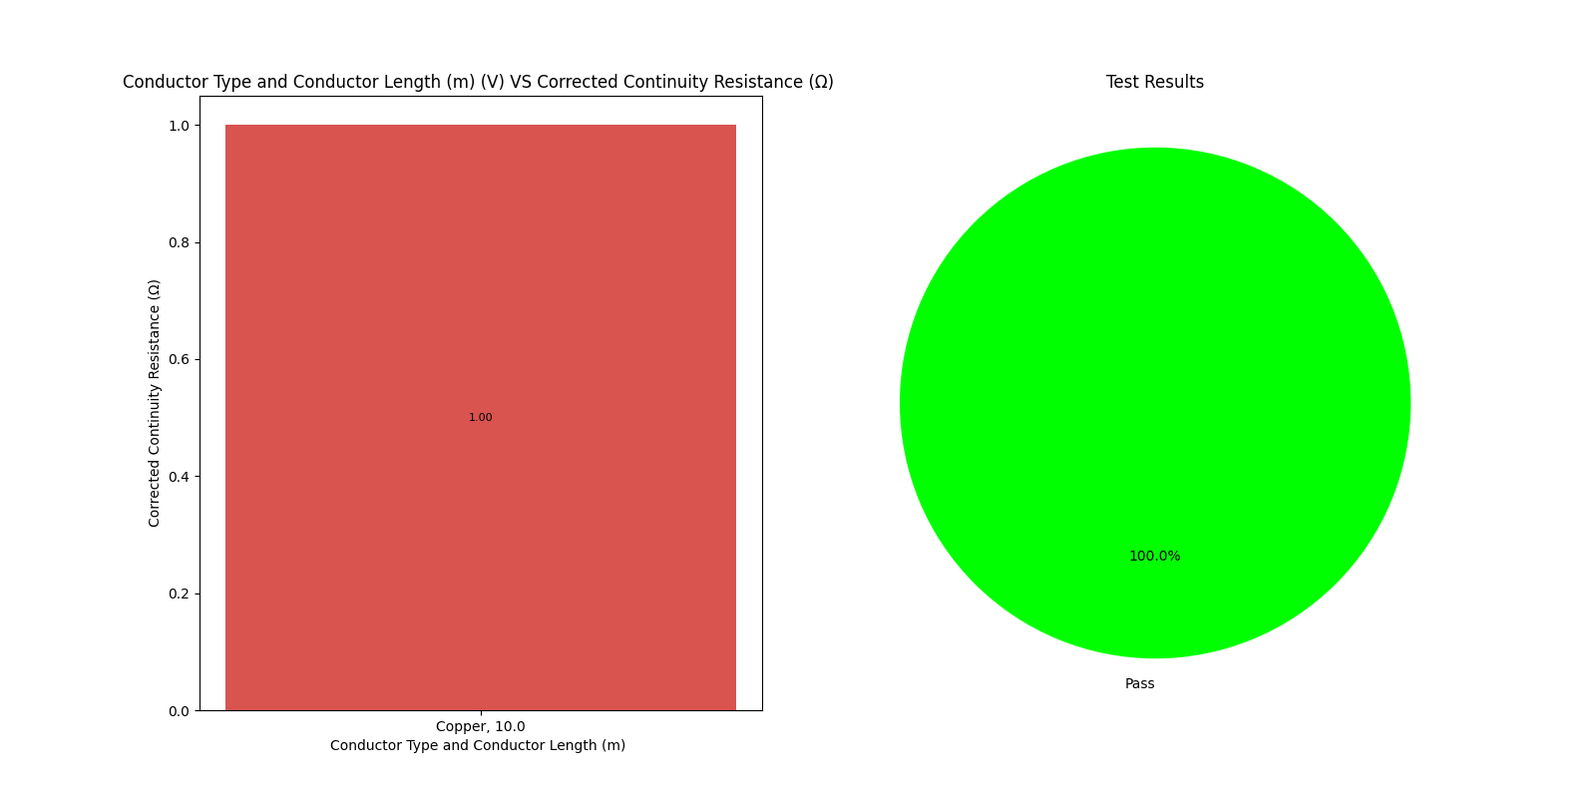

Phase Sequence test

|  |  |  |  |  |  |  |  |  |  |  |
| --- | --- | --- | --- | --- | --- | --- | --- | --- | --- | --- |
| Location | Parent Location | Facility Area | VL1-L2 (V) | VL2-L3 (V) | VL3-L1 (V) | VL1-N (V) | VL2-N (V) | VL3-N (V) | Phase Sequence | Result |
| MCB 1 | Feeder 2 | LT Panel Room | 420.0 | 417.0 | 419.0 | 242.0 | 241.0 | 242.0 | RBY | ANTICLOCKWISE |
| MCB 4 | Feeder 3 | Workshop MCC | 421.0 | 418.0 | 420.0 | 242.0 | 240.0 | 239.0 | RYB | CLOCKWISE |

Voltage Drop test

|  |  |  |  |  |  |  |  |  |  |  |  |  |  |  |  |
| --- | --- | --- | --- | --- | --- | --- | --- | --- | --- | --- | --- | --- | --- | --- | --- |
| Location | Parent Location | Facility Area | Circuit Route 'From' | Circuit Route 'To' | Measured Voltage (V, L-N) 'From' | Measured Voltage (V, L-N) 'To' | Nominal Circuit Voltage (V) | Type of Installation Supply System | Purpose of Supply | Conductor Type | Insulation Type | Cable Length (m) | Calculated Voltage Drop (V) | Voltage Drop % | Result |
| Main ACB | MLTP 1 | LT Panel Room | Main ACB | Light | 220.0 | 215.0 | 230 | Public | Lighting | Copper | XLPE | 10.0 | 5.0 | 2.27 | Pass |

Polarity test

|  |  |  |  |  |  |  |  |
| --- | --- | --- | --- | --- | --- | --- | --- |
| Location | Parent Location | Facility Area | Device Type | Type of Supply | Line to Neutral Voltage (V) | Polarity Reference | Result |
| MCB 1 | Feeder 2 | LT Panel Room | MCB | AC | 230.0 | Cores | OK |
| MCB 4 | Feeder 3 | Workshop MCC | MCB | DC | 220.0 | Device | REVERSE |

Residual current device test

|  |  |  |  |  |  |  |  |  |  |  |  |  |  |  |  |
| --- | --- | --- | --- | --- | --- | --- | --- | --- | --- | --- | --- | --- | --- | --- | --- |
| Location | Parent Location | Facility Area | type_supply of Voltage Waveform | type_supply of Earthing System | Nominal Line to Earth Voltage (V) | Nominal Current Rating(A) | Rated Residual Operating Current,IΔn (mA) | Application type_supply | Trip curve type_supply | No. of Poles | Test Current (mA) | Trip Current (mA) | Trip Time (ms) | Device Tripped | Result |

Earth Pit test

|  |  |  |  |  |  |  |  |  |  |  |  |  |
| --- | --- | --- | --- | --- | --- | --- | --- | --- | --- | --- | --- | --- |
| Location | Parent Location | Facility Area | No of Parallel Electrodes | Earthing Application | Type of Earthing | Earth Electrode Depth (m) | Nearest Electrode Distance (m) | Measured Earth Resistance - Individual (O) | Calculated Earth Resistance - Individual (O) | Electrode Distance Ratio | Result | Remark |

Three Phase Symmetry test

|  |  |  |  |  |  |  |  |  |  |  |  |  |  |  |  |  |  |  |  |  |  |  |  |
| --- | --- | --- | --- | --- | --- | --- | --- | --- | --- | --- | --- | --- | --- | --- | --- | --- | --- | --- | --- | --- | --- | --- | --- |
| Location | Parent Location | Facility Area | Rated Line Voltage (V) | Voltage-L1L2 (V) | Voltage-L2L3 (V) | Voltage-L3L1 (V) | Voltage-L1N (V) | Voltage-L2N (V) | Voltage-L3N (V) | Average Line Voltage (V) | Average Phase Voltage (V) | Voltage Unbalance % | Rated Phase Current (A) | Current-L1 (A) | Current-L2 (A) | Current-L3 (A) | Average Phase Current (A) | Current Unbalance % | Voltage-NE (V) | Zero Sum Current (mA) | Current Result | NEV Result | ZeroSum Result |
| Main ACB | MLTP 1 | LT Panel Room | 415.0 | 425.0 | 420.0 | 415.0 | 243.0 | 245.187 | 240.813 | 420.0 | 243.0 | 0.9 | 630.0 | 508.713 | 458.3 | 407.487 | 458.3 | 11.0 | 3.7 | 156.0 | FAIL | FAIL | FAIL |

Function and operation test

|  |  |  |  |  |  |  |
| --- | --- | --- | --- | --- | --- | --- |
| Location | Parent Location | Facility Area | Device type | Functional Check | Interlock check | result |

PAT test

|  |  |  |  |  |  |  |  |  |  |  |  |  |  |
| --- | --- | --- | --- | --- | --- | --- | --- | --- | --- | --- | --- | --- | --- |
| Location | Parent Location | Facility Area | Device ID | Device Name | Location | Voltage Rating (V) | Fuse Rating (A) | Visual Inspection | Earth Continuity (?) | Insulation Resistance (MO) | Polarity Test | Leakage (mA) | Functional Check |