TESTING REPORT

FLOOR-RESISTANCE TEST

|  |  |  |  |  |  |  |  |  |  |
| --- | --- | --- | --- | --- | --- | --- | --- | --- | --- |
| SN | Location | Parent Location | Facility Area | Distance from previous test location (m) | Nominal Voltage to Earth of System (V) | Applied Test Voltage (V) | Measured Output Current (mA) | EffectiveResistance | Result |
| 1 | Point-1 | Main Floor | LT Panel Room | 1.2 | 230 | 230 | 3.1 | 74.19354838709677 | Pass |
| 2 | Point-2 | Wall -1 | LT Panel Room | 0.9 | 230 | 230 | 5.6 | 41.07142857142858 | Fail |
| 3 | Point-3 | Main Floor | Office Room | 1.1 | 230 | 230 | 3.2 | 71.875 | Pass |

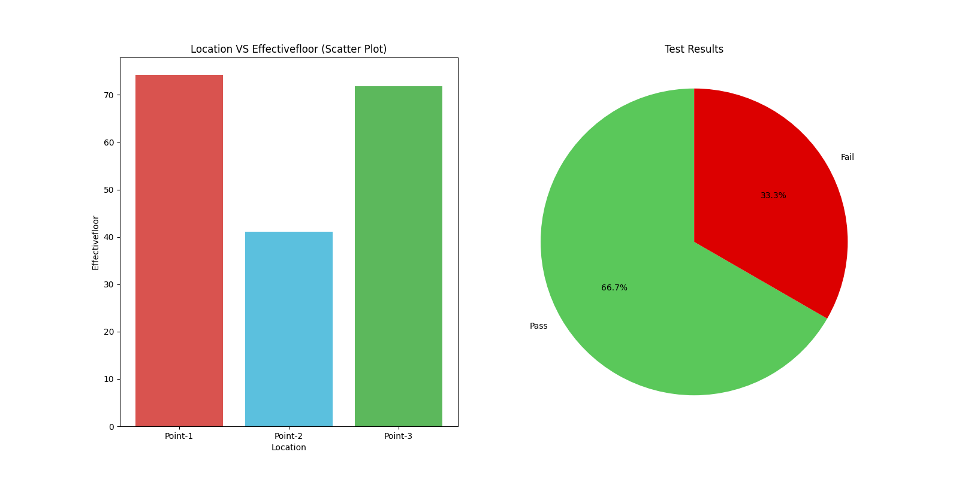

INSULATION TEST

|  |  |  |  |  |  |  |  |  |  |  |  |  |  |  |
| --- | --- | --- | --- | --- | --- | --- | --- | --- | --- | --- | --- | --- | --- | --- |
| SN | Location | Parent Location | Upstream Device Name | No. Poles | SPD Applicable | Earthing System | Nominal Circuit Voltage | Measurement Terminals | Test Voltage (V) | Conductor Type | Conductor Size | Insulation Type | Insulation Resistance (MΩ) | Result |
| 1 | MCB-1 | LV Board | MCCB-2 | Single | No | TNS | 230 | L1-E | 500 | Copper | 6.0 | PVC | 10.0 | Pass |
| 2 | MCB-4 | Feeder-2 | MCCB-1 | Single | No | TNS | 230 | L1-E | 500 | Aluminium | 4.0 | XLPE | 1.88 | Pass |
| 3 | MCB-6 | Feeder-3 | MCCB-1 | Three | No | TNS | 415 | L1L2L3-E | 500 | Copper | 10.0 | XLPE | 0.8 | Pass |
| 4 | MCB-6 | Feeder-3 | MCCB-1 | Three | No | TNC | 415 | L1-N | 500 | Copper | 10.0 | XLPE | 2.2 | Fail |
| 5 | MCB-6 | Feeder-3 | MCCB-1 | Three | No | TNC | 415 | L2-N | 500 | Copper | 10.0 | XLPE | 3.6 | Pass |
| 6 | MCB-6 | Feeder-3 | MCCB-1 | Three | No | TNC | 415 | L3-N | 500 | Copper | 10.0 | XLPE | 0.5 | Pass |
| 7 | Socket-2 | LV Board | MCB-6 | Single | Yes | TNS | 230 | L1-E | 500 | Aluminium | 2.5 | PVC | 0.9 | Fail |
| 8 | HT Breaker-1 | HT Panel | Main HT Incomer | Three | No | TNS | 11000 | L1L2L3-E | 1000 | Aluminium | 400.0 | XLPE | 50.0 | Fail |

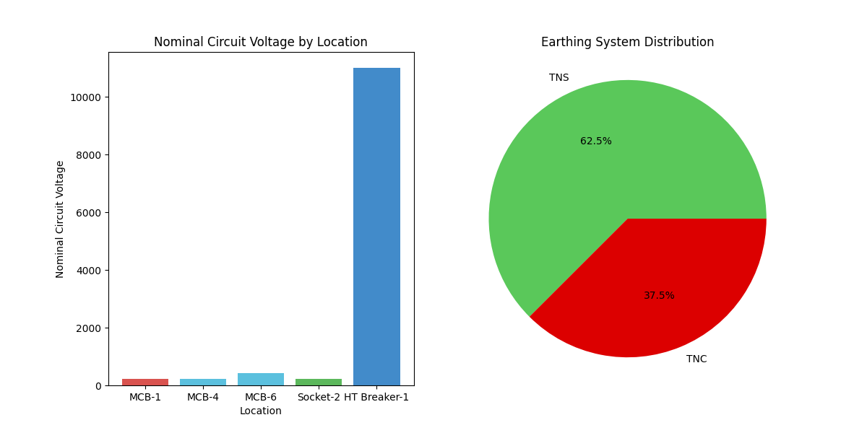

PHASE SEQUENCE TEST

|  |  |  |  |  |  |  |  |  |  |  |  |  |
| --- | --- | --- | --- | --- | --- | --- | --- | --- | --- | --- | --- | --- |
| SN | Location | Location Type | Parent Location | Facility Area | V-L1-L2 | V-L2-L3 | V-L3-L1 | V-L1-N | V-L2-N | V-L3-N | Phase Sequence | Result |
| 1 | SFU-1 | SFU | DB-2 | Electrical Panel Room | 415 | 412 | 414 | 240 | 238 | 239 | RYB | CLOCKWISE |
| 2 | MCCB-1 | MCCB | Main Panel | Electrical Panel Room | 420 | 417 | 419 | 242 | 241 | 242 | RBY | ANTICLOCKWISE |

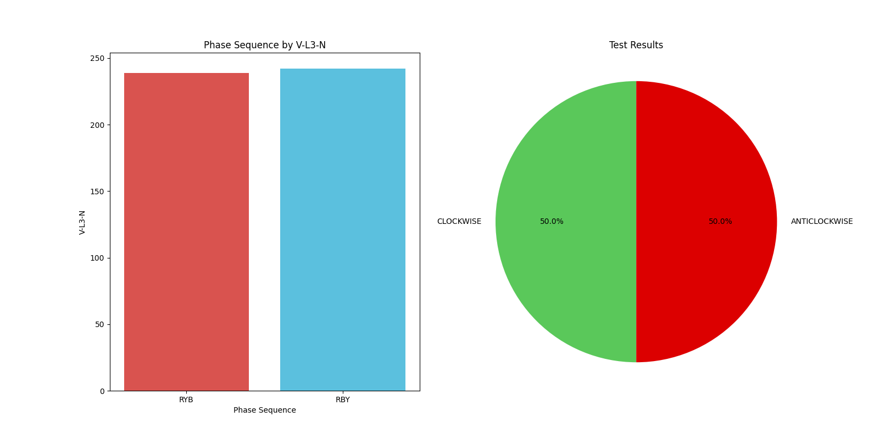

POLARITY TEST

|  |  |  |  |  |  |  |  |  |
| --- | --- | --- | --- | --- | --- | --- | --- | --- |
| SN | Location | Parent Location | Facility Area | Device Type | Line to Neutral Voltage (V) | Type of Supply | Polarity Reference | Result |
| 1 | MCB-1 | DB-1 | Offiice Room | MCB | 230 | AC | Cores | OK |
| 2 | DC MCB-2 | UPS | Electrical Panel Room | MCB | 220 | DC | Device | REVERSE |
| 3 | RCB-2 | DB-2 | Workshop | RCCB | 235 | AC | Cores | REVERSE |

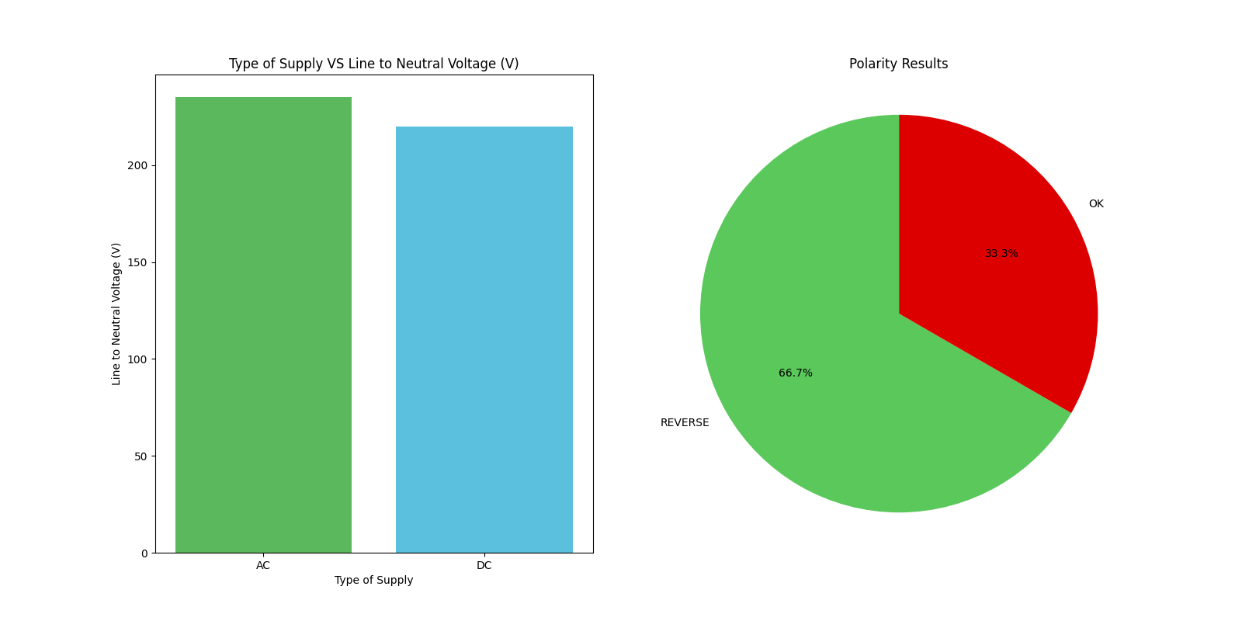

VOLTAGE DROP TEST

|  |  |  |  |  |  |  |  |  |  |  |  |  |  |
| --- | --- | --- | --- | --- | --- | --- | --- | --- | --- | --- | --- | --- | --- |
| SN | Circuit Route[FROM] | Circuit Route[TO] | Measured Voltage (V, L-N)[FROM] | Measured Voltage (V, L-N)[TO] | Nominal Circuit Voltage (V AC) | Type of Installation Supply System | Purpose of Supply | Cable Length (m) | Conductor Type | Insulation Type | Calculated Voltage Drop (V) | Voltage Drop % | Result |
| 1 | Main ACB | Light | 220 | 215 | 230 | Public | Lighting | 160 | Cu | PVC | 5 | 2.27 | Pass |
| 2 | Main ACB | Computer Station | 225 | 201 | 230 | Private | Other | 80 | Al | XLPE | 24 | 10.67 | Fail |

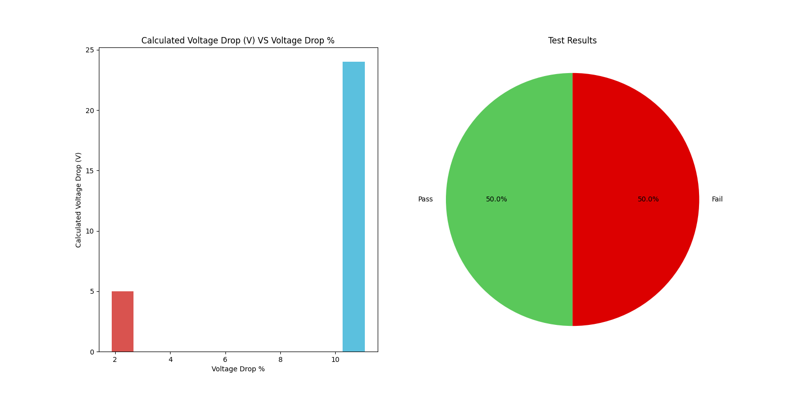

Residual Current Device Test

|  |  |  |  |  |  |  |  |  |  |  |  |  |  |  |  |
| --- | --- | --- | --- | --- | --- | --- | --- | --- | --- | --- | --- | --- | --- | --- | --- |
| Location | Parent Location | Facility Area | Type of Voltage Waveform | Type of Earthing System | Nominal Line to Earth Voltage (V) | Nominal Current Rating(A) | Rated Residual Operating Current,I?n (mA) | Type | Trip curve type | No. of Poles | Test Current (mA) | Trip Current (mA) | Trip Time (ms) | Device Tripped | Result |
| RCCB-1 | LT Panel | LT Panel Room | AC | TN | 230 | 100 | 100 | A | Standard | 2 | 50 | - | - | No | Pass |
| RCCB-1 | LT Panel | LT Panel Room | AC | TN | 230 | 100 | 100 | A | Standard | 3 | 100 | 101 | 151 | Yes | Pass |
| RCCB-1 | LT Panel | LT Panel Room | AC | TN | 230 | 100 | 100 | A | Standard | 4 | 200 | 201 | 102 | Yes | Pass |
| RCCB-1 | LT Panel | LT Panel Room | AC | TN | 230 | 100 | 100 | A | Standard | 5 | 500 | 501 | 75 | Yes | Pass |
| RCCB - 2 | DB | Workshop Area | AC | TN | 228 | 63 | 100 | AC | General | 2 | 50 | 50 | 90 | Yes | Fail |
| RCCB - 2 | DB | Workshop Area | AC | TN | 229 | 63 | 100 | AC | General | 3 | 100 | 102 | 352 | Yes | Fail |
| RCCB - 2 | DB | Workshop Area | AC | TN | 230 | 63 | 100 | AC | General | 4 | 200 | 202 | 156 | Yes | Fail |
| RCCB - 2 | DB | Workshop Area | AC | TN | 231 | 63 | 100 | AC | General | 5 | 500 | 502 | 57 | Yes | Fail |
| RCCB-1 | LT Panel | LT Panel Room | AC | TN | 230 | 100 | 100 | A | Standard | 2 | 50 | 502 | 57 | Yes | Fail |
| RCCB-1 | LT Panel | LT Panel Room | AC | TN | 230 | 100 | 100 | A | Standard | 3 | 100 | 101 | 1500 | Yes | Fail |
| RCCB-1 | LT Panel | LT Panel Room | AC | TN | 230 | 100 | 100 | A | Standard | 4 | 200 | 201 | 102 | No | Fail |
| RCCB-1 | LT Panel | LT Panel Room | AC | TN | 230 | 100 | 100 | A | Standard | 5 | 500 | 501 | 1000 | Yes | Fail |
| RCCB - 2 | DB | Workshop Area | AC | TN | 228 | 63 | 100 | AC | General | 2 | 50 | - | - | No | Pass |
| RCCB - 2 | DB | Workshop Area | AC | TN | 229 | 63 | 100 | AC | General | 3 | 100 | 102 | 250 | Yes | Pass |
| RCCB - 2 | DB | Workshop Area | AC | TN | 230 | 63 | 100 | AC | General | 4 | 200 | 202 | 140 | Yes | Pass |
| RCCB - 2 | DB | Workshop Area | AC | TN | 231 | 63 | 100 | AC | General | 5 | 500 | 502 | 33 | Yes | Pass |

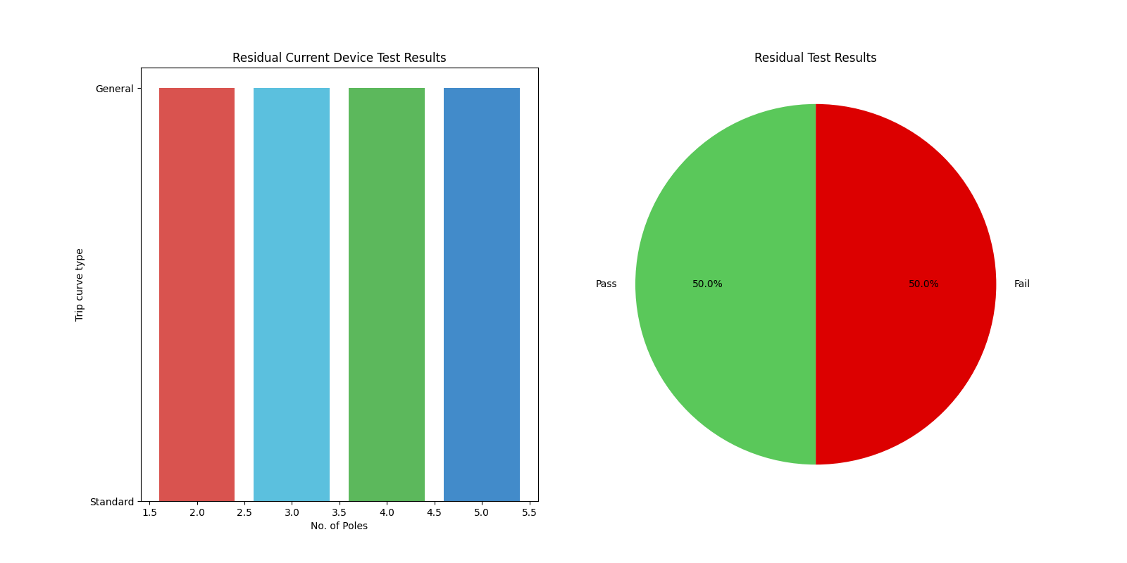

EARTH PIT RESISTANCE TEST

|  |  |  |  |  |  |  |  |  |  |  |  |  |
| --- | --- | --- | --- | --- | --- | --- | --- | --- | --- | --- | --- | --- |
| SN | Earth Pit Name | Earth Pit Location | No. of Parallel Electrodes | Earthing Application | Type of Earthing | Earth Electrode Depth | Nearest Electrode Distance | Measured Earth Resistance - Individual | Electrode Distance Ratio | Calculated Earth Resistance - Individual (Ω) | Remark | Result |
| 1 | Earth Pit -1 | Transformer Area | 2 | Body Earth | Chemical Electrode Earthing | 3 | 2 | 1.9 | 0.67 | 3.8 | Test Electrodes are not properly placed | PASS |
| 2 | Earth Pit -2 | Outdoor Area | 2 | Body Earth & Protection | Chemical Electrode Earthing | 3 | 3 | 3.6 | 1.0 | 7.2 | Test Electrodes are properly placed | FAIL |
| 3 | Earth Pit -3 | Transformer Area | 2 | Body Earth | Chemical Electrode Earthing | 3 | 2 | 2.1 | 0.67 | 4.2 | Test Electrodes are not properly placed | FAIL |
| 4 | Earth Pit -4 | Outdoor Area | 2 | Body Earth & Protection | Chemical Electrode Earthing | 3 | 3 | 1.5 | 1.0 | 3.0 | Test Electrodes are properly placed | PASS |

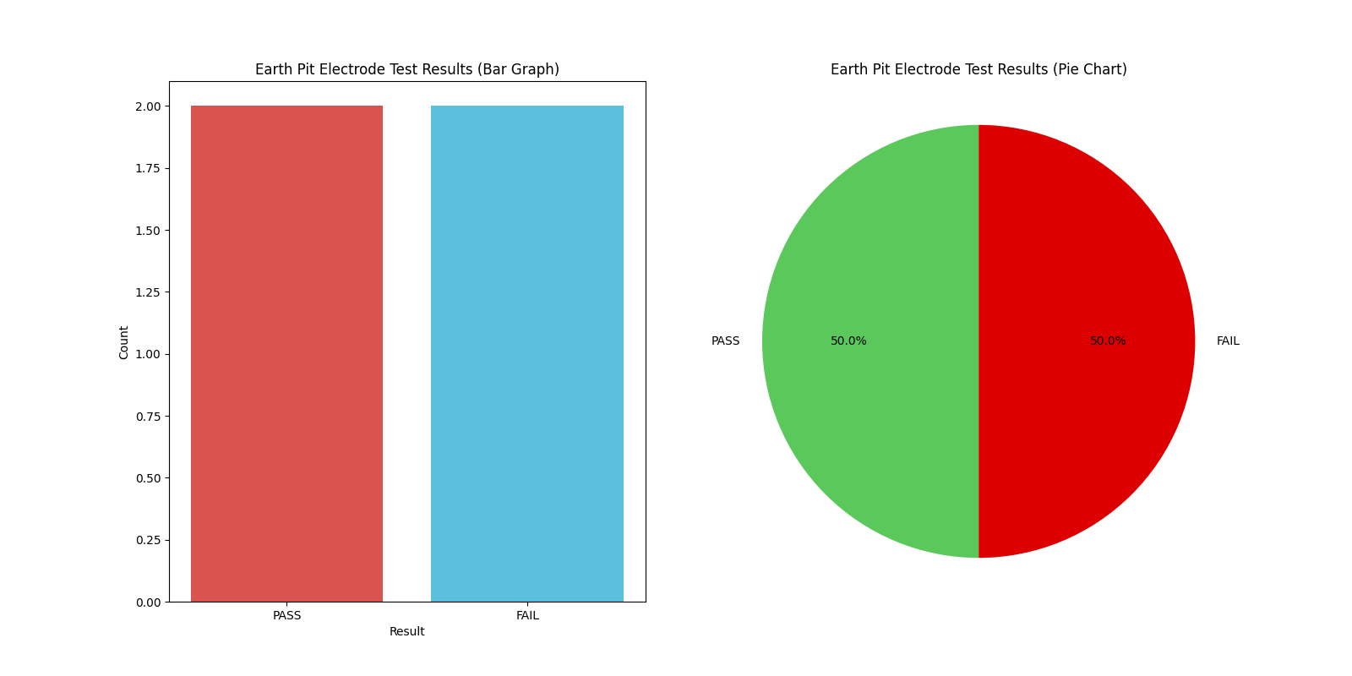

THREE PHASE SYMMETRY TEST

|  |  |  |  |  |  |  |  |  |  |  |  |  |  |  |  |  |
| --- | --- | --- | --- | --- | --- | --- | --- | --- | --- | --- | --- | --- | --- | --- | --- | --- |
| Sr. No. | Location Name | Parent Location | Facility Area | Rated Line Voltage (V) | Average Line Voltage (V) | Average Phase Voltage (V) | Voltage Unbalance % | Voltage Result | Rated Phase Current (A) | Average Phase Current (A) | Current Unbalance % | Current Result | Voltage-NE (V) | NEV Result | Zero Sum Current (mA) | ZeroSum Result |
| 1 | Main Incomer | MLTP | Electrical Panel Room | 415 | 418.33 | 230.0 | 43.82 | FAIL | 630 | 465.0 | 4.78 | PASS | 3 | FAIL | 105 | PASS |
| 2 | Main Incomer | MLTP | Electrical Panel Room | 450 | 420.0 | 252.0 | 43.65 | FAIL | 670 | 553.0 | 4.76 | PASS | 2 | PASS | 150 | FAIL |

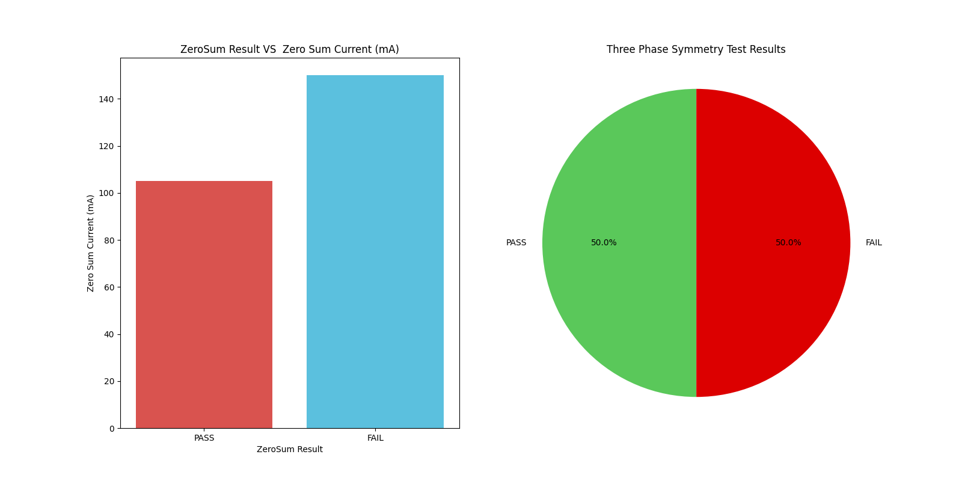

RESISTANCE CONDUCTOR TEST

|  |  |  |  |  |  |  |  |  |  |  |  |  |
| --- | --- | --- | --- | --- | --- | --- | --- | --- | --- | --- | --- | --- |
| Conductor Location | Facility Area | No of runs of Conductor | Conductor Type | Conductor Size (sq. mm) | Conductor Length (m) | Conductor Temperature (°C) | Is Continuity found? | Lead Internal Resistance (?) | Continuity Resistance (?) | Corrected Continuity Resistance (Ω) | Specific Conductor Resistance (MΩ/m) at 30°C | Result |
| Main ACB | Electrical Panel Room | 2 | Cu | 6 | 10 | 32 | Yes | 0.1 | 1.1 | 1.0 | 9.91493e-07 | Pass |
| MCCB-1 | DB-1 | 1 | GI | 10 | 15 | 40 | No | 0.2 | 2.5 | 2.3 | 2.161451e-06 | Fail |

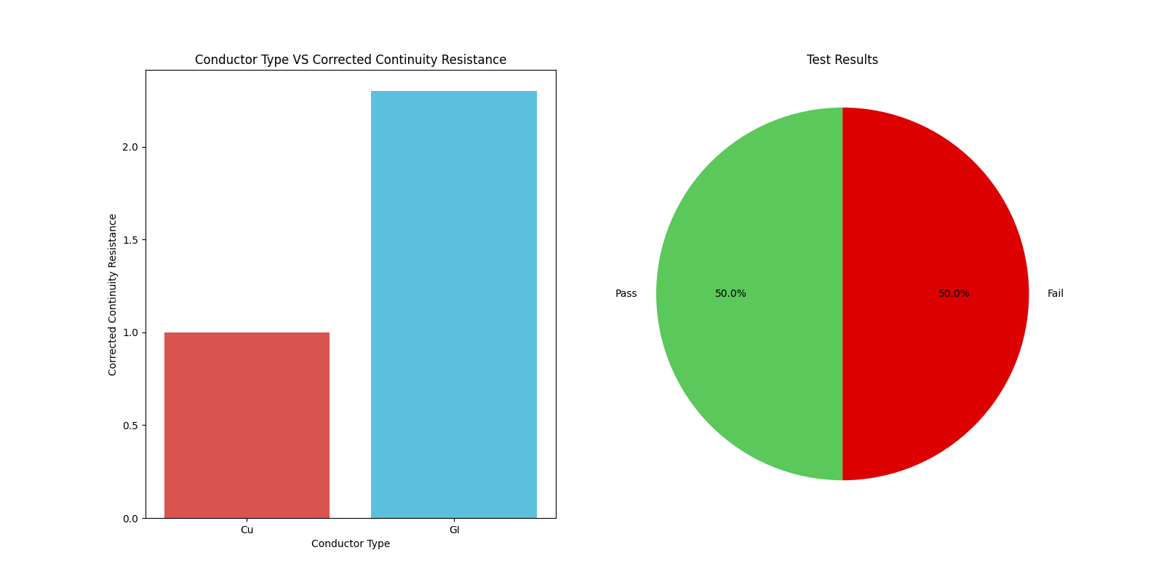

# FUNCTIONS AND OPERATION TEST

|  |  |  |  |  |  |  |  |
| --- | --- | --- | --- | --- | --- | --- | --- |
| SN | Location | Parent Location | Facility Area | Device type | Functional Check | Interlock check | Result |
| 1 | Starter-1 | Starter | Workshop | Relays | OK | OK | pass |
| 2 | Panel-1 | Electrical Panel | Control Room | Switches | OK | Not OK | fail |

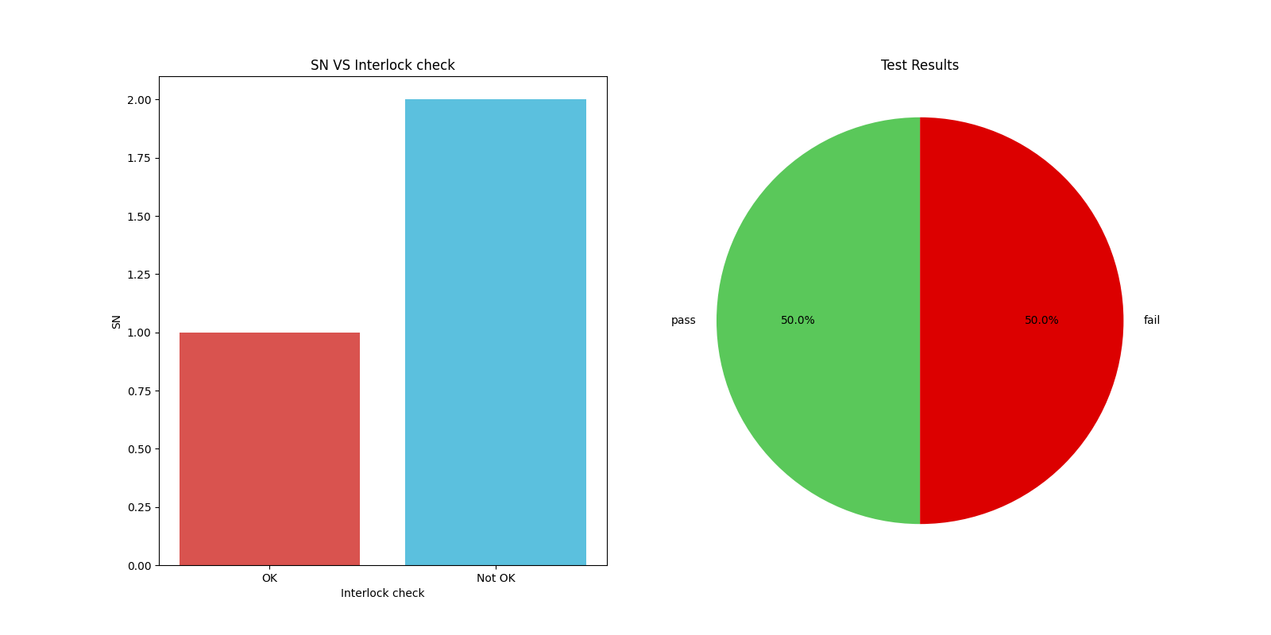

# PAT TEST

|  |  |  |  |  |  |  |  |  |  |  |  |  |
| --- | --- | --- | --- | --- | --- | --- | --- | --- | --- | --- | --- | --- |
| SN | Device ID | Device Name | Location | Voltage Rating (V) | Fuse Rating (A) | Visual Inspection | Earth Continuity (?) | Insulation Resistance (M?) | Polarity Test | Leakage (mA) | Functional Check | Overall Result |
| 1 | A1024 | Hand Drill | Workshop | 240 | 10 | OK | 0.1 | 1 | OK | 0.1 | OK | PASS |
| 2 | B1024 | Hot Blower | Electrical Panel Room | 240 | 10 | Not OK | 0.2 | 2 | OK | 0.1 | OK | FAIL |
| 3 | C1024 | Angle Grinder | Workshop | 240 | 10 | OK | 0.15 | 2 | Not OK | 0.05 | OK | PASS |

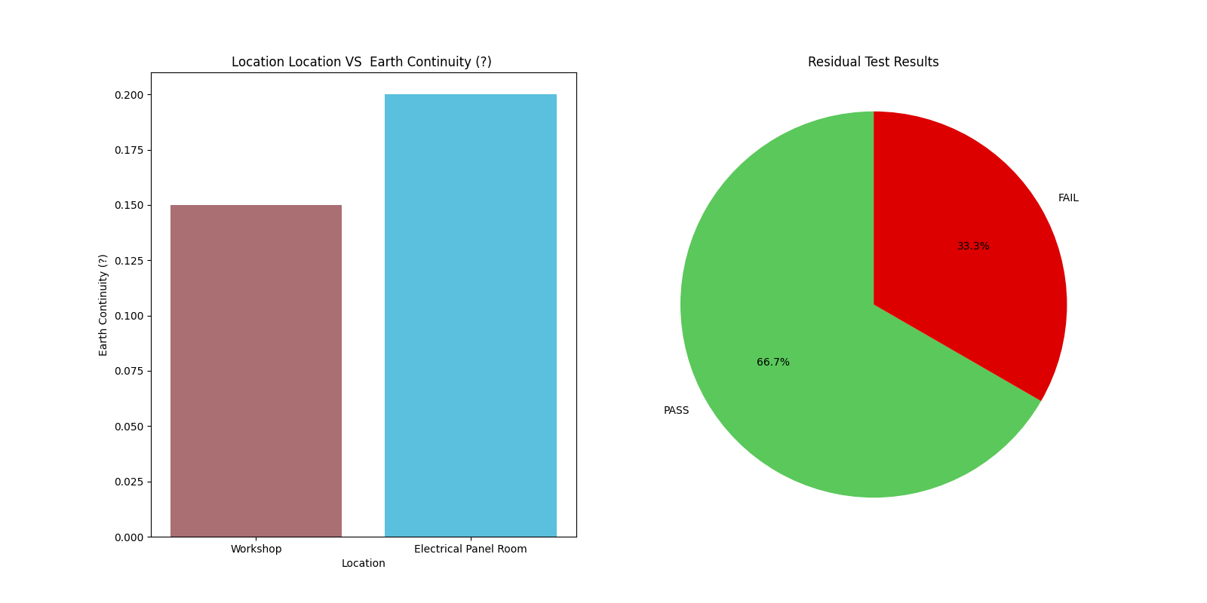

ELI SOCKET TEST

|  |  |  |  |  |  |  |  |  |
| --- | --- | --- | --- | --- | --- | --- | --- | --- |
| SN | Location | Parent Location | Facility Area | Distance from previous test location (m) | Nominal Voltage to Earth of System (V) | Applied Test Voltage (V) | Measured Output Current (mA) | EffectiveResistance |
| 1 | Point-1 | Main Floor | LT Panel Room | 1.2 | 230 | 230 | 3.1 | 74.19354838709677 |
| 2 | Point-2 | Wall -1 | LT Panel Room | 0.9 | 230 | 230 | 5.6 | 41.07142857142858 |
| 3 | Point-3 | Main Floor | Office Room | 1.1 | 230 | 230 | 3.2 | 71.875 |

|  |  |  |  |  |  |  |  |  |  |  |  |  |  |
| --- | --- | --- | --- | --- | --- | --- | --- | --- | --- | --- | --- | --- | --- |
| SN | Socket Name | Socket Rating (A) | Socket Type | No. of Phases | V_LN | V_LE | V_NE | L1-ELI | L2-ELI | L3-ELI | Psc (kA) | Suggested Max ELI (Ω) | Result |
| 1 | Socket-1 | 6 | Domestic | 3 | 240 | 241 | 1 | 3.6 | 3.64 | 3.63 | 0.07 | 1.92 | Fail |
| 3 | Socket-3 | 6 | Domestic | 3 | 238 | 239 | 1 | 0.56 | 0.49 | 0.62 | 0.43 | 1.48 | Pass |
| 2 | Socket-2 | 16 | Industrial | 3 | 236 | 236 | 0 | 0.56 | 0.68 | 0.72 | 0.36 | 7866.67 | Pass |
| 3 | Socket-4 | 6 | Domestic | 3 | 238 | 239 | 1 | 0.56 | 0.49 | 0.62 | 0.43 | 0.04 | Fail |

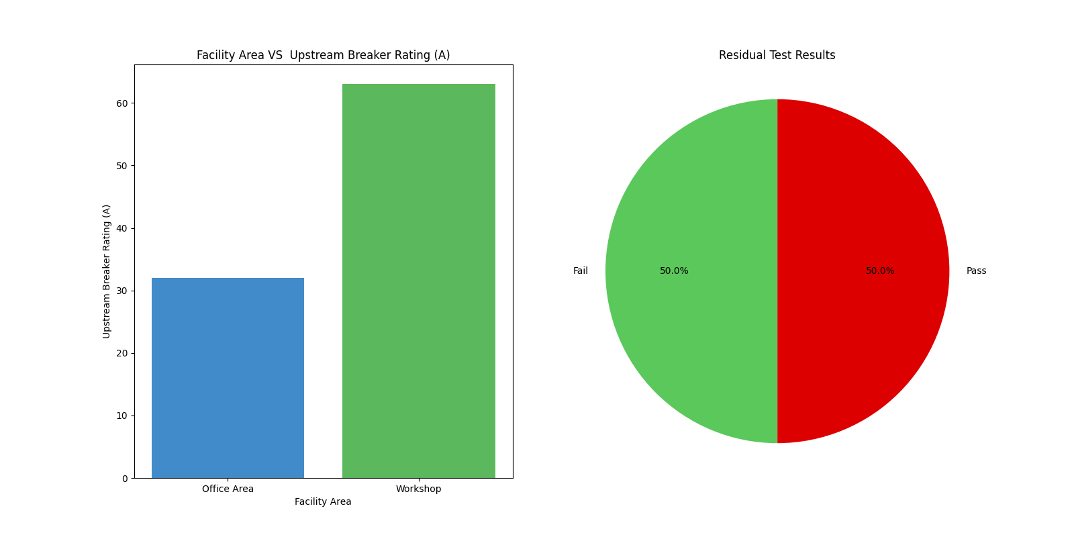

ELI TEST

# Earth Loop Impedance Test - Circuit Breaker

|  |  |  |  |  |  |  |  |  |  |  |  |
| --- | --- | --- | --- | --- | --- | --- | --- | --- | --- | --- | --- |
| SN | Device Name | Location | Facility Area | Earthing Configuration | Type of Circuit Location | Device Rating (A) | Device Make | Device Type | Device Sensitivity (mA) | No. of Phases | Trip Curve |
| 1 | MCB-1 | LT panel | LT Panel Room | TN |  | 63 | ABB | MCB |  | 3 | D |
| 2 | MCB-2 | DB | Office Area | TN |  | 32 | Schneider | MCB |  | 1 | B |
| 3 | MCB-3 | DB | Workshop | TT |  | 16 | Siemens | MCB |  | 3 | C |
| 4 | MCB-4 | DB | Workshop | TT |  | 25 | Siemens | MCB |  | 3 | C |
| 5 | RCD-1 | LT panel | LT Panel Room | TN |  | 40 | ABB | RCCB | 100.0 | 3 | G |
| 6 | RCD-2 | DB | Office Area | TT |  | 63 | Schneider | RCCB | 300.0 | 3 | G |
| 7 | MCCB-1 | DB | Workshop | TN | Final | 25 | Siemens | MCCB |  | 3 | IEC Very Inverse |
| 8 | MCCB-2 | LT panel | LT Panel Room | TT | Distribution | 40 | Siemens | MCCB |  | 3 | IEC Long-Time Inverse |
| 9 | MCCB-3 | DB | Workshop | TN | Final | 63 | ABB | MCCB |  | 3 | IEC Very Inverse |
| 10 | MCCB-4 | LT panel | LT Panel Room | TT | Distribution | 100 | Schneider | MCCB |  | 3 | IEC Extremely Inverse |
| 11 | ACB-1 | DB | Office Area | TN | Final | 630 | Siemens | ACB |  | 3 | IEC Ultra Inverse |
| 12 | ACB-2 | DB | Workshop | TT | Distribution | 800 | Siemens | ACB |  | 3 | IEEE Moderately Inverse |
| 13 | ACB-3 | DB | Office Area | TN | Distribution | 1000 | ABB | ACB |  | 3 | IEEE Very Inverse |
| 14 | ACB-4 | DB | Workshop | TT | Distribution | 1250 | Schneider | ACB |  | 3 | IEEE Extremely Inverse |

|  |  |  |  |  |  |  |  |  |  |  |  |  |  |
| --- | --- | --- | --- | --- | --- | --- | --- | --- | --- | --- | --- | --- | --- |
| SN | Device Name | Device Rating (A) | Device Type | No. of Phases | V_LN | V_LE | V_NE | L1-ELI | L2-ELI | L3-ELI | Psc (kA) | Suggested Max ELI (Ω) | Result |
| 1 | MCB-1 | 63 | MCB | 3 | 240 | 240 | 1 | 3.6 | 3.64 | 3.63 | 0.066 | 0.12 | Fail |
| 2 | MCB-2 | 32 | MCB | 1 | 236 | 236 | 0 | 0.56 | nan | nan | 0.421 | 0.96 | Pass |
| 3 | MCB-3 | 16 | MCB | 3 | 238 | 238 | 1 | 1.56 | 1.49 | 0.62 | 0.195 | 0.96 | Fail |
| 4 | MCB-4 | 25 | MCB | 3 | 238 | 238 | 1 | 0.56 | 0.49 | 0.6 | 0.425 | 0.61 | Pass |
| 5 | RCD-1 | 40 | RCCB | 3 | 240 | 240 | 1 | 2500.0 | 2000.0 | 2350.0 | 0.000105 | 2400.00 | Fail |
| 6 | RCD-2 | 63 | RCCB | 3 | 240 | 240 | 1 | 150.0 | 102.0 | 114.0 | 0.00197 | 166.67 | Pass |
| 7 | MCCB-1 | 25 | MCCB | 3 | 240 | 240 | 1 | 0.27 | 0.26 | 0.25 | 0.92 | 0.28 | Pass |
| 8 | MCCB-2 | 40 | MCCB | 3 | 240 | 240 | 1 | 0.03 | 0.06 | 0.01 | 7.2 | 0.05 | Fail |
| 9 | MCCB-3 | 63 | MCCB | 3 | 240 | 240 | 1 | 0.1 | 0.09 | 0.08 | 2.67 | 0.11 | Pass |
| 10 | MCCB-4 | 100 | MCCB | 3 | 240 | 240 | 1 | 0.11 | 0.09 | 0.15 | 2.06 | 0.12 | Fail |
| 11 | ACB-1 | 630 | ACB | 3 | 240 | 240 | 1 | 0.02 | 0.01 | 0.02 | 12.0 | 0.03 | Pass |
| 12 | ACB-2 | 800 | ACB | 3 | 240 | 240 | 1 | 0.05 | 0.3 | 0.1 | 1.6 | 0.04 | Fail |
| 13 | ACB-3 | 1000 | ACB | 3 | 240 | 240 | 1 | 0.09 | 0.08 | 0.05 | 3.27 | 0.10 | Pass |
| 14 | ACB-4 | 1250 | ACB | 3 | 240 | 240 | 1 | 0.01 | 0.05 | 0.03 | 8.0 | 0.02 | Fail |

