BZME Insights | Project 12
FP&A Budget vs Actual and Rolling Forecast
Project guide: how the workbook works and how to read it
Sector | Finance / FP&A
Tool | Excel (formula-driven)
Data | Synthetic (made up) data for a fictional Kenyan FMCG distributor, Savanna Fresh Foods Ltd
Period | Budget Jan to Dec 2026; actuals Jan to Sep 2026; forecast Oct to Dec 2026
Workbook | FPA_Budget_vs_Actual_Portfolio.xlsx
Author | Madikizelah (Maddie) Nduta, BZME Insights
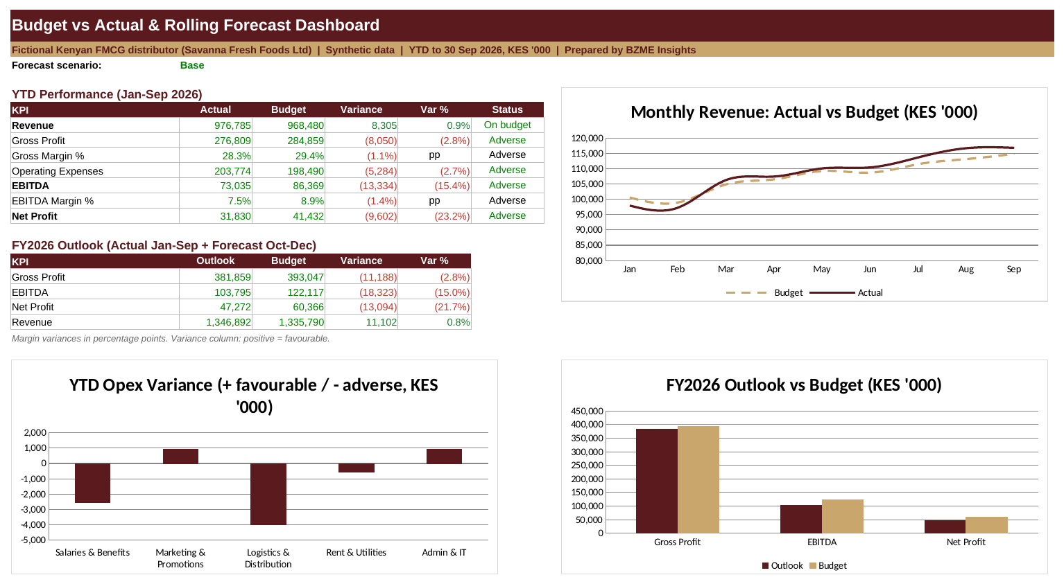

1. The business question
Revenue is right on budget, yet profit is falling behind. Where is the gap coming from, and how will the full year finish if nothing changes? This project answers those two questions the way a finance team would: with a budget vs actual comparison and a rolling forecast.

2. How the workbook is built
Sheet | What it does
README | The problem, questions, definitions, notes and recommendations in one place.
Dashboard | KPIs, FY outlook, charts and key findings. Everything links to the other sheets.
Assumptions | COGS percentages, tax rate and the scenario selector (cell B18). The only sheet you need to change.
Budget | Monthly P&L for Jan to Dec 2026, with year and year-to-date totals.
Actuals | The same P&L for Jan to Sep 2026. COGS, tax and totals are formulas.
Variance | Year-to-date actual vs budget for every line, with favourable or adverse status and a driver comment.
Forecast | Jan to Sep actuals plus an Oct to Dec forecast, compared with the full-year budget.

3. How to use it
- Open the Dashboard sheet and read the key findings at the top.
- Go to Assumptions and change the scenario in B18 to Base, Upside or Downside.
- Return to the Dashboard and see the FY outlook, charts and findings update.
- Click any Dashboard number and trace it back to the Variance or Forecast sheet, then to Budget and Actuals.

4. How the numbers are calculated
- Colour code: blue = hardcoded input, black = formula, green = link to another sheet.
- Variance: positive means favourable to profit. Income lines use actual minus budget; cost lines use budget minus actual. A variance within plus or minus 1% is shown as On budget.
- EBITDA: gross profit minus operating expenses, before depreciation, finance costs and tax.
- Forecast revenue (Oct to Dec): the budget for the month x the segment's year-to-date actual/budget ratio x the scenario multiplier (Base 1.00, Upside 1.05, Downside 0.92).
- Forecast costs: COGS uses each segment's year-to-date COGS percentage. Operating cost lines use their year-to-date run-rate against budget. Depreciation and finance costs follow budget.
- Tax: 30% of positive profit before tax, applied monthly (a simplification).

5. Key results
Measure (KES '000) | Actual / Outlook | Budget | Variance
Revenue, YTD Sep | 976,785 | 968,480 | +0.9%
Gross margin, YTD | 28.3% | 29.4% | -1.1 pts
Operating expenses, YTD | 203,774 | 198,490 | 2.7% over
EBITDA, YTD | 73,035 | 86,369 | -15.4%
Net profit, YTD | 31,830 | 41,432 | -23.2%
EBITDA, FY outlook (Base) | 103,795 | 122,117 | -15.0%
Net profit, FY outlook (Base) | 47,272 | 60,366 | -21.7%

- Wholesale grew about 5.2%, but e-commerce (-7.5%) and retail (-2.4%) fell short of budget.
- Gross margin slipped because of input cost inflation and lower-margin wholesale volume.
- Logistics ran about 8% over budget (fuel and longer routes) and salaries ran over on early hires. Marketing was under budget.

6. What the business should do
- Renegotiate fuel and route contracts and consolidate deliveries to bring logistics back toward budget.
- Review wholesale contract pricing to protect margin on the new volume.
- Accelerate the e-commerce recovery with targeted promotions inside the marketing budget.
- Phase marketing spend evenly across months to avoid catch-up overspend.
- Re-forecast every month and track actuals against the Upside and Downside range.

7. Limits of this project
- All data is synthetic. Targets, COGS percentages and scenario multipliers are illustrative assumptions.
- The forecast is a run-rate method on purpose, so anyone can follow it. A real engagement would add seasonality, pipeline and cash flow.
- In a real engagement the budget and actuals come from the client's accounting system and the variance thresholds are agreed with management.

8. Plain-language glossary
Term | Meaning
Budget | What the business planned to earn and spend.
Actual | What really happened.
Variance | The gap between actual and budget.
Favourable / adverse | Good for profit / bad for profit.
Rolling forecast | Actuals to date plus a forecast for the remaining months, updated as new actuals arrive.
Gross margin | Sales minus direct costs, as a percentage of sales.
EBITDA | Operating profit before depreciation, interest and tax.
Scenario | A what-if version of the forecast: Base, Upside or Downside.

Built by Madikizelah (Maddie) Nduta | BZME Insights | linkedin.com/in/maddie-nduta

