# Assignment-based Subjective Questions

# Question 1. From your analysis of the categorical variables from the dataset, what could you infer about their effect on the dependent variable? (Do not edit)

# Total Marks: 3 marks (Do not edit)

# Answer: <Your answer for Question 1 goes below this line> (Do not edit)

# 

# 

# 

**Question 2.** Why is it important to use **drop_first=True** during dummy variable creation? (Do not edit)

**Total Marks:** 2 marks (Do not edit)

# Answer: <Your answer for Question 2 goes below this line> (Do not edit)

# 

**Question 3.** Looking at the pair-plot among the numerical variables, which one has the highest correlation with the target variable? (Do not edit)

**Total Marks:** 1 mark (Do not edit)

# Answer: <Your answer for Question 3 goes below this line> (Do not edit)

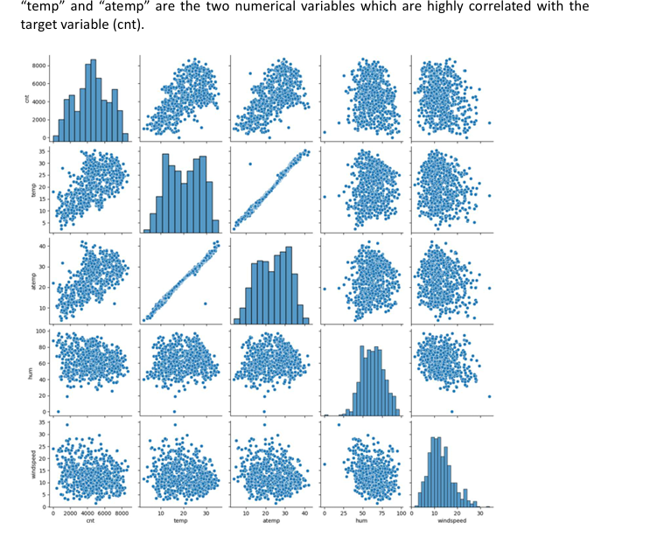

**Question 4.** How did you validate the assumptions of Linear Regression after building the model on the training set? (Do not edit)

**Total Marks:** 3 marks (Do not edit)

# Answer: <Your answer for Question 4 goes below this line> (Do not edit)

# 

**Question 5.** Based on the final model, which are the top 3 features contributing significantly towards explaining the demand of the shared bikes? (Do not edit)

**Total Marks:** 2 marks (Do not edit)

# Answer: <Your answer for Question 5 goes below this line> (Do not edit)

# 

# General Subjective Questions

**Question 6.** Explain the linear regression algorithm in detail. (Do not edit)

**Total Marks:** 4 marks (Do not edit)

**Answer:** Please write your answer below this line. (Do not edit)

# <Your answer for Question 6 goes here>

# 

**Question 7.** Explain the Anscombe’s quartet in detail. (Do not edit)

**Total Marks:** 3 marks (Do not edit)

**Answer:** Please write your answer below this line. (Do not edit)

# <Your answer for Question 7 goes here>

# 

# 

**Question 8.** What is Pearson’s R? (Do not edit)

**Total Marks:** 3 marks (Do not edit)

**Answer:** Please write your answer below this line. (Do not edit)

# <Your answer for Question 8 goes here>

# 

# 

**Question 9.** What is scaling? Why is scaling performed? What is the difference between normalized scaling and standardized scaling? (Do not edit)

**Total Marks:** 3 marks (Do not edit)

**Answer:** Please write your answer below this line. (Do not edit)

# <Your answer for Question 9 goes here>

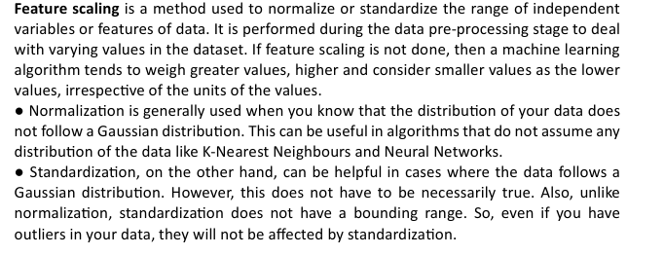

**Question 10.** You might have observed that sometimes the value of VIF is infinite. Why does this happen? (Do not edit)

**Total Marks:** 3 marks (Do not edit)

**Answer:** Please write your answer below this line. (Do not edit)

# <Your answer for Question 10 goes here>

# 

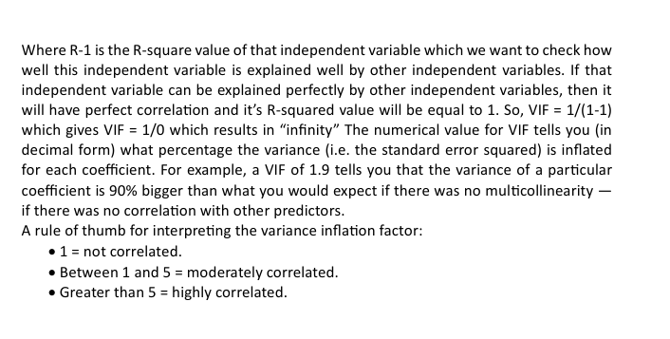

**Question 11.** What is a Q-Q plot? Explain the use and importance of a Q-Q plot in linear regression.

(Do not edit)

**Total Marks:** 3 marks (Do not edit)

**Answer:** Please write your answer below this line. (Do not edit)

# <Your answer for Question 11 goes here>

# 