**Sprint 1 - The SOS game is described in CS449HomeworkOverview.docx. You should read the description very carefully.**

In this assignment, you aim to specify the requirements (i.e., user stories and acceptance criteria) of the target software that allows a human player to play a simple or general SOS game against a human opponent. These requirements will be fully implemented by the end of sprint 3. The minimum features include choosing the board size, choosing the game mode (simple or general), starting a new game, making a move (in a simple or general game), determining if a simple or general game is over. The following is a sample GUI layout.

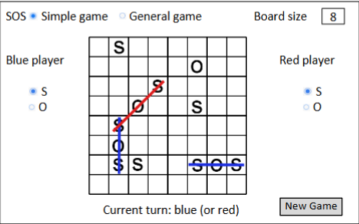

Use the following tables to document your user stories and acceptance criteria.

You are required to use the free ChatGPT or another LLM to complete 2 user stories and 2 of their respective acceptance criteria. You must ensure that the generated user stories are correct and fix them if not. At the end of the submission, provide screenshots of your LLM prompts and answers, along with the description of errors the LLM made that you had to correct. Points will be deducted if no screenshots/description are provided.

**User Stories (3 points)n: Template → As a <role>, I want <goal> [so that <benefit>]**

| ID | Story Name | Description | Priority | Estimated Hours |
| --- | --- | --- | --- | --- |
| 1 | Board size | As a **player**, I want to **choose the size of the board game** (8x8 as the example) so that **I can play the game at different level difficulties** | High | 3 Hours |
| 2 | Game mode | As a **player**, I want to **choose the game mode** (simple or general) after selecting the board size so tha**t I can play according to my preferred rule setting** | High | 2 Hours |
| 3 | New game | As a **player**, I want to **start a new game using the chosen board size and game mode** so that **the board is ready to play** | High | 2 Hours |
| 4 | Make in simple | As a **player**, I want to **make a move in a simple game** so that **I can progress the game toward completion** | High | 2 Hours |
| 5 | SImple game over | As a **player**, I want to see **when a simple game is over** so that **the game provides a result** | Medium | 2 Hours |
| 6 | Move in general | As a **player**, I want to **make a move in a general game** so that **I can score points forming an SOS sequence** | High | 3 Hours |
| 7 | General game over | As a **player,** I want to see **when a general game is over**, that **I can know who the winner is or it its a tie** | Medium | 2 Hours |

| User ID & Name | AC ID | Acceptance Criterion | Status |
| --- | --- | --- | --- |
| Board size | 1.1 | **Given** the game menu is displayed, **when** a player selects their board game size, **then** the game sets the board to that size | ToDo |
|  | 1.2 | **Given** the player has not selected a board game size, **when** they try to play the game, **then** the system will prompt them to choose a board game size first | ToDo |
| Game mode | 2.1 | **Given** the player has chosen a board game size, **when** the plater selects “simple” mode, **then** the game is set to simple game rules | ToDo |
|  | 2.2 | **Given** the player has chose a board game size, **when** the player selects “general” mode, **then** the game mode is set to general game rules | ToDo |
| New game | 3.1 | **Given** a player has chosen a board game size and mode, **when** the player selects “start a new game”, **then** a new board is generated & displayed | ToDo |
|  | 3.2 | **Given** a game is already in progress, **when** a player chooses “start a new game”, **then** the current game will be cleared and a new game will start | ToDo |
| Make a simple game move | 4.1 | **Given** it’s a players turn, **when** they place an “S” or an “O” in an empty cell, **then** the letter is displayed in that chosen cell | ToDo |
|  | 4.2 | **Given** they chosen cell is already filled, **when** the player attempts to place a letter, **then** the system will prevent the move and show an error | ToDo |
| Simple game over | 5.1 | **Given** the board game is full, **when** theres no more moves to make, **then** the system ends the game and declares the game results (either draw or who the winner is) | ToDo |
|  | 5.2 | **Given** a winning SOS sequence is formed, **when** the winning move is placed, **then** the system immediately declares that the game is over | ToDo |
| General game | 6.1 | **Given** it’s a player’s turn, **when** they place an “S” or an “O” in a empty cell, **then** the letter is displayed in that selected cell | ToDo |
|  | 6.2 | **Given** a player create one or more SOS sequences with their move, **when** the move is placed, **then** the system awards a paint and allows the same player that just went to take another turn | ToDo |
| General game over | 7.1 | **Given** the board is full, **when** no more moves can be mode, **then** the system end the game and displays who wins and the total scores | ToDo |
|  | 7.2 | **Given** both players have equal scores, **when** the game ends, **then** the system declares the result as a draw | ToDo |

LLM Screenshots (ChatGBT):  
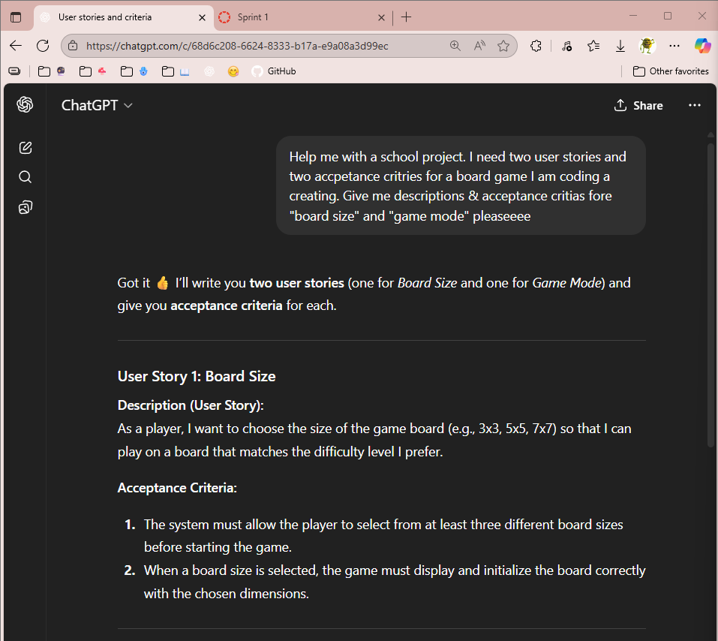

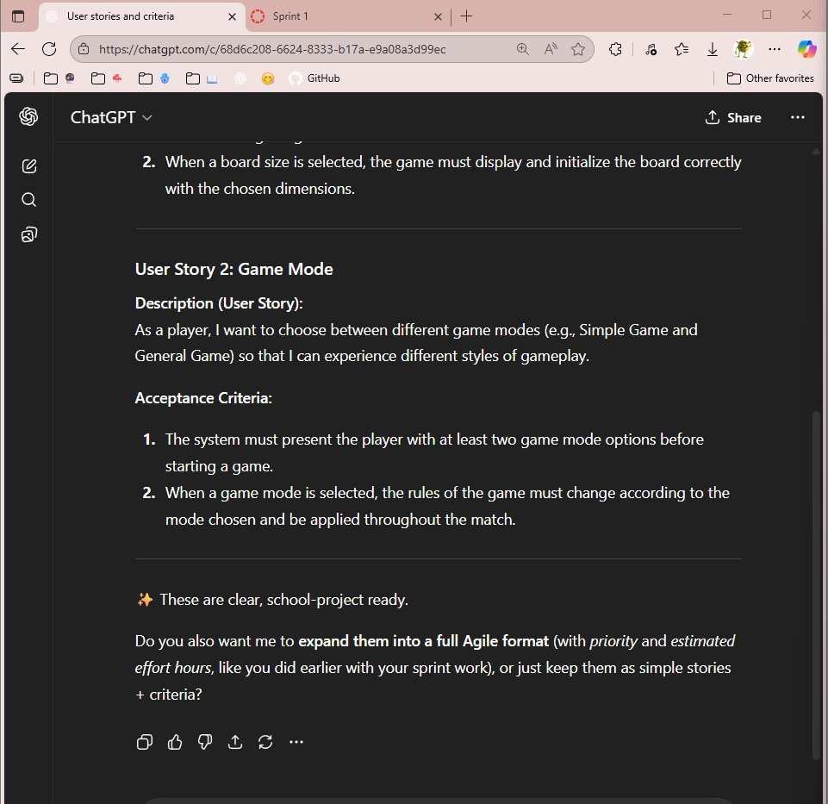

* My feedback with what chatGBT gave me is that the user stories are pretty well written, using the correct layout given (As a <role>, I want <goal> [so that <benefit>]), but the acceptance criteria is not in the correct format. Acceptance criteria should be in the format “Given….,When…,Then”, which was not provided in the chatGBT process.