Project Sprint #2
The SOS game is described in CS449HomeworkOverview.docx. You should read the description very carefully. Your submission must include the GitHub link to your project and you must ensure that the instructor has the proper access to your project. You will receive no points otherwise.
~ GitHub link:MadisonAlex14/SOSGame ~

Implement the following features of the SOS game: (1) the basic components for the game options (board size and game mode) and initial game, and (2) S/O placement for human players without checking for the formation of SOS or determining the winner. The following is a sample interface. The implementation of a GUI is required. You should practice object-oriented programming, making your code easy to extend. It is required to separate the user interface code and the game logic code into different classes (refer to the TicTacToe example). xUnit tests are required.

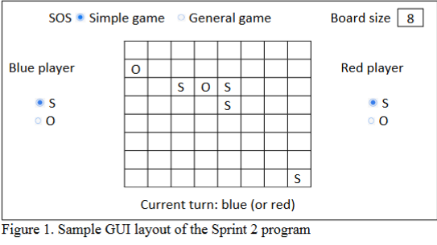

Deliverables:
- Demonstration (8 points)
- Submit a link to a video of no more than three minutes, clearly demonstrating that you have implemented the required features and written some automated unit tests. In the video, you must explain what is being demonstrated. No points will be given without a video link.
 | Feature
1 | Choose board size
2 | Choose game mode
3 | Start new game of the chosen board size and game mode
4 | “S” moves
5 | “O” moves
6 | Automated unit tests

- YouTube/Panopto link: https://umsystem.hosted.panopto.com/Panopto/Pages/Viewer.aspx?id=718ee63f-26aa-4850-9ec7-b37d0161ce4f&start=0

- Summary of Source Code:

Source code file name | Production code/test code | # of lines of code
GameBoard.cs | Production | 210
GameBoardTests.cs | Test | 100
Total: |  | 310

Source Code Screenshots:
Form1.cs
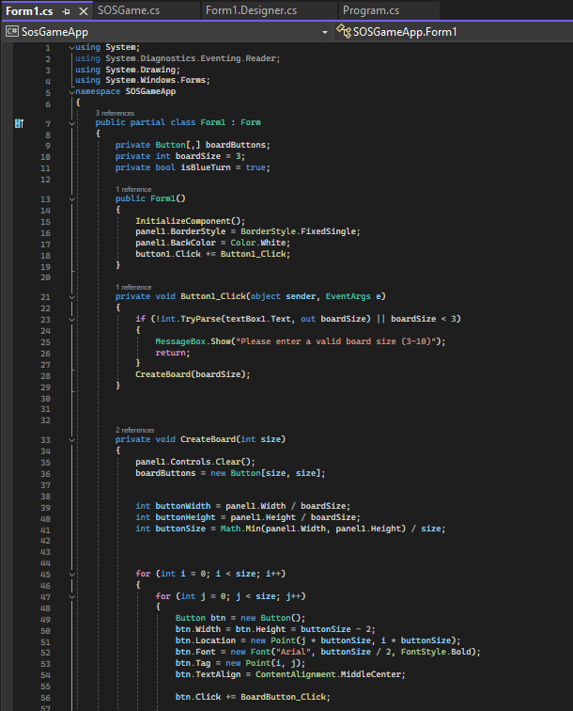
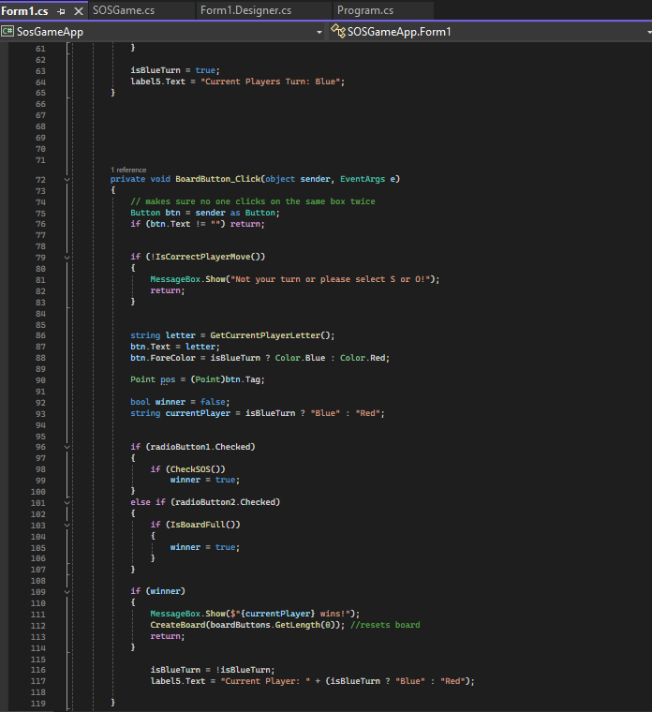
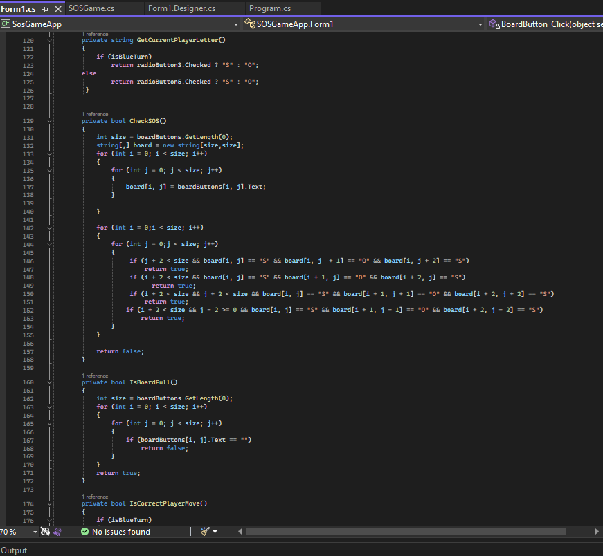
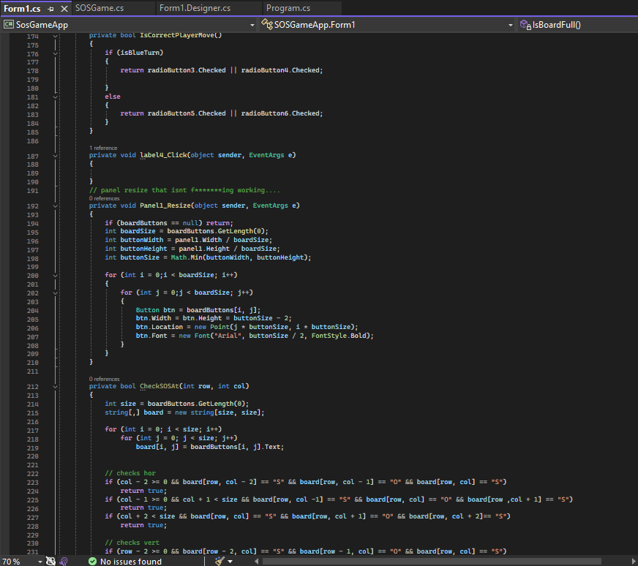
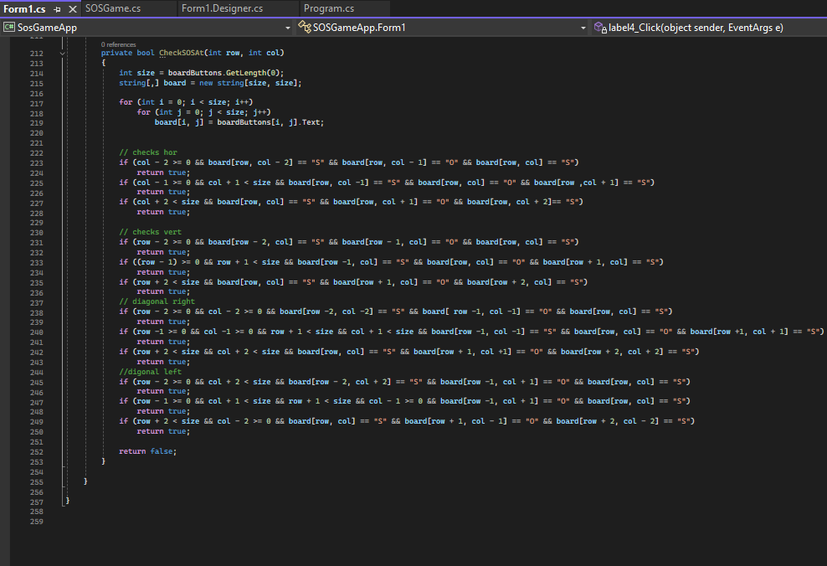
Form1.Designer.cs
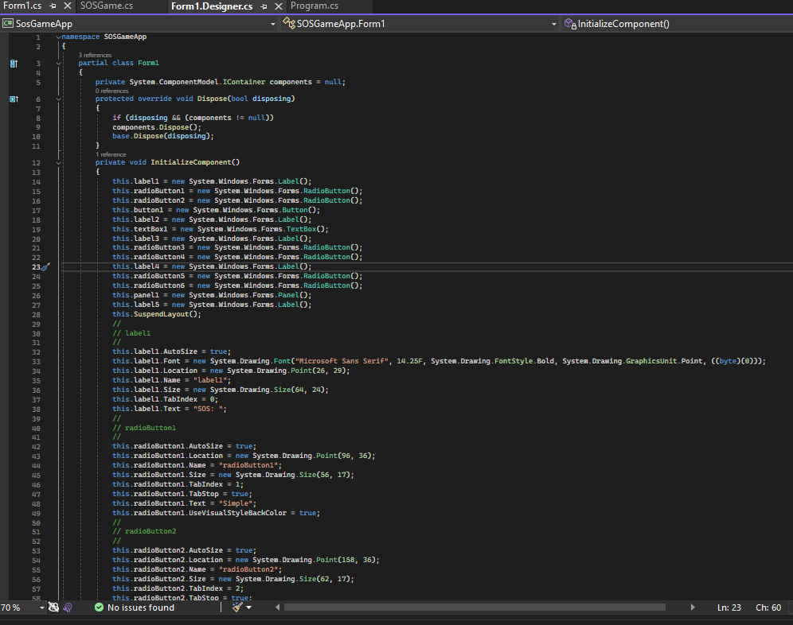
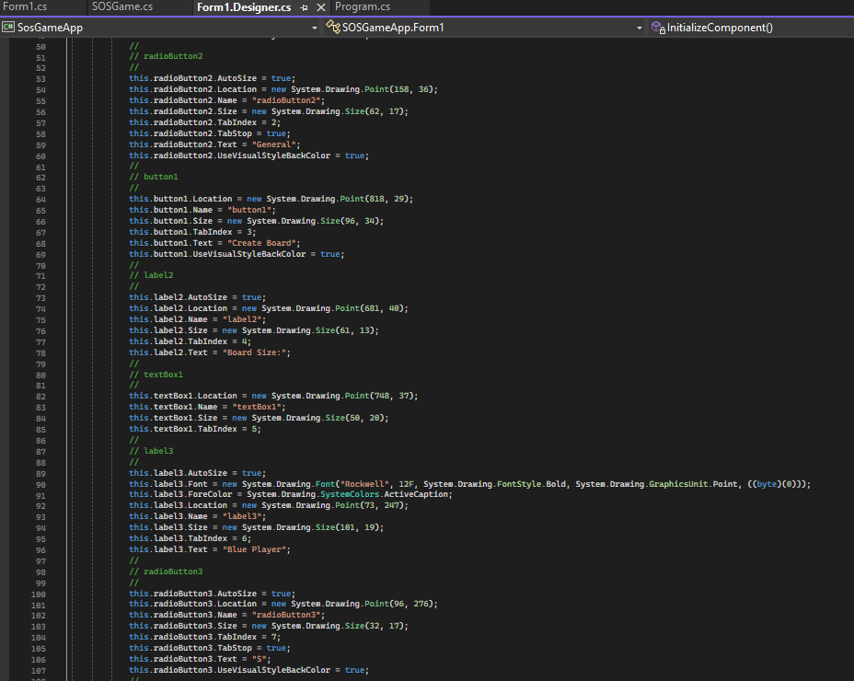
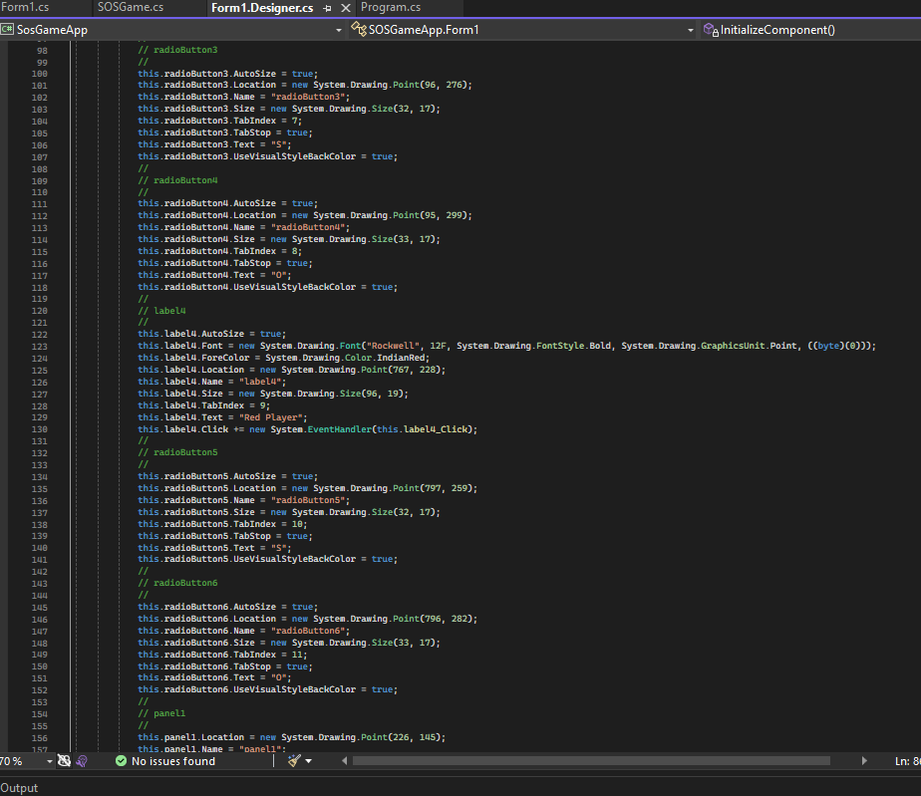
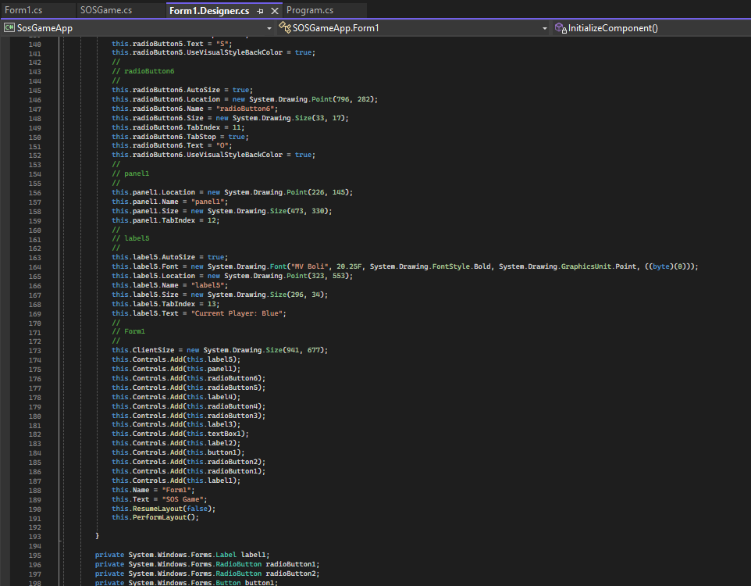
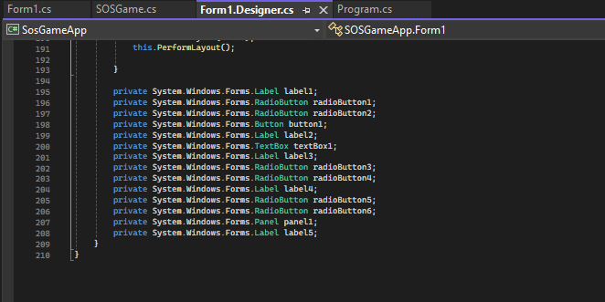
SOSGame.cs
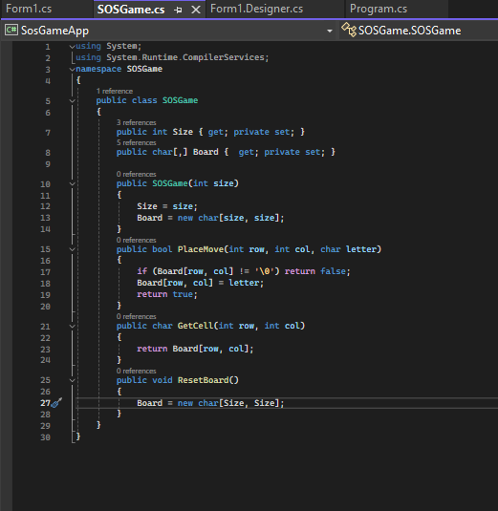
Program.cs
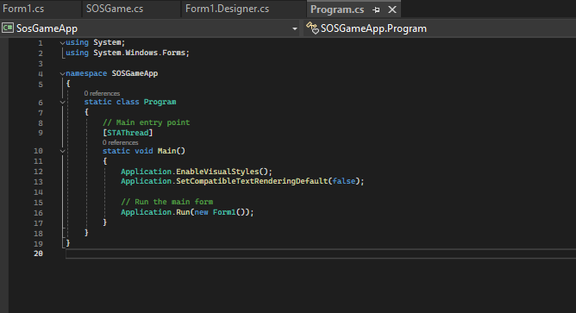

You must submit all source code to get any credit for this assignment!!!! →

- Production code vs user stories/acceptance criteria
- Update your user stories and acceptance criteria from the previous assignment and ensure they adequately capture the requirements. Summarize how each of the following user story/acceptance criteria is implemented in your production code (class name and method name etc.)

User Story ID | User Story Name
1 | Choose board size
2 | Choose game mode for chosen board size
3 | Start a new game of the chosen board size and game mode
4 | Make a move in a simple game
6 | Make a move in general game

User Story ID and Name | AC ID | Class Name(s) | Method Name(s) | Status (Completed or not)
1 - Board Size | 1.1: Allow the user to either select a 3x3 or 10x10 board | GameSettings | SetBoardSize(int size) | ✅
 | 1.2: When the size is chosen, a grid of that chosen size is displayed | GameBoard | InitializeGrid(int size) | ✅
 | 1.3: All cells are empty at the start of a new game | GameBoard | ClearBoard() | ✅
2 - Game Mode | 2.1: User can select “simple” or “general” mode using the radio buttons | GameSettings | SetGameMode(string mode) | ✅
 | 2.2: The chosen mode is then applied to the current game | SOSGame | ApplyGameMode() | ✅
3 - New game | 3.1: Start a new game clears the current board | SOSGame | StartNewGame() | ✅
 | 3.2: The board size and mode reflects on the current selections | SOSGame | StartNewGame() | ✅
 | 3.3:The game starts with the Blue players turn | SOSGame | ResetTurn() | ✅
4 - Simple Game | 4.1: The player can select the letters “S” or “O” | GameControllerTests | TestSelectLetter_SetsCorrectLetter() | ✅
 | 4.2: Confirms that the letter is correctly placed | GameBoardTests | TestPlaceLetter_ValidPlacement() | ✅
 | 4.3: Ensures that an occupied space cannot be replaced | GameBoardTests | TestPlaceLetter_PreventsOverwrite() | ✅
 | 4.4: Detects valid SOS formations | GameLogicTests | TestCheckForSOS_DetectsPatterns() | ✅
 | 4.5:Verifies game ends after SOS found | GameControllerTests | TestEndGameIfSOSFound_StopsGame() | ✅
6 - General Game | 6.1:Checks player letter selection in General mode | GameControllerTests | TestSelectLetter_SetsCorrectLetter_General() | ✅
 | 6.2: Ensures the valid places on General board | GameBoardTests | TestPlaceLetter_ValidPlacement_General() | ✅
 | 6.3: Verifies SOS detection logic works for scoring | GameLogic | CheckForSIS() | ✅
 | 6.4: Increases player score when SOS is found | ScoreTracker | UpdateScore(sting player) | ✅
 | 6.5: Alternates turns after a valid move is made | GameController | SwitchTurn() | ✅
 | 6.6: Ends game when all cells are filled | GameController | EndGameIfBoardFull() | ✅

- Test vs. User stories/Acceptance Criteria
- Summarize how each of the user story/acceptance criteria is tested by your test code (class name and method name) or manually performed tests
User Story ID | User Story Name
1 | Choose board size
2 | Choose game mode for chosen board size
3 | Start a new game of the chosen board size and game mode
4 | Make a move in a simple game
6 | Make a move in general game

- 4.1 Automated tests directly corresponding to the acceptance criteria of the above user stories. You are required to use ChatGPT to create at least 2 unit tests. You also need to ensure that the generated user stories are correct, and refine them if not. At the end of the submission, provide the screenshots of your ChatGPT prompts and answers, along with errors ChatGPT made and you fixed. You may also use another LLM, including hosted locally. Points will be deducted if no screenshots are provided.

User Story ID and Name | AC ID | Class Name(s) of Test Code | Method Name(s) of Test Code | Description of the Test Case
1 - Board Size | 1.1 | GameSettingsTests | TestSetBoardSize_ValidRange() | Ensures that the board size is only 3x3 or 10x10
 | 1.2 | GameBoardTests | TestIntitialGrid_SizeMatchesSelection() | Checks the grid that was just created to make sure its the correct size
 | 1.3 | GameBoardTests | TestClearBoard_StartsEmpty() | Ensures all cells are empty at the start of the game
2 - Game Mode | 2.1 | GameSettingsTests | TestSetGameMode_ValidModesOnly() | Verifies that only Simple or General game modes can be selected
 | 2.2 | GameControllerTests | TestStartGame_StoresModeCorrectly() | Checks that the selected mode is stored in memory
 | 2.3 | GameUITests | TestDisplayModeIndicator_UpdatesCorrectly() | Confirms GUI updates with active mode
3 - New game | 3.1 | PlayerSettingsTests | TestSetPlayerType_Player1() | Tests Player 1 Human/Computer assignment
 | 3.2 | PlayerSettingTests | TestSetPlayerType_Player2() | Tests that PLayer 2 Human/Computer Assignment
 | 3.3 | GameUITests | TestDisplayPlayerTypes_ShowsCorrectly() | Berries that both player types are displayed correctly
 | 3.4 | AIPlayerTests | TestMakeMove_AIValidMove() | Ensures AI can make a valid move automatically
4 - Simple Game | 4.1 | GameControllerTests | TestSelectLetter_SetsCorrectLetter() | Ensures player letter (S or O) selection work
 | 4.2 | GameBoardTests | TestPlaceLetter_ValidPlacement() | Confirms the correct letter placement
 | 4.3 | GameBoardTests | TestPlaceLetter_PreventsOverwrite() | Ensures occupied cells cant be changed if already filled
 | 4.4 | GameLogicTests | TestCheckForSOS_DetectsPatterns() | Detects to see if there is a valid SOS
 | 4.5 | GameControllerTests | TestEndGameIfSOSFound_StopGame() | Verifies that there is a win and ends game after
6 - General Game | 6.1 | GameControllerTests | TestSelectLetter_SetsCorrectLetter_General() | Checks that the player letter selection is in General mode
 | 6.2 | GameBoardTests | TestPLaceLetter_ValidPlacement_General() | Makes sure that the valid placement in general game
 | 6.3 | GameLogicTests | TestCheckForSOS_DetectsAndScore() | Verifies that SOS detection logic works for scoring
 | 6.4 | ScoreTrackerTests | TestUpdateScore_AddsPointsToPlayer() | Ensure player score updates correctly
 | 6.5 | GameControllerTests | TestSwitchTurn_AlternatesPlayers() | Checks turn order alternates properly
 | 6.6 | GameControllerTests | TestEndGameIfBoardFull_StopsGame() | Ends game when all cells are filled

- 4.2 Manual tests directly corresponding to the acceptance criteria of the above user stories

User Story ID and Name | AC ID | Test Case Input | Test Oracle | Notes
1 - Board Size | 1.1 | Enter board size “2” then enter “5” | “2” is rejected, “5” creates a board | Valid range is 3-10
 | 1.2 | Select Board size 5x5 and press start | Game window shows a 5x5 grid | Confirms board size settings
 | 1.3 | Start a new game after finishing one | Board displays all empty cells starting off | Verifies board resets
2 - Game Mode | 2.1 | Choose “Simple Game” or “General Game” | Only “simple” or “general” can be selected | Invalid modes are ignored
 | 2.2 | Select “general game”, press start, and check internal mode variables | mode variable = “general” | confirmed via debug or UI display
 | 2.3 | After selecting a mode, look at GUI label | GUI will display “Mode: general” or “Mode: Simple” | Confirms visual mode feedback
3 - New game | 3.1 | Red player selects either “S” or “O” from radio button | Red player assigned correctly | Verifies red player set up
 | 3.2 | Blue player selects either “S” or “O” from radio buttons | Blue player assigned correctly | Verifies blue player set up
 | 3.3 | Check GUI player display | GUI shows “red player” and “blue player” | Confirms names displayed correctly
 | 3.4 | Start game and check who does first | Correct starting player will be indicated | Confirms names displays correctly
4 - Simple Game | 4.1 | Red player clicks “Start game” in Simple Game mode | Game board initializes correctly based on size inputted previously and simple game mode | Red players starts first
 | 4.2 | Red players selects a move | move is applied and board updates | Blue player waits
 | 4.3 | red player tries an invalid move | move is rejected, board is unchanged | ensure validation works
 | 4.4 | red player completes winning move | game displays the winner | test all winning conditions
 | 4.5 | player clicks “rests” board rests to initial state | board rests to initial state | test after mid-game
6 - General Game | 6.1 | Blue player clicks “start game” in General Game mode | game board is initialized in general game mode and board size given previously | Blue player starts first
 | 6.2 | Blue player selects a move | Move is applied and game state updates | red player then waits for their turn
 | 6.3 | Game rules are enforced, player tries an illegal move | move is rejected, state is unchanged | validate all rule types
 | 6.4 | Game can recognize end conditions, red player wins | game announces results | tests all end conditions
 | 6.5 | Game supports reset, player clicks “resets” | game resets to its starting state | test mid-game and post-game results

- 4.3 Other automated or manual tests not correspond to the acceptance criteria of the above user stories

Number | Test Input | Expected Result | Class Name of the Test Code | Method Name of the Test Code
1 | A player tries to move before the game starts | Move is rejected, error message is shown | SimpleGameTest | testMoveBeforeStart()
2 | A player tried to move in an already taken up cell | Move rejected, board is unchanged | SimpleGameTest | testMoveOnOccupiedCell()
3 | A player performs many moves in a row | Only first move in accepted, others are rejected | SimpleGameTest | testMultipleMovesSameTurn()
4 | Start a general game and instantly reset the game | Board returns to its starting state | GeneralGameTest | testImmediateReset()
5 | A player attempt to make an invalid move type | Move rejected, error legged | GeneralGameTest | testInvalidMoveType()
6 | Stree test: perform 1,000 moves in general game | game handles without crashes | GeneralGameTest | testSquentialMovesStress()
7 | Random input, invalid characters in move input | input rejected, no crash | GeneralGameTest | testInvalidCharacterInput()
8 | A player quits mid-game | game terminates, opponent is notified | SimpleGameTest | testPlayerQuit()

Unit Test Screen Shots:
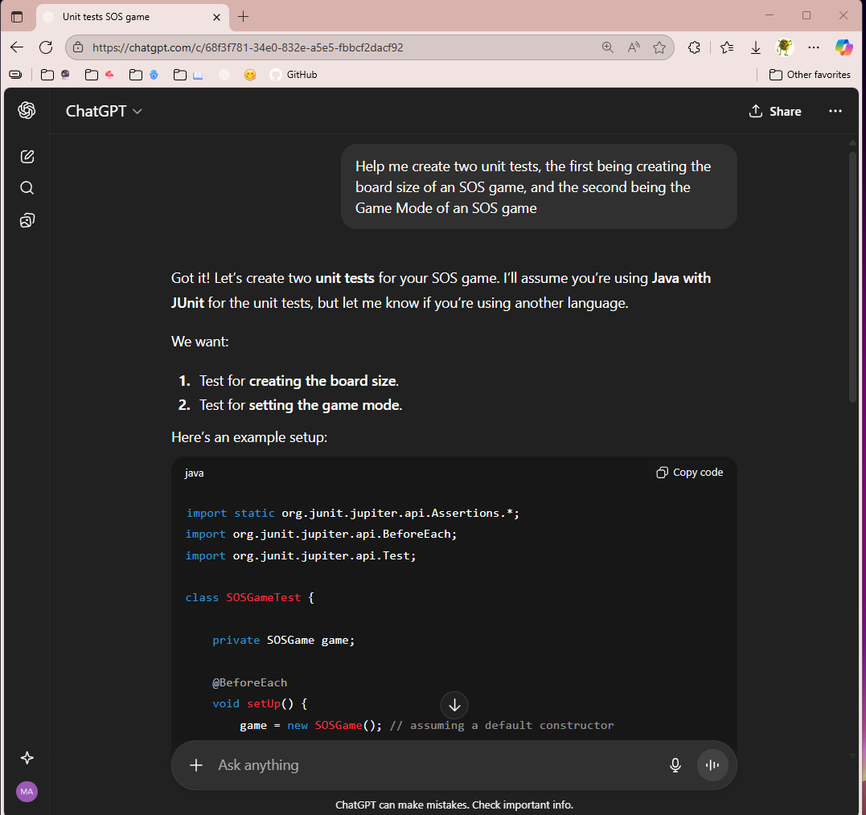
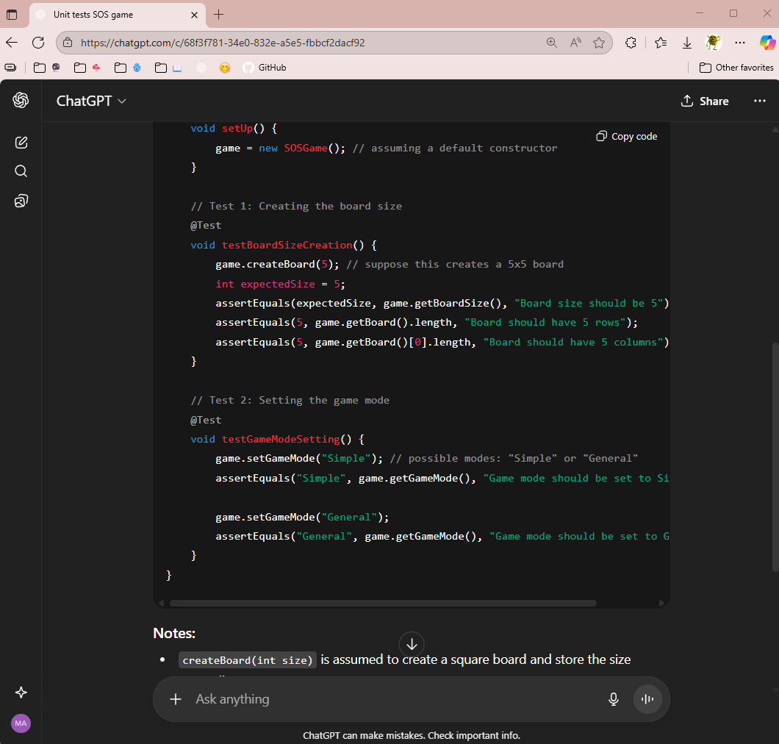
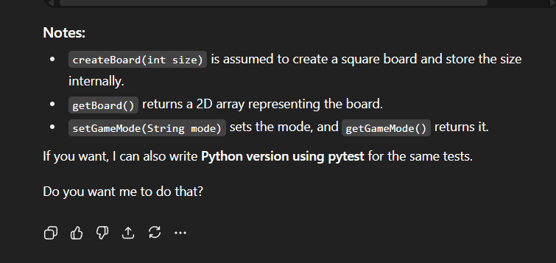

- I did forget to ask to put it in C#, which is my chosen coding language for this project, but overall, although extremely simplified, I do think these unit tests might work with some tweaking and corrections, but not too bad. It doesn’t fulfill all the requirements I need however, like yes I will be able to create a board and choose a size, but none of the rules or tests will be in place that I need for me to be able to turn this in and get full points as needed.

