~Sprint 3~
Github Link:https://github.com/MadisonAlex14/SosGame
Video Link: Sprint 3 Demo - Madison Alexander

Implement all the features that support a human player to play a simple or general SOS game against a human opponent and refactor your existing code if necessary. Minimum features include:
- Choosing the game mode (simple or general)
- Choosing the board side
- Setting up a new game
- Making a move (in a simple or general game)
- Determining if a simple or general game is over
The following is a sample GUI layout. It is required to use a class hierarchy to deal with the common requirements of the Simple Game and the General Game. If your code for Sprint 2 has not considered class hierarchy, it is time to refactor your code.
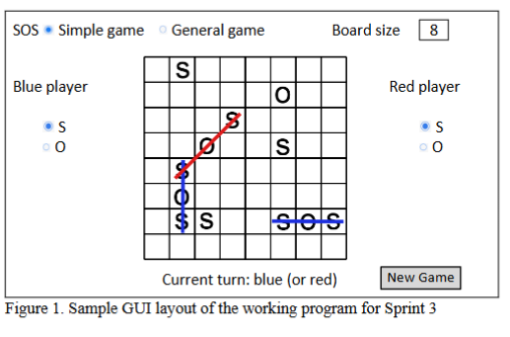
Deliverables: (they will expand & improve sprint 2)
- Demo Video (no more than 5 mins!)
  - Simple game where blue player is the winner
  - Simple draw game with the same board size as (a)
  - General game that red is the winner (new board size)
  - General game that is a draw that is the same size as ©
  - Automated unit test for Simple
  - Automated unit test for General
- PUT ALL SOURCE CODE IN GITHUB!! → DONE :)
Source code file name | Production code or test code | # lines of code
Program.cs | Production Code | 10
Form1.cs | UI Logic Production Code | 250
SOSGame.cs | Game Logic Production Code | 200
SOSGameTests.cs | Test code (Unit tests) | 100
Total: |  | 560
- Production Code vs User Stores/Accpetancde Criteria

User ID | User Story Name:
1 | Choose a board size
2 | Choose the game mode (w/chosen board size)
3 | Start a new game (w/board size & game mode)
4 | Make a move in a simple game
5 | A simple game is over
6 | Make a move in a general game
7 | A general game is over

User ID | AC ID | Class Name | Method Name | Status | Notes
1 | 1.1 | Form1 | CreateBoard() | ✅ | Generates board size when “create board” is clicked
 | 1.2 | Form1 | DisableBoard() | ✅ | Board doesn’t work until both size a game mode are choosen
 | 1.3 | Form1 | InitializeBoard() | ✅ | Clears board after every game
2 | 2.1 | Form1 | radioButtonSimple_CheckedChanged() | ✅ | Activates Simple game mode
 | 2.2 | Form1 | radioButtonGeneral_CheckChanged() | ✅ | Activates General game mode
 | 2.3 | Form1 | LockGameMode() | ✅ | Prevents users from switching game modes while playing
3 | 3.1 | Form1 | button1_Click | ✅ | Starts new game
 | 3.2 | SOSGame | StartNewGame() | ✅ | Can restart the game at any time
 | 3.3 | Form1 | ResetUI() | ✅ | Clears board before each round
4 | 4.1 | Form1 | boardButtons_Click() | ✅ | Handles each players clicks and moves
 | 4.2 | SOSGame | MakeMove(int row, int col, char letter) | ✅ | Records a players move and checks for SOS after each move
 | 4.3 | SOSGame | CheckForSOS() | ✅ | Detects SOS pattern after each players move
5 | 5.1 | SOSGame | IsSImpleGameOver() | ✅ | Determines is an SOS is made and the game is over
 | 5.2 | Form1 | DisplayWinner() | ✅ | Tells which player wins after each round
6 | 6.1 | SOSGame | IsGeneralGameOver() | ✅ | Checks if the general game terms work
 | 6.2 | SOSGame | GetScore(Player player) | ✅ | Keeps score for General game
7 | 7.1 | Form1 | DisplayWinner() | ✅ | Shows results at the end of General game
 | 7.2 | Form1 | EndGameMessage() | ✅ | Displays a game over message once game board is full

Notes: I over specified a lot in Sprint two so this is more simplyfed for this sprint. However, the information itself should be the same, just easier to read.

4.1 Automated tests that directly corresponding to some acceptance criteria

User ID | AC ID | Class Name | Method Name | Description
1 | 1.1 | SOSGameTests | TestBoardCreation() | creates board with the size input (if user puts in 5, then a 5x5 board is created with 25 buttons)
 | 1.2 | SOSGameTests | TestBoardReset() | ressets game and all board cells are cleard
 | 1.3 | SOSGameTests | TestBoardInitilzation() | Initilizes board size and displays empty cells
2 | 2.1 | SOSGameTests | TestSimpleModeSelection() | Simple game mode is activated when its pressed
 | 2.2 | SOSGameTests | TestGeneralModeSelection() | When you click the General game → general mode will be activated
 | 2.3 | SOSGameTests | TestGameModeLocked() | Locks in game mode and board size
3 | 3.1 | SOSGameTests | TestStartNewGame(0 | board becomes clear and ready to play
 | 3.2 | SOSGameTests | TestRessetUI() | clears previous game
4 | 4.1 | SOSGameTests | TestMakeMove() | When a player wants to place an S, an S will appear on the baord
 | 4.2 | SOSGameTests | TestCheckForSOS() | SOS detection sequence
 | 4.3 | SOSGameTests | TestScoreIncrement() | If a player forms a SOS, then their score goes up by one
5 | 5.1 | SOSGameTests | TestSimpleGameOver() | An SOS is made, the game is over
 | 5.2 | SOSGameTests | TestSimpleWinner() | if blue makes an SOS first, then blue is the winner
6 | 6.1 | SOSGameTests | TestGeneralGameOver() | when board is filled, then the game ends
 | 6.2 | SOSGameTests | TestGeneralScoreComparsion() | compares score of both players, the higher scores win
7 | 7.1 | SOSGameTests | TestEndGameDisplay() | when a game is completed, a game over pop-up appears
 | 7.2 | SOSGameTests | TestFinalScoreDisplayed() | ends general game

4.2 Manual Tests Directly Corresponding to Some Acceptance Criteria

User ID | AC ID | Test Case Input | Test Oracle | Notes
1 | 1.1 | Type in 5 and click create | 5x5 grid will appear | works as expected
 | 1.2 | Reset board after play | all cells are cleared | UI resets
2 | 2.1 | Select simple game mode | simple mode radio button lights up
 | 2.2 | Try changing mode mid game | game mode stays unchanged | prevents user error
3 | 3.1 | Click start after selecting size/mode | board initilalizes with empty buttons
 | 3.2 | Start new game again | new empty grid replaces old one
4 | 4.1 | Click the letter S and then click a board cell | cell updates with chosen letter
 | 4.2 | Form SOS pattern | player then gains a point | Correct scoring behavior
5 | 5.1 | Fill board with an SOS | Message “game over” appears
 | 5.2 | End game with more points for Blue | message “Blue wins” appears | correct winner messaging
6 | 6.1 | End game in General mode | “Game over” message displayed
 | 6.2 | Compare both player scores | Correct final results are displayed
7 | 7.1 | Game ends | message box “game over” appears
 | 7.2 | Review final screen | Red/Blue final scores

4.3 Other Automated or Manual Tests Not Corresponding to Acceptance Criteria

# | Test Input | Expected Result | Class Name | Method Name
1 | Click on board before starting game | Board is disabled | SOSGameTests | TestBoardDisabledBeforeStart()
2 | Input invalid board # | Message “Must put valid board input” | SOSGameTests | TestInvalid Move()
3 | Alternate turns | Players alternate correctly | SOSGameTests | TestTurnOver()
4 | Click “Reset” mid-game | board resets | SOSGameTests | TestResetMidGame()
5 | Clase and reopen application | game initializes correctly | SOSGameTests | TestAppStartup()

Writing Prompts Below:

Part 1: Class Hierarchy
In my SOS game project, I have designed the class hierarchy to separate the game logic itself from the user interface, while also handling the shared and unique requirements for both the Simple Game and General Game modes. The overall structure of my code include the three main classes: Form1, which manages most of the graphical user interface; SOSGame, which operates the controls of the core game logic and rules for users; and finally Player, which represents the players and their scores. This flow of organization not only allows both games types to share the same foundation, but also apply their own rules to each game, along with handling turns and winners.
At the core of this hierarchy, the SOSGame class functions are the main logic controllers. It not only maintains the game board, but also the current players turn, move validations, and if anyone made an SOS throughout the game play. This design ensures that common features like inilitzing the board or placing a ‘S’ or ‘O’ are implemented only once and are used across both game types. This then helps the developer keep down redundant code and untilizes the updates to the games rules and behaviors.
The main key difference between the Simple and General game modes is how the winner is determined, and this is personally what I struggled with the most. In the Simple game mode, its a race for time. The first player to form a SOS pattern wins and declares the game over. This method is handled by CheckForSOS() and the conditional logic inside MakeMove(). In contrast, the General game mode is based on skill, whoever has the highest amounts of SOS’s made when the board is filled is declared the winner. This distinction is made possible by the game mode flag, like gameMode or boolean like isSimpleGame, that is stored within the SOSGame class. Depending on which game mode/ radio button the user has clicked in Form1, the program then sets this flag and triggers the right rule logic during game play.
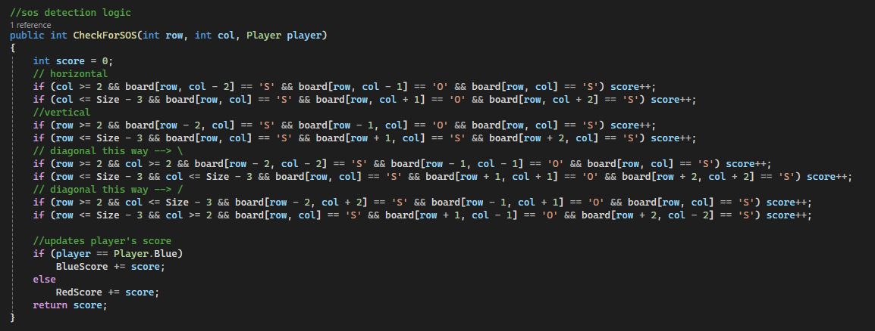

Part 2: Using ChatGPT to Analyze Design Principles
To look at how well my SOS Game code followed the normal design principles, I used ChatGPT (a widely known large language model) to review my Form1.cs and my SOSGame.cs files to look for modularity, cohesion, coupling, and encapusltion. I wanted to make sure my project structure was supported and had clear separation between the game’s logic and the users interface.

In my first interaction, I asked ChatGPT:
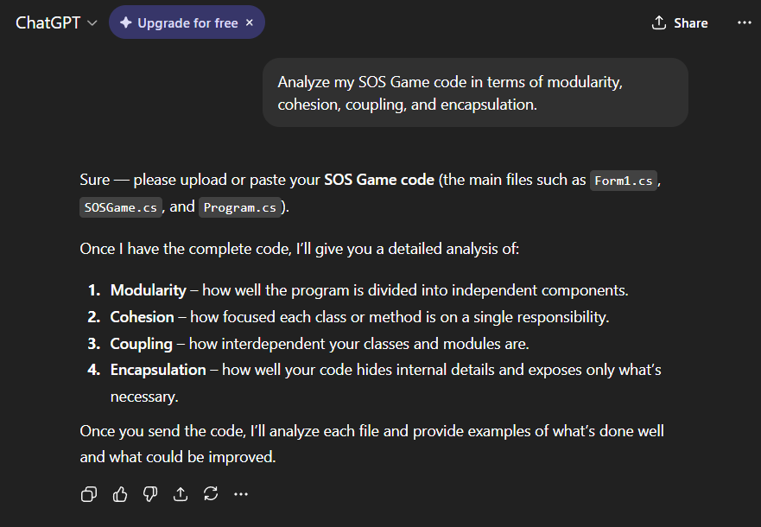
Once I sent over my full code for those three files, the model then responded that my designed showed strong modularity because I kept the main game logic inside of SOSGame.cs, separate from the main form interface in Form1.cs. This then made is easier for me to update the different game rules and scoring without messing with the whole GUI itself. It also said that I had good cohesion, since the SOSGame class is mainly focused on only handling the board, moves, and detecting when someone made an SOS, while Form1 handled mainly button clicks and user interactions.
However, ChatGPT did point out that my program did have some tight coupling between Form1 and SOSGame because FOrm1 has accessed internal data and logic directly instead of doing the normal go through a well-defined public matter method. It was also noted that my encapsulation could use some work. I had limiting public variables that expose my SOSGame. For example, I had public char[,] board; that allowed Form1 to read and mody it directly, which violates some excapuslation principles.
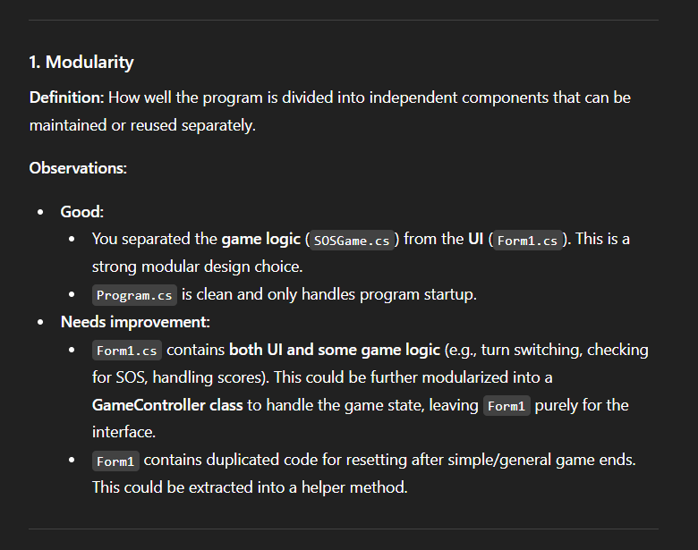
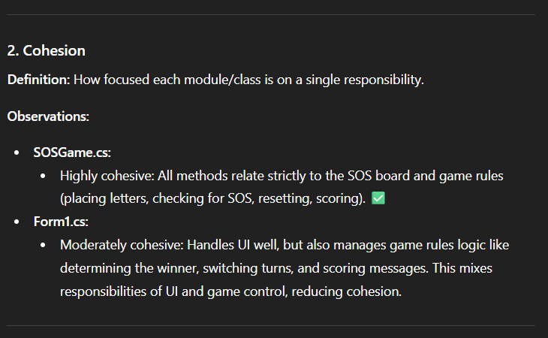
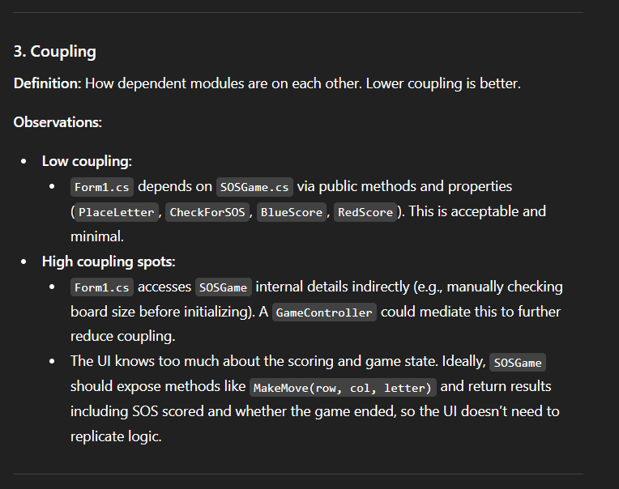
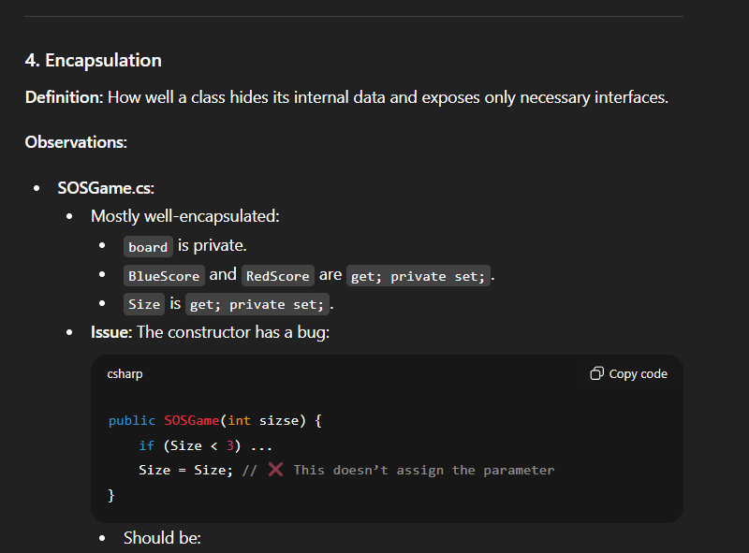
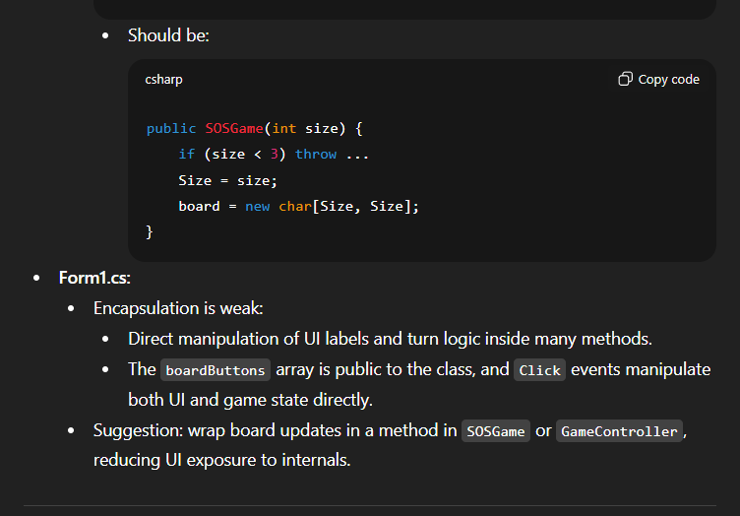

ALL SOURCE CODE IN GITHUB!!

