Sprint 4
~24 points total~
GitHub Link:GitHub Link
Video Demo Link: Sprint 4 Demo

Implement all the features that support a player (human or computer) to play a simple or general SOS game against another player (human or computer). The minimum features include choosing a human or computer for red and/or blue players, choosing the game mode (simple or general), choosing the board size, setting up a new game, making a move (in a simple or general game), and determining if a simple or general game is over. The computer component must be able to play complete simple and general games. You are encouraged to consider basic strategies for winning simple or general games (e.g., against a poor human player). Optimal play is not required. The following is a sample GUI layout. You must use a class hierarchy to deal with the computer opponent requirements. If your current code has not yet considered class hierarchy, it is time to refactor your code

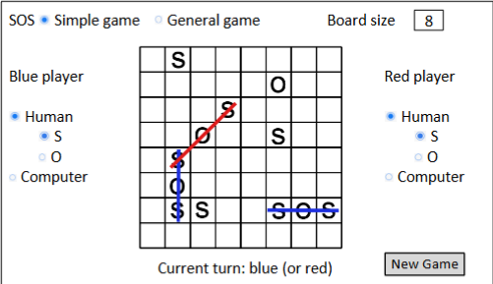

- Demo Video: (5 mins or less) (8 Points)
  - A complete simple game where the blue player is a human, the red player is the computer, and there is a winner
  - A complete general game where the blue player is the computer, the red player is a human, and there is a winner
  - A complete simple game where both sides are played by the computer
  - A complete general game where both sides are played by the computer
  - Some automated unit tests for the computer opponent.

2. User Stores for the Computer Opponent Requirements (As a <role>, I want <goal>[so that <benefit>] ( 1 point)

ID | User Name | User Story Description | Priority | Estimated Hours
8 | Simple Game (HvC) | As a player, I want to finish a Simple game where the blue player is human and the red player is the computer, making sure there is a winner. | High | 3
9 | General Game (HvC) | As a player, I want to play a complete General game where the blue player is the computer and the red player is a human, making sure there is a winner. | High | 3
10 | Simple Game (CvC) | As a user, I want to watch a complete Simple game fully played by the computer for both blue and red players | Medium | 2
11 | General Game (CvC) | As a user, I want to watch a complete General game that is fully played by the computer for both blue and red players. | High | 4
12 | Automated Tests | As a developer, I want some automated unit tests for the computer opponent logic to ensure the reliability of an AI’s decisions | Medium | 2

3. Acceptance Criteria (AC) for the Computer Opponent Requirements ( 4 points)

ID | AC ID | Description | Status
8 | 8.1 | Given a Simple game, when blue is human and red is a computer, the game plays to completion with a clear winner each round. | Half
9 | 9.1 | Given a General game, when blue is a computer and red is a human, the game then plays to completion and there is a clear winner each round. | Half
10 | 10.1 | Given a Simple game, when both sides are the computer, then the game plays until there the board is full and the player with the most points is the winner. | Half
11 | 11.1 | Given a General game, when both sides are computer controlled, then the game will play until the board is clear and the player with the most points wins. | Half
12 | 12.1 | Given the computer opponent logic, when automated tests are executed, then all decision-making logic passes. | Half

4. Summary of All Source Code ( 1 Point)

Source code file name | Production code or test? | # lines of code
Form1.cs | Production | 250
Form1.Designer.cs | Production | 350
SOSGameTests.cs | Test | 113
Player.cs | Production | 18
SOSGame.cs | Production | 150
GameController.cs | Production | 150
Program.cs | Production | 10
Total: |  | 891

5. Production Code vs. New User stories/AC ( 2 points)

User ID/Name | AC ID | Class Name | Method Name | Status | Notes
8 | 8.1 | SOSGame | PlaySimpleGame_HumanBlue_ComputerRed | ✅ - 80% | Works for a human vs computer simple game, still working on winner detection but SOS’s are made clear
9 | 9.1 | SOSGame | layGeneralGame_ComputerBlue_HumanRed | ✅ - 85% | Game logic can handle a general game in any human vs computer aspect, still working on winner detection but SOS’s are highlighted and made clear
10 | 10.1 | SOSGame | PlaySimpleGame_ComputerVsComputer | ✅ | Two computers can play against each other in in a simple game and a winner is declared after each round.
11 | 11.1 | SOSGame | PlayGeneralGame_ComputerVsComputer | ✅ - 90% | Two computers can play again each other in a general game, winner isnt declared yet but SOS is made clear
12 | 12.1 | GameController | GetSmartComputer | ✅ | Could use some improvement - computer does make SOS’s but could make less randoms moves
13 | 13.1 | GameController | MakeComputerWinMove | Not really | Isn’t very cut throat yet, will finish some SOS’s but is still an easy thing to beat in a normal game
14 | 14.1 | GameController | ValidateSOSColor | ✅ | No colors mixing in SOS, Blue cant make an SOS with a red letter and vise versa
15 | 15.1 | SOSGame | FullGameSimulation | ✅ - 80% | Automated so full games are played correct - could use some work on Simple game automation

6. Tests vs New User stories/AC ( 2 points)

6.1 → Automated test directly corresponding to some acceptance criteria

User ID/Name | AC ID | Class Name of Test Code | Method Name of Test Code | Description of Test Case
8 | 8.1 | SOSGameTests | Test_SimpleGame_HumanBlue_ComputerRed | Verifies a simple game where blue player is the human, red is a computer, and there is a winner
9 | 9.1 | SOSGameTests | Test_GeneralGame_ComputerBlue_HumanRed | Verifies a general game mode where blue is the computer, red is the human, and there is a winner
10 | 10.1 | SOSGameTests | Test_SimpleGame_ComputerVsComputer | Verifies that it's a simple game where both red and blue are computers, ensure that the game will still run
11 | 11.1 | SOSGameTests | Test_GeneralGame_ComputerVsComputer | Verifies that a the general game mode where both players are computer controlled are playing and there is a winner or a tie
12 | 12.1 | SOSGameTests | Test_ComputerWins_SOSDetected | Ensures that the computer can detect and make a winning SOS sequence
13 | 13.1 | SOSGameTests | Test_NoMixedColorsInSOS | Verifies that an SOS can only be made with one single color (I had problems with SOS detection and color mixing)
14 | 14.1 | SOSGameTests | Test_FullGame_PlayThrough | Runs a complete automated game sequence and makes sure that the game processes are correct from start to finish

6.2 → Manual tests directly corresponding to some acceptance criteria

ID | AC ID | Test Case Input | Test Oracle
8 | 8.1 | Simple Game → HvC | Game completes, winner is announced
9 | 9.1 | General Game → HvC | Game completes, winner is announced
10 | 10.1 | Simple Game → CvC | Game completes, winner or tie is announced
11 | 11.1 | General Game CvC | Game completes, winner or tie is announced

6.3 → Other automated or manual tests not corresponding to acceptance criteria

# | Test Input | Expected Result | Class name of Test Code | Method Name of Test Code
 | SOSGameTests | Test_BoardInitization | Automated | Verifies that the board goes onto panel1 and is cleared and emptied at the start of each game
 | SOSGameTests | Test_PlayerSwitching | Automated | Makes sure that turns do alternate between players correctly
 | SOSGameTests | Test_MoveOnOccupiedCell | Automated | Makes sure no one can play their letter on a cell that's already full.

7. Present the class diagram of your production code (3 points) and describe how the class hierarchy in your design deals with the computer opponent requirements (3 points)

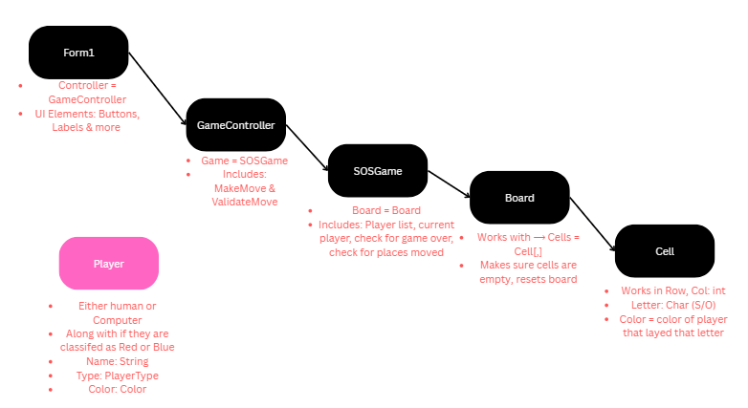
I made this in Canva → Canva link

- Player.cs
  - Each Player has a Type which is either Human or Computer
  - The Color they choose (red or blue) distinguishes visually
  - The MakeMove() method I used works on this logic
    - If Type = Human, then the move comes from the use r
    - If Type = Computer, then the move comes from the AI logic in GameController.cs
- GameController.cs
  - This is mainly where the computer move logic is stored
  - The method I used → GetSmartComputerMove() determines where the best place for the computer to go is, it picks based on
    - Empty cells
    - Attempts to make an SOS
    - Blocking the opponent from making a move
  - The MakeMove(player, row, col, letter) method is for both human and computer and makes sure they run uniformly. This controller not only checks PlayerType to decide to call on GetSmartComputerMove() or just wait for the human input
- SOSGame.cs & Board class
  - The game first loads up with an independent player type
  - PlaceMove(() validates all moves and updates on the board aka Board.Cells
  - CheckGameOver() works the same regardless on if a computer or human just make the move
- Form1.cs
  - Handles only the UI
  - When CurrentPLayer is a computer is then triggers GameController.GetSmartComputerMove() instantly, that the computer can play with no human intervention
  - Separating these can ensure that the Ai logic is decoupled from the interface itself, making it easier to test and build on later.
- OVERALL FLOW SUMMARY
  - Form1 → GameController → SOSGame → Board and Player (if type is computer) goes into GameController
  - When its the computers turn, GameController makes the computer player make a move, updates the SOSGame, and refreshes the UI
  - The same structure works for different game types. Human vs computer, computer vs computer, and human vs human games.

Advantages:
- Decoupled AI Logic → Compute movies are handled by GameController
- Flexible game modes → you can switch even after the game mode and board is already chosen
- Testable → Al moves can be tested automatically using SOSGameTests.cs
- Scalable → Supports smarter AI, many board sizes, and advanced strategies without even touching Form1.cs

