COMP 4200 Final Project
SESH: Student Planner
Group 8
Madison Gosselin, Nicholas Flay, Asifur Rahman and Kayra Guner

COMP 4200: Mobile Application Development
Dr. Shaon Bhatta Shuvo
March 29th, 2026
Table of Contents
Technical Details 3
User Manual 3
Installation Instructions 3
Login Screen 3
Home Page 3
Activity/Edit Page 3
Task Detail Page 3
GitHub Link 3
Contributions 3

Technical Details
The SESH Student Planner application is an Android app developed with the use of Java, XML, and the Android Studio development environment. Below is a breakdown of how the app was built and how it works overall.

Project Structure
SESH utilizes four main activities:
- LoginActivity
  - User login input validation
  - Navigation to the home page
- MainActivity
  - Displays the main dashboard which includes:
    - Task overview.
    - List of current tasks
- AddEditTaskActivity
  - Allows users to create a new task
  - Enables editing details of currently existing tasks
- TaskDetailActivity
  - Show full task information
  - Provides access to edit, delete, and mark task as completed options.

Layouts
The user interface was made using the following XML layout files:
- activity_login.xml
  - Email & password field
  - Validation
  - Login button
- activity_main.xml
  - Home page layout
  - Summary cards of current tasks
  - Upcoming task list
  - Add new task button
- activity_add_edit_task.xml
  - Input fields for title, course/subject, due date, priority, and extra notes
- activity_task_detail.xml
  - Displays the full details of a specific task
  - Task organization buttons

Local Database
SESH saves user data in a local database using Room with the following components:
- Task
  - Defines the fields for student tasks within the database, these include:
    - id (Primary key)
    - title
    - subject
    - dueDate
    - priority
    - notes
    - isCompleted
- TaskDao
  - Contains the operations to be used on the database:
    - insert(Task)
    - update(Task)
    - delete(Task)
    - getAllTasks()
    - getTaskById()
- TaskDatabase
  - Initializes the Room database instance

Files for App Configuration
- AndroidManifest.xml
  - Defines the activities for the application and ensures LoginActivity is the launch screen
- strings.xml
  - Stores all text strings used across the application
- themes.xml/colors.xml
  - Defines the color scheme and overall visual look of the application
- /drawable folder
  - Stores application logo and icons utilized throughout

Application Workflow
- User Login
  - User enters email and password into respective fields
  - Basics validation checks on format and password strength
  - If credentials are valid, user is redirected to the home screen (MainActivity)
- Task Management
  - AddEditTaskActivity allows users to create or edit tasks
  - When “Save Task” is clicked, the task is inserted/updated in the Room database
  - The new task will be reflected on the home screen (MainActivity)
- View Task Details
  - Upon selecting a task, the TaskDetailActivity is opened
  - Users can then:
    - Mark the task as completed
    - Edit the task
    - Delete the task
  - User changes are then reflected on the home screen (MainActivity)

Collaboration and Version Control
- A GitHub repository was utilized for source control:
  - The main branch was the base project.
  - Changes were not to be pushed directly to main
    - Instead, each group member created their own respective branch.
  - Pull requests were used to merge changes.

User Manual
SESH is a mobile student planner application designed to help students organize their academics. Students can add tasks, track deadlines and monitor their schedules in one centralized, easy-to-use application. SESH allows users to create, edit, organize and track tasks with fields to track due dates, priority levels and completion status.

Installation Instructions
- Clone or download the project from GitHub.
- Download or open Android Studio
- Open the project in the IDE and allow Gradle to sync and install dependencies
- Connect an android device or start an emulator
- Build and run to install and launch the SESH.

Login Screen
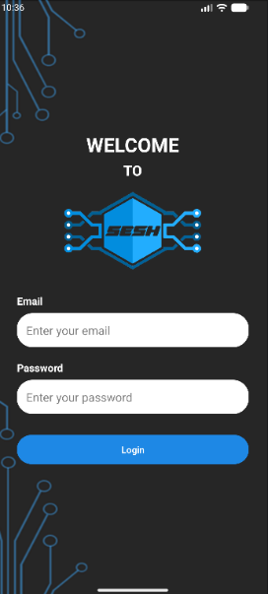
This is the entry point of the application. To get started, enter a valid email address and a password that meets the following requirements:
- Minimum six characters
- At least one uppercase letter
- At least one number
- At least one special character
To check your password, you can toggle to Show/Hide the value of the textbox as needed.

If the users’ credentials are valid, they are redirected to the Home Page with a personalized welcome message!

Home Page
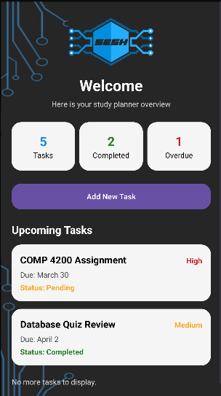
This is the dashboard and central hub for viewing and managing your tasks. For easy access to the most important information, SESH has the following widgets:
Task Overview: Displays total number of tasks, completed tasks and overdue tasks.
Add New Task: Allows the user to quickly input all their new tasks and redirects them to the Activity Page
Upcoming Tasks: Displays the title, due date, priority and status of the users’ tasks.

Add/Edit Task Page
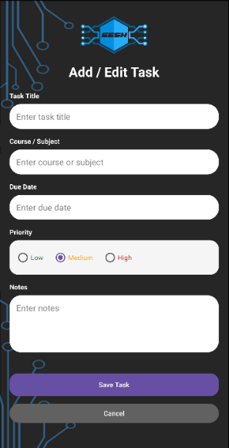
This activity page allows users to create or modify tasks. For task creation, enter the tasks title, course/subject, due date, priority and notes. For task modifications, edit the desired fields.
To confirm the action, the user can click “Save Task” to store the information or “Cancel” to discard changes. The user is then redirected to the Home Page.

Task Detail Page
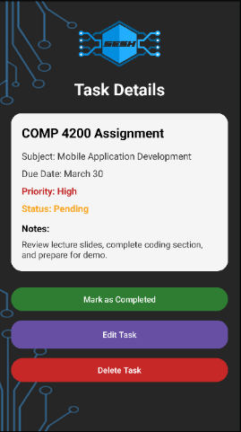
The Task Detail Page displays complete information for a selected task and allows the user to review, update or manage that task.
- Displays all stored task information including task title, subject/course, due date, priority level, notes and completion status.
- Provides options for task management such as “Edit Task”, “Mark as Completed” and “Delete Task”.
Any updates made are saved and immediately reflected in the Home Page overview section that the user is redirected to.

GitHub Link
https://github.com/MadisonGosselin/COMP4200_StudentPlanner

Contributions
We are Group 8 and the following is a table of each group members contributions:
Madison Gosselin | Nicholas Flay | Asifur Rahman | Kayra Guner
GitHub repository | Documentation |  | App Edit activity
Coordinating | Overall layout & ordering |  | App Edit activity layout
User Manual | Text & images
App Config files | Technical Details
Purple: General Red: Code Green: Presentation Orange: Report

