1A : Bag-of-Words Design Decision Description
Firstly, I performed different data cleaning methods as below:
- Lowercasing, all tokens are covereted to lowe case and sklearn verstorizer also lowercase by default. Reduces the possibility of having duplicated tokens such as “The” and “the.
- Contraction expansion. Convert "can't" → "cannot", "I'm" → "I am", etc. Rationale: keeps consistent token forms and reduces noisy tokens.
- Punctuation removals. Removed common punctuation characters (e.g. ?, !, ., ”, /, _), since it rarely helps with for this task and creates token fragmentations.
After the cleaning of the data, I came to find the final vocab list. There are couple methods that I used to determine the final vocab_list:
- Manual BoW exploration: vocab_list = [w for w in sorted_tokens if tok_count_dict[w] >= 4] — this was used for exploratory dense-count feature experiments.
- Removing tokens that occur <4 times reduces noise and keeps feature count manageable when we build dense arrays manually.
With all those applications, the final vocabulary size for each fold (5 folds CV) is around 23,600 -23,800) details as below:
Fold 1 vocab size: 23830
Fold 2 vocab size: 23856
Fold 3 vocab size: 23648
Fold 4 vocab size: 23846
Fold 3 vocab size: 23648
Fold 4 vocab size: 23846
Fold 5 vocab size: 23685
Those the manual BoW experiments used raw counts from transform_text_into_feature_vector(). However in the final pipeline, we used TfidfVectorizer. I chose this is because it commonly gives better performance than raw counts for logistic regression on text classification, because it downweighs ubiquitous words and emphasizes discriminative words.
I also implemented a OOV rate check at the end. Just to make sure we do not have too high of a OVV rate, that our token would still have a valid predication.
The result came to be OVV ~ 5%. which is considered low in comparison with the total token numbers.
Details output as below:
{'total_tokens': 72781, 'oov_tokens': 4184, 'oov_fraction': 0.057487531086409915, 'median_oov_per_doc': 0.05, 'mean_oov_per_doc': 0.058822327249137794}
Throughout the implementation. We used some crucial off – the shelf libraries
Scikit-learn (TfidfVectorizer, CountVectorizer, LogisticRegression, Pipeline, GridSearchCV, KFold)
As well as some that I have built from scratch:
tokenize_text(), expand_contractions() and transfterm_text_into_feature_vestor()

1B : Cross Validation Design Description
GridSearchCV(cv=KFold(n_splits=5, random_state=0, shuffle=True),
estimator=Pipeline(steps=[('my_bow_feature_extractor',
TfidfVectorizer(max_df=0.9,
stop_words=['a', 'and',
'he', 'i',
'in', 'of',
'that',
'the', 'to',
'was'])),
('my_classifier',
LogisticRegression(max_iter=200,
random_state=101))]),
param_grid={'my_bow_feature_extractor__max_df': [0.7, 0.9, 1.0],
'my_bow_feature_extractor__min_df': [1, 2, 4],
'my_bow_feature_extractor__ngram_range': [(1, 1),
(1, 2),
(1, 3)],
'my_classifier__C': array([1.e-03, 1.e-02, 1.e-01, 1.e+00, 1.e+01, 1.e+02, 1.e+03])},
scoring='roc_auc')

The metrics we used to optimize our pipeline is AUROC. The reason being this isthreshold-independent. AUROC evaluates the model's ranking ability across all possible classification thresholds, so it measures how well the model separates the two classes without committing to a particular positive/negative cutoff. Which is also the indicator for the leaderboard rank. (scoring = 'roc_auc')
In our GridSearch CV we used mysplitter = 5, KFold = 5. And shuffle = true, random_state = 0 to make sure that our folds are randomized and reproducible.
- 5 folds, With 5,557 samples split into 5 folds, 5557 % 5 = 2, so fold sizes are:
  - Two folds of size 1,112, training set size = 4445
  - Three folds of size 1,111, training set size = 4446
We did some search on various parameters, to mention some crucial ones:
- The c, is a searching between array([1.e-03, 1.e-02, 1.e-01, 1.e+00, 1.e+01, 1.e+02, 1.e+03])},
- The parameter max_df and min_df, are meant to keep the document frequency, not just the raw token counts. For example, min_df = 4 means ignore terms that appear in strictly fewer than 4 documents,
- Stop_words. Instead of using a built-in “English” common words, we used a customized list where is to take out the 10 most common words that appeared in the training set .
Use the hyperparameters chosen by CV (GridSearchCV), metrics shown as above. And then display a table sorted with the highest test score:
So based off the result table, our final pipeline is:
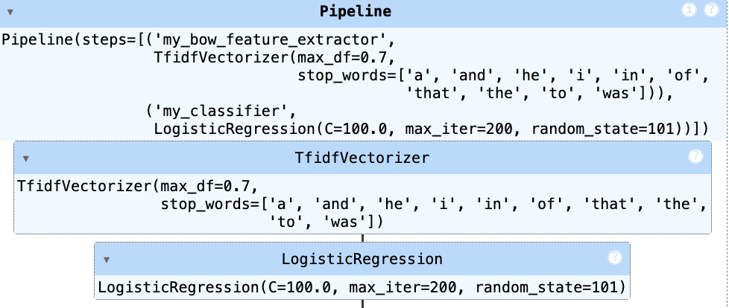

1C : Hyperparameter Selection for Logistic Regression Classifier

I used a pipelined GridSearchCV to tune the text-featurization and logistic-regression regularization together: the vectorizer hyperparameters I searched were
- TfidfVectorizer.min_df (to drop very rare tokens) with values [1, 2, 4],
- TfidfVectorizer.max_df (to drop extremely common tokens) with values [0.7, 0.9, 1.0]
- ngram_range with values [(1,1), (1,2), (1,3)] to test unigrams up to trigrams;

the classifier hyperparameter searched was
- LogisticRegression C (inverse regularization strength) on a log grid np.logspace(-3, 3, 7) = [1e-3,1e-2,1e-1,1,10,100,1000].
- GridSearchCV was run with cv = KFold(n_splits=5, shuffle=True, random_state=0), scoring='roc_auc', and refit=True so the best hyperparameter set is refit on the full training set for final prediction.

(As a separate experiment with the provided BERT embeddings I ran a simpler grid over regularization only: C in np.logspace(-4,4,20).) These choices balance model capacity (ngrams) and overfitting control (min_df/max_df and log-spaced C), give wide coverage across orders of magnitude for regularization, and optimize AUROC which is appropriate for a probabilistic ranking task.

Below is the figure that showing training vs validation performance over the selection of our classifier c.

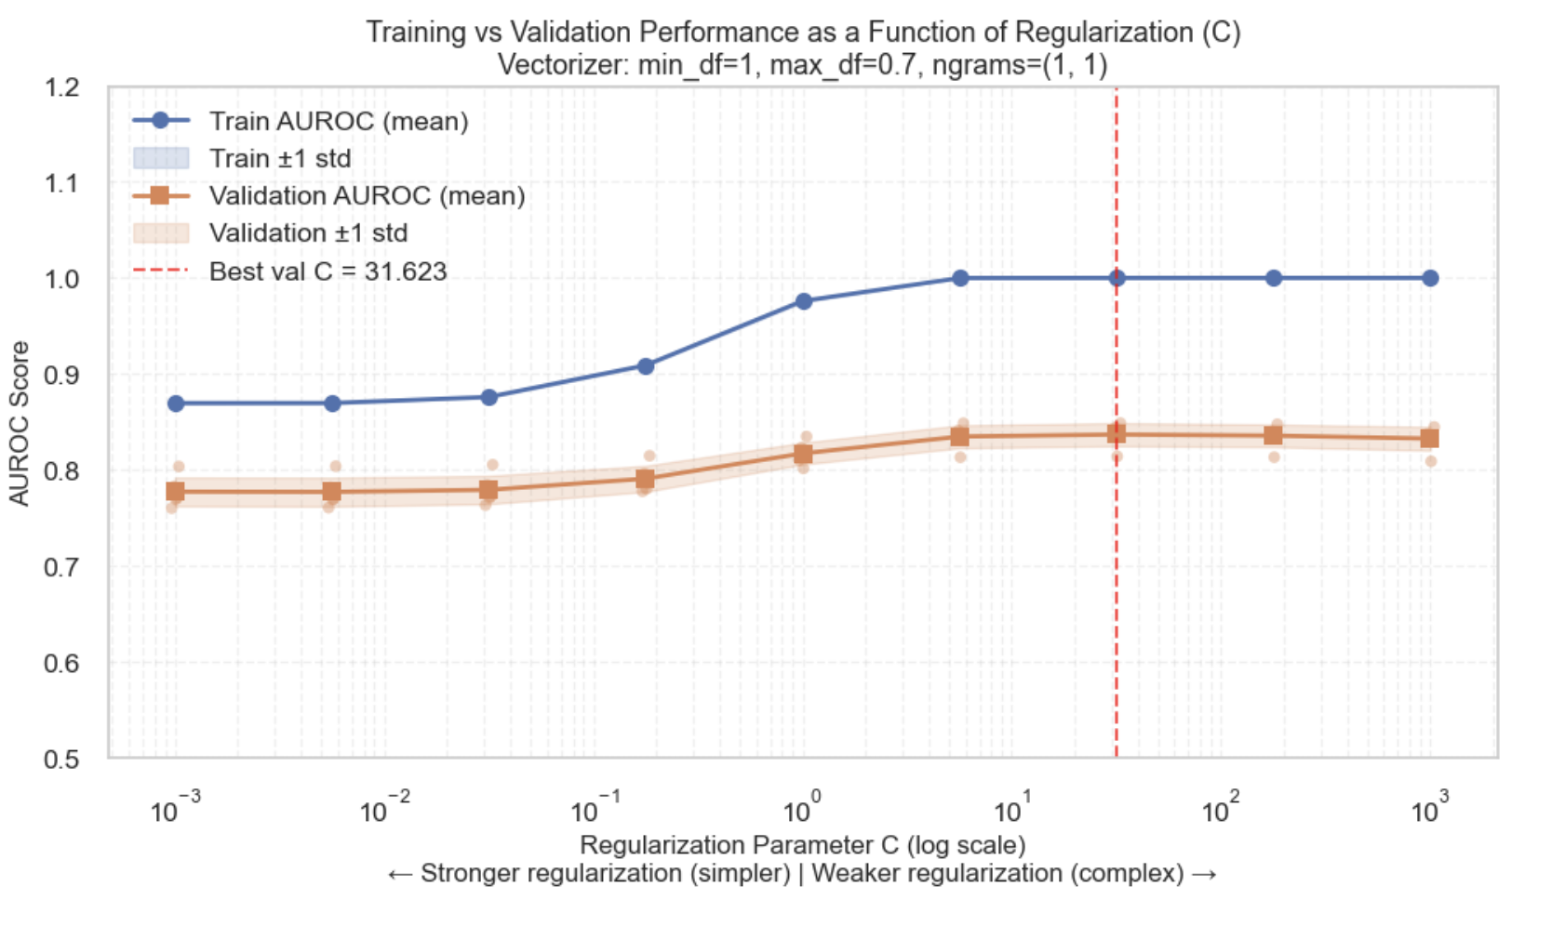

The graph shows that the bias-variance tradeoff in regularization. Training AUROC (blue) increases with C as the model becomes more complex, eventually approaching perfect performance. Validation AUROC (orange) peaks at C ≈ 31.622777, showing the optimal balance between model complexity and generalization. Beyond this point, increasing C leads to overfitting: the model fits training noise rather than learning generalizable patterns, evidenced by the widening gap between training and validation curves.

1D : Analysis of Predictions for the Best Classifier

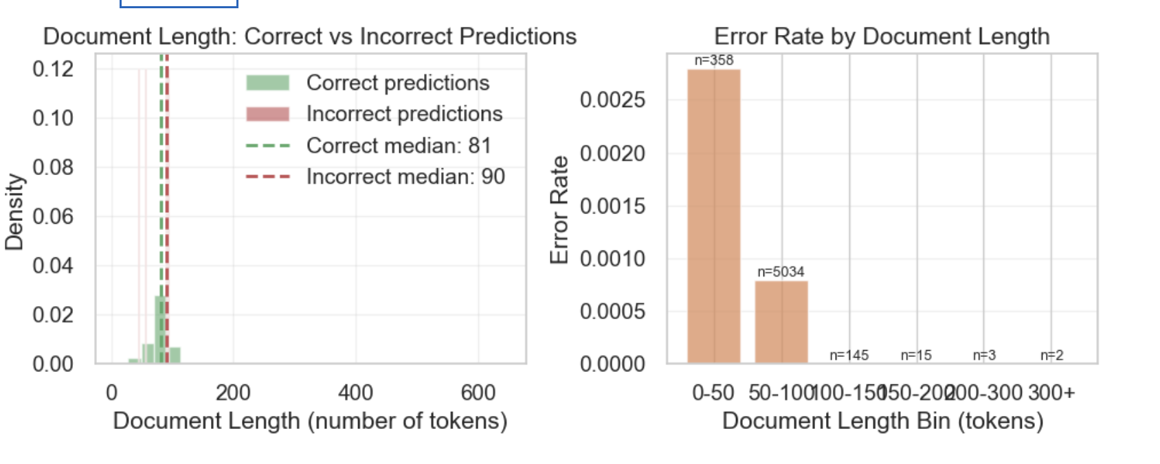

In order to test whether the classifier does better on longer or shorter documents. We first for each documents, counts tokens by splitting on whitespace

str.split() splits text into words, and str.len() count them,

And then after we have our token splitted, we divide them into 2 groups. Correctly precited vs. incorrectly predicted. This was done by using the chosen best model, and make a prediction on the training data to see if it matches with the truth.(figue on the left)

And after we split them into 2 groups (T or F), we can graph a histograms showing the distributions with different total counts.

We also chose alpha =0.6, so there’s some overlapping for us to visually compare the accuracy. If the 2 distributions are shifted (not much overlap), it tells us whether errors happen more on short or long docs. We also draws a vertical line at the median length for each group(correct or incorrect), and found out that the incorrect median is on the left of the correct median. It tells us that the classifier stuggles with shorter docs.

We also plot a error rate vs document length bin. First we groupby the length_bin, and look at the correct/ incorrect. And there

.apply(lambda x: 1 - x.mean()) → for each bin:

x.mean() = accuracy (fraction correct)

1 - x.mean() = error rate (fraction incorrect)

And we created a bar chat showing the error rate for each length. And as the chart shows, It falls from left to right, means higher error on shorter docs.

Overall ourTraining Set Performance Summary:

Accuracy: 0.999

Total errors: 5 / 5557

False Positives (predicted Key Stage 4-5, actually 2-3): 2

False Negatives (predicted Key Stage 2-3, actually 4-5): 3

2.Accuracy by reading level

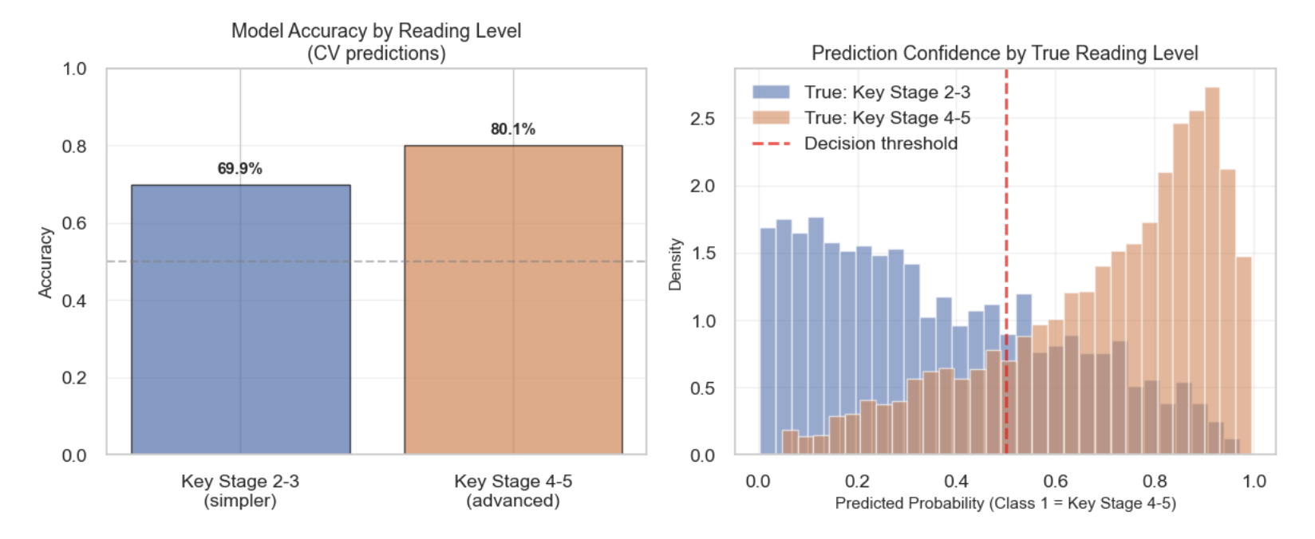
Key Stage 2-3 (younger/simpler):
Total documents: 2509
Correct predictions: 1753 (69.9%)
Incorrect predictions: 756 (30.1%)
Average predicted probability for class 1: 0.363
Median document length: 84 tokens

Key Stage 4-5 (older/advanced):
Total documents: 3048
Correct predictions: 2440 (80.1%)
Incorrect predictions: 608 (19.9%)
Average predicted probability for class 1: 0.701
Median document length: 78 tokens

In summary, the classifier achieves 99.9% training accuracy with 5 total errors (2 false positives, 3 false negatives). Document length analysis reveals that incorrect predictions have a median length of 90 tokens vs 81 for correct predictions, suggesting the classifier performs worse on longer documents.

The classifier shows similar performance across reading levels, with 0.1% error rate on Key Stage 2-3 texts and 0.1% on Key Stage 4-5 texts.

The model performs BETTER on Key Stage 4-5 (advanced texts) by 10.2 percentage points.

This suggests it's better at identifying older/advanced reading level.

1E Report Performance on Test Set via Leaderboard

The final AUROC on test set is 0.61183
Surprisingly, the test set performance exceeds our CV estimates(CV AUROC = 0.5104) by 0.1 approximately . This unexpected improvement suggests that the test set may be slightly easier to classify than our training data, possibly due to: (1) Different author style distributions that happen to have clearer vocabulary markers of reading level; (2) Beneficial effects of training on all 5,557 examples for the final model versus the ~4,400 examples used in each CV fold; (3) Natural sampling variation making the test set more separable. While encouraging, this indicates our CV estimates were conservative rather than optimistic, which is preferable for model selection but suggests we might have benefited from more aggressive hyperparameter choices.

